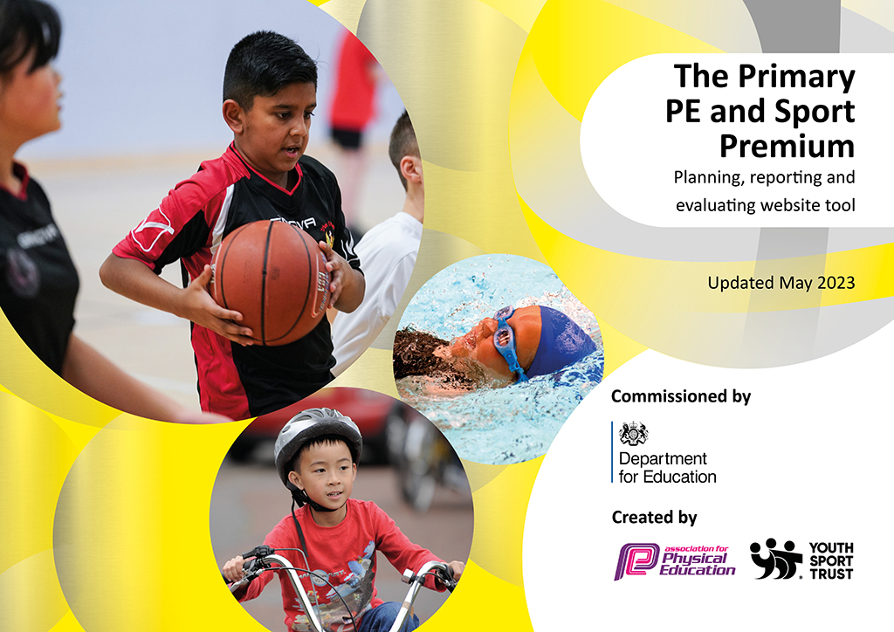
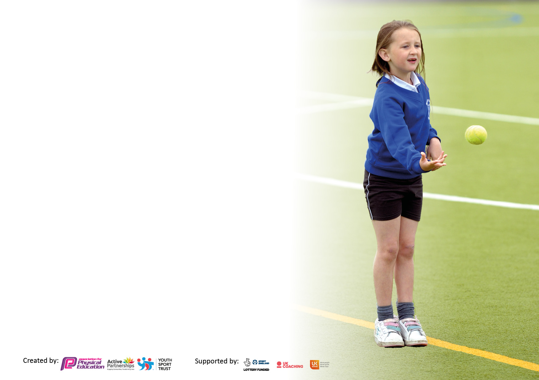

It is important that your grant is used effectively and based on school need. The Education Inspection Framework makes clear there will be a focus on ‘whether leaders and those responsible for governors all understand their respective roles and perform these in a way that enhances the effectiveness of the school’.

Under the Quality of Education Ofsted inspectors consider:
Intent - Curriculum design, coverage and appropriateness
Implementation - Curriculum delivery, Teaching (pedagogy) and Assessment
Impact - Attainment and progress

To assist schools with common transferable language this template has been developed to utilise the same three headings which should make your plans easily transferable between working documents.

Schools must use the funding to make additional and sustainable improvements to the quality of Physical Education, School Sport and Physical Activity (PESSPA) they offer. This means that you should use the Primary PE and sport premium to:

- Develop or add to the PESSPA activities that your school already offer
- Build capacity and capability within the school to ensure that improvements made now will benefit pupils joining the school in future years
- The Primary PE and sport premium should not be used to fund capital spend projects; the school’s budget should fund these.

Please visit gov.uk for the revised DfE guidance including the 5 key indicators across which schools should demonstrate an improvement. This document will help you to review your provision and to report your spend. DfE encourages schools to use this template as an effective way of meeting the reporting requirements of the Primary PE and Sport Premium.

We recommend you start by reflecting on the impact of current provision and reviewing the previous spend.

Schools are required to publish details of how they spend this funding, including any under-spend from 2021/2022, as well as on the impact it has on pupils’ PE and sport participation and attainment. All funding must be spent by 31st July 2023.

We recommend regularly updating the table and publishing it on your website throughout the year. This evidences your ongoing self-evaluation of how you are using the funding to secure maximum, sustainable impact. Final copy must be posted on your website by the end of the academic year and no later than the 31st July 2023. To see an example of how to complete the table please click HERE.

Details with regard to funding
Please complete the table below.

Total amount carried over from 2021/22 | £11364.55
Total amount allocated for 2021/22 | £17200.00
How much (if any) do you intend to carry over from this total fund into 2022/23? | £4139.00
Total amount allocated for 2022/23 | £17190.00
Total amount of funding for 2023/23. To be spent and reported on by 31st July 2023. | £ 21329.96
Swimming Data
Please report on your Swimming Data below.

Meeting national curriculum requirements for swimming and water safety.

N.B. Complete this section to your best ability. For example you might have practised safe self-rescue techniques on dry land which you can then transfer to the pool when school swimming restarts.
Due to exceptional circumstances priority should be given to ensuring that pupils can perform safe self rescue even if they do not fully meet the first two requirements of the NC programme of study
What percentage of your current Year 6 cohort swim competently, confidently and proficiently over a distance of at least 25 metres?  N.B. Even though your pupils may swim in another year please report on their attainment on leaving primary school at the end of the summer term 2022.  Please see note above | 95%
What percentage of your current Year 6 cohort use a range of strokes effectively [for example, front crawl, backstroke and breaststroke]?  Please see note above | 95%
What percentage of your current Year 6 cohort perform safe self-rescue in different water-based situations? | 95%
Schools can choose to use the Primary PE and sport premium to provide additional provision for swimming but this must be for activity over and above the national curriculum requirements. Have you used it in this way? | Yes – water polo and poolside rescue

Action Plan and Budget Tracking
Capture your intended annual spend against the 5 key indicators. Clarify the success criteria and evidence of impact that you intend to measure to evaluate for pupils today and for the future.

Academic Year: 2022/23 | Total fund allocated: | Date Updated:
Key indicator 1: The engagement of all pupils in regular physical activity – Chief Medical Officers guidelines recommend that primary school pupils undertake at least 30 minutes of physical activity a day in school |  |  |  | Percentage of total allocation:
 |  |  |  | 1.56%
Intent | Implementation |  | Impact
Your school focus should be clear what you want the pupils to know and be able to do and about  what they need to learn and to  consolidate through practice: | Make sure your actions to achieve are linked to your intentions: | Funding allocated: | Evidence of impact: what do pupils now know and what can they now do? What has changed?: | Sustainability and suggested next steps:
- Pupils to be safe during PE lessons.  - Children to be physically active both during PE lessons and during playtimes and other times.  - Children to increase core fitness following covid years and lack of physical exercise. | Regular stock-take to ensure adequate equipment and maintain current equipment needed for PE provision . PE resources purchased to improve quality of PE curriculum:  - Includes new rope, electric ball pump, footballs and rugby balls .  - Service of outdoor gym equipment and resurfacing of gym equipment surface.  - Hire of local recreation ground for KS2 PE provision as school field unusable. | £334.06 | - Feedback from staff, increased confidence in teaching PE  - Children’s engagement in PE  - The variety of sports on offer which address different skills.  Increased physical activity during playtimes which improved health and well being.  Safety whilst using the gym equipment. | Continue to use gym equipment both at play times and during PE sessions (and other curricular subjects eg science – heart rate)  School field being restored for use asap – badger survey complete and fence to be erected.
Key indicator 2: The profile of PESSPA being raised across the school as a tool for whole school improvement |  |  |  | Percentage of total allocation:
 |  |  |  | 29.68%
Intent | Implementation |  | Impact
Your school focus should be clear what you want the pupils to know and be able to do and about  what they need to learn and to  consolidate through practice: | Make sure your actions to achieve are linked to your intentions: | Funding allocated: | Evidence of impact: what do pupils now know and what can they now do? What has changed?: | Sustainability and suggested next steps:
- Opal playground development  Scheme to enhance fair play, social and emotional learning thorough play | - Training staff on risk assessments  - Visiting another opal school  - Collection and organization of opal resources  - Parental communication about the play scheme  - Coordinating meetings of opal team including governor and parent.  - Reporting to governors on effectiveness of Opal provision | £6331.67 | Less playground disruption and children engaged in variety of activities | Monitor future provision, replace broken equipment  Increase in the variety of physical activities children can take part in

Key indicator 3: Increased confidence, knowledge and skills of all staff in teaching PE and sport |  |  |  | Percentage of total allocation:
 |  |  |  | 13.26%
Intent | Implementation |  | Impact
Your school focus should be clear  what you want the pupils to know  and be able to do and about  what they need to learn and to  consolidate through practice: | Make sure your actions to  achieve are linked to your  intentions: | Funding  allocated: | Evidence of impact: what do  pupils now know and what  can they now do? What has  changed ?: | Sustainability and suggested.  next steps:
- Improvement in staff subject knowledge and confidence in teaching PE.  - After schools sports club offered. | Specialist PE Coach to teach children and be observed by staff | £2830.00 | Quality provision observed by teachers. Children’s skills development. Also enhanced by after school clubs offered to children: multi-skills, netball and football | School will embed PE practice and active learning across additional curriculum areas. Maintain staff training.
Key indicator 4: Broader experience of a range of sports and activities offered to all pupils |  |  |  | Percentage of total allocation:
 |  |  |  | 49.90%
Intent | Implementation |  | Impact
Your school focus should be clear  what you want the pupils to know  and be able to do and about  what they need to learn and to  consolidate through practice: | Make sure your actions to  achieve are linked to your  intentions: | Funding  allocated: | Evidence of impact: what do  pupils now know and what  can they now do? What has  changed?: | Sustainability and suggested  next steps:
Additional achievements:  - Forest Schools staffing and equipment | Improve delivery of Forest Schools which develops the whole child and encompasses a variety of sports and OOA activities. | £10,645.66 | Increasing children’s physical, social and emotional wellbeing especially see benefits for SEND children. | Ensure forest schools equipment is well maintained

Key indicator 5: Increased participation in competitive sport |  |  |  | Percentage of total allocation:
 |  |  |  | 0.64%
Intent | Implementation |  | Impact
Your school focus should be clear  what you want the pupils to know  and be able to do and about  what they need to learn and to  consolidate through practice: | Make sure your actions to  achieve are linked to your  intentions: | Funding  allocated: | Evidence of impact: what do  pupils now know and what  can they now do? What has  changed?: | Sustainability and suggested  next steps:
- More children to experience a wider variety of sports and compete in intra/inter school events.  - Children to train to lead sports events and activities for other children. | - staff training days including all staff on opal  - Supply staff to take to sports fixtures  - Sports crew have been trained in Autumn Term and led playtime activities for younger children and an inter school event leading activities for Year 2 children across the cluster. | £138.57 | Inclusion in competitions has kept children engaged with physical activity. Ensured more SEND and BAME children take part in sports fixtures to increase their self confidence.  Year 5 crew children have become great leaders and are able to organise younger children. | Year 5 Sports Crew were trained to encourage sustainability into the next academic year.

Signed off by
Head Teacher: | L.Hobby and G.Blake Hatton
Date: | 17 July 23
Subject Leader: | L.Newman
Date: | 17 July 23
Governor: | D.Hawe
Date: | 19 July 23

