TIPS TO HELP
- Know that a GPC is a grapheme phoneme correspondence. That means a sound is matched to one or more written letters: /a/ /ai/
/ay/.

- Saying pure sounds is important

- Some sounds stretch e.g. m, n, r

- Some bounce e.g. b, p.

- Say them softly and say a word that begins with the sound to help.

- Try to avoid a big ‘Uh’ sound at the end

- Be aware that your child will be learning GPCs each week and applying them to reading and writing.

- The Shared Reader you practise at home with your child will include the focus GPC that they have just learnt that week.

- They will have also read that Shared Reader in class that week.

PARENT PORTAL
https://parents.fft.org.uk

The portal contains useful videos of how to pronounce each of the graphemes, as well as tips on how to help at home and additional information about the phonics stages.
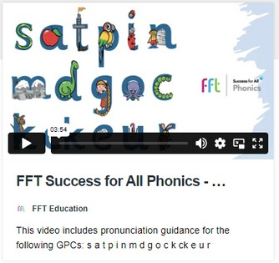
PHONICS AND
EARLY
READING AT ASHURST WOOD PRIMARY

WHY DO CHILDREN NEED TO LEARN PHONICS?
Researchers who looked at the impact of parents reading with their children quoted the following figures in a news release about their findings:
Here’s how many words kids would have heard by the time they were 5 years old:
Never read to, 4,662 words;
1–2 times per week, 63,570 words;
3–5 times per week, 169,520 words;
daily, 296,660 words;
five books a day, 1,483,300 words.
The only effective route to closing this gap is for children to be taught systematically to read as soon as they start school. In this way, they do not have to rely on adults to read to them.
Children who become engaged in reading can make huge progress in their literacy development simply through their independent reading, whatever the nature of their early experiences.

WHAT DO YOU USE TO TEACH PHONICS AND EARLY READING?
Success for All Phonics supports your child to learn all the skills needed to successfully read, write and spell.
It is part of a wide range of literacy programmes that come from FFT.
There are lots of engaging resources e.g. flashcards and sound mats to support learning.
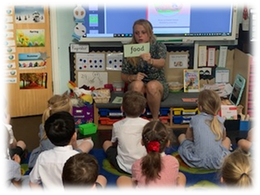
There are also 68 decodable reading books which will be used in class and sent home in either hard copies or digital books.

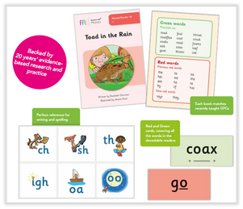
WHAT HAPPENS IN A LESSON?

Each day:
Revisit phonemes and graphemes
Consolidate learning before new content is introduced Orally blend
Segment
Read words and then sentences

Also:
Learn the alphabet
How to write letters in upper and lower case
Write simple words and then sentences

Reading:
Daily opportunities to apply their learning into reading Discussing the text to develop their comprehension skills

