Ashurst Wood Primary School

**School Uniform Policy**

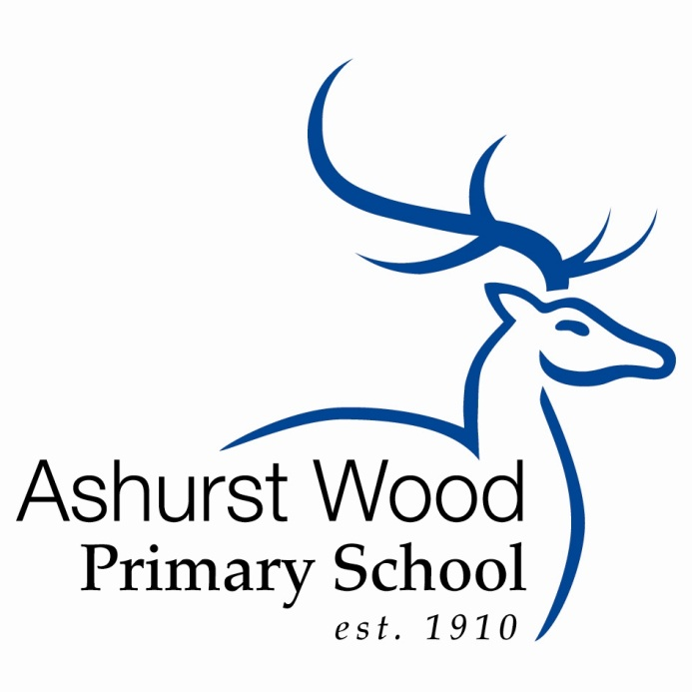

Reviewed May 2023

Review Date Spring 2. 2024

**Ashurst Wood Primary School Uniform**

At Ashurst Wood we pride ourselves in being smart, well presented and ready for learning. We ask children to wear their shirts tucked into their skirts, shorts or trousers and to take a pride in their personal appearance. It is our school policy that all children wear school uniform when attending school, or when participating in school-organised events outside normal school hours.

We make every effort to consult with parents when making decisions concerning uniform and every effort is made to consider the impact of cost on any changes. The School Uniform Policy Audit contains details of this information. Some items of uniform can be purchased from Sussex Uniforms ([Ashurst Wood – Sussex Uniforms](https://www.sussexuniforms.co.uk/collections/ashurst-wood?msclkid=e88c90a8d12811ecafe27a331274ea79)), whilst others are easily available, at very competitive prices, at local shops including supermarkets. A complete list of the items needed for school uniform including those for Physical Education is below. (https://www.sussexuniforms.co.uk/collections/ashurst-wood)

Aims and objectives

Our policy on school uniform is based on the belief that we are pleased to wear a uniform that:

• Promotes a sense of pride in our school

• Helps to create a sense of community and belonging towards the school

• Identifies pupils with the school

• Supports the school’s commitment to inclusion

• Prevents pupils from wearing ‘fashion clothes’ that could be distracting in class • Is practical, smart, and designed with health and safety in mind

• Is considered to be good value for money

Jewellery, Hair Ornaments, Make-up and Nail Varnish

For many reasons, including safety, we do not allow children to wear jewellery. The exceptions to this rule are ear-ring studs in pierced ears. Children are required to remove any items during P.E. lessons to prevent them from causing injury. *Please note: teachers are not permitted to remove earrings*. Hair bands, ribbons/bows or ‘scrunchies’ should be plain and either royal blue or pink to match our uniform. Hair bands should not have large flowers or other decoration attached. Make up and nail varnish should not be worn to school. Extreme hairstyles are not appropriate for school. The use of styling products should be kept to a minimum and children should not have decorative patterns cut into their hair or have their hair coloured or dyed. Tattoos, temporary or otherwise are not permitted.

Footwear

For health and safety reasons we do not allow children to wear shoes with platform soles or high heels. All children are required to wear plain black shoes without logos as stated in the uniform list. If boots are worn these should also be plain black. If boots are large and prevent children from sitting comfortably on the floor they may be asked to change into another pair of shoes whilst inside the school building.

Examples of boys; shoes

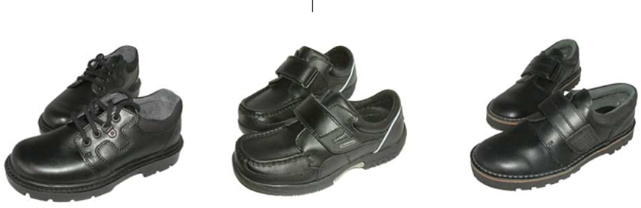

Examples of girls’ shoes

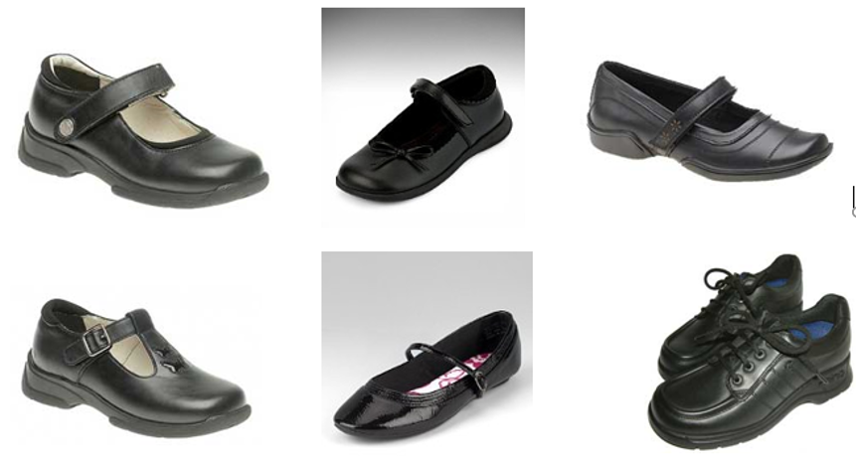

The Role of Parents

We believe that one of the responsibilities of parents is to ensure that their child has the correct uniform, Forest School kit and PE kit, and that it is clean, in good repair and that the child’s name is visibly labelled on all items. If a parent has difficulties for any reason with fulfilling this request, they are asked to speak confidentially to a senior member of staff to discuss the issues. Parents should be assured that we will do all we can to help. Children who arrive at school wearing non-school uniform clothing will be loaned an appropriate item from our lost property to wear for that day if possible. The same system will apply for children who do not have a PE kit or Forest School kit. Parents will be contacted to discuss the matter. The school welcomes children from all backgrounds and faith communities. If there are serious reasons, for example on religious grounds, why parents want their child to wear clothes that differ from the school uniform, the Uniform Policy will consider such requests sympathetically. If any parent would like to request an exception to the uniform policy they should, in the first instance, contact the Headteacher and then the Governors.

The Role of Governors

The governing body supports the Headteacher in implementing the School Uniform Policy. It considers all representations from parents regarding the Uniform Policy and liaises with the Headteacher to ensure that the policy is implemented fairly and with sensitivity. It is the governors’ responsibility to ensure that the school uniform meets all regulations concerning equal opportunities. Governors ensure that the School Uniform Policy enables children to dress sensibly, in clothing that is hardwearing, safe and practical.

Monitoring and Review

The Governing Body monitors and reviews the School Uniform Policy through its committee work by:

• seeking the views of parents, to ensure that they agree with and support the policy;

• considering, with the Headteacher, any requests from parents for individual children to have special dispensation with regard to school uniform.

School Uniform

Winter Uniform

|  |  |  |
| --- | --- | --- |
|  |  | Available from: |
| *Blue V-necked jumpers, and cardigans with embroidered school logo |  | [Ashurst Wood – Sussex Uniforms](https://www.sussexuniforms.co.uk/collections/ashurst-wood?msclkid=e88c90a8d12811ecafe27a331274ea79) |
| Plain white shirt (long or short Sleeved) | White, formal collared shirt, long or short sleeved.  Reception children should wear a polo shirt. | Sussex Uniforms or  local shops, including supermarkets |
| School tie (from Year 1) | Reception children should wear a polo shirt as they do not wear a tie. | School Office |
| Grey trousers, shorts, pinafore dress, skirt or skort | Plain grey skirt or pinafore **without** obvious embellishments. Length should be just above the knee.  Plain grey school style trousers or shorts. Fashion boot cut or skinny leg trousers are **not** permitted. | Sussex Uniforms or  local shops, including supermarkets |
| Grey socks or tights | Plain grey | Local shops, including supermarkets |
| Boots | Boots/wellingtons may be worn **to and from** school. Please provide shoes that comply with the uniform policy for wearing indoors. | Local shops, including supermarkets |
| Hair accessories | Long hair (boys and girls) must be tied off the face at all times with discreet royal blue or brown hairbands or elastic ties. Hair bands, ribbons/bows or ‘scrunchies’ should be plain and either royal blue or pink to match our uniform. Hair bands should not have large flowers or other decoration attached. | Local shops, including supermarkets |
| Vests | Plain white vests or T-shirts without embellishments or logos may be worn under shirts in extremely cold weather. | Local shops, including supermarkets |
| *Book Bags | Royal blue bags with the school logo  (Compulsory for Year R, Year 1 and Year 2 pupils) | [Ashurst Wood – Sussex Uniforms](https://www.sussexuniforms.co.uk/collections/ashurst-wood?msclkid=e88c90a8d12811ecafe27a331274ea79) |

Summer Uniform

|  |  |  |
| --- | --- | --- |
|  |  | Available from: |
| * Blue V-necked jumpers, and cardigans with embroidered school logo |  | [Ashurst Wood – Sussex Uniforms](https://www.sussexuniforms.co.uk/collections/ashurst-wood?msclkid=e88c90a8d12811ecafe27a331274ea79) |
| Plain white polo shirt |  | Sussex Uniforms or  local shops, including supermarkets |
| Grey shorts, skirt or skort | Please see guidance for the winter specifications.  If grey is worn, socks should also be grey. | Sussex Uniforms or  local shops, including supermarkets |
| Grey socks | Plain grey | Local shops, including supermarkets |
| Dresses | Pink gingham summer dress without obvious embellishments or trimmings. | Local shops, including supermarkets |
| White socks – no embellishments | If pink dresses are worn, then white socks (not grey) should also be worn. | Sussex Uniforms or  local shops, including supermarkets |
| Hair accessories | Long hair (boys and girls) must be tied off the face at all times with discreet royal blue or brown hairbands or elastic ties. Hair bands, ribbons/bows or ‘scrunchies’ should be plain and either royal blue or pink to match our uniform. Hair bands should not have large flowers or other decoration attached. | local shops including supermarkets |
| *Book Bags | Royal blue bags with the school logo  (Compulsory for Year R, Year 1 and Year 2 pupils) | [Ashurst Wood – Sussex Uniforms](https://www.sussexuniforms.co.uk/collections/ashurst-wood?msclkid=e88c90a8d12811ecafe27a331274ea79) |

**\***All items marked with an asterisk must be bought through the online website

https://www.sussexuniforms.co.uk/collections/ashurst-wood

**The school tie can only be purchased from the school office**

PE Kit – *School Uniform is not worn on PE days*

|  |  |
| --- | --- |
| **\***PE Shirt | Royal blue with school logo from Sussex Uniforms |
| Shorts or skort | Plain black football style shorts – no logos |
| Plimsolls/trainers | Black plimsolls, or plain black or white trainers without logos or embellishments. Trainers must have non-marking soles. |
| **\***Hoodie | Royal blue with school logo. ***This is an optional item but must be purchased through Sussex Uniforms*** |
| Jog pants | Plain Black or Royal Blue with no embellishments or logos |

**Forest School Kit**

School uniform is not to be worn on Forest School days and old clothes that may become dirty are recommended. Clothes that will probably be needed are listed below, but please take into account local weather conditions and dress children appropriately.

Forest School Winter Uniform

|  |  |
| --- | --- |
| Vest or T-shirt |  |
| Long sleeved top |  |
| Hooded top/Fleece or thick jumper | On really cold days layers with 2 or 3 jumpers are most effective |
| Waterproof jacket |  |
| Thick socks | Thermal socks or 2 pairs thin socks |
| Warm trousers |  |
| Waterproof trousers |  |
| Wellington boots or walking boots |  |
| Hat, gloves and scarf |  |
| Flannel/small towel |  |
| Metal or plastic mug with handle and  teaspoon |  |

Forest School Summer Uniform

|  |  |
| --- | --- |
| Long sleeved light T-shirt | Arms must be covered in the woodland |
| Light trousers – **NO** shorts | Legs must be covered in the woodland |
| Socks |  |
| Wellington boots or walking boots | Sandals and flip-flops are NOT suitable |
| Sunhat |  |
| Sunglasses | If required |
| Sunscreen/Insect Repellent | Pupils are responsible for providing and applying their own sunscreen/repellent |
| Flannel/small towel |  |
| Metal or plastic mug with handle and  teaspoon |  |

Frequently Asked Questions

Do I have to buy all school uniform from the school?

The only items that must be purchased through the school uniform online website are the school jumper/cardigan, PE shirt, book bags (KS1) and school hoodie (optional). The school tie must be purchased from the school. All other items of uniform can be purchased from retailers of your choice.

Will the school provider supply only the compulsory school purchased items?

No, a full range of school uniform is available for you to browse and order, including trousers, skirts, shorts, dresses, pinafores, shirts, and blouses; however these items can still be bought from retailers of your choice.

Do the girls have to wear dresses in the summer?

No, the girls and boys can choose which summer uniform elements they wish to wear. The only stipulation is pink dress + white socks. Grey shorts etc. + grey socks.

Does the school make a profit on the sale of school uniform?

The school will not make a profit on the sale of uniform.

Where can I find a copy of the school uniform policy?

Paper copies are available from the school office, detailed in the prospectus and on the school website.

How do I order school uniform?

Sussex Uniforms, provides an online system for parents to order our school uniform directly. This can be accessed by visiting <https://www.sussexuniforms.co.uk/collections/ashurst-wood>. Sussex Uniforms offer a free click and collect service, so that parents/carers can order their uniform online and collect it for free from one of their stores if they so wish. The Haywards Heath store and Hove store addresses can be found on the above website. Although Sussex Uniforms only offer us an online service, parents/carers are welcome to take their children to one of their stores for sizing and advice. As stated above, the school tie must be purchased through the school.

What does ‘plain’ mean in the policy?

The definition of plain in the policy is “no fashion embellishments, no contrasting colours, stripes or markings, no advertisements or brand logos”. This helps to ensure that we minimise competition between the children in terms of the clothes that they wear.

What help will be available for my child to tie their school tie?

Children will be given the opportunity to practice at school and staff will be available to assist the younger children. The following website also provides useful guidance on half windsor tie knots http://www.tie-a-tie.net/halfwindsor.html. We will strongly encourage children to slide the knot of their tie down rather than untie it completely when getting undressed.

Can my child wear earrings to school if they have just been pierced?

### One pair of small stud earrings is permitted but must be removed for PE or swimming.