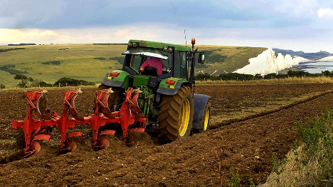

**Maths**

Place Value

Addition & Subtraction

Multiplication & Division

Solving problems

Measures

Time

Position and direction

**English**

Book Review

Letters – Dear Greenpeace

Explanation texts – The journey of chocolate

Poetry

Handwriting

Phonics

Spellings

Whole class reading

**Computing**

E-Safety

Stop Motion storyboarding then creating simple animations

**Art/DT**

Fruity feasts – ice lollies

Design and packaging

**Science**

Forest Schools

Living things and their habitats

Animals including humans

Farm to fork

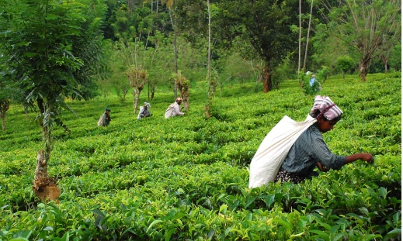

**Beliefs and Values**

St Georges Day

Queens Jubilee

Islam

**PSHE/E4S**

Physical health and well being

Emotional health and well being

**Geography**

How does weather affect crops?

Differences between farming in the UK and India

Traditional foods in the UK

What grows locally

**P.E**

Ball skills

Multi sports

Sports Day

**Owl Wows!**

Visit to a local farm

**Music**

Exploring sounds

Beat