Ashurst Wood Primary School

Curriculum Policy

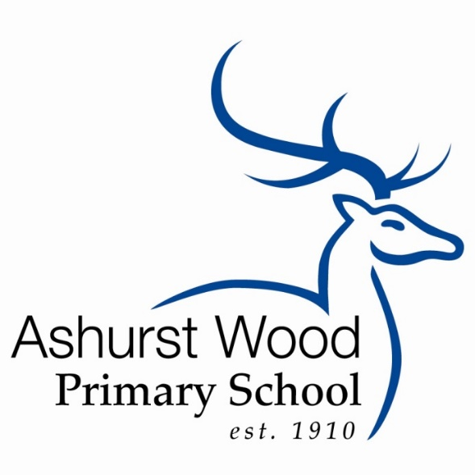

The Little School with a Big Heart

Updated: Feb 2020

Review: Autumn 1 2021

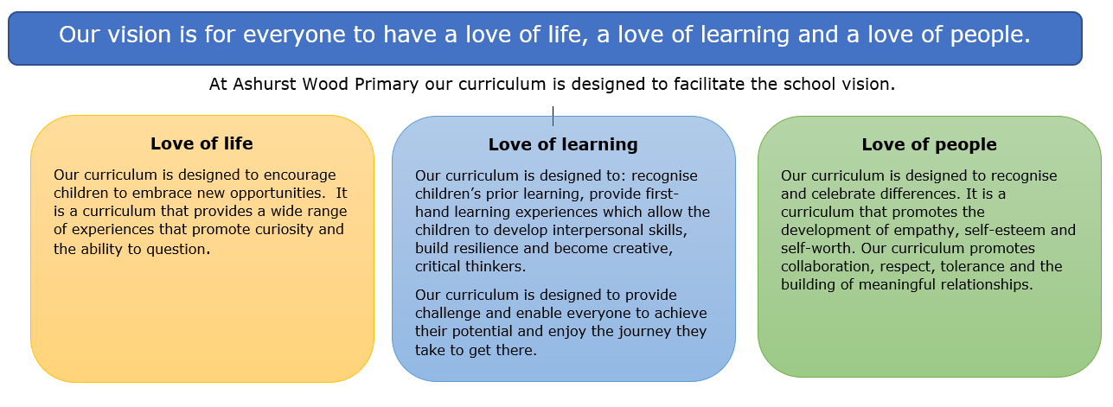
Curriculum Intent

To expand on this, we have the following aims for our curriculum. It will enable our children to:
- develop lively and enquiring minds;
- communicate confidently and effectively;
- learn the essential life skills;
- express themselves creatively and be inspired by the creativity of others;
- develop personal, ethical and moral qualities, including respect for others, in line with core British values;
- be prepared for the opportunities of life in a changing world;
- play an active role in and engage with their community;
- learn how to learn and to regard learning as an enjoyable and lifelong activity;
- experience rich and meaningful learning with many first-hand experiences;
- appreciate the need for a healthy lifestyle;
- set personal standards of achievement and value excellence.

Our curriculum is:
- Broad so that it provides a wide range of knowledge, skills and experiences;
- Rich so that each subject has sufficient time to contribute effectively to learning. There must be time for teachers to teach knowledge, content and skills with sufficient depth, and time for children to make sense, practise and achieve mastery;
- Relevant so that learning can be linked to real experiences, both in the children’s local community and the world at large;
- Coherent so that subject areas can be linked to make the learning experience more meaningful;
- Progressive so that objectives are specific and progress year on year ensuring consistency, continuity and rigour;
- Challenging so that there are high aspirations for all children to achieve the very best they can do;
- Accessible so that there is equal opportunity for all children to access all areas of the curriculum.

Curriculum Implementation

Organisation and Planning

Each class has a long-term plan. This indicates what topics and which National Curriculum objectives are taught in each term. Our curriculum is thematic with a cross-curricular approach to enable ‘joined up/purposeful’ learning to take place. Some subjects are taught in single year groups and some are taught as discrete subjects.

Subject | Delivery
 | KS1 | KS2
Science | Through Forest Schools and in mixed Year group classes in blocks. | As discrete subject in single year groups.  Through Forest Schools.
French | Through a paid club | In mixed classes as a discrete subject
Computing | In mixed classes as a discrete subject | In mixed classes as a discrete subject
D.T. | In mixed classes as a discrete subject or as part of topic work. | In mixed classes as a discrete subject or as part of topic work.
P.E | In mixed classes as a discrete subject. | In mixed classes as a discrete subject, delivered by teachers and a sports coach who will also work with targeted groups of children in addition to class P.E. lessons.
Music | In mixed classes as a discrete subject or as part of topic work. | In mixed classes as a discrete subject – learning an instrument. As part of Topic work or work towards school performances.
RE | In mixed classes as a discrete subject. | In mixed classes as a discrete subject.
Art | In mixed classes as part of topic work. | In mixed classes as part of topic work.
History | In mixed classes as part of topic work. | In mixed classes as part of topic work.
Geography | In mixed classes as part of topic work. | In mixed classes as part of topic work.
PSHE / P4C | In mixed classes as a discrete subject or as part of topic work. | In mixed classes as a discrete subject or as part of topic work.
English | In single year groups as discrete lessons driven by the topic and or high quality texts. | In mixed classes as a discrete lessons driven by the topic and or high quality texts.
Maths | In single year groups as discrete lessons. | In mixed classes as a discrete lessons.

We teach all subjects using the National Curriculum (2014). This ensures progression in learning and provides children with many opportunities to consolidate learning. Our medium term plans show the objectives being taught and how the children will learn, i.e. the activities that they will undertake and the skills that they will develop.

Our short-term plans are those that our teachers write on a weekly or daily basis. We use these to set out the learning objectives and success criteria for each session, and to identify what resources and activities we are going to use in the lesson. Weekly plans are written for English and Maths, showing differentiation for groups of children with different abilities. A weekly plan shows what other areas of the curriculum and objectives are being covered. They also show the teaching activities and differentiation within these lessons.

We plan the curriculum carefully, so that there is coherence and full coverage of all aspects of the National Curriculum, and there is planned progression in all curriculum areas.

Forest Schools Curriculum

A portion of the curriculum at Ashurst Wood Primary School, particularly science, is taught outdoors through Forest Schools. Each session is planned to incorporate Forest School skills, (such as fire lighting or tool work) elements of the science curriculum and links to the class topic where appropriate.
We believe all children benefit, in a variety of ways, from access to Forest Schools learning. Our Forest Schools sessions provide an engaging curriculum for all children and opportunities for learning in a different environment. The sessions are particularly accessible to those on the SEN register and also children whose learning styles are more physical.

Children with Special Needs

The curriculum in our school is designed to provide access and opportunity for all children who attend the school. If we think it necessary to adapt the curriculum to meet the needs of individual children, then we do so only after the parents of the child have been consulted and, if necessary, advice has been sought from external agencies.

If a child has special needs, our school does all it can to meet these individual needs. We comply with the requirements set out in the SEN Code of Practice in providing for children with special needs. If a child displays signs of having special needs, the class teacher makes an assessment of these needs. In most instances the teacher is able to provide resources and educational opportunities which meet the child’s needs within the normal class organisation. Children’s special educational needs may be met by the use of intervention groups or one-to-one support from Teaching Assistants and teachers.

The school provides an Individual Learning Plan (ILP) for each of the children who are on the special needs register. This sets out the analysis of the needs, strengths and areas for development and how these will be supported. Advice from the appropriate external agencies is incorporated into the profile.

The Early Years Foundation Stage

The curriculum that we teach in the reception class meets the requirements set out in the revised National Curriculum at Foundation Stage. We use Song of Sounds as a phonic scheme. For reading we use phonically decodable books as well as banded books, supplemented with many texts from suitable schemes.

Our school fully supports the principle that young children learn through play and by engaging in well-planned structured activities. Teaching in the Foundation class builds on the experiences of the children in their pre-school learning. We have an excellent positive partnership with the pre-school provider who shares the school site.

During the children’s first term in the Foundation class, their teacher begins to record the skills of each child on entry to the school. This assessment forms an important part of the future curriculum planning for each child. The Foundation Stage Profile is used to assess children’s progress during the year.

Monitoring

Our governing body is responsible for monitoring the way the school curriculum is implemented. Governors review each subject area according to the policy review timetable and staff share information during Full Governor Meetings. The curriculum and standards leadership teams monitor the way each subject is taught throughout the school and ensure all classes are taught the full requirements of the National Curriculum.

Review

This policy will be reviewed every year.

Appendix 1

