ASHURST WOOD PRIMARY SCHOOL-FRENCH POLICY

CURRICULUM INTENT
At Ashurst Wood Primary our curriculum is designed to facilitate the school vision.
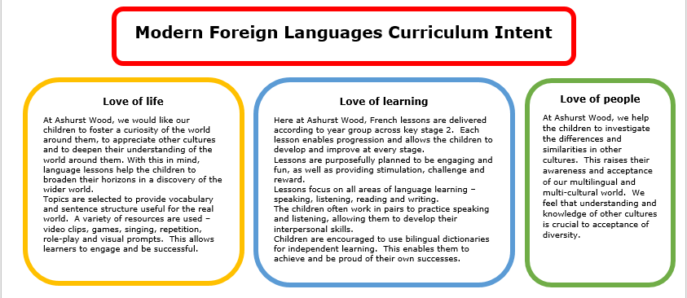

Purpose of study
“Learning a foreign language is a liberation from insularity and provides an opening to other cultures. A high-quality languages education should foster pupils’ curiosity and deepen their understanding of the world. The teaching should enable pupils to express their ideas and thoughts in another language and to understand and respond to its speakers, both in speech and in writing. It should also provide opportunities for them to communicate for practical purposes, learn new ways of thinking and read great literature in the original language. Language teaching should provide the foundation for learning further languages, equipping pupils to study and work in other countries.”

The National Curriculum in England: Key stages 1 and 2 Framework Document. September 2013
Implementation Overview
At Ashurst Wood, we teach French in KS2. We intend that children should master French to such an extent that they can go on to have careers within languages and make use of languages effectively in their everyday lives. Our children are taught French in a way that ensures progression of each skill, following a sequence to build on previous learning. The key areas of language learning are listening, speaking, reading and writing. Our children will gain experience and skills in the different areas of languages in a way that will enhance their learning opportunities, enabling them to use languages across a range of subjects to be creative and solve problems, ensuring they make progress. We follow a broad and balanced languages curriculum that builds on previous learning and which provides both support and challenge for learners. We follow the Primary Languages Network scheme that ensures progression of skills and covers all aspects of the languages curriculum.

Teaching of French in Key Stage 1
Though the study of a foreign language is only statutory in KS2, it is important that KS1 are introduced to language learning through exploring other cultures and languages beyond our own. Although there will be no formal lessons in KS1, children will be encouraged to sing song and rhymes.

Teaching of French in Key Stage 2
As part of the primary National Curriculum, learning French is a requirement from age seven within KS2.At Ashurst Wood, all KS2 classes have a scheduled language lesson each week.

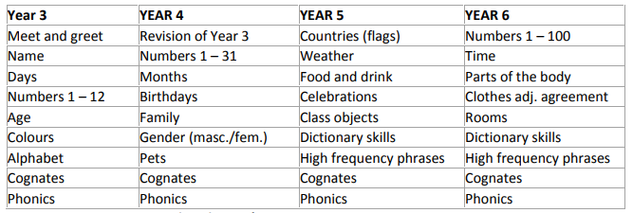

CURRICULUM PLANNING
Primary Language learning is planned following the broad guidelines set out in the Key Stage 2 Framework for Languages (DfES 2005) and from the Primary Languages Network Schemes of work. These schemes of work ensure that there is continuity and progression in both skills and content across all classes. We want to ensure that languages is embedded in our whole school curriculum and that opportunities for enhancing learning by using languages are always taken. French is taught in a whole class setting, by the class teacher and lessons are designed to motivate children from the first moment and are mainly practical in focus. They have clear, achievable objectives and incorporate different learning styles. Teachers should plan together using suggested teaching ideas and resources from the PLN scheme of work for French which Provides a wealth of ideas. Each class has a timetabled lesson of at least thirty minutes per week. French can also be revisited in short sessions throughout the week to consolidate knowledge and ensure new language is retained. Informal assessment of progress will be made by the teacher during lessons through questioning and oral feedback.

MEETING THE REQUIREMENTS (POS),
Teaching of a foreign language should allow pupils in KS2 to make substantive progress in one language. Progress needs to be shown in four skills of listening, speaking, reading and writing. The development of the knowledge of grammar in the foreign language is seen as important, with an awareness of phonology and vocabulary, laying foundations for transition into KS3 and of further foreign language teaching and cultural diversity.
SPECIAL EDUCATIONAL NEEDS
SEN children have access to the curriculum through variation of task, grouping or support from an adult. Primary Language teaching at Ashurst Wood Primary School aims to be fully inclusive. No child is excluded by reason of a learning difficulty, or because they have English as an additional language. Language learning research indicates that some children can derive particular benefit from taking part in Primary Language learning activities in which they may be less disadvantaged than in other areas of the curriculum. Language learning activities are planned in such a way as to encourage the full and active participation of all pupils. Work is differentiated as appropriate to the needs of individual children. Pairs and groups for collaborative work may be made up in different ways, depending on the task.
SPIRITUAL, MORAL, SOCIAL & CULTURAL DEVELOPMENT
French, for the children in Ashurst Wood Primary School, gives the opportunity to acknowledge that other languages exist in the wider world. Through the teaching of French, children are additionally provided with the knowledge that people around the world have a different, but an equally valuable, way of life
Moral
French supports moral development by encouraging children to look, discuss and evaluate a range of social and moral issues found in other cultures.
Spiritual
French supports spiritual development by exploring new language and vocabulary. Children are encouraged to express themselves in the target language.
Cultural
French supports the cultural development of a child by exposing them to a foreign language and culture. It helps promote internationalism and their role within the world.
Social
French lessons give children the opportunity to develop their interpersonal skills by lots of speaking and listening work, paired activities, and group work. Children must develop their confidence in these lessons to speak aloud and practise their pronunciation accuracy. Additionally, children must turn-take within their conversations allowing their peers the opportunity to develop their skills. Their work in general helps them to develop a respect for their peers, the abilities of others and it also encourages them to collaborate and cooperate across a range of activities. The children learn to respect and work with each other, and with adults.

ASSESSMENT & RECORDING
Teachers assess children’s progress informally during the lessons, evaluating progress against the four national Attainment Targets of: Listening and Responding; Speaking; Reading and Responding; Writing. Pupils’ work is assessed informally on the basis of observation during the lesson. This is particularly important for oral work. At the end of a piece of work, pupils may check each other’s answers, particularly for a listening or reading activity, but the teacher will always mark and comment on the work. Very simple comments are made in the target language such as Bien, Bon effort etc, and longer comments in English. Verbal feedback is also given with examples of good practice shared to encourage and motivate. Teachers make long-term assessments towards the end of the school year, and they use these to assess progress against school MFL targets. With the help of these long-term assessments, teachers are able to set targets for the next school year and summarise the progress of each child before reporting it to the child’s parents at the end of the academic year.

MONITORING & REVIEW
Opportunities to monitor the children’s progress in Primary Languages are built into our termly programmes of study. Progress in languages is demonstrated through regular review of children’s work, to ensure that progression of skills is taking place. The teacher’s look at pupils’ book work, especially over time as they improve their skills and knowledge. Teachers observe how they perform in lessons, and talk to them to assess what they know and how to push them further. Pupils are encouraged to talk confidently about their work, and to share their work with others. This policy will be reviewed annually by staff and governors.
IMPACT
Our French curriculum will ensure all pupils develop key language learning skills, as set out by the national curriculum, as well as a love of languages and learning about other cultures. These are as follows:
- understand and respond to spoken and written language from a variety of authentic sources
- speak with increasing confidence, fluency and spontaneity, finding ways of communicating what they want to say, including through discussion and asking questions, and continually improving the accuracy of their pronunciation and intonation
- can write at varying length, for different purposes and audiences, using the variety of grammatical structures that they have learnt
discover and develop an appreciation of a range of writing in the language studied.

