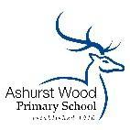
ASHURST WOOD PRIMARY SCHOOL-GEOGRAPHY POLICY

CURRICULUM INTENT - At Ashurst Wood Primary our curriculum is designed to facilitate the school vision.
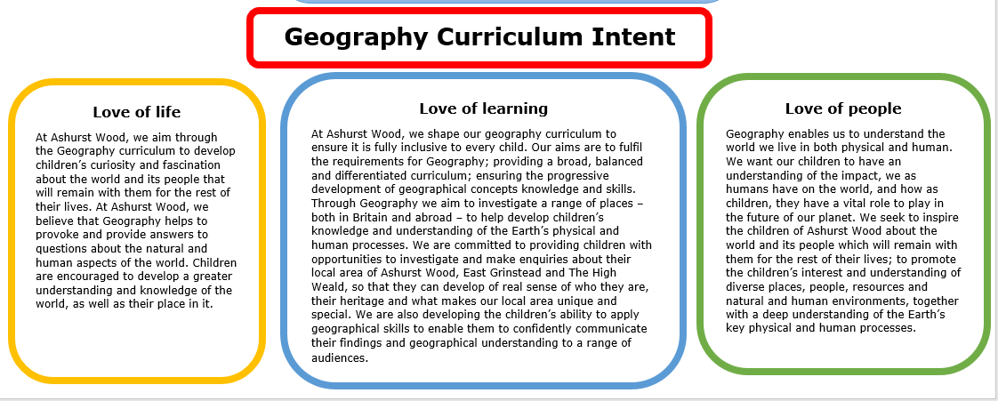

Essential characteristics of Geographers
- An excellent knowledge of where places are and what they are like.
- An excellent understanding of the ways in which places are interdependent and interconnected and how much human and physical environments are interrelated.
- An extensive base of geographical knowledge and vocabulary.
- Fluency in complex, geographical enquiry and the ability to apply questioning skills and use effective analytical and presentational techniques.
- The ability to reach clear conclusions and develop a reasoned argument to explain findings.
- Significant levels of originality, imagination or creativity as shown in interpretations and representations of the subject matter.
- Highly developed and frequently utilised fieldwork and other geographical skills and techniques.
- A passion for and commitment to the subject, and a real sense of curiosity to find out about the world and the people who live there.
- The ability to express well-balanced opinions, rooted in very good knowledge and understanding about current and contemporary issues in society and the environment.
Implementation Overview
Geography teaching at Ashurst Wood Primary School involves adapting and extending the curriculum to match all pupils’ needs. Where possible, Geography is linked to our topic based curriculum. In Key Stage 1 we have a three year rolling programme and in Key Stage 2 we have a Four year rolling cycle of topics where we cover the planned curriculum, allowing for progression of skills to be developed. Certain topics are more heavily Geography focussed than others. Children receive an ambitious, broad, balanced and inclusive Geography curriculum, with teachers planning to suit their children’s interests, current events, their own teaching style, the use of any support staff and the resources available. Geography is taught either as a weekly lesson or as a block unit particularly in Key Stage 1.
We have developed our pedagogy and curriculum to teach memorably and make learning stick. At the heart of our approach is retrieval practice, and our curriculum is carefully designed to ensure that this can take place. Retrieval practice is a staple classroom strategy used to ensure children are regularly recalling and reviewing previously taught concepts to ensure that they are not forgotten and thus can be built upon.

Teaching of Geography in EYFS
We teach Geography in the Foundation stage as an integral part of the topic work covered during the year. It comes under Understanding the World in the EYFS. Children must be supported in developing their knowledge, skills and understanding to help them to make sense of the world. Their learning is supported through learning about their locality i.e. where they live, where our school is and the local woods.

Teaching of Geography In Key Stage 1
During Key Stage 1, pupils investigate their local area, finding out about the environment and the people who live there. They also begin to learn about the wider world. They carry out geographical enquiry inside and outside the classroom. In doing this, they ask geographical questions about people, places and environments, and use geographical skills and resources, such as maps and photographs.

Teaching of Geography in Key Stage 2
During Key Stage 2, pupils investigate a variety of people, places and environments in the United Kingdom and abroad, and start to make links between different places in the world. They find out how people affect the environment and how they are affected by it. Pupils carry out geographical enquiry inside and outside the classroom. In doing this, they ask geographical questions, and use geographical skills and resources, such as maps, atlases, aerial photographs and ICT. Children will develop geographical enquiry skills, including asking geographical questions, collecting and recording information and identifying different views. They will acquire the appropriate practical skills associated with Geography, including using suitable vocabulary, fieldwork techniques and maps, plans and atlases. Pupils will use secondary sources of information with accuracy, including aerial photographs, satellite images, etc. As well as making its own distinctive contribution to the school curriculum, geography contributes to the wider aims of primary education. Teachers will ensure that links between subjects are maximized.

CURRICULUM PLANNING
Our school uses the National Curriculum in England 2014 Framework for Geography to ensure a detailed and comprehensive approach to Geography planning and delivery across our school. Other curriculum areas are used to explore Geography such as: English, i.e. writing about famous explorers, letter writing about climate change. We have also implemented application writing, where children have the opportunity to apply their knowledge of a writing purpose to Geography.
Teachers and children work collaboratively to design an engaging, enriching, and relatable curriculum which stimulates curiosity and imagination. We use a variety of teaching and learning styles in our geography lessons. We believe in whole-class teaching methods and we combine these with enquiry-based research activities. We encourage children to ask as well as answer geographical questions. Wherever possible, we involve the children in ‘real’ geographical activities. We enable all pupils to have access to the full range of activities involved in learning Geography. Where children are to participate in activities outside the classroom, e.g. fieldwork or forest school, we carry out a risk assessment prior to the activity, to ensure that the activity is safe and appropriate for all pupils.

FOREST SCHOOL
Forest Schools is an important aspect of our school and we believe passionately in its value for developing children’s scientific and geographical curiosity and understanding of the world around them. Some of our Geography is also taught through Forest Schools and outdoor learning. Through our Forest School provision, children at Ashurst Wood are able to experience their local environment on a regular basis, on top of their already Geography-rich curriculum. In their Forest School sessions, children are also given the opportunity to explore deep and meaningful topics such as climate change and other environmental concerns.

ECO-SCHOOL
As an eco-school, we want our curriculum to empower children with a deep understanding of local, national and global ecological issues and provide them with the necessary knowledge to make a positive change.
SPECIAL EDUCATIONAL NEEDS
At our school, we teach Geography to all children, regardless of ability and individual need. This is in accordance with the school's curriculum policy of providing a broad and balanced education to all children. Through our Geography teaching, we provide learning opportunities that enable all pupils to make good progress. We strive hard to meet the needs of those pupils with special educational needs, those with disabilities, those with special gifts and talents, and if necessary, those learning English as an additional language, and we take all reasonable steps to achieve this, in line with our school’s commitment to inclusion.

SPIRITUAL, MORAL, SOCIAL & CULTURAL DEVELOPMENT
Children at Ashurst Wood School, use Geography to make sense of and know about the world. We are aware that Geography has the ability to make us feel both enormously insignificant (compared to the scale of the visible universe) and enormously significant (we are genetically unique). At Ashurst Wood, we use Science to help us understand our relationship with the world around us (how the physical world behaves, the interdependence of all living things). We are aware that making new discoveries increases our sense of awe and wonder at the complexities and elegance of the natural world.

ASSESSMENT & RECORDING
At Ashurst Wood we aspire to promote children’s independence and for all children to take responsibility in their own learning, therefore we use self/teacher assessment sheets, which the children use to track their achievements. At the beginning of every topic children will be assessed on their prior learning in an informal way and at the end of a topic children will work in groups to undertake group assessment demonstrating knowledge retention of learning taught, including geographical skills, knowledge and vocabulary.
Teachers assess children’s work in Geography both by making informal judgements as they observe them during lessons and at the end of each unit of work using the assessment packs provided. At the end of the year, the teacher makes a summative judgement about the work of each pupil in relation to the skills they have developed in-line with the National Curriculum in England 2014 and these are reported to parents as part of the child’s annual school report. Key pieces of work are recorded on Tapestry (currently EYFS) building up a picture of a child’s ability and understanding through their time at the school.

MONITORING & REVIEW
Individual teachers are responsible for the standard of children’s work and for the quality of their teaching in Geography. Teachers work collaboratively to support each other in the teaching of Geography, understanding and applying current developments in the subject, and providing direction for the subject in the school.

The Geography leads will evaluate the strengths and weaknesses in the subject and indicate areas for further improvement. Book scrutinise will take place at the end of a Geography topic to ensure consistency and implementation of policy across the school. As a school, we value pupil voice and therefore a survey of Humanities will be carried out annually with a sample of children to ensure Humanities knowledge retention.

IMPACT
The impact and measure of this is to ensure children not only acquire the appropriate age related knowledge linked to the Geography curriculum, but also skills which equip them to progress from their starting points, and within their everyday lives.
All children will have:
- A wider variety of skills linked to both Geographical knowledge and understanding, and enquiry/investigative skills.
- A richer vocabulary, which will enable to articulate their understanding of taught concepts.
- High aspirations, which will support them through further study, work and a successful adult life.

