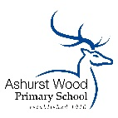
ASHURST WOOD PRIMARY SCHOOL-HISTORY POLICY

CURRICULUM INTENT
At Ashurst Wood Primary our curriculum is designed to facilitate the school vision.

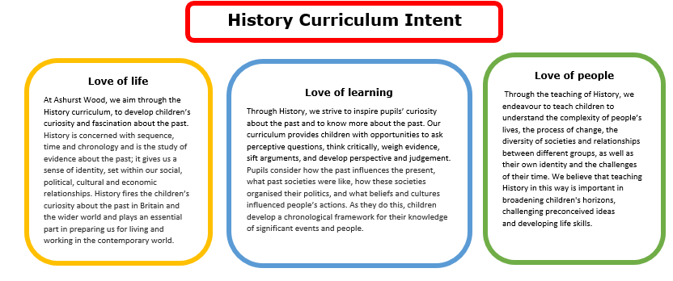

Essential characteristics of Historians
History is about real people who lived, and real events which happened in the past. History is concerned with sequence, time and chronology and is the study of evidence about the past; it gives us a sense of identity, set within our social, political, cultural and economic relationships. History fires the children’s curiosity about the past in Britain and the wider world and plays an essential part in preparing us for living and working in the contemporary world. Pupils consider how the past influences the present, what past societies were like, how these societies organised their politics, and what beliefs and cultures influenced people’s actions. As they do this, children develop a chronological framework for their knowledge of significant events and people. They see the diversity of human experience, and understand more about themselves as individuals and members of society. What they learn can influence their decisions about personal choices, attitudes and values. In history, children find evidence, weigh it up and reach their own conclusions. To do this they need to be able to research, sift through evidence, and argue for their point of view – skills that are prized in adult life.
.
Implementation Overview
History teaching at Ashurst Wood Primary School involves adapting and extending the curriculum to match all pupils’ needs. Where possible, History is linked to our topic based curriculum. In Key Stage 1 and 2 we have a three year rolling cycle of topics where we cover the planned curriculum. Certain topics are more heavily History focussed than others. Children receive a broad and balanced History curriculum. Teachers plan to suit their children’s interests, current events, their own teaching style, the use of any support staff and the resources available. History is taught either as a weekly lesson or as a block unit particularly in Key Stage 1.

Teaching of History in EYFS
History is taught in Reception as an integral part of the topic work through child-initiated and adult led activities. The children are given the opportunity to find out about past and present events in their own lives, and those of their families and other people they know. In the Foundation stage history makes a significant contribution to developing a child’s understanding of the world through activities such as looking at pictures of famous people in history or discovering the meaning of new and old in relation to their own lives.

Teaching of the History in Key Stage 1 (Milestone 1)
During Key Stage 1, pupils learn about people’s lives and lifestyles. They find out about significant men, women, children and events from the recent and more distant past in Britain and the wider world. They listen, and respond to stories and use sources of information to help them ask and answer questions. They learn how the past is different from the present.

Teaching of History in Key Stage 2 (Milestone 2 and 3)
During Key Stage 2 pupils learn about significant people, events and places from both recent and more distant past. They learn about change and continuity in their own area, in Britain and in other parts of the world. They look at history in a variety of ways, for example from political, economic, technological and scientific, social, religious, cultural or aesthetic perspectives. They use different sources of information to help them investigate the past both in depth and in overview, using dates and historical vocabulary to describe events, people and developments. They also learn that the past can be represented and interpreted in different ways.

CURRICULUM PLANNING
Our school uses the National Curriculum in England 2014 Framework for History to ensure a detailed and comprehensive approach to History planning and delivery across our school. Other curriculum areas are used to explore History such as: English, i.e. writing a diary entry as a famous person in History.

SPECIAL EDUCATIONAL NEEDS
We teach History to all children, whatever their ability, in accordance with the school curriculum policy of providing a broad and balanced education to all children. Teachers provide learning opportunities matched to the needs of children with learning difficulties.

SPIRITUAL, MORAL, SOCIAL & CULTURAL DEVELOPMENT
Children at Ashurst Wood School, use History to make sense of and know about the world through time. We use a variety of teaching strategies which involve visitors talk about personal experiences of the past, listening to and interacting with stories from the past or undertaking fieldwork by interviewing family and older friends about changes in their own and other people’s lives

ASSESSMENT & RECORDING
At Ashurst Wood we aspire to promote children’s independence and for all children to take responsibility in their own learning, therefore we use self/teacher assessment sheets, which the children use to track their achievements and progress against the Learning Objective (Key Stage 2).
Teachers assess children’s work in History both by making informal judgements as they observe them during lessons and at the end of each unit of work. At the end of the year, the teacher makes a summative judgement about the work of each pupil in relation to the skills they have developed in-line with the National Curriculum in England 2014 and these are reported to parents as part of the child’s annual school report. Key pieces of work are recorded on Tapestry (currently EYFS) building up a picture of a child’s ability and understanding through their time at the school. This will be rolled out throughout the rest of the school in due course.

MONITORING & REVIEW
Individual teachers are responsible for the standard of children’s work and for the quality of their teaching in History. Teachers work collaboratively to support each other in the teaching of History, understanding and applying current developments in the subject, and providing direction for the subject in the school.

The Curriculum Team should evaluate the strengths and weaknesses in the subject and indicate areas for further improvement. Book scrutiny’s will take place at the end of a History topic to ensure consistency and implementation of policy across the school. As a school, we value pupil voice and therefore a survey of Humanities will be carried out annually with a sample of children to ensure Humanities knowledge retention.

IMPACT
The impact and measure of this is to ensure children not only acquire the appropriate age related knowledge linked to the History curriculum, but also skills which equip them to progress from their starting points, and within their everyday lives.
All children will have:
- A wider variety of skills linked to both Historical knowledge and understanding, and enquiry/investigative skills.
- A richer vocabulary, which will enable to articulate their understanding of taught concepts.
- High aspirations, which will support them through further study, work and a successful adult life.

