Our vision is for everyone to have a love of life, a love of learning and a love of people.

At Ashurst Wood Primary our curriculum is designed to facilitate the school vision.

**Love of people**

Our curriculum is designed to recognise and celebrate differences. It is a curriculum that promotes the development of empathy, self-esteem and self-worth. Our curriculum promotes collaboration, respect, tolerance and the building of meaningful relationships.

**Love of learning**

Our curriculum is designed to: recognise children’s prior learning, provide first-hand learning experiences which allow the children to develop interpersonal skills, build resilience and become creative, critical thinkers.

Our curriculum is designed to provide challenge and enable everyone to achieve their potential and enjoy the journey they take to get there.

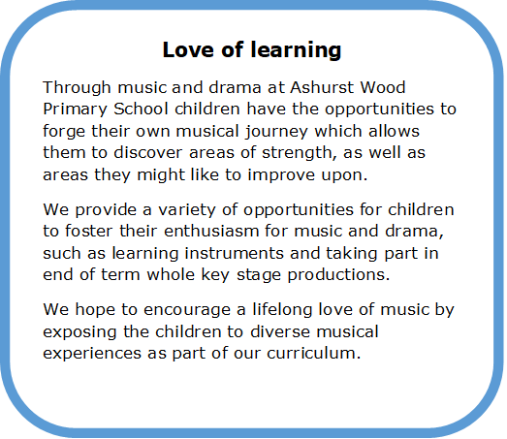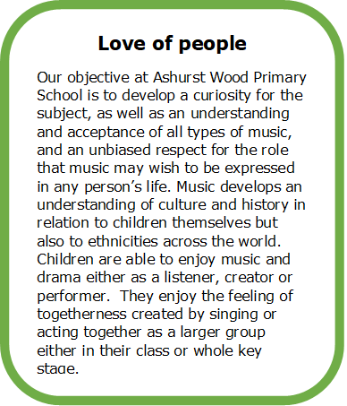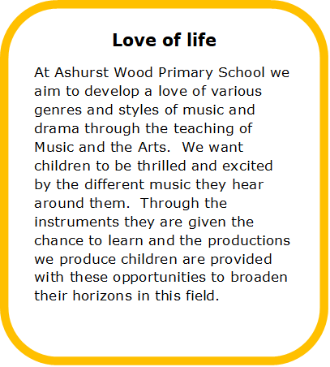

**Music Curriculum Intent**

**Love of life**

Our curriculum is designed to encourage children to embrace new opportunities. It is a curriculum that provides a wide range of experiences that promote curiosity and the ability to question.