ASHURST WOOD PRIMARY SCHOOL-D&T POLICY

CURRICULUM INTENT

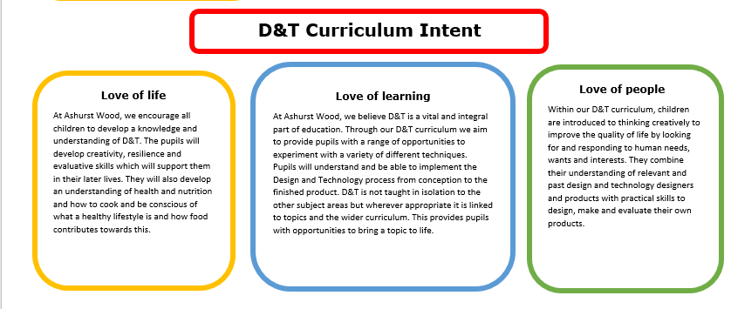
At Ashurst Wood Primary our curriculum is designed to facilitate the school vision.

Implementation Overview
The implementation of the Design & Technology curriculum at Ashurst Wood Primary School is based on the National Curriculum for Key Stage 1 and 2 and the Early Learning Goals in the Early Years Foundation Stage (EYFS). Children at both Key Stages and EYFS will develop knowledge, skills and understanding through different explorations within D&T. Where possible, D&T is linked to our topic-based curriculum. In Key Stage 1 and 2 we have a three-year rolling cycle of topics where we cover the planned curriculum. Children receive a broad and balanced D&T curriculum which is designed to bring topics to life, meet the interests of the children and current events. The school’s high quality D&T curriculum is supported through the availability of a wide range of quality resources, which are used to support children’s confidence in the use of different media.

Teaching of D&T in EYFS
The EYFS provides a rich environment in which we encourage and value creativity. D&T is a fundamental part of the topic work covered throughout the year in EYFS; it comes under the Foundation stage using guidance from the Knowledge and Understanding of the World. Pupils are provided with opportunities to explore and experiment with different areas of design and technology through these different topics. The pupil’s creative development is underpinned by the objectives set out in the Early Learning Goals.

Teaching of the D&T in Key Stage 1 & 2
Key Stages 1 and 2 - Each aspect of Design and Technology is visited at least once in both Key Stage 1 and Key Stage 2. Every class carries two Design and Technology projects per year, one of which must be a food based project. In Key Stage 2 children are given the opportunity to look at key events and individuals in Design and Technology that have helped shape the world.
We use a variety of teaching and learning styles in our Design & Technology lessons to cater for the variety of learning styles of pupils. Teachers provide demonstrations of techniques in each lesson. They model techniques and talk through the processes involved. Examples of previous work or teacher examples are provided for children to see expectations. However, these must be varied, so children’s work doesn’t look the same or restrict individual creativity.

CURRICULUM PLANNING
Our school uses the National Curriculum in England 2014 Framework for D&T to ensure a detailed and comprehensive approach to D&T planning and delivery across our school. Teachers are provided with a long-term plan which is divided into the topics which are taught across the year. There are a variety of D&T ideas and a recommendation of products which could be researched, designed, created and evaluated. This long-term plan ensures pupils are being taught the main areas of D&T. Furthermore, the long-term plan builds upon prior learning and offers children the opportunity to develop and practise skills as they move up through the school.

Teachers and children work collaboratively to design an engaging, enriching, and relatable curriculum which stimulates curiosity and imagination. Other curriculum areas are also used to explore different areas of D&T such as through our Forest School provision and outdoor learning. Forest School sessions provide pupils with opportunities to cook and use tools to experiment with carving wood.

SPECIAL EDUCATIONAL NEEDS
At our school, we teach D&T to all pupils, regardless of their ability and individual needs. This is in accordance with the school's curriculum policy of providing a broad and balanced education to all children. Teachers provide learning opportunities matched the needs of the children in their class to ensure all children are making good progress and can reach their full potential in the Design & Technology curriculum. We aim to include all children in their D&T lessons by differentiating the learning outcome, using different resources or adult support from the teacher or teaching assistants to enable equal access to learning D&T. A variety of children’s outcomes are displayed around the school to highlight all children’s successes within their D&T learning.

SPIRITUAL, MORAL, SOCIAL & CULTURAL DEVELOPMENT
At our school children will have opportunities in D&T to:
Spiritual
Be introduced to the work of great Designers and experience wonder and awe at the achievements of the products they have created that have improved our lives.
Moral
Show compassion and consideration when assessing the work of others and be able to understand how their comments can build up or upset another’s self-belief.
Social
Work in pairs or groups collaboratively to design, create or evaluate a D&T project. Thus, developing teamwork and cooperative skills.
Respect each other’s ideas and opinions when talking about pieces of art including the work of their peers.
Cultural
Study D&T as part of a topic and be given an insight into other cultures and providing strong links with our past.
Understand the ideas behind design and technology projects and foods in different cultures and religions.

ASSESSMENT & RECORDING
Teachers assess children’s knowledge, understanding and skills in D&T by making informal judgements as they observe pupils working during lessons. Teachers will provide children with verbal feedback throughout lessons, particularly when exploring and practising key skills, which will support them to make progress within the subject. Pupils are also encouraged to be critical of their own work, highlighting their own next steps. At the end of the year, the teacher makes a summative judgement about the work of each pupil in relation to the skills they have developed in-line with the National Curriculum in England 2014 and these are reported to parents as part of the child’s annual school report. This information is also passed on to the next teacher at the end of each year.
D&T learning is recorded in Topic books across the school. Pupils’ development of skills, their observations, planning and evaluations are included in their Topic books. Progression from each year groups should be clear. Teachers may also store photographs of finished pieces.

MONITORING & REVIEW
The monitoring of the standards of children’s work and the quality of the teaching in D&T is the responsibility of the Curriculum Team. Teachers work collaboratively to support each other in the teaching of D&T, understanding and applying current developments in the subject, and providing direction for the subject in the school. The Curriculum Team should evaluate the strengths and weaknesses in the subject and indicate areas for further improvement.

IMPACT
D&T Projects produced is of high-quality and pupils take pride in what they have created. Our D&T lessons are meaningful to pupils and enhances work in other areas of the curriculum.
All children will have embedded the key design skills needed to allow them to produce imaginative and original projects. We aim to inspire children, thus gaining a love for creating their own products in the future.

