ASHURST WOOD PRIMARY SCHOOL
Religious Education (R.E) POLICY

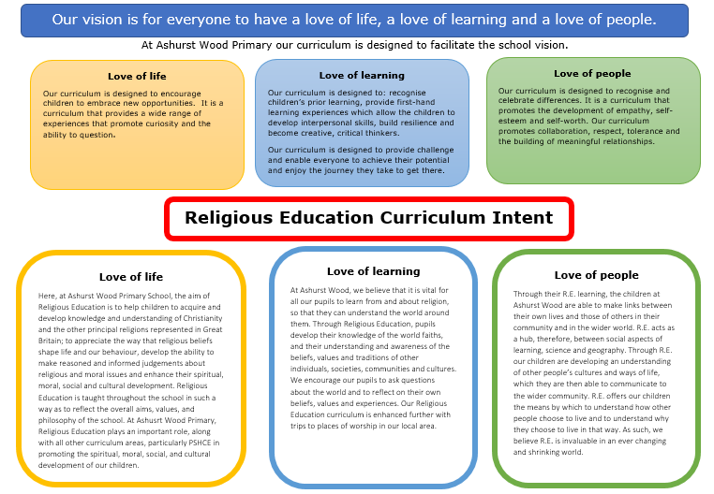

CURRICULUM INTENT
At Ashurst Wood Primary our curriculum is designed to facilitate the school vision.
Religious Education is unique in the school curriculum in that it is neither a core subject nor a foundation subject but the 1988 Education Act states that ‘Religious Education has equal standing in relation to core subjects of the National Curriculum in that it is compulsory for all registered pupils’.
Religious Education is taught in our school because it makes:

“A major contribution to the education of children and young people. At its best, it is intellectually challenging and personally enriching. It helps young people develop beliefs and values, and promotes the virtues of respect and empathy, which are important in our diverse society. It fosters civilised debate and reasoned argument, and helps pupils to understand the place of religion and belief in the modern world”. (RE: realising the potential, Ofsted 2013).
IMPLEMENTATION OVERVIEW

At Ashurst Wood Primary School, we follow the West Sussex Agreed Syllabus (2021), incorporating the main themes, which are complemented by Discovery RE, an enquiry approach to Religious Education. We deliver the curriculum on a 2 year rolling programme, to ensure progression and breath of content coverage.

Teaching of R.E in EYFS and Key Stage 1
During Key Stage One (KS1) pupils are taught the knowledge and skills in order to understand: Christianity and at least one other principle religion. The religions of Judaism and Islam are taught due to the connections between the Abrahamic religions of Christianity, Judaism and Islam.

Teaching of R.E in Key Stage 2

During Key Stage Two (KS2) pupils are taught the knowledge and skills to further understand Christianity alongside other principle religions such as, Islam, Hinduism, Sikhism and Buddhism.

CURRICULUM PLANNING
We follow the West Sussex County Council Agreed Syllabus for RE (2020-25) and use Discovery RE scheme as a toolkit for supporting the objectives, philosophy and content of the curriculum. Discovery RE is a scheme approved by West Sussex. We adopt an enquiry based approach to learning about faiths and encourage the children to consider other people's views, beliefs and cultures; implicitly exploring and promoting British Values, respect and tolerance.

The aims of our RE, using the Discovery RE Scheme of Work at Ashusrt Wood Primary School.

Discovery RE meets the requirements of our locally agreed syllabus and is aligned to the non- statutory guidance described above.
By following Discovery RE at Ashurst Wood Primary School, we intend that Religious Education will:
- Adopt an enquiry- based approach as recommended by Ofsted, beginning with the children’s own life experience before moving into learning about and from religion.
- Provoke challenging questions about the meaning and purpose of life, beliefs, the self, and issues of right and wrong, commitment and belonging. It develops pupils’ knowledge and understanding of Christianity, other principal religions, and religious traditions that examine these questions, fostering personal reflection and spiritual development.
- Encourage pupils to explore their own beliefs (religious or non-religious), in the light of what they learn, as they examine issues of religious belief and faith and how these impact on personal, institutional and social ethics; and to express their responses.
- Enable pupils to build their sense of identity and belonging, which helps them flourish within their communities and as citizens in a diverse society.
- Teach pupils to develop respect for others, including people with different faiths and beliefs, and helps to challenge prejudice.
- Prompt pupils to consider their responsibilities to themselves and to others, and to explore how they might contribute to their communities and to wider society. It encourages empathy, generosity and compassion.
- Develop a sense of awe, wonder and mystery.
- Nurture children’s own spiritual development.

LINKS TO OTHER CURRICULUM AREAS
We recognise the clear link between RE and the following policies and staff are aware of the need to refer to these policies when appropriate.
- Collective Worship where appropriate.
- Teaching and Learning Policy
- Equal Opportunities Policy
- Child Protection Policy
- SMSC Policy

SPECIAL EDUCATIONAL NEEDS
Discovery RE is written as a universal core curriculum provision for all children. Inclusivity is part of its philosophy. Teachers will tailor each enquiry to meet the needs of the children in their classes. To support this differentiation, many enquiries suggest creative learning activities that allow children to choose the media with which they work and give them scope to work to their full potential. To further help teachers differentiate for children in KS1 and 2 classes with special educational needs, each enquiry has level exemplars for the full range likely for that age group, allowing children to evidence levels from L1 to L5.

SPIRITUAL, MORAL, SOCIAL & CULTURAL DEVELOPMENT
RE gives particular opportunities to promote an ethos of respect for others, challenge stereotypes and build understanding of other cultures and beliefs. This contributes to promoting a positive and inclusive school ethos that champions democratic values and human rights. If appropriate: RE is an important subject in contribution to the schools development as a Rights Respecting School.

External contributors from the community, e.g. local clergy, local members/speakers from other religions etc make a valuable contribution to the RE programme as do visits to places of worship. Their input is carefully planned and monitored so as to fit into and complement the programme.
Teachers are always present during these sessions and remain responsible for the effective delivery of the RE programme.

Establishing a safe, open and positive learning environment based on trusting relationships between all members of the class, adults and children alike, is vital. To enable this, it is important that respect for each-others’ views and beliefs and those of the believers of that religion is encouraged at all times and that any artefacts are handled with respect and care.

ASSESSMENT & RECORDING
Teachers are eager to ensure children are making progress with their learning throughout their RE. Therefore, each enquiry has built-in assessment. This task is the formal opportunity for teacher assessment of the children’s knowledge of that religion, depth of critical thinking, and ability to answer the enquiry question. This stand-alone evidence is used in conjunction with other evidence such as records of discussions and annotations from other lessons within the enquiry to assist the teacher in reaching a best-fit level. Each enquiry has assessment levels and exemplars based on the current nationally agreed levels

To support the teachers in tracking each child’s progress throughout the year, there is an overview sheet for each enquiry on which to record the progress of the whole class. This supports teacher overview and facilitates subject leader monitoring and moderation.

MONITORING & REVIEW
Individual teaches are responsible for the standard of children’s work and for the quality of their teaching in R.E. Teachers work collaboratively to support each other in the teaching of the R.E, understanding and applying current developments in the subject, and providing direction for the subject in the school. The curriculum team should evaluate the strengths and weaknesses in the subject and indicate areas for further improvement.

WITHDRAWAL FROM R.E. LESSONS
Parents/carers have the right to withdraw their children from all or part of the Religious Education. Those parents/carers wishing to exercise this right are invited in to see the head teacher and/or RE Leader who will explore any concerns and discuss any impact that withdrawal may have on the child. The school will ensure that parents who want to withdraw their children from RE are aware of the RE syllabus and that it is relevant to all pupils, and respects their own personal beliefs. Parents will be made aware of the learning objectives and what is covered in the RE curriculum and should be given the opportunity to discuss this, if they wish. The school may also wish to review such a request each year, in discussion with the parents.

The use of the right to withdraw should be at the instigation of parents and it should be made clear whether it is from the whole of the subject or specific parts of it. No reasons need be given. Where parents have requested that their child is withdrawn, their right must be respected, and where RE is integrated in the curriculum, the school will need to discuss the arrangements with the parents or carers to explore how the child’s withdrawal can be best accommodated. Once a child has been withdrawn they cannot take part in the RE programme until the request for withdrawal has been removed.

As a school it is our duty to inform our local Standing Advisory Council on RE regarding the numbers of children being withdrawn.

