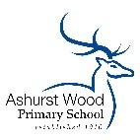
ASHURST WOOD PRIMARY SCHOOL-SCIENCE POLICY
CURRICULUM INTENT - At Ashurst Wood Primary our curriculum is designed to facilitate the school vision.
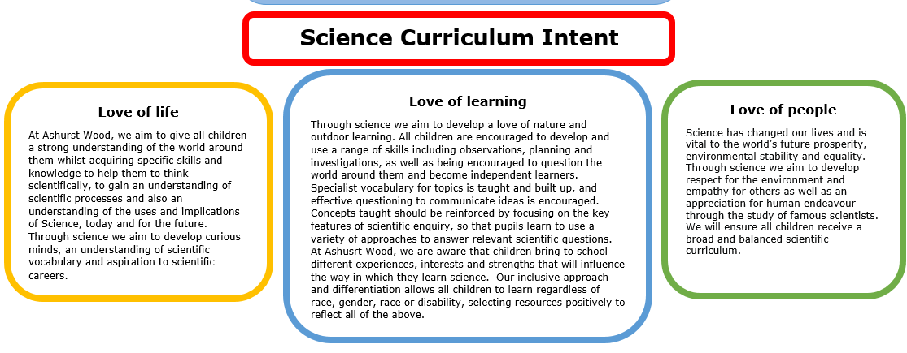

Implementation Overview
Science teaching at Ashurst Wood Primary School involves adapting and extending the curriculum to match all pupils’ needs. Where possible, Science is linked to our topic based curriculum. Science is taught as discrete units and lessons where needed to ensure coverage. Due to mixed phase classes in Key Stage 2 science is taught in specific year groups once a week and it is taught on an annual rolling programme. This ensures progression between year groups and ensures children receive a broad and balanced scientific curriculum. Teachers plan to suit their children’s interests, current events, their own teaching style, the use of any support staff and the resources available. Science is taught consistently, once a week for up to two hours, but is also taught in a variety of different contexts throughout all areas of the curriculum.

Teaching of Science in EYFS
We teach science in the Foundation stage as an integral part of the topic work covered during the year. It comes under Understanding the World in the EYFS. Children must be supported in developing the knowledge, skills and understanding that helps them to make sense of the world. Their learning is supported through offering opportunities for them to use a range of tools safely; encounter creatures, people, plants and objects in their natural environments and in real-life situations; undertaking practical ‘experiments’; and working with a range of materials.

Teaching of the Science in Key Stage 1
During years 1 and 2, pupils should be taught to use the following practical scientific methods, processes and skills through the teaching of the programme of study content:
- Asking simple questions and recognising that they can be answered in different ways
- Observing closely, using simple equipment
- Performing simple tests
- Identifying and classifying
- Using their observations and ideas to suggest answers to questions
- Gathering and recording data to help in answering questions.

Teaching of Science in Key Stage 2
During years 3 and 4, pupils should be taught to use the following practical scientific methods, processes and skills through the teaching of the science curriculum:
- Asking relevant questions and using different types of scientific enquiries to answer them
- Setting up simple practical enquiries, comparative and fair tests
- Making systematic and careful observations and, where appropriate, taking accurate measurements using standard units, using a range of equipment, including thermometers and data loggers
- Gathering, recording, classifying and presenting data in a variety of ways to help in answering questions
- Recording findings using simple scientific language, drawings, labelled diagrams, keys, bar charts, and tables
- Reporting on findings from enquiries, including oral and written explanations, displays or presentations of results and conclusions
- Using results to draw simple conclusions, make predictions for new values, suggest improvements and raise further questions
- Identifying differences, similarities or changes related to simple scientific ideas and processes
- Using straightforward scientific evidence to answer questions or to support their findings.

The main focus of the teaching of Science in years 5 and 6, is to enable pupils to develop a deeper understanding of a wide range of scientific ideas. They achieve this through exploring and talking about their ideas; asking their own questions about scientific phenomena; and analysing functions, relationships and interactions in a more systematic way. Pupils begin to encounter more abstract ideas and recognise how these ideas help them to understand and predict how the world operates. They should also begin to recognise that scientific ideas change and develop over time. They should also select the most appropriate ways to answer science questions using different types of scientific enquiry.

CURRICULUM PLANNING
Our school uses the National Curriculum in England 2014 Framework for Science and the Kent Primary Science Scheme of Work 2014 to ensure a detailed and comprehensive approach to Science planning and delivery across our school. Science is taught discretely and as part of the school’s overall topic based curriculum. Other curriculum areas are used to explore science such as: English, i.e. writing a letter to a local politician regarding the closure of a park/biography of a famous scientist’s life. We have also implemented application writing, where children have the opportunity to apply their knowledge of a writing purpose to science. The children must complete an extended piece of writing, based within their current science topic, in the style of their most recent writing journey. Links are made to termly topics where appropriate but primarily science is taught discretely. Any links are identified on the termly theme Curriculum Maps and individual Medium Term Plans.

FOREST SCHOOL
Forest Schools is an important aspect of our school and we believe passionately in its value for developing children’s scientific curiosity and understanding of the world around them. Much of our science is also taught through Forest Schools and outdoor learning. Each class has at least 3 sessions a term at the Forest and this is collaboratively planned by the class teacher and Forest School Leader.

SPECIAL EDUCATIONAL NEEDS
We teach science to all children, whatever their ability, in accordance with the school curriculum and inclusion policy, of providing a broad and balanced education to all children. We firmly believe that everyone is entitled to an ambitious Science curriculum, therefore we have ensured that our curriculum design is accessible for all, including children with SEND and disadvantage backgrounds. This is achieved through teachers providing learning opportunities matched to the needs of children.

SPIRITUAL, MORAL, SOCIAL & CULTURAL DEVELOPMENT
Children at Ashurst Wood School use Science to make sense of the world. We are aware that Science has the ability to make us feel both enormously insignificant (compared to the scale of the visible universe) and enormously significant (we are genetically unique). At Ashurst Wood, we use Science to help us understand our relationship with the world around us (how the physical world behaves, the interdependence of all living things). We are aware that making new discoveries increases our sense of awe and wonder at the complexities and elegance of the natural world

ASSESSMENT & RECORDING
At Ashurst Wood we aspire to promote children’s independence and for all children to take responsibility in their own learning, therefore we use self/teacher assessment sheets, which the children use to track their achievements and progress against the Learning Objective. We have also developed scientific vocabulary tasks, which are to be completed both at the beginning (pre-learning task) and end (post-learning task) of a topic in order to show clear progression and children’s new found knowledge and understanding. These tasks also enable the children to articulate scientific concepts clearly and precisely, assisting them in making their thinking clear, both to themselves and others. Teachers assess children’s work in science both by making informal judgements as they observe them during lessons and at the end of each unit of work using the Kent scheme assessment tools. At the end of the year, the teacher makes a summative judgement about the work of each pupil in relation to the skills they have developed in-line with the National Curriculum in England 2014 and these are reported to parents as part of the child’s annual school report. Key pieces of work are recorded on Tapestry building up a picture of a child’s ability and understanding through their time at the school.

MONITORING & REVIEW
Individual teachers are responsible for the standard of children’s work and for the quality of their teaching in science. Teachers work collaboratively to support each other in the teaching of science, understanding and applying current developments in the subject, and providing direction for the subject in the school.

The Curriculum leads should evaluate the strengths and weaknesses in the subject and indicate areas for further improvement. Termly book scrutiny alongside teaching and learning observations take place to ensure consistency and implementation of policy across the school. As a school, we value pupil voice and therefore a survey will be carried out termly with a sample of children to ensure scientific knowledge retention.

IMPACT
The impact and measure of this is to ensure children not only acquire the appropriate age related knowledge linked to the science curriculum, but also skills which equip them to progress from their starting points, and within their everyday lives.
All children will have:
- A wider variety of skills linked to both scientific knowledge and understanding, and scientific enquiry/investigative skills.
- A richer vocabulary, which will enable them to articulate their understanding of taught concepts.
- High aspirations, which will support them through further study, work and a successful adult life.

