Ashurst Wood Primary School

Curriculum Policy

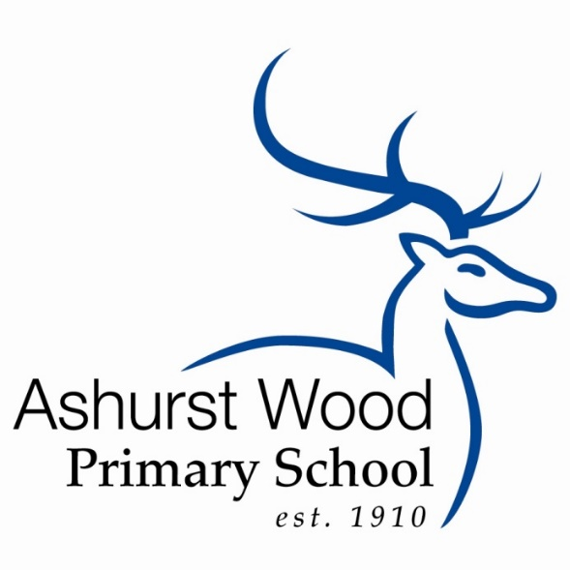

The Little School with a Big Heart

Updated: Autumn 2021

Review: Autumn 1 2022

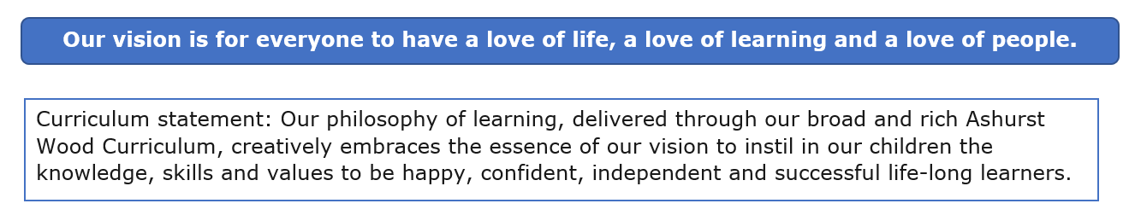
Curriculum Intent

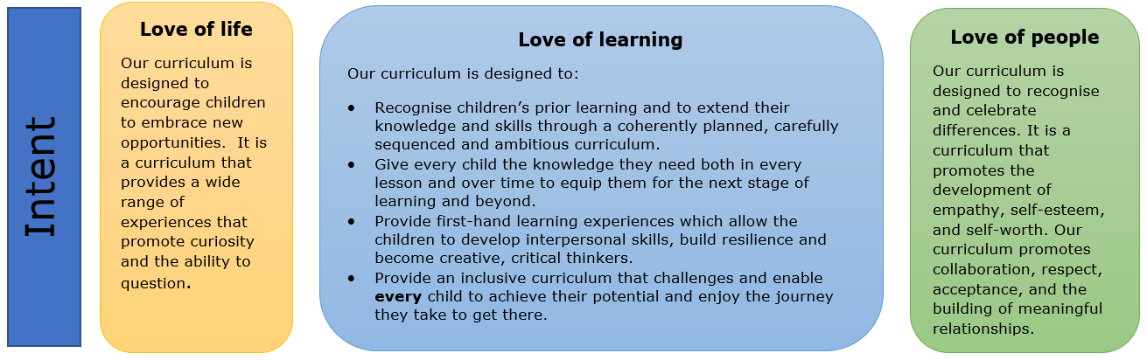

How the National Curriculum and Ashurst Wood Curriculum aligns:
The National Curriculum provides pupils with an introduction to the essential knowledge that they need to be educated citizens. It introduces pupils to the best that has been thought and said and helps engender an appreciation of human creativity and achievement.
The National Curriculum provides an outline of core knowledge around which teachers can develop exciting and stimulation lessons to promote the development of pupils’ knowledge, understanding and skills as part of the wider school curriculum.
The diagram below shows how the subject areas, their capacity to move between topics, interwoven with our expectations of pupil’s skill development or mastery skills within the curricular experience.
Learning expectations need to take account of: Key skills, personal development and subject knowledge and skills. (See Curriculum progression document)

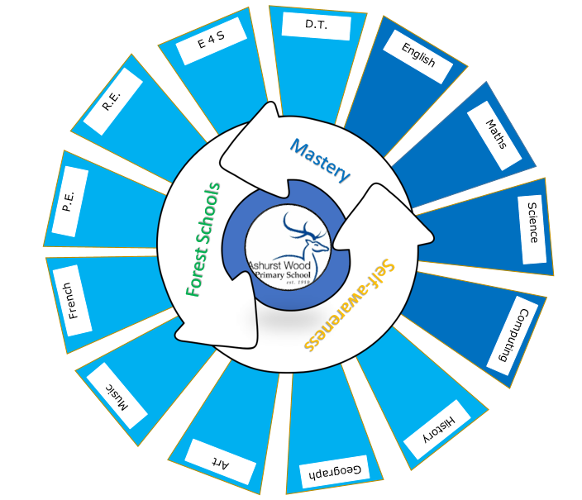

Our curriculum is:
- Broad so that it provides a wide range of knowledge, skills and experiences.
- Rich so that each subject has sufficient time to contribute effectively to learning. There must be time for teachers to teach knowledge, content and skills with sufficient depth, and time for children to make sense, practise and achieve mastery.
- Relevant so that learning can be linked to real experiences, both in the children’s local community and the world at large.
- Coherent so that subject areas can be linked to make the learning experience more meaningful.
- Progressive so that objectives are specific and progress year on year ensuring consistency, continuity and rigour.
- Challenging so that there are high aspirations for all children to achieve the very best they can do.
- Accessible so that there is equal opportunity for all children regardless of ability or background to access all areas of the curriculum.

Curriculum Implementation

Organisation and Planning

Each subject has a progression of knowledge This indicates when key knowledge and skills are taught.
We teach all the National Curriculum subjects. This ensures progression in learning and provides children with many opportunities to consolidate learning. Our medium-term plans show the knowledge and objectives being taught and how the children will learn, i.e. the activities that they will undertake and the skills that they will develop.

Short term planning is fluid as it reflects children’s progress in a lesson or unit of work. It is changed to address misconceptions and gaps in learning particularly post Covid.

Children with Special Needs

The curriculum in our school is designed to provide access and opportunity for all children who attend the school. If we think it necessary to adapt the curriculum to meet the needs of individual children, then we do so only after the parents of the child have been consulted and, if necessary, advice has been sought from external agencies.

If a child has special needs, our school does all it can to meet these individual needs. We comply with the requirements set out in the SEN Code of Practice in providing for children with special needs. If a child displays signs of having special needs, the class teacher makes an assessment of these needs. In most instances the teacher is able to provide resources and educational opportunities which meet the child’s needs within the normal class organisation. We use the OAIP to support this.

The school provides an Individual Learning Plan (ILP) for each of the children who are on the special needs register. This sets out the analysis of the needs, strengths and areas for development and how these will be supported. Advice from the appropriate external agencies is incorporated into the profile.

The Early Years Foundation Stage

The curriculum that we teach in the reception class meets the requirements set out in the revised National Curriculum at Foundation Stage. We use Song of Sounds as a phonic scheme. For reading we use phonically decodable books linked to the phonics scheme.

Our school fully supports the principle that young children learn through play and by engaging in well-planned structured activities. Teaching in the Foundation class builds on the experiences of the children in their pre-school learning. We have an excellent positive partnership with the pre-school provider who shares the school site.

During the children’s first term in the Foundation class, their teacher begins to record the skills of each child on entry to the school. This assessment forms an important part of the future curriculum planning for each child. In addition, the children take the National Foundation Stage assessment.

Monitoring

Each subject is led by two teachers one from each key stage and all teachers are on either the Maths or Literacy Team. Teachers monitor the implementation and outcomes on each subject in accordance with a monitoring plan linked to the School Development Plan.
Our governing body is responsible for monitoring the way the school curriculum is implemented which is done through the governor monitoring plan.

Assessment
See the assessment policy.

Review

This policy will be reviewed every year.

