Ashurst Wood Primary School

Collective Worship Policy

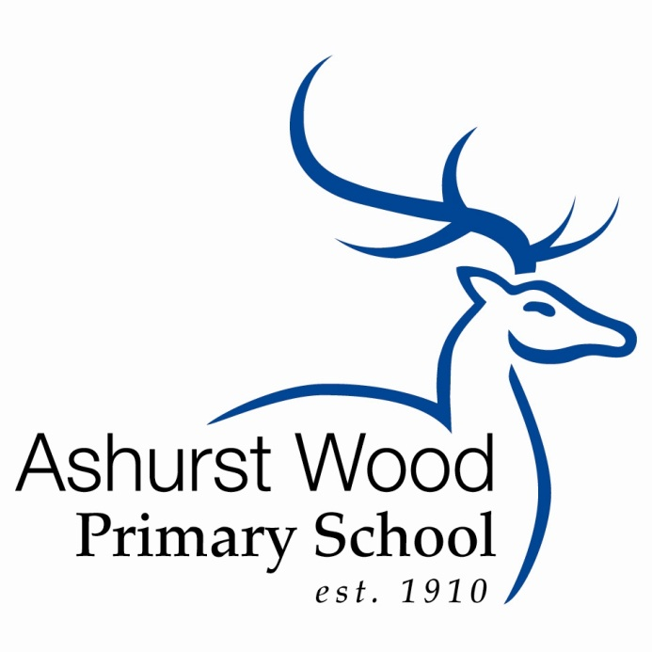
The Little School with a Big Heart

Reviewed: April 2021
Review Date: Summer 1 2022

Ashurst Wood Primary School
Relationships, Sex and Health Education Policy

Rationale and Ethos

From April 2021, the Department for Education statutory guidance for RSHE states that all primary schools must deliver Relationships, Sex and Health Education. Our children are growing up in an increasingly complex world, which presents many positive and exciting opportunities, but also challenges and risks.

Therefore the purpose of RSHE is to ensure that all children receive their entitlement to an education that enables them to make informed decisions about their wellbeing, health and relationships. Teaching and learning will support our children in developing resilience, to know how and when to ask for help and to know where to ask for support.

Our school’s guiding principle is that the content of RSHE must be age-appropriate and developmentally-appropriate for our children. It will be taught sensitively and inclusively, with respect to the backgrounds and beliefs of pupils and parents. We view the partnership between home and school as vital in developing a shared set of values which ensures our children are supported effectively. It is important that parents are kept informed and are consulted to ensure that the children are given the best PSHE and RSE provision possible.

Once the policy has been reviewed by staff and Governors, it is then made available for parents and carers to view on the school website. We encourage any feedback and suggestions which could be reflected in our policy, as well as any questions that parents and carers may have. Parents and carers will be asked to respond to questions as part of our consultation process.

Defining Relationships, Sex and Health Education
At Ashurst Wood, relationships education is learning about the physical, social, legal and emotional aspects of human relationships including friendships, family life and relationships with other children and adults. Relationships education supports children to be safe, happy and healthy in their interactions with others now and in the future.
In our school we take the approach that Relationships and Sex Education are best approached in an integrated way, for example, when teaching about how a baby is born we will also discuss the care that families give to babies. We will take care to highlight lessons that contain what we define as sex education so that we can respect the wishes of parents who have withdrawn their children from this content. Simultaneously, we will seek to nurture children’s curiosity about the world around them, supporting their development and their respect for themselves and each other.
The new legislation gives parents the right to request to withdraw their child from sex education in primary school, but not from Relationships Education, Health Education or science. .
DfE 2019 Outcomes for Relationships and Health Education by the end of primary school:
Families and people who care for me
Pupils should know:
• that families are important for children growing up because they can give love, security and stability
• the characteristics of healthy family life, commitment to each other, including in times of difficulty, protection and care for children and other family members, the importance of spending time together and sharing each other’s lives
• that others’ families, either in school or in the wider world, sometimes look different from their family, but that they should respect those differences and know that other children’s families are also characterised by love and care
• that stable, caring relationships, which may be of different types, are at the heart of happy families, and are important for children’s security as they grow up
• that marriage represents a formal and legally recognised commitment of two people to each other which is intended to be lifelong
• how to recognise if family relationships are making them feel unhappy or unsafe, and how to seek help or advice from others if needed

Caring friendships
Pupils should know:
• how important friendships are in making us feel happy and secure, and how people choose and make friends
• the characteristics of friendships, including mutual respect, truthfulness, trustworthiness, loyalty, kindness, generosity, trust, sharing interests and experiences and support with problems and difficulties
• that healthy friendships are positive and welcoming towards others, and do not make others feel lonely or excluded
• that most friendships have ups and downs, and that these can often be worked through so that the friendship is repaired or even strengthened, and that resorting to violence is never right
• how to recognise who to trust and who not to trust, how to judge when a friendship is making them feel unhappy or uncomfortable, managing conflict, how to manage these situations and how to seek help or advice from others, if needed

Respectful relationships
Pupils should know:
• the importance of respecting others, even when they are very different from them (for example, physically, in character, personality or backgrounds), or make different choices or have different preferences or beliefs
• practical steps they can take in a range of different contexts to improve or support respectful relationships
• the conventions of courtesy and manners
• the importance of self-respect and how this links to their own happiness
• that in school and in wider society they can expect to be treated with respect by others, and that in turn they should show due respect to others, including those in positions of authority
• about different types of bullying (including cyberbullying), the impact of bullying, responsibilities of bystanders (primarily reporting bullying to an adult) and how to get help
• what a stereotype is, and how stereotypes can be unfair, negative or destructive
• the importance of permission-seeking and giving in relationships with friends, peers and adults

Online relationships
Pupils should know:
• that people sometimes behave differently online, including by pretending to be someone they are not
• that the same principles apply to online relationships as to face-to-face relationships, including the importance of respect for others online including when we are anonymous
• the rules and principles for keeping safe online, how to recognise risks, harmful content and contact, and how to report them
• how to critically consider their online friendships and sources of information including awareness of the risks associated with people they have never met
• how information and data is shared and used online

Being safe
Pupils should know:
• what sorts of boundaries are appropriate in friendships with peers and others (including in a digital context)
• about the concept of privacy and the implications of it for both children and adults; including that it is not always right to keep secrets if they relate to being safe
• that each person’s body belongs to them, and the differences between appropriate and inappropriate or unsafe physical, and other, contact
• how to respond safely and appropriately to adults they may encounter (in all contexts, including online) whom they do not know
• how to recognise and report feelings of being unsafe or feeling bad about any adult
• how to ask for advice or help for themselves or others, and to keep trying until they are heard
• how to report concerns or abuse, and the vocabulary and confidence needed to do so
• where to get advice e.g. family, school and/or other sources

National Curriculum Statutory Science

Key Stage 1:

  - to identify, name, draw and label the basic parts of the human body and say which part of the body is associated with which sense
The science programme of study does not list parts of the body to teach and does not prohibit teaching any parts. Therefore, teaching will also include identifying and naming the ‘private’ parts of the human body, which may include ‘penis’ and ‘vagina’. This is also safeguarding and is compatible with Relationships Education.
  - that animals, including humans, have offspring which grow into adults

Key Stage 2:

  - describe the life processes of reproduction in some plants and animals i.e. find out about different types of reproduction, including sexual and A-sexual reproduction in plants and sexual reproduction in animals, including humans
  - describe the differences in the life cycles of a mammal, an amphibian, an insect and a bird
  - describe the changes as humans develop to old age
  - learn about the physical and emotional changes experienced in puberty for girls and boys, including periods and wet dreams, personal hygiene and keeping clean

Non-Statutory Sex Education – Parents have the right to withdraw their child from this teaching

Upper Key Stage 2:
  - learn about the stages of the birth of baby, including the sperm and the egg, conception, sexual intercourse and birth

Roles and Responsibilities

Responsibility for the RSHE policy ultimately lies with the Governing Body, who work alongside the PSHE subject leader and SLT to develop and review the policy every two years. This is to ensure that it continues to meet the needs of the pupils, staff and parents and that it is in line with current Department for Education advice and guidance.

The PSHE subject leader is responsible for and monitors the scheme of work delivered by teachers. Class teachers will deliver the RSHE curriculum predominantly during Science and PSHE lessons but will also make relevant links during other lessons such as online safety in Computing and looking after our bodies, including body privacy, in PE.

Curriculum Design

RSHE forms part of the whole school curriculum for PSHE and is taught in all year groups. Class teachers are responsible for planning RSHE for their year group and use the whole school RSHE curriculum to ensure that the appropriate content is taught in each year group.
The Ashurst Wood RSHE curriculum has been developed using the West Sussex Education for Safeguarding (E4S) online tools. The tools enable us to analyse the various datasets and pupil information we have collated, to create a tailored curriculum for each key stage appropriate to the needs of the children.
The West Sussex Education for Safeguarding curriculum is intended to become the universal provision for all schools in West Sussex. It is designed to enable schools to develop a needs based curriculum for all pupils whilst also ensuring that the national expectations for RSHE are fully addressed.

The West Sussex Education for Safeguarding (E4S) curriculum is based on the national Department for Education Relationships, Sex and Health Education (RSHE) guidance and numerous national frameworks, including the PSHE Association, but adapted and enriched for schools in West Sussex. This has been developed via a multi-agency approach combining teams from Safeguarding in Education, Contextual Safeguarding, Health and Education in West Sussex.

RSHE teaching will be differentiated, where appropriate, to meet the needs of all pupils. Teachers will include differentiated questioning in their planning and will consider whether there are any pupils who need to be taught aspects of the RSHE curriculum in small groups or on a 1:1 basis. Teachers will also ensure that RSHE teaching and learning is inclusive and relevant for the pupils by taking into account a range of factors such as disability, diversity, ethnicity, culture, age, religion or belief or other life experience.

Teachers will assess the pupils’ learning through questioning and pupil response, addressing any misconceptions at an age appropriate level.

Safe and Effective Practice

Prior to teaching the RSHE units, class teachers will establish a clear set of ground rules with the children which will enable them to create a safe and effective learning environment. Teachers should establish clear expectations of what is appropriate and inappropriate in a whole class setting, for example; use of the correct vocabulary, be respectful to themselves and others, refrain from distracting others, understand that RSHE lessons are very important because these changes are going to happen to everyone , use of a ‘Question Box’ for pupils to ask questions privately.
Questions asked by the children will be answered honestly at an appropriate time and will consider the age, maturity and understanding of the children. If a question is asked which is considered to be inappropriate for the age and level of understanding of the child, the class teacher and/or PSHE subject leader will inform the child’s parents and support them in addressing the question at home.

Teachers may feel concerned about responding to questions or comments about potentially sensitive or controversial issues and will therefore need to seek advice and/or support from other members of staff or outside agencies.

For example:

- If a question is too personal, the teacher should remind the pupil of the ground rules. If the pupil needs further support, the teacher can refer them to the appropriate person, such as the Learning Mentor, school nurse, help line, or an outside agency or service;

- If a teacher does not know the answer to a question, it is important to acknowledge this and to suggest that, if age appropriate, the pupil or teacher or both together research the question later;

- If a question is too explicit, feels too old for a pupil, is inappropriate for the whole class, or raises concerns about sexual abuse, the teacher should acknowledge it and promise to attend to it later, on an individual basis. In this way, the pupil will feel they have been treated with respect, but the rest of the class will not have to listen to personal experience or inappropriate information. To maintain trust and respect, the teacher must remember to talk with the pupil later; and

- If a teacher is concerned that a pupil is at risk of sexual abuse, they should follow the school’s child protection procedures.

- To protect pupils’ and teachers’ privacy, distancing techniques such as appropriate videos and online quizzes are used as well as depersonalising discussions to help pupils discuss sensitive issues and develop their decision-making skills in a safe environment.

Teachers will receive the appropriate training and will plan RSHE lessons as a team to ensure consistency of content and delivery.

Resources

Teachers will use the RSHE curriculum concepts and themes to ensure that resources are carefully selected to support their RSHE teaching. Resources will be suggested and monitored by the Standards team and shared with parents prior to the lessons, where appropriate.

Safeguarding

Staff must not agree confidentiality if a child discloses information of a sexual nature to them. At Ashurst Wood such a disclosure should be shared with a DSL as soon as possible who will listen and take the appropriate action. Ideally, staff should make notes during or immediately after the disclosure (see Child Protection and Safeguarding Policy). There are four DSLs at Ashurst Wood Primary; Lisa Hobby – Headteacher, Gemma Blake Hatton – SENDCo, Lou Newman – Teacher, Sarah Cubitt - Teacher

All staff will understand the curriculum content for RSHE and will ensure that parents and carers are informed. All staff receive annual training in child protection, including the procedures to follow.

Engaging Stakeholders

The RSHE policy is made available to parents and carers on the school website and they are invited to share their views whenever the policy is updated.

Parents and carers of children in relevant year groups are informed before any non-statutory teaching takes place. Parents and carers are invited in to school to view the teaching materials and resources before they are delivered to the children. Parent and carers can also use this opportunity to share any concerns with staff and ask relevant questions.

Parents have the right to request to withdraw their child from sex education in primary school, but not from statutory Relationships Education, Health Education or science. Parents and carers are asked to write to the head teacher with their request to withdraw their child(ren). The school has the responsibility to consult with parents and carers about how they will support their child with this aspect of their learning if they have chosen for this not to take place in school.

Monitoring, Reporting and Evaluation

The Standards team will monitor planning on a regular basis and give feedback to teachers where appropriate. In line with all subject monitoring at Ashurst Wood, whole school issues will be discussed as a staff during staff meetings and addressed as a priority on the Standards team Action Plan where appropriate.

