Ashurst Wood Primary School

School Uniform Policy

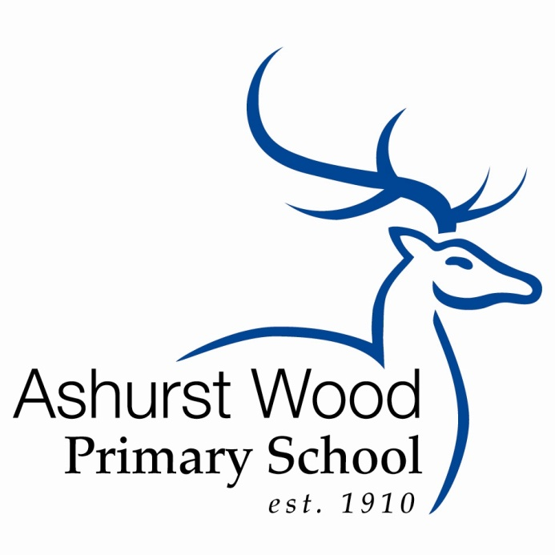

Ratified by Policy Committee May 2021

Review Date Summer 1. 2022

Ashurst Wood Primary School Uniform

School uniform plays a valuable role in contributing to the ethos of a school. It helps to instill pride in the school, supports positive behaviour and discipline, encourages identity and support for the school and protects children from social pressures to dress in a particular way. Above all, it helps to support effective teaching and learning.

Our uniform policy gives our children the opportunity to be as smart and well turned out as any other school in the local area. We are therefore request the support of all parents in our efforts to uphold the standards of our school uniform.

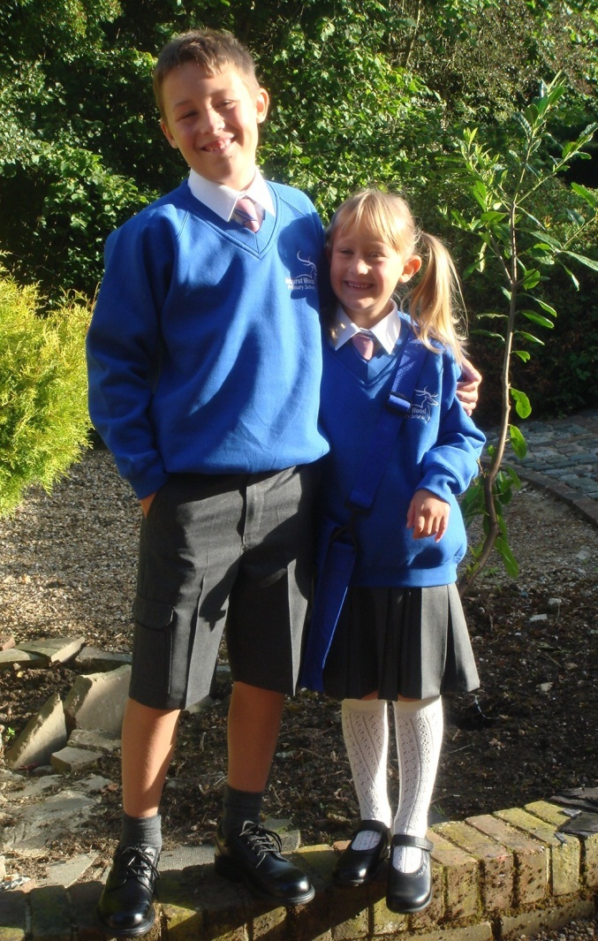

Ashurst Wood Primary School Uniform List
GIRLS
Winter Uniform – (Autumn and Spring Terms)
*Royal blue V neck sweater/cardigan | With school logo.
Tie | Traditional tie for all year groups.
Skirts/Pinafore Dresses | Plain grey skirt or pinafore without obvious embellishments. Length should be just above the knee.
Trousers | Plain grey school style. Fashion bootcut or skinny leg trousers are not permitted.
Shirts | White, formal collared shirt, long or short sleeved.
Tights | Plain grey
Socks | Knee length plain grey socks
Shoes | Plain, flat, black lace up or strap styles only. See examples on separate shoe page.
Boots | Boots/wellingtons may be worn to and from school. Please provide shoes that comply with the uniform policy for wearing indoors.
Hair accessories | Long hair must be tied off the face at all times with discreet royal blue or brown hairbands or elastic ties. Royal blue or pink (to match tie colour) ribbons may be used but other embellishments or adornments are not allowed.
Vests | Plain white vests or T-shirts without embellishments or logos may be worn under shirts in extremely cold weather.

Summer Uniform – (Summer Term)
*Royal blue V neck sweater/cardigan | With school logo.
Dresses | Pink gingham summer dress without obvious embellishments or trimmings.
Socks | White ankle or knee length socks. Trainer socks are not permitted.
Shoes | As for Winter. Plain black, navy or white sandals may also be worn. Crocs or Jellies are not allowed. See examples of acceptable styles on separate shoe page.
Hair accessories | As for Winter. A pink gingham scrunchie may be worn with the gingham summer dress is worn.

*All items marked with an asterisk must be bought through the online website
https://www.sussexuniforms.co.uk/collections/ashurst-wood
The school tie can only be purchased from the school office

Ashurst Wood Primary School Uniform List
BOYS
Winter Uniform – (Autumn and Spring Terms)
*Royal blue V neck sweater | With school logo
Tie | Traditional tie for all year groups
Trousers | Plain grey school style. Fashion patch or cargo pockets are not allowed
Shirts | White, formal collared shirt, long or short sleeved.
Socks | Plain grey knee or ankle socks. Trainer socks are not allowed.
Shoes | Plain, black lace up or velcro styles only. Trainer styles are not allowed. See examples on separate shoe page.
Boots | Boots/wellingtons may be worn to and from school. Please provide shoes that comply with the uniform policy for wearing indoors.
Hair accessories | Long hair must be tied off the face at all times with discreet royal blue or brown hairbands or elastic ties. Extreme hairstyles and dyed hair are not allowed.
Vests | Plain white vests or T-shirts without embellishments or logos may be worn under shirts in extremely cold weather.

Summer Uniform – (Summer Term)
*Royal blue V neck sweater | With school logo
Shorts | Plain grey without patch or cargo pockets.
Tie | Ties may be removed in the Summer with teacher’s permission.
Shirts | White, formal collared shirt with short sleeves.
Socks | Grey ankle or knee length socks. Trainer socks are not permitted.
Shoes | As for Winter. Plain black or navy sandals may also be worn. Crocs or Jellies are not allowed. See examples of acceptable styles on separate shoe page.
Hair accessories | As for Winter.

*All items marked with an asterisk must be bought through the online website
https://www.sussexuniforms.co.uk/collections/ashurst-wood
The school tie can only be purchased from the school office

Ashurst Wood Primary School Uniform List

Boys PE Kit

*T – Shirt | Royal blue with school logo
Shorts | Plain black football style shorts – no logos
Plimsolls/Trainers | Black plimsolls, or plain black or white trainers without logos or embellishments. Trainers must have non-marking soles.
*Hoodie | Royal blue with school logo. This is an optional item but must be purchased through the online website.
Jog pants | Plain Black or Royal Blue with no embellishments or logos

Girls PE Kit

*T - Shirt | Royal blue with school logo
Shorts | Plain black shorts – no logos. (Football or cycling shorts are acceptable)
Plimsolls/Trainers | Black plimsolls, or plain black or white trainers without logos or embellishments. Trainers must have non-marking soles.
*Hoodie - optional | Royal blue with school logo. This is an optional item but must be purchased through the online website.
Jog pants | Plain Black or Royal Blue with no embellishments or logos

Book Bags *Royal blue bags with the school logo (Compulsory for Year R, Year 1 and Year 2 pupils)

PE Bags A named drawstring bag no larger than 40cm x 40cm must be provided. There is no requirement to have school colours. There is a PE bag with the school logo available on the online website.

*All items marked with an asterisk must be bought through the online website
https://www.sussexuniforms.co.uk/collections/ashurst-wood

Jewellery and Personal Adornment
Jewellery is not allowed.
If ears have been pierced one small pair of studs is allowed. These must be removed or taped over for PE or swimming.
Slim discreet wristwatches may be worn by children in KS 2 only. Novelty watches are not allowed. All watches must be removed for PE.
If a Medi Alert pendant or bracelet has been recommended for your child please discuss with the school.
Nail varnish is not permitted.
Tattoos, temporary or otherwise are not permitted.

Forest School Clothing Requirements

School Uniform is not to be worn on Forest Days and old clothes that may become dirty are recommended. Clothes that will probably be needed are listed below, but please take into account local weather conditions and dress children appropriately.

Winter uniform

Vest or T-shirt

Long sleeved top

Hooded top/Fleece or Thick jumper | On really cold days layers with 2 or 3 jumpers are most effective
Waterproof Jacket

Thick socks | Thermal socks or 2 pairs thin socks
Warm trousers

Waterproof Trousers

Wellington Boots or Walking Boots

Hat, Gloves and Scarf

Flannel/Small towel

Metal or plastic mug with handle
Teaspoon

Summer Uniform

Long sleeved light T-shirt | Arms must be covered in the woodland
Light trousers – NO shorts | Legs must be covered in the woodland
Socks

Wellington Boots or Walking Boots | Sandals and flip-flops are NOT suitable
Sunhat

Sunglasses | If required
Sunscreen/Insect Repellent | Pupils are responsible for providing and applying their own sunscreen/repellent
Flannel/Small towel

Metal or plastic mug with handle
Teaspoon

Frequently Asked Questions

Do I have to buy all school uniform from the school?
The only items that must be purchased through the school uniform online website are the school jumper/cardigan, PE shirt, Book Bags (KS1) and school hoodie (optional). The school tie must be purchased from the school. All other items of uniform can be purchased from retailers of your choice.

Will the school supply only the compulsory school purchased items?
No, a full range of school uniform is available for you to browse and order, including trousers, skirts, shorts, dresses, pinafores, shirts, and blouses; however these items can still be bought from retailers of your choice.

Do the girls have to wear dresses in the Summer?
Yes, the girls have to wear dresses in the Summer term.

Does the school make a profit on the sale of school uniform?
The school will not make a profit on the sale of uniform.

Where can I find a copy of the school uniform policy?
Paper copies are available from the school office, detailed in the prospectus and on the school website.

How do I order school uniform?
Sussex Uniforms, provides an online system for parents to order our school uniform directly. This can be accessed by visiting https://www.sussexuniforms.co.uk/collections/ashurst-wood. Sussex Uniforms offer a free click and collect service, so that parents/carers can order their uniform online and collect it for free from one of their stores if they so wish. The Haywards Heath store and Hove store addresses can be found on the above website. Although Sussex Uniforms only offer us an online service, parents/carers are welcome to take their children to one of their stores for sizing and advice. As stated above, the school tie must be purchased through the school.

What does ‘plain’ mean in the policy?
The definition of plain in the policy is “no fashion embellishments, no contrasting colours, stripes or markings, no advertisements or brand logos”. This helps to ensure that we minimise competition between the children in terms of the clothes that they wear.

What help will be available for my child to tie their school tie?
Children will be given the opportunity to practice at school and staff will be available to assist the younger children. The following website also provides useful guidance on half windsor tie knots http://www.tie-a-tie.net/halfwindsor.html. We will strongly encourage children to slide the knot of their tie down rather than untie it completely when getting undressed.

Can my child wear earrings to school if they have just been pierced?

One pair of small stud earrings is permitted but must be removed or taped over for PE or swimming.

Shoes

Shoe styles have been chosen with health and safety in mind ie no high heels or slip on shoes. High heels represent tripping hazards and restrict the child’s ability to play freely. Research indicates that slip on shoes impede proper foot development as the toes are used abnormally to hold the shoe on. Trainers and other styles have been deselected to rule out fashion items being a distraction and ensuring that all children feel equal to their peers in terms of appearance.

Examples of Appropriate Girls’ Winter shoes

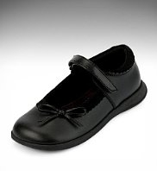
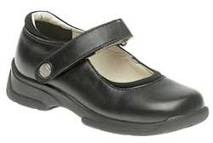
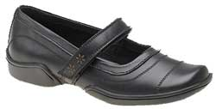

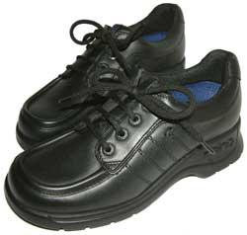
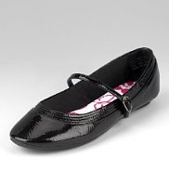
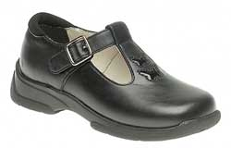

Examples of Appropriate Boys’ Winter Shoes

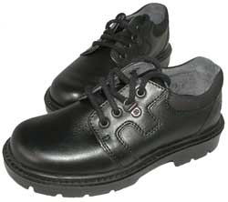
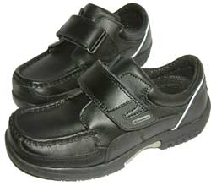
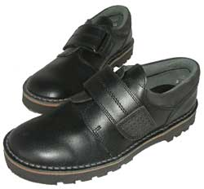

Examples of Appropriate Girls’ Summer shoes

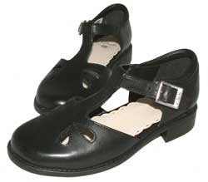
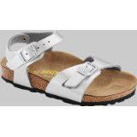
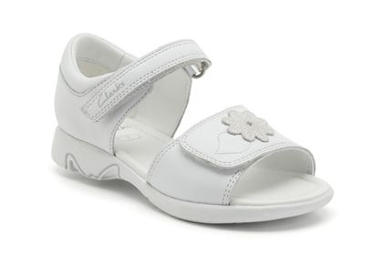

Examples of Appropriate Boys’ Summer Shoes

