SCHOOL RESULTS 2019

This is the fourth year of the new testing and assessment arrangements for Year 2 and Year 6. These arrangements reflect the more challenging national curriculum introduced in 2014 which provide greater challenges with higher expectations set for the end of KS2. This group of children is the last to have been taught on both curriculums.
The information below compares the attainment of our pupils with local authority and national averages.
Early Years Foundation Stage – GLD
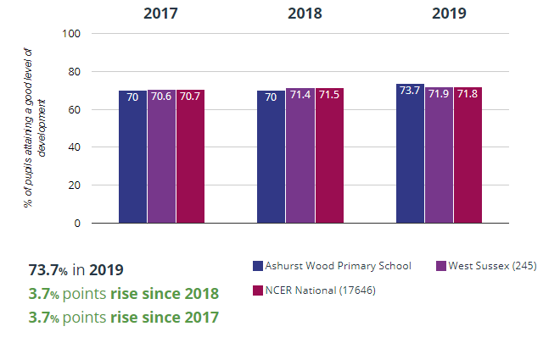 | A Good Level of Development is defined as children working at the expected standard or exceeding the expected standard in the key areas of literacy, maths, physical development, communication and language and personal, social and emotional development.

Year One Phonic Screening
Phonics Screening Year 1  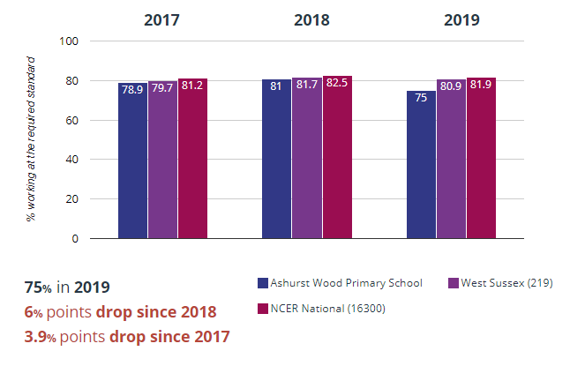  Phonics screening Y2  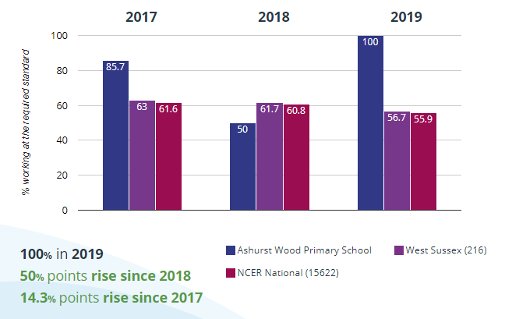 | 75% of pupils in Year One attained the expected standard in the Phonic Screening test.  As we have small groups of children, each child is worth 5%.  If children do not meet the standard in Y1 they sit the assessment again in Y2.  As a school we put additional support in for children who take longer to master phonics and any child who does not manage this by Y2 is supported in Y3.

Key Stage One
At the end of KS1 (Yr2), teachers are required to assess each child in the areas of reading, writing, maths and science. National Curriculum assessment tests are used to support teachers’ judgements. Expected Standard: Working at the expected standard for a child at the end of Year.
Greater Depth: Working at greater depth within the expected standard, with a strong understanding of the curriculum.
END OF KS1 RESULTS 2019
 | End of KS1 Teacher assessments
 | Reading |  | Writing |  | Maths
 | Ashurst Wood | National Average | Ashurst Wood | National Average | Ashurst Wood | National Average
Percentage of pupils who achieved the expected standard | 75% | 74.9% | 80% | 69.2% | 90% | 75.6%
Percentage of pupils who achieved a high level of attainment | 20% | 25% | 20% | 14.8% | 20% | 21.7%

Key Stage Two
Children in Year 6 are also assessed on their knowledge and understanding of the curriculum. The curriculum introduced in 2014 provides greater challenge with higher expectations set at the end of KS2.
The results of the SATs (tests) are reported using a scaled score, where a score of 100 represents the expected standard. The highest possible score is 120 and the lowest is 80.
In addition to these measures and in line with requirements, we have reported the percentage of children achieving a High Standard. Children with a scaled score of 110 and above are included in this group. Year 6 pupils were assessed in reading, writing, grammar, punctuation and spelling, maths and science.
Children are awarded one of the following Teacher Assessment judgements in writing:
Expected Standard: Working at the expected standard for their age Greater Depth:
Working at greater depth within the expected standard and has a strong understanding of the curriculum
END OF KS2 SATs RESULTS 2019
End of KS2 (end of primary school) results 2019
These results are based on a cohort of 18 children who represent 5.5 % each.
33% of the children had additional needs.
 | Reading | Writing | GPS | Maths
Percentage of pupils who achieved the expected standard | 44% | 50% | 33.3 | 38.9
Percentage of pupils who achieved a high level of attainment | 16.7% | 5.6% | 16.7 | 5.6
Average Progress scores | -1.25 | -4.75 |  | -5.23
Average Scaled Scores | 101.2 |  | 98.7 | 97.7

The school governors and staff have ensured that the children in this cohort received additional support and this cohort presented challenges which are not reflected across the rest of the school.

