DISHES AND THEIR ALLERGEN CONTENT – ASTON TOWER COMMUNITY PRIMARY SCHOOL – WEEK 1 MENU

DISHES | 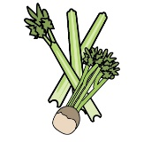 | 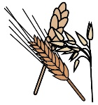 | 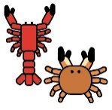 |  |  |  |  |  |  | 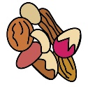 | 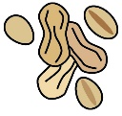 | 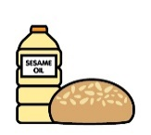 |  | 
 | Celery | Cereals containing gluten | Crustaceans | Eggs | Fish | Lupin | Milk | Mollusc | Mustard | Nuts | Peanuts | Sesame seeds | Soya | Sulphur Dioxide
Halal Chicken Meatballs in Tomato Sauce |  |  |  |  |  |  |  |  |  |  |  |  | ü
Vegan Style Chicken Fillet |  | üwheat
Pasta in tomato sauce |  | üwheat
Pineapple sponge |  | üwheat |  | ü |  |  |  |  |  |  |  |  |  | ü
Halal All Day Brunch |  | üwheat |  | ü |  |  | ü |  | ü  May
Vegetarian All Day Brunch |  | üwheat |  | ü |  |  | ü
Custard |  |  |  |  |  |  | ü |  |  |  |  |  |  | ü
Cocoa Crunch Tray Bake |  | üwheat |  |  |  |  |  |  |  |  |  |  |  | ü
Vegan Chocolate Brownie bites with Mandarin oranges |  | GF |  |  |  |  | ü  May
Fishless Fingers |  | üwheat |  |  |  |  | ü
Bread |  | üwheat |  | ü  May |  |  | ü |  |  |  |  |  | ü

DISHES
 | Celery | Cereals containing gluten | Crustaceans | Eggs | Fish | Lupin | Milk | Mollusc | Mustard | Nuts | Peanuts | Sesame seeds | Soya | Sulphur Dioxide
Cheesy bean wrap |  | üwheat |  |  |  |  | ü
Baked potato |  | üwheat |  |  |  |  |  |  |  |  |  |  | ü
Margherita pizza |  | üwheat |  | ü |  |  | ü |  |  |  |  |  | ü
Fish fingers |  | üwheat |  |  | ü
Quorn vegan nuggets |  | üwheat
Omelette |  |  |  | ü
Banana mousse |  |  |  |  |  |  | ü

Week 1 February 2026

