DISHES AND THEIR ALLERGEN CONTENT – ASTON TOWER COMMUNITY PRIMARY SCHOOL – WEEK 1 MENU

DISHES | 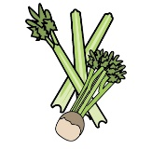 | 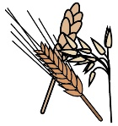 | 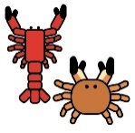 |  |  | 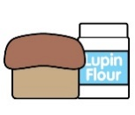 |  |  | 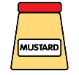 | 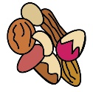 | 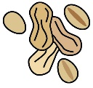 | 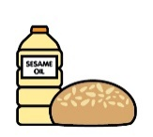 |  | 
 | Celery | Cereals containing gluten | Crustaceans | Eggs | Fish | Lupin | Milk | Mollusc | Mustard | Nuts | Peanuts | Sesame seeds | Soya | Sulphur Dioxide
Cheese & Potato pie |  |  |  |  |  |  | ü
Fishless Fingers |  | üwheat
Pizza |  | üwheat |  | May contain |  |  | ü |  |  |  |  |  | ü
Muller Yoghurt |  |  |  |  |  |  | ü
Halal All Day Brunch |  | üwheat |  | ü |  |  | ü |  | ü
Vegetarian All Day Brunch |  | üwheat |  | ü |  |  | ü
Mashed Potatoes |  |  |  |  |  |  | ü |  |  |  |  |  |  | ü
Vanilla Ice Cream |  |  |  |  |  |  | ü
Vegan Chocolate Brownies with Mandarin oranges |  | üwheat
Naan Bread |  | üwheat |  |  |  |  | ü
Pasta |  | üwheat |  |  |  |  |  |  | May Contain |  |  |  | May contain

DISHES
 | Celery | Cereals containing gluten | Crustaceans | Eggs | Fish | Lupin | Milk | Mollusc | Mustard | Nuts | Peanuts | Sesame seeds | Soya | Sulphur Dioxide
Sprinkle Tray Bake Cake |  | üwheat |  | ü
Custard |  |  |  |  |  |  | ü
Coleslaw |  |  |  | ü
Harry Ramsden’s Salmon and Sweet Potato fish cake |  | üwheat |  |  | ü
Halal BBQ Chicken Wrap |  | üwheat |  |  |  |  |  |  |  |  |  |  | ü
Vegan Quorn Nuggets |  | üwheat
Spaghetti Hoops |  | üwheat
Chicken Sausage |  | üwheat
Omelette |  |  |  | ü
Vanilla Whirl Biscuit |  | ü
Very berry mousse |  |  |  |  |  |  | ü

Week 1 Sept 25

