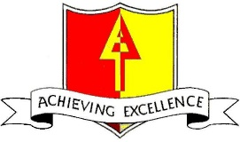

FREE SCHOOL MEAL VOUCHERS – DECEMBER 2020

As part of the Government’s £170 million Covid Winter Grant Scheme, Birmingham City Council are providing Free School Meal vouchers during the holiday period in December.
The value of the vouchers is £15 per week for eligible children in Reception to Year 6 and £7.50 per week for eligible children in Nursery.
The vouchers will be provided by Edenred (the same company the Government used during the Summer Term) and where we have email addresses for parents, we have requested the codes to be delivered by email on 18th December 2020. You will need to do exactly the same as you did during the summer to redeem the codes for vouchers.
Please go to:
https://www.edenred.co.uk/reward-recipients/Free-School-Meal-Vouchers/
where you can redeem your code and find user guides and answers to Frequently Asked Questions (FAQs).
If we do not have email addresses, the vouchers will be sent home on Thursday 17th December 2020.

