Uniform Expectations
 | Reception | Year 1 |  | Year 2 |  | Year 3 | Year 4 | Year 5 | Year 6
Everyday Uniform
Top | White / navy polo shirt - preferably embroidered with school logo, but not essential.
Top | Navy blue sweatshirt / cardigan / fleece - preferably embroidered with school logo, but not essential.
Top | No hoodies to be worn in school |  |  |  |  |  |  |  | School Leavers’ Sweatshirt
Bottoms | Navy / black jogging bottoms. |  |  | Black or grey shorts / trousers / pinafore / skirt.
Bottoms | Own choice of socks. |  |  | Own choice of socks, tights or leggings.
Summer | Navy or black shorts may be worn. |  |  | Blue gingham dress or playsuit may be worn.
Shoes | Black school shoes / trainers (no obvious branding, please). No boots.
Shoes | No laces – Velcro only. |  |  | Laces allowed, if a child can tie them independently.
Other | Long hair must be tied back and off the face – boys and girls.  Jewellery is limited to stud earrings, watches (no smart watches) and any jewellery worn for religious reasons.  No nail varnish, tattoos, make-up or distracting hair accessories.
PE Kit
Top | Plain coloured t-shirt in your child’s House colour – preferably embroidered with school logo.
 | School sweatshirt
Bottoms | Navy or black plain shorts and jogging bottoms. No branding or logos.
Shoes | Trainers (preferably dark-coloured). No obvious branding, please
Other | All jewellery must be removed for PE. If earrings cannot be removed, please provide Micropore tape to cover.
Weather /Term |  |  | Outdoor Clothing – to be kept in school
Sunny/warm | Waterproof trousers or ‘bib and brace’ overalls (preferable) |  |  |  |  | Waterproof trousers
Colder | ‘All in one’ waterproof suit or ‘bib and brace’ overalls and jacket (preferable) |  |  |  |  | Waterproof trousers and jacket
Very cold | The items above need to be padded out with fleecy tops/leggings/thermals etc.
Autumn & Spring | Wellies – in school everyday
Summer | Sunhat – in school everyday
Other items
Water bottle | Water bottle (containing water only) – in school everyday
School bag | School bag not required |  |  |  | Book bag or backpack, to fit A4.
Painting apron | Painting apron not required |  |  |  | Please provide an old, oversized shirt.

Examples of everyday uniform
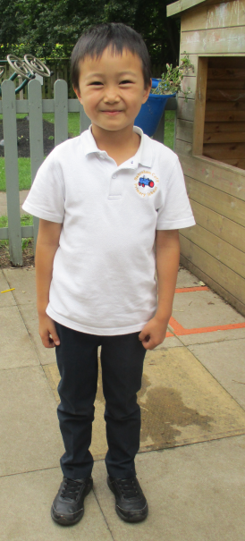 | 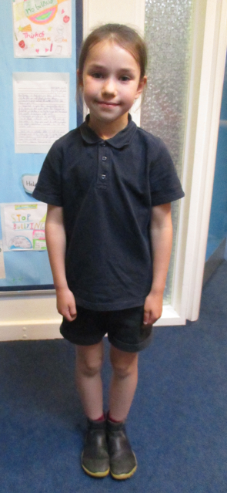 |  | 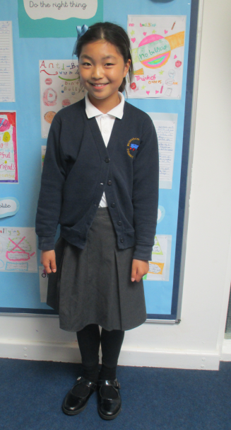 |  | 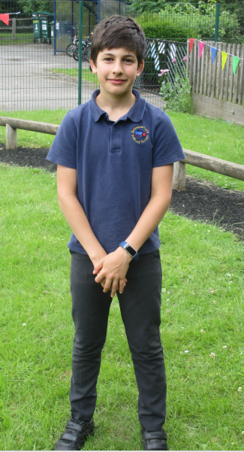 |  | 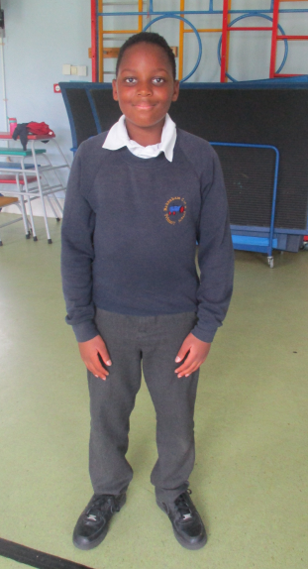
Examples of PE Kit
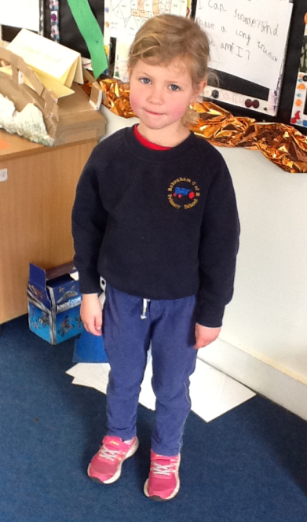 |  | 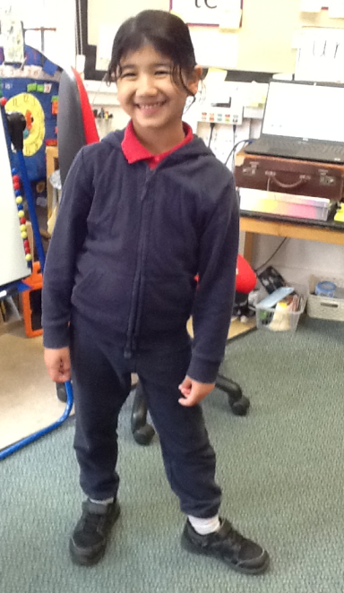 |  | 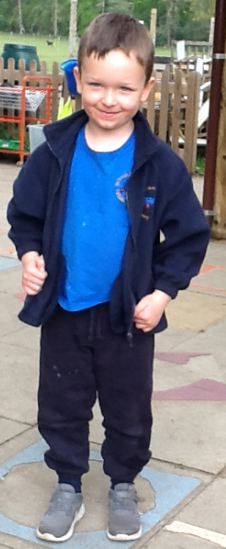 |  | 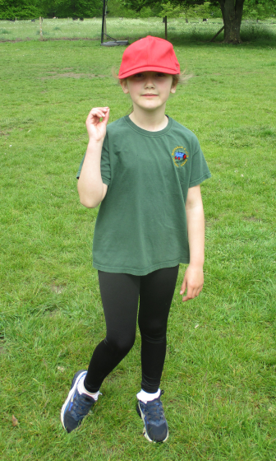 |  | 