Substantive Concepts – see below)

**KS3**

PD Opportunity

Spring

Autumn

Summer

One Voice concert

**PLASTIC**

**Rap**

Composition on the theme of pollution

**You’ve got a friend**

**70’s Ballad/Pop**

History of music – Carole King

**Music & Me**

Creating, exploring and expressing identities through music and women in the music industry.

**Reflect, Rewind & Replay**

Consolidates the learning that has occurred during the year. All the learning is focused around revisiting songs and musical activities, a context for the History of Music and the beginnings of the Language of Music.

Christingle

Leaver’s performance

**Classroom Jazz 2**

**Jazz**

Improvisation and composition

History of music - Jazz

One Voice concert

**Reflect, Rewind & Replay**

Consolidates the learning that has occurred during the year. All the learning is focused around revisiting songs and musical activities, a context for the History of Music and the beginnings of the Language of Music.

**Y6**

**Happy**

**Pop/Neo Soul**

Exploring pop music based on earlier trends (soul)

Christmas carol concert

**Make you feel my love**

**Pop ballad**

Exploring the ‘pop ballad’ genre and performance skills

Christmas carol concert

Rotherham music services

**Livin on a Prayer**

**Classic rock**

Learning about Rock Anthems and performance skills

**Ukuleles**

Exploring and developing playing skills

- Melodic instruments

**Ukuleles**

Exploring and developing playing skills

- Melodic instruments

**Fresh Prince of Bel Air**

**Old School Hip-Hop**

Refining Rapping skills

One Voice- choir children

Christingle

**Y5**

One Voice concert

**Reflect, Rewind & Replay**

Consolidates the learning that has occurred during the year. All the learning is focused around revisiting songs and musical activities, a context for the History of Music and the beginnings of the Language of Music.

**Stop**

**Grime**

Focus on writing lyrics on a theme to a backbeat

**Mamma Mia**

**Pop**

Exploring history of music - ABBA

**Lean on Me**

**Soul/Gospel**

The importance of helping one another – expressed through song

Rotherham music services

One Voice concert

**Djembes**

Exploring and developing playing skills – Percussion instruments

**Reflect, Rewind & Replay**

Consolidates the learning that has occurred during the year. All the learning is focused around revisiting songs and musical activities, a context for the History of Music and the beginnings of the Language of Music.

**Djembes**

Exploring and developing playing skills

- Percussion instruments

**Bringing us together**

Disco

Exploring the theme of Friendship, hope and unity through music

**Y4**

Christingle

Christmas carol concert

Christmas carol concert

**The Dragon Song**

**Pop**

Music from around the world. How music can celebrate our differences and encourage us to be kind to one another.

**Three Little Birds**

**Reggae**

History of music Focus on Bob Marley – famous Reggae artist.

**Magical Christmas Journey**

Showcase performing skills

**Let your spirit fly**

**R&B**

Explore the Rhythm and Blues style of music and its history

Christingle

**Y3**

One Voice concert

**Reflect, Rewind & Replay**

**Classical**

The history of music, look back and consolidate your learning, learn some of the language of music.

**Friendship song**

**Pop**

Communicating ideas about friendship through songs

**Zootime**

**Reggae**

An integrated approach to music where games, the dimensions of music, singing and playing instruments are all linked

**KS2**

**I Wanna Play In a Band**

**Rock**

Focuses on the importance of playing together

Christingle

**Exploring simple patterns**

**Exploring different genres throughout the unit**

How does music help us to make friends?

**Hands Feet Heart**

**Afropop, South African music**

Awareness of different genres of music from around the world

**Reflect, Rewind & Replay**

The history of music, look back and consolidate your learning, learn some of the language of music.

**Combining pulse, rhythm and pitch (MMC)**

Celebrating a wide range of musical styles with opportunities to listen/sing/play/perform

**Y2**

Christmas nativity

**Your Imagination**

Original song for children

Using your imagination

How music can help you to express your imagination

Christmas nativity

**Summer 2**

**Learning nursery rhymes**

Building a bank of known nursery rhymes

**Round and Round**

**Bossa Nova/Latin**

An integrated approach to music where games, the dimensions of music, singing and playing instruments are all linked

**Rhythm in the way we walk & Banana Rap**

**Reggae and Hip Hop**

Continue to embed the interrelated dimensions of music through games and singing.

**Hey You**

Rap

Learn about the differences between pulse, rhythm and pitch and to learn how to rap.

As well as learning to sing, play, improvise and compose with this song, children will listen and appraise other Old-School Hip Hop tunes.

**Y1**

**Summer 1**

**Learning nursery rhymes**

Building a bank of known nursery rhymes

Christingle

Christmas nativity

**Spring 2**

**Learning nursery rhymes**

Building a bank of known nursery rhymes

**Spring 1**

**Learning counting songs and rhymes**

Pulse, pitch and rhythm

**Autumn 2**

**Learning nursery rhymes**

Beginning of pitch and rhythm

**Autumn 1**

**Learning action songs**

Moving to the pulse

**FS2**

**Area of EYFS**

Nursery rhyme performance

Christingle

Learn a new song

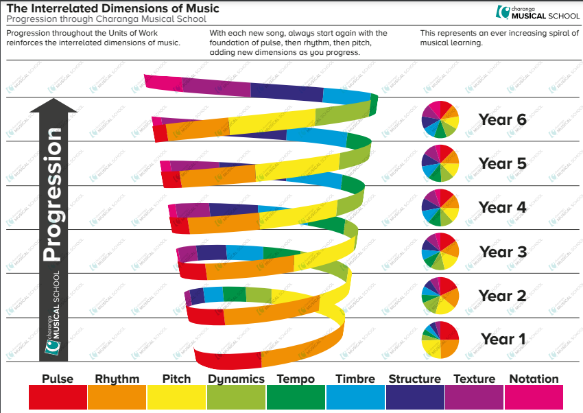

Substantive Concepts