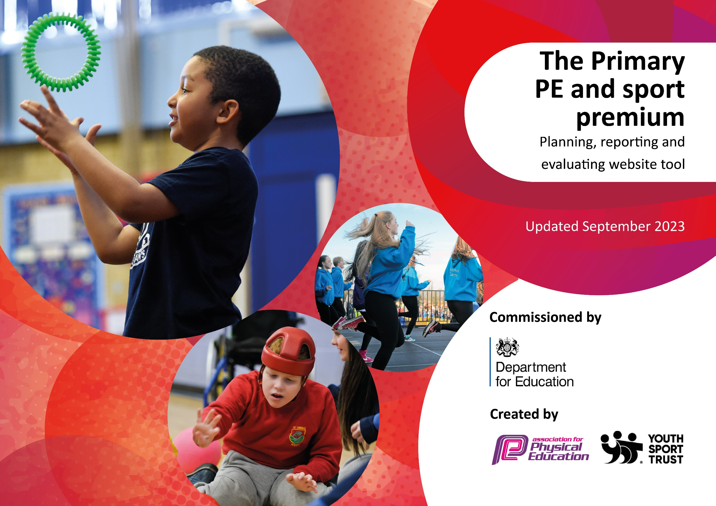

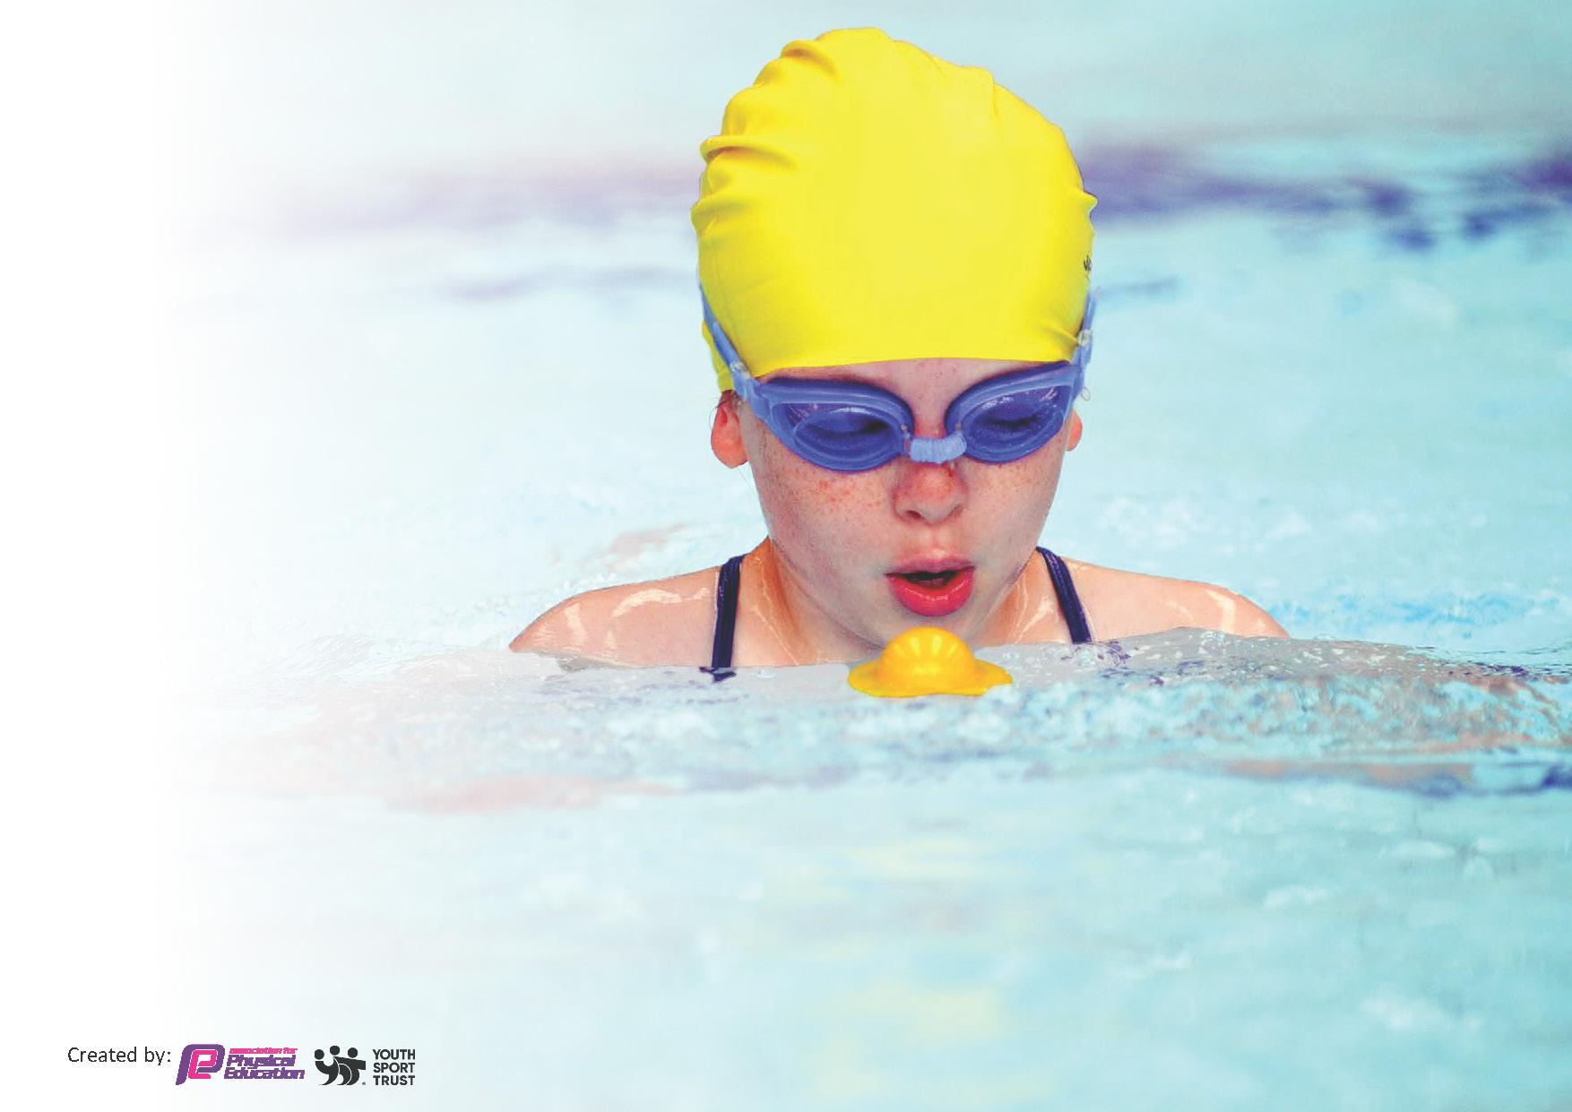
This template can be used for multiple purposes:
by:
- It enables schools to effectively plan their use of the Primary PE and sport premium
- It helps schools to meet the requirements (as set out in guidance) to publish information on their Primary PE and sport premium
- It will be an effective document to support Ofsted inspections enabling schools to evidence progress in Physical Education (PE) and evidence swimming attainment, which forms part of the PE National Curriculum. We would recommend schools consider
the Intent, Implementation and Impact of any spend, as examined within the Education Inspection Framework.

It is important that your grant is used effectively and based on school need.

Schools must use the funding to make additional and sustainable
improvements to the quality of the PE, School Sport and Physical Activity (PESSPA)
they offer. This means that you should use the Primary PE and sport premium to:

- Build capacity and capability within the school to ensure that improvements made now will benefit pupils joining the school in future years
- Develop or add to the PESSPA activities that your school already offers.

The Primary PE and sport premium should not be used to fund capital spend projects; the school’s core budget should fund these. Further detail on capital expenditure can be found in the updated Primary PE and sport premium guidance.

The Primary PE and sport premium guidance, outlines 5 key priorities that funding should be used towards. It is not

necessary that spending has to meet all the key priorities, you should select the priorities that you aim to use any funding towards.

Although completing this template is not a requirement for schools, schools are required to publish details of how they spend this funding. Schools must also outline what the impact this funding has had on pupils’ PE and sport participation and attainment and how any spending will be sustainable in the future. All funding must be spent by 31st July 2024.

The Department for Education has worked closely with the Association for Physical Education (afPE) and the Youth Sport Trust (YST) to develop this template and encourages schools to use it. This template is an effective way of meeting the reporting requirements of the Primary PE and sport premium.
Review of last year’s spend and key achievements (2022/2023)

We recommend you start by reflecting on the impact of current provision and reviewing your previous spend.

Activity/Action | Impact | Comments
- Provide 6 different sports after school clubs for all year groups from Year 1-6 running throughout the year.  - School Games Mark- Platinum  - Lancashire PE leader lead CPD training for all teachers.  - Continue to develop assessment for PE.  - High attainment in all competitions that the school entered. Medals achieved in many sports.  - Developed outdoor provision for breaktimes to promote active lives and increase physical activity. | - 87% of KS1 and KS2 children and 100% of Pupil Premium children participated in at least 1 after school club.  - Achieved Platinum School Games Mark for the second year recognising outstanding PE provision and engagement in this subject.  - Staff feel far more confident in teaching PE and as a result, outcomes have improved.  - The use of the PE passport assessment tool has allowed staff to be more confident in reporting the progress of the children and what they need to do next to continue to make good/excellent progress.  - Children take pride in representing the school and learn essential skills for competition.  - Children are more physically active during the school day. | - Pupils have been introduced to more sports which has increased the levels of participation in school and at community club.  - We have achieved Gold in the School Games Mark for 9 years then Platinum for the last two. We will apply for Platinum again this year showing a commitment and dedication to providing outstanding PE provision for all children.  - Improved assessment has meant that children have made improved progress in this subject.  - Children take pride in representing the school at competition level. There have been more children than ever before representing the school  - Pupil voice shows that children believe that there are plenty of opportunities for physical activity during the school day and that they do more because of the provision that has been put in place.

Key priorities and Planning
This planning template will allow schools to accurately plan their spending.

Action – what are you planning to do | Who does this action impact? | Key indicator to meet | Impacts and how sustainability will be achieved? | Cost linked to the action
- Access to high quality resources during PE sessions. Enough quantity of resources to enable access for all  - Continue to offer a wide range of extra-curricular activities to all children  - PALS training  - CPD for teachers  - School Games Mark- Platinum  - Competitions- intra and inter  - Access to increased range of high quality resources to facilitate active play across EYFS, KS1 and KS2.  - Purchase of the PE Passport app to ensure consistency of planning and assessment  - All Year 5 children given Bikeability cycling training  - Year 6 children assessed for Sports Star and participate in Sports Star academy  - All Year 4 children visited the Anderton Outdoor and Adventurous Activity Centre  - To attend local sports competitions to work alongside and compete against other local schools. Try to give as many children as possible the opportunity to compete and represent the school.  - Wheelchair basketball assembly and sessions | - Teachers and all children participating in PE  - Children who take part and staff members who run clubs  - Children leading the activities and the children participating in them  - Staff and children  - All children and staff  - Children participating in competitions and staff member coaching children  - All children  - Teachers and children  - Year 5 children  - Year 6 children  - All Year 4 children  - Children participating in sporting competitions and festivals  - All KS2 children | - Key indicator 1,2,3,4 and 5  - Key indicator 2, 4 and 5  - Key indicator 2,3 and 4  - Key indicator 1 and 3  - Key indicator 1,2,3,4 and 5  - Key indicator 3 and 4  - Key indicator 2  - Key indicator 1 and 2  - Key indicator 2,3,4 and 5  - Key indicator 5  - Key indicator 4  - Key indicator 5  - Key indicator 4 and 5 | - All pupils benefit from all planned PE sessions being fully resourced leading to greater participation and active minutes in lessons.  - More children achieving more daily physical activity and increased participation in more sports.  - Children trained to promote and encourage 60 minutes of structured active playtime. Children participating achieve more active minutes  - PE provision improved  - The school is recognised for outstanding PE provision which leads to greater opportunities and participation  - Children will continue to develop resilience, teamwork and leadership skills.  - Purchase of additional playtime resources and replacement of lost or broken resources. Children have access to a wider range of resources which encourage active play both on the playground and on the school field during the summer months. Children’s play is more active.  - App used to support staff in understanding how to assess children throughout the different units of work, to be able to identify pupils who may need intervention on certain PE skills.  - increased confidence when riding bikes on roads and general cycling skills.  - Pupils to participate in an academy to improve confidence and ability, with links and pathways to community settings and clubs for pupils to access.  - Children have increased resilience and experience of challenge. By the time they leave school, all children will have had this.  - More children experience competitive sport  - Children develop their resilience as well as appreciation of diversity | - £1700+  - £3240  - £150  - £120  - £1200  - £7311  - £550  - £50  - £150  - £1860  - £2433  £431

Key achievements 2023-2024
This template will be completed at the end of the academic year and will showcase the key achievements schools have made with their Primary PE and sport premium spending.

Activity/Action | Impact | Comments
Continue to offer a broad range of extra-curricular activities for all pupils  CPD for teachers  School Games Mark –Platinum awarded  PALs training  Participation in competitions  KS2 Wheelchair basketball assembly and workshops | More children achieving 30-60 active minutes  Teachers continue to develop their skills in this subject leading to improved outcomes for the children  Recognition of the excellent PE offer and provision for all children  PALs feel empowered and responsible. EYFS and KS1 children benefit from structured playtimes leading to increased physical activity.  An increased sense of pride. Children have developed their resilience, teamwork and leadership skills.  All KS2 children have participated in a sport that they have never experienced before and have an increased respect and admiration for people with disabilities | This provision has allowed 88% of KS1 and KS2 children to access at least 1 extra-curricular sports club this year with 100% of Pupil Premium and 86 % of SEN also participating  Staff have been vocal about the benefit of the CPD they have received. Subject leader attends PLT days and receives updates from Youth Sport Trust  We now have the Platinum status for the next two years.  This has been really successful and observations by subject lead show that the infants benefit greatly from this.  The children have had success across a range of sports. An increased number of new competitors have been involved this year.  The children enjoyed this so much. We will have the same workshop next year and include KS1.

Swimming Data
Meeting National Curriculum requirements for swimming and water safety.
Priority should always be given to ensuring that pupils can perform safe self-rescue even if they do not fully meet the first two requirements of the National Curriculum programme of study

Question | Stats: | Further context  Relative to local challenges
What percentage of your current Year 6 cohort can swim competently, confidently and proficiently over a distance of at least 25 metres? | 100%
What percentage of your current Year 6 cohort can use a range of strokes effectively [for example, front crawl, backstroke, and breaststroke]? | 100%

What percentage of your current Year 6 cohort are able to perform safe self-rescue in different water-based situations? | 100%
If your schools swimming data is below national expectation, you can choose to use the Primary PE and sport premium to provide additional top-up sessions for those pupils that did not meet National Curriculum  requirements after the completion of core lessons. Have you done this? | No
Have you provided CPD to improve the knowledge and confidence of staff to be able to teach swimming and water safety? | No | Swimming lessons are provided by the local swimming pool with qualified coaches teaching the children

Signed off by:

Head Teacher: | Helen Gregson
Subject Leader or the individual responsible for the Primary PE and sport premium: | Will Woodrow
Governor: | Jade Gibson
Date: | 31/07/24

