Diversity Role Models: Stereotypes Worksheet
Hello! My name is
__________________
my age is _________
and my job is ____________________
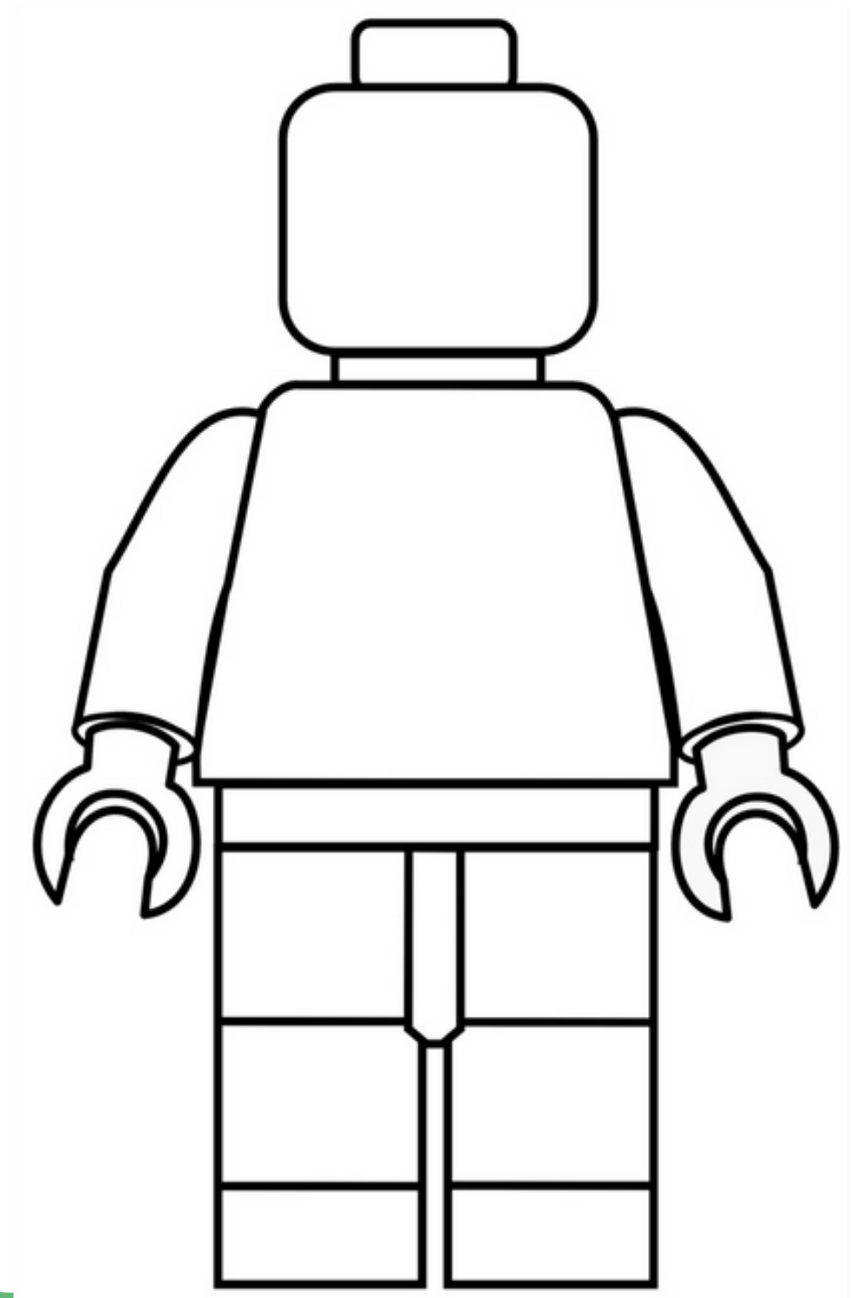
Design your own Lego figure character here. Remember to break at least two stereotypes!
When people meet me, they are often surprised to learn that I…

My hobbies are:
1.
2.
3.

My favourite subjects at school were:
1.
2.
3.

