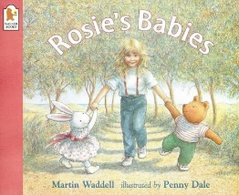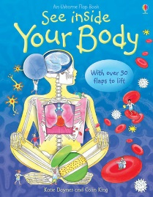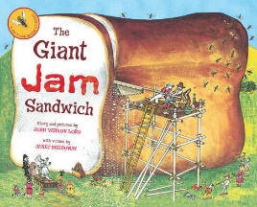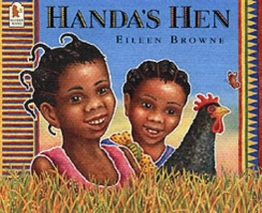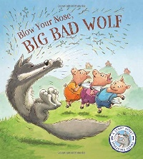

OUR BOOKS OF THE WEEK

KEY VOCABULARY

|  |  |  |  |
| --- | --- | --- | --- |
| Health | Food, eating, exercise, sleeping, washing, brushing teeth, getting dressed, being happy. | Our Body | Heart, lungs, brain, stomach, blood. |
| Food | Healthy, unhealthy, vegetables, fruit, sugar, sweets, water, energy, cook, bake, chop, slice, grate, spread, fridge, oven. | Birdwatch | Birds, species, fly, feather, nest, beak, wings, song, seeds, eggs, robin, blackbird, pigeon, blue tit, great tit, sparrow, magpie. |
| Safety | Rules, signs, listen, follow instructions, hot, deep, icy, scissors, sharp, kitchen, oven, road, adults we know. | Chinese New Year | China, calendar, emperor, princess, race, dragons, lanterns, year of the Ox, tradition, culture. |

Keeping Healthy

WHAT WE ARE LEARNING ABOUT

* KEEPING OURSELVES HEALTHY AND SAFE
* FOOD GIVES US ENERGY
* FOOD THAT IS HEALTHY AND FOODS THAT ARE TREATS
* IMPORTANCE OF SLEEP, TEETH BRUSHING, WASHING HANDS, EXERCISING AND KEEPING HAPPY
* NAMING SOME INTERNAL PARTS OF OUR BODY
* SCISSOR SAFETY, ROAD SAFETY, KICTCHEN SAFETY, GERM SAFETY, WATER SAFETY, FIRE SAFETY
* RSPB’S SCHOOL BIRDWATCH
* EXPLORING LOCAL BIRD SPECIES AND TAKING CARE OF THEM
* CHINESE NEW YEAR
* FOOD PREP AND FOOD TASTING
* HELICOPTER STORIES
* SEQUENCING STORIES
* POSITIONAL LANGUAGE
* PATTERN

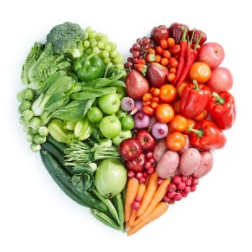

FOX CUBS CURRICULUM LEAFLET

Spring 1

Keeping Healthy

PERSONAL, SOCIAL & EMOTIONAL DEVELOPMENT

**WE WILL BE:**

-LEARNING ABOUT KEEPING OURSELVES SAFE.

-BUILDING CONFIDENCE IN MAKING NEW FRIENDS.

**YOU CAN HELP AT HOME BY:**

-REMINDING ABOUT OR INSTILLING SAEFTY RULES, E.G. ROAD SAFETY, KITCHEN SAFETY, DEVICE SAFETY.

LITERACY

**WE WILL BE:**

-TELLING STORIES AND ACTING STORIES OUT THROUGH HELICOPTER STORIES.

-OBSERVING ADULTS WRITING DOWN OUR VERBALISED THOUGHTS.

**YOU CAN HELP AT HOME BY:**

-MAKING UP STORIES TOGETHER AND ACTING THEM OUT.

UNDERSTANDING THE WORLD

**WE WILL BE:**

-FINDING OUT ABOUT BIRDS WITH EQUIPMENT, BOOKS AND OBSERVATIONS.

-OBSERVING CHANGES IN FOOD AS IT IS COOKED.

-USING OUR SENSES TO TASTE.

**YOU CAN HELP AT HOME BY:**

-DISCUSSING TASTE AND TEXTURES OF FOOD AT MEAL TIMES, INTRODUCING VOCABULARY TO DESCRIBE FLAVOUR.

EXPRESSIVE ARTS

**WE WILL BE:**

-CREATING SCULPTURES.

-USING FOOD AS ART (PRINTING).

-LEARNING AN INCREASING VARIETY OF SONGS.

**YOU CAN HELP AT HOME BY:**

-USING OLD BOXES, CARTONS AND PACKAGING TO CREATE SCULPTURES AT HOME WITH ME.

MATHEMATICAL DEVELOPMENT

**WE WILL BE:**

-EXPLORING A NUMBER A WEEK WITH NUMBERBLOCKS.

-EXPLORING POSITIONAL LANGUAGE.

-EXPLORING ORDINAL NUMBERS.

**YOU CAN HELP AT HOME BY:**

-DISCUSS POSITIONS IN A RACE OR WHEN IN A QUEUE, 1ST, 2ND, 3RD ETC.

LANGUAGE & COMMUNICATION DEVELOPMENT

**WE WILL BE:**

-SPEAKING AND LISTENING TO KITCHEN STAFF ABOUT HOW THEY PREPARE LUNCHES.

-SHARING WEEKEND NEWS.

**YOU CAN HELP AT HOME BY:**

-HAVING CONVERSATIONS WITH ME WHERE WE REVISIT OUR FAMILY TIMES TOGETHER.

PHYSICAL DEVELOPMENT

**WE WILL BE:**

-FOOD SAFETY AND PREP.

-INCREASED INDEPENDENCE IN SELF CARE.

**YOU CAN HELP AT HOME BY:**

-INCLUDING ME IN COOKING AND BAKING ACTIVITIES.

-ENCOURAGING ME TO DO SOME THINGS FOR MYSELF.