

**Banks St Stephen’s**

**Mathematics**

**Calculation Policy**

**Mental Calculation Strategies**

**Progression Toward Mental Calculation Strategies  
(Addition and Subtraction)**

The ability to calculate mentally is an essential skill, but, as with written methods of calculation, children need to be taught. **It is important to ensure that when teaching particular strategies, children have the appropriate prerequisite skills and are guided as to how and when that strategy is appropriate.**

Children should be taught and encouraged to ask themselves the following questions when faced with a calculation:

* Do I know the answer?
* Can I work it out in my head?
* Do I need to do a jotting?
* Do I need to use a written method?

When using a jotting, there is no requirement to follow a particular method of recording.

A feature of mental calculation is that a type of calculation can often be worked out in several different ways. Which method is best will depend on the numbers involved, the age of the children and the range of methods that they are confident with.

In developing a progression through mental calculation strategies for addition and subtraction, it is important that children understand the relevant concepts, in that addition is:

* combining two or more groups to give a total or sum
* increasing an amount

and subtraction is:

* removal of an amount from a larger group (take away)
* comparison of two amounts (difference)

They also need to understand and work with certain principles, that:

* addition and subtraction are inverses
* addition is commutative i.e. 5 + 3 = 3 + 5 but subtraction is not 5 - 3 is not the same as 3 - 5
* addition is associative i.e. 5 + 3 + 7 = 5 + (3 + 7) but subtraction is not 10 - 3 - 2 is not the same as 10 - (3 - 2)

Commutativity and associativity mean that calculations can be rearranged, e.g. 4 + 13 = 17 is the same as 13 + 4 = 17.

**nursery**

**Objectives:**

***Develops an awareness of number names through their enjoyment of action rhymes and songs that relate to numbers.***

***Has some understanding that things exist, even when out of sight (developing early counting and problem-solving skills).***

***Begins to organise and categorise objects, e.g., putting toys into groups or stacking blocks****.*

***Develop fast recognition of up to 3 objects, without having to count them individually (‘subitising’).***

***Recite numbers past 5.***

***Say one number for each item in order: 1,2,3,4,5.***

***Know that the last number reached when counting a small set of objects tells you how many there are in total (‘cardinal principle’).***

***Show ‘finger numbers’ up to 5.***

***Link numerals and amounts: for example, showing the right number of objects to match the numeral, up to 5.***

***Experiment with their own symbols and marks as well as numerals. Solve real world mathematical problems with numbers up to 5.***

***Compare quantities using language: ‘more than’, ‘fewer than’.***

Before introducing calculations, it's important for children to develop a strong understanding of numbers. In Nursery, children are introduced to the concepts of subitising, counting, number order, and number recognition through hands-on activities.

Examples include songs like "5 Little Ducks," "5 Current Buns," "10 Green Bottles," "1 Potato, 2 Potato," and "Once I Caught a Fish Alive."

Children also learn to count one-to-one by pointing to each object as they count and understand that anything can be counted—such as claps, steps, and jumps—and that the last number they count represents the total.

They will be introduced to 5 frames, where they can place objects to support counting and subitising. Children are encouraged to recognize numbers in their surroundings, with staff creating environments that promote early math skills—such as hanging objects from trees or placing numbers to match corresponding quantities.

During play, children are prompted to notice how numbers combine. For example, when pretending to have tea and cake, they might observe that there are "2 on the top and 2 on the bottom, so that's 4." Adults will model this kind of language to help children grasp these concepts.

**reception**

**End of Year Objective (ELGs):**

***Have a deep understanding of number to 10, including the composition of each number.***

***Automatically recall (without reference to rhymes, counting or other aids) number bonds up to 5 (including subtraction facts) and some number bonds to 10, including double facts.***

In the EYFS, children are encouraged to develop a mental picture of the number system in their heads to use for calculation. They should experience practical calculation opportunities using a wide variety of practical equipment, including small world play, role play, counters, cubes etc.

To solve addition and subtraction problems, they may know familiar calculations such as 5 + 5 or 10 – 1, but for other calculations, they may use either a counting all or counting on strategy for addition and a taking away strategy for subtraction. They will subtract by using practical equipment to count out the first number and then remove or take away the second number to find the solution by counting how many are left.

Counting forwards is the preferable strategy at this stage as counting back requires an abstract understanding of the number system.

**Y1**

**End of Year Objective:**

***Add and subtract one-digit and two-digit numbers to 20, including zero.***

**Rapid Recall**

Children should be able to:

* represent and use number bonds and related subtraction facts within 20

Number bonds can be represented practically using:

Double sided counters:

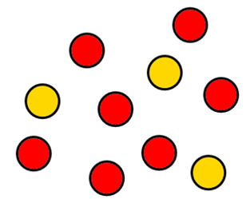

Ten frames:

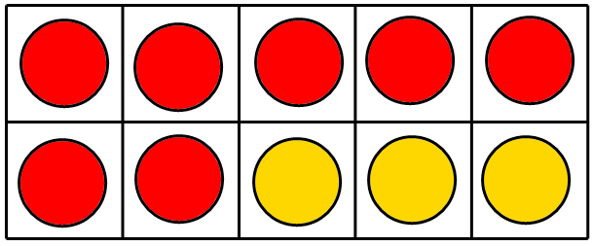

Beadstrings

**Mental Strategies**

***Count on or back in ones (chain count and linked to objects, i.e. 1-1 correspondence)***

Initially, children’s counting for addition and subtraction should be linked to the objects that they are using to represent the calculation, e.g. cubes, counters etc. It is important that at this stage the counting and calculating are supported by practical equipment and/or be in context so that they support children’s developing understanding of the concepts of addition and subtraction in a concrete rather than abstract way.

Children can begin to use chain counting (i.e. unsupported by objects) when they are confident with the concepts of addition and subtraction and have developed their understanding of using counting on or back, rather than counting all, as a strategy for these calculations.

*Examples of calculations:*

4 + 5 count on in ones from 4 (or in ones from 5)

8 – 3 count back in ones from 8

10 + 7 count on in ones from 10 (or use place value)

13 + 5 count on in ones from 13

17 – 3 count back in ones from 17

*Prerequisite skills:*

* Count using one to one correspondence
* Count forwards and backwards in ones

To develop an understanding of addition and subtraction, the progression through learning should be:

Concrete Model Abstract

An example of this might be:

Using counters Using a beadstring Placing cubes on a number track Using a number line (Concrete – random) (Concrete – organised) (Model) (Abstract)

**Addition**

3 + 2 = 5

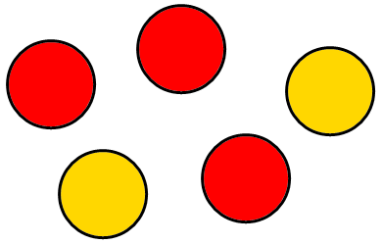 Counters

Beadstring

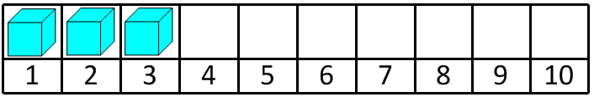 Number track stage 1

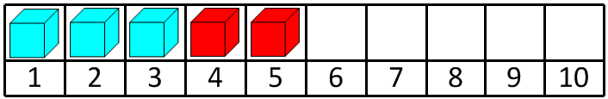 Number track stage 2

3 + 2 = 5

+1

+1

___________________________________________ Number line

0 1 2 3 4 5 6 7 8 9

**Subtraction**

5 – 2 = 3

Touch count and remove the number to be taken away, in this case 2.

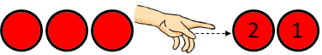 Counters stage 1

Touch count to find the number that remains.

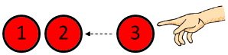 Counters stage 2

 Beadstring stage 1

 Beadstring stage 2

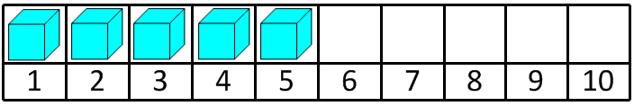 Number track stage 1

 Number track stage 2

5 – 2 = 3

-1

-1

__________________________________­_ Number line

0 1 2 3 4 5 6 7 8 9 10

**Addition**

8 + 5 = 13

Beadstring

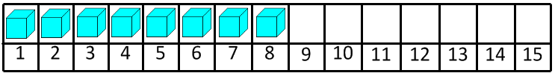 Number track stage 1

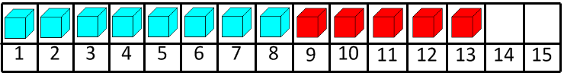 Number track stage 2

8 + 5 = 13

+1

+1

+1

+1

+1

Number line

0 1 2 3 4 5 6 7 8 9 10 11 12 13 14 15

**Subtraction**

13 – 5 = 8

Touch count and remove the number to be taken away, in this case 5.

 Beadstring stage 1

Touch count to find the number that remains.

 Beadstring stage 2

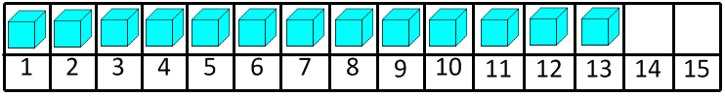 Number track stage 1

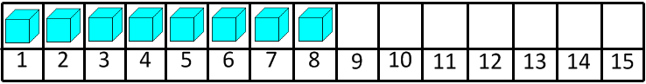 Number track stage 2

13 – 5 = 8

-1

-1

-1

-1

-1

Number line

0 1 2 3 4 5 6 7 8 9 10 11 12 13 14 15

***Reorder numbers in a calculation***

In Y1, children need to recognise that they can rearrange an addition, but not a subtraction. They also need to understand that the principle behind reordering a calculation is to make it more efficient, particularly when utilising a counting on strategy. Children need to be encouraged to identify calculations which should be reordered and those that are already in the most efficient format.

*Examples of calculations:*

8 + 3 doesn’t need reordering as the greater number is first already

2 + 7 reorder as 7 + 2

5 + 13 reorder as 13 + 5

11 + 6 doesn’t need reordering as the greater number is first already

*Prerequisite skills:*

* Understand the place value of numbers to identify which number is the greater
* Understand that reordering works (at this stage) for addition but not subtraction* *(because children are not at the level when they are solving calculations such as 16 – 3 – 6, when reordering would be appropriate).*

***Partition small numbers, e.g. 8 + 3 = 8 + 2 + 1***

Utilising partitioning in this way is useful as a strategy for bridging across 10 or multiples of 10 to make calculations more efficient.

*Examples of calculations:*

7 + 5 partitioned as 7 + 3 + 2

9 + 7 partitioned as 9 + 1 + 6

6 + 8 partitioned as 6 + 4 + 4

*Prerequisite skills:*

* Partition numbers in different ways, e.g. 5 as 2 + 3 to enable 8 + 5 as 8 + 2 + 3
* Know, or quickly derive, number bonds for numbers up to and including 10

This method can be supported by the use of practical equipment, e.g.

**Addition**

8 + 3 = 11

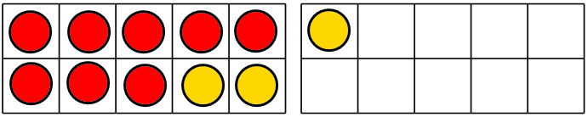 Ten frame

8 + 3 = 11

3 partitions into 2 and 1

Beadstring

8 + 3 = 11

+1

+2

0 1 2 3 4 5 6 7 8 9 10 11 12 13 14 15

Number line

**Subtraction**

11 – 3 = 8

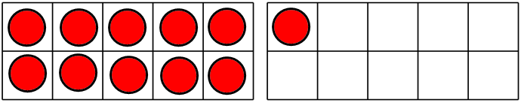Ten frame stage 1

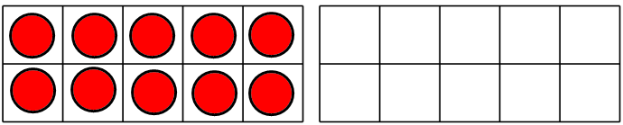Ten frame stage 2 (take away 1)

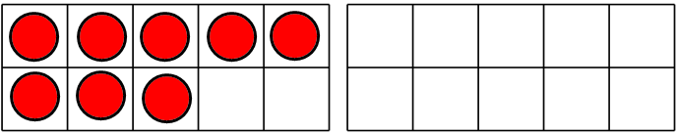Ten frame stage 3 (take away 2)

11 – 3 = 8

Beadstring stage 1

Beadstring stage 2 (take away 1)

Beadstring stage 3 (take away 2)

11 – 3 = 8

-1

-2

0 1 2 3 4 5 6 7 8 9 10 11 12 13 14 15

**Y2**

**End of Year Objective:**

***Add and subtract numbers mentally, including: a two-digit number and ones; a two-digit number and tens; two two-digit numbers; three one-digit numbers.***

**Rapid Recall**

Children should be able to:

* recall and use addition and subtraction facts to 20 fluently
* derive and use related facts up to 100

Beadstrings are useful for deriving and using related facts up to 100.

60 + 40 = 100

**Mental Strategies**

***Partition and combine multiples of tens and ones***

Partitioning numbers is a core strategy for adding and subtracting pairs of numbers. Children can either partition both of the numbers in the calculation, or keep the first number the same and just partition the second. They should be encouraged to use mental methods when adding or subtracting:

* multiples of 10
* TU + or – U (not crossing tens boundaries)
* TU + or – TU (not crossing tens boundaries)

*Examples of calculations*

40 + 37 40 add 30 and 7 = 40 add 30 add 7

15 + 14 10 and 5 add 10 and 4 = 10 add 10 add 5 add 4 or 15 add 10 add 4

37 + 12 37 add 10 and 2 = 37 add 10 add 2

78 – 42 78 take away 40 and 2 = 78 take away 40 take away 2

80 – 35 80 take away 30 and 5 = 80 take away 30 take away 5

*Prerequisite skills:*

* Count using one to one correspondence
* Count forwards and backwards in ones and tens from any one- or two-digit number
* Understand place value, understand which digit represents tens and which digit represents ones and identify what changes if one is added or subtracted, and what changes if ten is added or subtracted.
* Partition numbers into tens and ones

**Addition**

34 + 3 = 37 (shown using Base 10 equipment)

10

1010

1

111111

34 + 3 = 37 (shown using a beadstring)

+1

+1

+1

34

37

34 + 3 = 37 (shown using a number line)

+1

+1

+1

34 35 36 37

34 + 20 = 54 (shown using Base 10 equipment)

Children could use Base 10 equipment to calculate this as:

30 + 20 = 50

50 + 4 = 54

10

10101010

11

11

34 + 20 = 54 (shown using a beadstring)

Children could use a beadstring to calculate this as:

34 + 10 = 44

44 + 10 = 54

+10

+10

34

54

34 + 20 = 54 (shown using a number line)

+10

+10

34 44 54

34 + 23 = 57 (shown using Base 10 equipment to partition both numbers)

Children could use Base 10 equipment to calculate this as:

30 + 20 = 50

4 + 3 = 7

50 + 7 = 57

1010101010

111

111

1

34 + 23 = 57 (shown using a beadstring to keep the first number the same and just partition the second)

Children could use a beadstring to calculate this as:

34 + 10 = 44

44 + 10 = 54

54 + 3 = 57

+1

+1

+1

+10

+10

34

57

34 + 23 = 57 (shown using a number line to keep the first number the same and just partition the second)

+10

+10

+1

+1

+1

34 44 54 55 56 57

Encourage children to become more efficient by adding the units in one jump (by using the known fact 4 + 3 = 7).

34 + 23 = 57

+10

+10

+3

34 44 54 57

Followed by adding the tens in one jump and the units in one jump.

34 + 23 = 57

+20

+3

34 54 57

**Subtraction**

47 – 3 = 44 (shown using Base 10 equipment)

10

110101011101010

110

1

11

11 which leaves so 47 – 3 = 44

1

1

47 – 3 = 44 (shown using a beadstring)

-1

-1

-1

44

47 – 3 = 44 (shown using a number line)

-1

-1

-1

44 45 46 47

47 – 20 = 27 (shown using Base 10 equipment)

1010101010111111

10

11111

11

1 which leaves so 47 – 20 = 27

47 – 20 = 27 (shown using a beadstring)

Children could use a beadstring to calculate this as:

47 – 10 = 37

37 – 10 = 27

-10

-10

27

47 – 20 = 27 (shown using a number line)

-10

-10

27 37 47

47 – 23 = 24 (shown using Base 10 equipment)

1010101010

110

11 which leaves so 47 – 23 = 24

111111

11

47 – 23 = 24 (shown using a beadstring)

Children could use a beadstring to calculate this as:

47 – 10 = 37

37 – 10 = 27

27 – 3 = 24

-1

-1

-1

-10

-10

24

47 – 23 = 24 (shown using a number line)

- 10

- 10

-1

-1

-1

24 25 26 27 37 47

Encourage children to become more efficient by subtracting the units in one jump (by using the known fact 7 – 3 = 4).

- 10

- 10

47 – 23 = 24

-3

24 27 37 47

Followed by subtracting the tens in one jump and the units in one jump.

- 20

47 – 23 = 24

-3

24 27 47

***Reorder numbers in a calculation***

In Y2, children need to recognise that they can rearrange an addition, but not a subtraction. They also need to understand that the principle behind reordering a calculation is to make it more efficient, particularly when utilising a counting on strategy. Children need to be encouraged to identify calculations which should be reordered and those that are already in the most efficient format. When adding three single digit numbers, reordering should be based on number bonds or doubles with which the child is familiar.

*Examples of calculations:*

5 + 34 34 + 5

42 +11 doesn’t need reordering as the greater number is first already

5 + 7 + 5 5 + 5 + 7 (utilising knowledge of number bonds or doubles)

*Prerequisite skills:*

* Understand the place value of numbers to identify which number is the greater
* Understand that reordering works for addition but not subtraction* *(because children are not at the level when they are solving calculations such as 16 – 3 – 6, when reordering would be appropriate).*

***Find a small difference by counting up from the lesser to the greater number***

Children should, using their knowledge of place value, be able to identify when numbers are close together. When that is the case, it is more efficient, when subtracting, to count on to find the difference, rather than taking away. For example, in the calculation 52 – 47, to solve this by:

52 – 47 = 5

-10

-10

-10

-10

-1

-1

-1

-1

-1

-1

-1

5 6 7 8 9 10 11 12 22 32 42 52

is far less efficient than:

47 48 49 50 51 52 (counting up from 47 – 52)

For children to use this method with understanding, it is important that they understand how counting on links to subtraction.

Initially, they should look at simple numbers to develop an understanding of the concept of difference and counting on. For example, with 7 – 4, they can make two towers, one of 7 cubes and one of 4 cubes (Step 1). The calculation can be phrased as ‘How many more do we need to make the towers the same size?’ To answer this question, the children can add cubes of a different colour onto the smaller tower until they are the same height.

Step 1 Step 2

3 more cubes are needed to make them the same size, so the difference between 7 and 4 is 3. This could be compared to taking away 4 from 7 so that children can see that it is the same answer.

The next stage from this would be to encourage children to use the cubes to make lines rather than towers.

Once children can find the difference using this method using numbers up to 20, they can continue to use this strategy to solve calculations with two-digit numbers, using base 10 materials rather than cubes. For example, with the calculation 61 – 52, children can use base 10 to set out two lines, one for each number (the base 10 in the illustration are two colours to enable tens to be identified, this does not need to be the case with the materials children are using).



To find how many more are needed, or the difference, children would use a second colour of base ten ones to make the lines the same:



how many more / the difference

To make this a more sustainable method, it can be modelled alongside a number line jotting, e.g.

52 53 54 55 56 57 58 59 60 61





*Examples of calculations*

52 – 47

74 – 66

81 – 79

32 – 25

*Prerequisite skills:*

* Understand the place value of numbers to identify which number is the greater or lesser
* Place numbers on a partially marked and then unmarked number line
* Establish whether numbers are close together
* Count forwards and backwards in ones and tens form any one- or two-digit number

***Begin to bridge through 10 when adding a single digit number (partitioning, e.g. 58 + 5 =  
58 + 2 + 3)***

Use of the bridging strategy relies heavily on children’s efficient and accurate recall of number bonds to 10 or how far away a number is from a multiple of 10 (*see use of 10 frames in Year 1*). When calculating, e.g. 48 + 5, consider using bead strings or different coloured blocks of 10 cubes to illustrate it as 48 + 2 + 3 using the natural colour demarcations in the bead string to support this identification. This can also be shown using 10 frames (*see Year 1 ‘Partition small numbers’ section for more information*).

48 + 5 = 53

+3

+2

53

50

48

48 + 5 = 53

+3

+2

48 50 53

43 – 7 = 36

-3

-4

43

40

36

43 – 7 = 36

-4

-3

36 40 43

*Examples of calculations*

25 + 6 as 25 + 5 + 1  
12 – 7 as 12 - 2 - 5  
66 + 7 as 66 + 4 + 3  
43 – 7 as 43 - 3 - 4

*Prerequisite skills:*

* Partition numbers in different ways, e.g. 5 as 2 + 3 to enable 58 + 5 as 58 + 2 + 3
* Know, or quickly derive, number bonds to 10

***Add or subtract 9 and 19 by rounding and compensating***

Children need to understand both the number system and number bonds in order to understand how to use a compensation method.

For adding 9, children should be shown how to add nine by using base 10 materials and then add ten to the same number to identify what would need to be adjusted to make the calculation correct,  
e.g. 23 + 9

 23 + 9

 23 + 10 is one too many, so I have to subtract one

*NB Teaching children to add nine on a hundred square without developing their understanding will not support their ability to understand and use this method effectively.*

*Examples of calculations*34 + 9 as 34 + 10 - 1  
77 + 19 as 77 + 20 - 1, or 77 + 10 + 10 - 1  
46 - 9 as 46 - 10 + 1  
63 - 19 as 63 - 20 + 1, or 63 - 10 - 10 + 1  
  
*Prerequisite skills:*

* Understand the relationship between 9 and 10 (i.e. a difference of 1)
* Be able to show visually using base 10 equipment

Empty number lines could be used to model the calculation.

**Addition**

We’ve added twenty which is one too many, so we need to take one away.

+20

57 + 19 = 76

-1

57 76 77

**Subtraction**

We’ve subtracted ten which is one too many, so we need to add one back.

-10

46 - 9 = 37

+1

36 37 46

**Y3**

**End of Year Objective:  
*Add and subtract numbers mentally, including: a three-digit number and ones; a three-digit number and tens; a three-digit number and hundreds.***

**Rapid Recall**

Children should be able to:

* recall and use addition and subtraction facts for 100 (multiples of 5 and 10)
* derive and use addition and subtraction facts for 100
* derive and use addition and subtraction facts for multiples of 100 that total 1000

**Mental Strategies**

***Partition and combine multiples of hundreds, tens and ones***

Partitioning numbers is a core strategy for adding and subtracting pairs of numbers. Children can either partition both of the numbers in the calculation, or keep the first number the same and just partition the second. *(See Y2 for more information).*

*Examples of calculations:*

526 + 200 counting on in hundreds

137 + 40 counting on in tens

272 + 8 counting on in ones

428 - 200 counting back in hundreds

323 - 70 counting back in tens

693 - 8 counting back in ones

37 + 15 37 add 10 and 5 = 37 add 10 add 5 (crossing tens boundaries)

42 – 25 42 take away 20 and 5 = 42 take away 20 take away 5 (crossing tens boundaries)

*Prerequisite skills:*

* Count forwards and backwards in ones, tens and hundreds from any one-, two- or three-digit number
* Understand place value and understand which digit changes if one, ten or hundred is added or subtracted
* Partition numbers into hundreds, tens and ones

**Addition**

37 + 15 = 52 (shown using a beadstring)

+5

+10

52

37

37 + 15 = 52 (shown using a number line)

+10

+5

37 47 52

37 + 15 = (shown using number sentences)

37 + 10 = 47

47 + 5 = 52

**Subtraction**

42 - 25 = 17 (shown using a beadstring)

-5

-10

-10

17

42 – 25 = 17 (shown using a number line)

- 20

-5

17 22 42

42 – 25 = 17 (shown using number sentences)

42 – 20 = 22

22 – 5 = 17

***Reorder numbers in a calculation***

In Y3, children need to build on their knowledge gained in Y2 and continue to reorder calculations to make them more efficient. *(See Y2 for more information).*

*Examples of calculations:*

23 + 54 54 + 23

12 + 19 + 12 12 + 12 + 19 (using knowledge of doubles)

6 + 8 + 4 6 + 4 + 8 (using knowledge of number bonds to 10)

70 + 50 + 30 70 + 30 + 50 (using knowledge of number bonds to 100)

*Prerequisite skills:*

* Understand the place value of numbers to identify which number is the greater
* Understand that reordering works for addition but not subtraction* *(because children are not at the level when they are solving calculations such as 16 – 3 – 6, when reordering would be appropriate).*

***Identify and use knowledge of number bonds within a calculation***

Number bonds to 10 and 100 can be used to make calculations more efficient when combined with other strategies such as reordering and partitioning.

*Examples of calculations:*

42 + 38 42 + 30 + 8 (recognising that 2 and 8 is a number bond to 10, so the answer will be a multiple of 10)

60 – 28 60 – 20 – 8 (utilising knowledge that 10 – 8 = 2, so 40 – 8 = 32)

120 – 50 120 – 20 – 30 (utilising knowledge of number bonds to 100, leaving an answer of 70)

*Prerequisite skills:*

* Know, or quickly derive, number bonds to 10 and 100
* Identify number bonds within other numbers, e.g. identifying 7 + 3 within the calculation 57 + 33
* Identify that when adding two two-digit numbers, that 57 + 43 = 100 but 57 + 53 does not and why

***Find differences by counting up through the next multiple of 10 or 100***

In Y3, children need to build on their knowledge and understanding gained in Y2 to find larger differences that cross 10 and 100 boundaries. Some of these calculations are preparing children for time and money calculations throughout KS2.

*Examples of calculations:*

60 – 43 useful for time calculations, e.g. a journey time from 2:43 until 3:00

53 – 38 efficient because the numbers are close to each other

104 – 95 efficient because the numbers are close to each other

200 – 86 useful for money calculations, e.g. change from £2 when spending 86p

*Prerequisite skills:*

* Understand the place value of numbers to identify which number is the greater or lesser
* Establish whether numbers are close together or near to multiples of 10 or 100
* Place numbers appropriately on an unmarked number line
* Count forwards and backwards in ones and tens

Children could use empty number lines to record the calculation.

53 – 38 = 15

+10

+3

+2

38 40 50 53

200 – 86 = 114

+100

+10

+4

86 90 100 200

***Bridge through 10 when adding or subtracting a single digit number (partitioning, e.g. 58 + 5 = 58 + 2 + 3 or 76 – 8 = 76 – 6 - 2)***

In Y3, children need to consolidate their knowledge and understanding gained in Y2. *(See Y2 for more information).*

*Examples of calculations*

35 + 7 as 35 + 5 + 2

97 + 6 as 97 + 3 + 3

178 + 5 as 178 + 2 + 3  
42 – 7 as 42 – 2 – 5   
204 – 6 as 204 – 4 – 2

371 – 5 as 371 – 1 – 4

*Prerequisite skills:*

* Partition numbers in different ways, e.g. 5 as 2 + 3 to enable 58 + 5 as 58 + 2 + 3
* Know, or quickly derive, number bonds to 10

Children could use empty number lines to record the calculation.

198 + 6 = 204

+4

+2

198 200 204

153 – 7 = 146

-3

-4

146 150 153

The bridging strategy can then be linked with the partitioning strategy for efficient addition and subtraction of two two-digit numbers.

***Add or subtract 9, 19, 29 etc by rounding and compensating***

In Y3, children need to build on their knowledge and understanding gained in Y2 *(See Y2 for more information)* to add and subtract one less than a multiple of 10 up to 89 to two and three-digit numbers.

*Examples of calculations*34 + 29 as 34 + 30 - 1  
127 + 49 as 127 + 50 - 1  
96 - 39 as 96 - 40 + 1  
273 - 59 as 273 - 60 + 1

*Prerequisite skills:*

* Identify the difference between the number being added and subtracted and the multiple of 10
* Understand that the adjustment needs to be the opposite of the operation carried out

127 + 49 = 176 (shown using a number line)

We’ve added fifty which is one too many, so we need to take one away.

+50

-1

127 176 177

127 + 49 = 176 (shown using number sentences)

127 + 50 = 177

177 – 1 = 176

273 - 59 = 214 (shown using a number line)

We’ve subtracted sixty which is one too many, so we need to add one back.

-60

+1

213 214 273

273 - 59 = 214 (shown using number sentences)

273 – 60 = 213

213 + 1 = 214

**Y4**

**End of Year Objective:**

***Add and subtract numbers mentally, including: a three-digit number to or from a three-digit multiple of tens; two three-digit numbers (where there is no carrying or exchange involved)***

**Rapid Recall:**

Children should be able to:

* recall and use addition and subtraction facts for 100
* recall and use addition and subtraction facts for multiples of 100 that total 1000
* derive and use addition and subtraction facts for 1 and 10 (with decimal numbers to one decimal place)

**Mental Strategies**

***Partition and combine multiples of hundreds, tens and ones***

Partitioning numbers is a core strategy for adding and subtracting pairs of numbers. Children can either partition both of the numbers in the calculation, or keep the first number the same and just partition the second. *(See Y2 and Y3 for more information).*

*Examples of calculations:*

320+150 320 add 100 and 50 = 320 add 100 add 50

243+230 243 add 200 and 30 = 243 add 200 add 30

460-140 460 take away 100 and 40 = 460 take away 100 take away 40

562 -320 562 take away 300 and 20 = 562 take away 300 take away 20

234+125 234 add 100 and 20 and 5 = 234 add 100 add 20 add 5 (crossing no boundaries)

765-241 765 take away 200 and 40 and 1 = 765 take away 200 take away 40 take away 1 (crossing no boundaries)

85 + 47 85 add 40 and 7 = 84 add 40 add 7 (crossing hundreds and tens boundaries)

122 – 35 122 take away 30 and 5 = 122 take away 30 take away 5 (crossing hundreds and tens boundaries)

*Prerequisite skills:*

* Count forwards and backwards in ones, tens and hundreds from any one-, two- or three-digit number
* Understand place value and understand which digit changes if one, ten or hundred is added or subtracted
* Partition numbers into hundreds, tens and ones

85 + 47 = 132 (shown using a number line)

+40

+7

85 125 132

85 + 47 = 132 (shown using number sentences)

85 + 40 = 125

125 + 7 =132

122 – 35 = 87 (shown using a number line)

-30

-5

87 92 122

122 – 35 = 87 (shown using number sentences)

122 – 30 = 92

92 – 5 = 87

***Reorder numbers in a calculation***

In Y4, children need to build on their knowledge gained in Y3 and continue to reorder calculations to make them more efficient. They should now be solving calculations involving subtraction such as 16 – 3 – 6, when reordering would be appropriate.

*Examples of calculations:*

7 + 12 + 3 + 5 7 + 3 + 12 + 5

18 + 6 – 8 18 – 8 + 6

27 + 75 75 + 27 (thinking of 27 as 25 + 2)

*Prerequisite skills:*

* Understand the place value of numbers to identify which number is the greater
* Understand that reordering works for addition but not subtraction

***Identify and use knowledge of number bonds within a calculation and identify related facts, e.g. 150 + 270 from 15 + 27***

Children should use their knowledge of the number system to help them use related facts to calculate, e.g. 15 is ten times bigger than 150, 270 is ten times bigger than 27, so the answer to 150 + 270 will be ten times bigger than 15 + 27.

*Examples of calculations:*

120 + 80 using knowledge of 12 + 8 = 20

250 + 130 using knowledge of 25 + 13 = 38

200 – 70 using knowledge of 20 – 7 = 13

460 – 150 using knowledge of 46 – 15 = 31

*Prerequisite skills:*

* Know, or quickly derive, number bonds to 10, 100 or 1000
* Identify number bonds within other numbers, e.g. identifying 7 + 3 within the calculation 257 + 343
* Identify that when adding two two-digit numbers, that 57 + 43 = 100 but 57 + 53 does not and why

***Find differences by counting up through the next multiple of 10 or 100***

In Y4, children need to build on their knowledge and understanding gained in Y3 to find larger differences that cross 10 and 100 boundaries. When deciding whether to use a mental or a written method for a calculation, **children should be encouraged to select the method which is most efficient**. e.g. 203 – 96 =. It is more efficient to count up from 96 to 203 in three steps (+4, +100, +3) than to use the formal written method of:

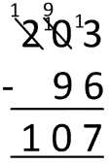

which requires a lot of exchanging.

*Examples of calculations:*

80 – 43

92 – 35

203 – 96

504 – 180

*Prerequisite skills:*

* Understand the place value of numbers to identify which number is the greater or lesser
* Establish whether numbers are close together or near to multiples of 10 or 100
* Place numbers appropriately on an unmarked number line
* Count forwards and backwards in ones and tens

Children could use empty number lines to record the calculation.

92 – 35 = 57

+50

+2

+5

35 40 90 92

504 – 180 = 324

+300

+4

+20

180 200 500 504

***Bridge through 10 when adding or subtracting a single digit number (partitioning, e.g. 58 + 5 = 58 + 2 + 3 or 76 – 8 = 76 – 6 - 2)***

In Y4, children need to build on their knowledge and understanding gained in Y3. *(See Y3 for more information).*

*Examples of calculations:*

48 + 35 as 48 + 2 + 33

97 + 64 as 97 + 3 + 61

103 – 25 as 103 – 3 – 22 (using number bonds to 100)

230 – 72 as 230 – 30 – 40 – 2

*Prerequisite skills:*

* Partition numbers in different ways, e.g. 5 as 2 + 3 to enable 58 + 5 as 58 + 2 + 3
* Know, or quickly derive, number bonds to 10

Children could use empty number lines to record the calculation.

97 + 64 = 161

+61

+3

97 100 161

230 – 72 = 158

-30

-40

-2

158 160 200 230

***Add or subtract a multiple of 10 and adjust (for those numbers close to multiples of 10)***

In Y4, children need to build on their knowledge and understanding gained in Y3 *(See Y3 for more information)* to add and subtract numbers close to a multiple of 10 up to 89 to two and three-digit numbers.

*Examples of calculations:*84 + 28 as 84 + 30 - 2  
167 + 48 as 167 + 50 - 2  
96 - 38 as 96 - 40 + 2  
213 - 58 as 213 - 60 + 2

*Prerequisite skills:*

* Identify the difference between the number being added and subtracted and the multiple of 10
* Understand that the adjustment needs to be the opposite of the operation carried out

We’ve added fifty which is two too many, so we need to take two away.

167 + 48 = 215 (shown using a number line)

+50

-2

167 215 217

167 + 48 = 215 (shown using number sentences)

167 + 50 = 217

217 – 2 = 215

213 - 58 = 155 (shown using a number line)

We’ve subtracted sixty which is two too many, so we need to add two back.

-60

+2

153 155 213

213 – 58 = 155 (shown using number sentences)

213 – 60 = 153

153 + 2 = 155

**Y5**

**End of Year Objective:**

***Add and subtract numbers mentally, including: two three-digit numbers where one or both are multiples of 10 or 100; two or three-digit numbers to or from a four digit number; two four-digit numbers (where there is no carrying or exchange involved); pairs of decimals to one decimal place***

**Rapid Recall:**

Children should be able to:

* Recall and use addition and subtraction facts for 1 and 10 (with decimal numbers to one decimal place)
* Derive and use addition and subtraction facts for 1 (with decimal numbers to two decimal places)

**Mental Strategies**

***Partition and combine multiples of thousands hundreds, tens and ones***

Partitioning numbers is a core strategy for adding and subtracting pairs of numbers. Children can either partition both of the numbers in the calculation, or keep the first number the same and just partition the second. *(See Y2, Y3 and Y4 for more information).*

*Examples of calculations:*

4300 + 1400 4300 add 1000 and 400 = 4300 add 1000 add 400

364 + 250 364 add 200 and 50 = 364 add 200 add 50

3600 - 1200 3600 take away 1000 and 200 = 3600 take away 1000 take away 200

432 - 240 432 take away 200 and 40 = 432 take away 200 take away 40

5124 + 1352 5124 add 1000 and 300 and 50 and 2 = 5124 add 1000 add 300 add 50 add 2 (crossing no boundaries)

7584 - 2351 7584 take away 2000 and 300 and 50 and 1 = 7584 take away 2000 take away 300 take away 50 take away1 (crossing no boundaries)

*Prerequisite skills:*

* Count forwards and backwards in ones, tens, hundreds and thousands
* Understand place value and understand which digit changes if one, ten or hundred is added or subtracted
* Partition numbers into hundreds, tens and ones

364 + 250 = 614 (shown using a number line)

+200

+50

364 564 614

364 + 250 = 614 (shown using number sentences)

364 + 200 = 564

564 + 50 = 614

432 – 240 = 192 (shown using a number line)

-200

-40

192 232 432

432 – 240 = 192 (shown using number sentences)

432 – 200 = 232

232 – 40 = 192

***Partition and combine multiples of ones and tenths***

Partitioning numbers is a core strategy for adding and subtracting pairs of numbers. Children can either partition both of the numbers in the calculation, or keep the first number the same and just partition the second. The calculations do not cross ones boundaries.

*Examples of calculations:*

5.4 + 3.2 5.4 add 3 and 0.2 = 5.4 add 3 add 0.2

4.7 – 2.5 4.7 take away 2 and 0.5 = 4.7 take away 2 take away 0.5

*Prerequisite skills:*

* Count forwards and backwards in tenths and ones
* Understand place value of decimal numbers

5.4 + 3.2 = 8.6 (shown using a number line)

+3

+0.2

5.4 8.4 8.6

5.4 + 3.2 = 8.6 (shown using number sentences)

5.4 + 3 = 8.4

8.4 + 0.2 = 8.6

4.7 – 2.5 = 2.2 (shown using a number line)

-2

-0.5

2.2 2.7 4.7

4.7 – 2.5 = 2.2 (shown using number sentences)

4.7 – 2 = 2.7

2.7 – 0.5 = 2.2

***Identify and use knowledge of number bonds within a calculation and identify related facts, e.g. 1.5 + 2.7 from 15 + 27***

Children should use their knowledge of the number system to help them use related facts to calculate, e.g. 1.5 is ten times smaller than 15, 2.7 is ten times smaller than 27, so the answer to 1.5 + 2.7 will be ten times smaller than 15 + 27.

*Examples of calculations:*

1.2 + 0.8 using knowledge of 12 + 8 = 20

2.5 + 1.3 using knowledge of 25 + 13 = 38

3.8 + 4.5 using knowledge of 38 + 45 = 83

2 – 0.7 using knowledge of 20 – 7 = 13

4.6 – 1.5 using knowledge of 46 – 15 = 31

8.3 – 5.4 using knowledge of 83 – 54 = 29

*Prerequisite skills:*

* Know, or quickly derive, number bonds to 1, 10, 100 1000
* Identify number bonds within other numbers, e.g. identifying
* 7 + 3 within the calculations 257 + 343 or 1.7 + 2.3

***Find differences by counting up through the next multiple of 1, 10, 100 or 1000***

In Y5, children need to build on their knowledge and understanding gained in Y4 to find differences that cross 1, 10, 100 and 1000 boundaries. When deciding whether to use a mental or a written method for a calculation, **children should be encouraged to select the method which is most efficient**.

e.g. 5003 – 1960 =. It is more efficient to count up from 1960 to 5003 in three steps (+40, +3000, +3) than to use the formal written method of:

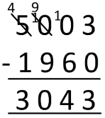

which requires a lot of exchanging.

*Examples of calculations:*

604 – 289

523 – 160

1200 – 785

5003 – 1960

7.3 – 2.8

20.1 – 6.7

*Prerequisite skills:*

* Understand the place value of numbers to identify which number is the greater or lesser
* Establish whether numbers are close together or near to multiples of 10 or 100
* Place numbers appropriately on an unmarked number line
* Count forwards and backwards in ones and tens

Children could use empty number lines to record the calculation.

5003 – 1960 = 3043

+3000

+40

+3

1960 2000 5000 5003

7.3 – 2.8 = 4.5

+4

+0.3

+0.2

2.8 3 7 7.3

20.1 – 6.7 = 13.4

+13

+0.3

+0.1

6.7 7 20 20.1

***Bridge through 10 when adding or subtracting a single digit number (partitioning, e.g. 58 + 5 = 58 + 2 + 3 or 76 – 8 = 76 – 6 - 2)***

In Y5, children need to build on their knowledge and understanding gained in Y4. *(See Y4 for more information).*

*Examples of calculations:*

594 + 170 as 594 + 6 + 164

1995 + 278 as 1995 + 5 + 273

703 – 128 as 703 – 3 – 125

3002 – 87 as 3002 – 2 – 85

*Prerequisite skills:*

* Partition numbers in different ways, e.g. 5 as 2 + 3 to enable 58 + 5 as 58 + 2 + 3
* Know, or quickly derive, number bonds to 10

Children could use empty number lines to record the calculation.

1995 + 278 = 2273

+273

+5

1995 2000 2273

3002 – 87 = 2915

-80

-5

-2

2915 2920 3000 3002

***Add or subtract a multiple of 10 and adjust (for those numbers close to multiples of 10)***

In Y5, children need to build on their knowledge and understanding gained in Y4 *(See Y4 for more information)* to add and subtract numbers close to a multiple of 10.

*Examples of calculations:*

257 + 68 as 257 + 70 – 2   
325 + 298 as 325 + 300 – 2

764 - 88 as 764 - 90 + 2

876 – 397 as 876 – 400 + 3

*Prerequisite skills:*

* Identify the difference between the number being added and subtracted and the multiple of 10
* Understand that the adjustment needs to be the opposite of the operation carried out

We’ve added three hundred which is two too many, so we need to take two away.

325 + 298 = 623 (shown using a number line)

+300

-2

325 623 625

325 + 298 = 623 (shown using number sentences)

325 + 300 = 625

625 – 2 = 623

876 - 397 = 479 (shown using a number line)

We’ve subtracted four hundred which is three too many, so we need to add three back.

-400

+3

476 479 876

876 – 397 = 479 (shown using number sentences)

876 – 400 = 476

476 + 3 = 479

**Y6**

**End of Year Objective:**

***Add and subtract numbers mentally, including: two three-digit numbers where one or both are multiples of 10 or 100; two or three-digit numbers to or from a four digit number; two four-digit numbers (where there is no carrying or exchange involved); pairs of decimals to one decimal place***

**Rapid Recall:**

Children should be able to:

* Recall and use addition and subtraction facts for 1 (with decimal numbers to two decimal places)

**Mental Strategies**

***Partition and combine multiples of thousands hundreds, tens and ones***

Partitioning numbers is a core strategy for adding and subtracting pairs of numbers. Children can either partition both of the numbers in the calculation, or keep the first number the same and just partition the second. *(See Y2, Y3, Y4 and Y5 for more information).*

*Examples of calculations:*

5800 + 2400 5800 add 2000 and 400 = 5800 add 2000 add 400

873 + 350 873 add 300 and 50 = 873 add 300 add 50

4100 - 1600 4100 take away 1000 and 600 = 4100 take away 1000 take away 600

2132 - 440 2132 take away 400 and 40 = 2132 take away 400 take away 40

5124 + 1352 5124 add 1000 and 300 and 50 and 2 = 5124 add 1000 add 300 add 50 add 2 (crossing no boundaries)

7584 - 2351 7584 take away 2000 and 300 and 50 and 1 = 7584 take away 2000 take away 300 take away 50 take away1 (crossing no boundaries)

*Prerequisite skills:*

* Count forwards and backwards in ones, tens, hundreds and thousands
* Understand place value and understand which digit changes if one, ten or hundred is added or subtracted
* Partition numbers into hundreds, tens and ones

873 + 350 = 1223 (shown using a number line)

+300

+50

873 1173 1223

873 + 350 = 1223 (shown using number sentences)

873 + 300 = 1173

1173 + 50 = 1223

2132 – 440 = 1692 (shown using a number line)

-400

-40

1692 1732 2132

2132 – 440 = 1692 (shown using number sentences)

2132 – 400 = 1732

1732 – 40 = 1692

***Partition and combine multiples of ones and tenths***

Partitioning numbers is a core strategy for adding and subtracting pairs of numbers. Children can either partition both of the numbers in the calculation, or keep the first number the same and just partition the second. The calculations include crossing ones boundaries. *(See Year 5 for more information)*

*Examples of calculations:*

8.4 + 3.8 8.4 add 3 and 0.8 = 8.4 add 3 add 0.8

13.2 – 4.5 13.2 take away 4 and 0.5 = 13.2 take away 4 take away 0.5

*Prerequisite skills:*

* Count forwards and backwards in tenths and ones
* Understand place value of decimal numbers

8.4 + 3.8 = 12.2 (shown using a number line)

+3

+0.8

8.4 11.4 12.2

8.4 + 3.8 = 12.2 (shown using number sentences)

8.4 + 3 = 11.4

11.4 + 0.8 = 12.2

13.2 – 4.5 = 8.7 (shown using a number line)

-4

-0.5

8.7 9.2 13.2

13.2 – 4.5 = 8.7 (shown using number sentences)

13.2 – 4 = 9.2

9.2 – 0.5 = 8.7

***Identify and use knowledge of number bonds within a calculation and identify related facts, e.g. 680 + 430, 6.8 + 4.3, 0.68 + 0.43 can all be worked out using the related calculation 68 + 43***

In Y6, children need to build on their knowledge and understanding gained in Y5 *(See Y5 for more information)* Children should use their knowledge of the number system to help them use related facts to calculate, e.g. 0.68 is one hundred times smaller than 68, 0.43 is a hundred times smaller than 43, so the answer to 0.68 + 0.43 will be a hundred times smaller than 68 + 43.

*Examples of calculations:*

0.62 + 0.38 using knowledge of 62 + 38 = 100

0.75 + 0.56 using knowledge of 75 + 56 = 131

2.8 + 0.43 using knowledge of 280 + 43 = 323

1 – 0.41 using knowledge of 100 – 41 = 59

0.92 – 0.35 using knowledge of 92 – 35 = 57

8.3 – 0.52 using knowledge of 830 – 52 = 778

*Prerequisite skills:*

* Know, or quickly derive, number bonds to 1, 10, 100 1000
* Identify number bonds within other numbers, e.g. identifying
* 7 + 3 within the calculations 257 + 343 or 1.7 + 2.3

***Find differences by counting up through the next multiple of 0.1, 1, 10, 100 or 1000***

In Y6, children need to build on their knowledge and understanding gained in Y5 to find differences that cross 0.1, 10, 100 and 1000 boundaries. When deciding whether to use a mental or a written method for a calculation, children should be encouraged to select the method which is most efficient.

*Examples of calculations:*

8.2 – 3.46

14.23 – 7.58

*Prerequisite skills:*

* Understand the place value of numbers to identify which number is the greater or lesser
* Establish whether numbers are close together or near to multiples of 10 or 100
* Place numbers appropriately on an unmarked number line
* Count forwards and backwards in ones and tens

Children could use empty number lines to record the calculation.

8.2 – 3.46 = 4.74

+4

+0.5

+0.2

+0.04

3.46 3.5 4 8 8.2

14.23 – 7.58 = 6.65

+6

+0.2

+0.4

+0.03

+0.02

7.58 7.6 8 14 14.2 14.23

***Bridge through 10 when adding or subtracting a single digit number (partitioning, e.g. 58 + 5 = 58 + 2 + 3 or 76 – 8 = 76 – 6 - 2)***

In Y6, children bridge using decimals to one place. To do this, it is essential that children can partition decimal numbers in different ways, e.g. 2.5 into 2 and 0.5, 2.5 into 1 and 1.5, 2.5 into 2.1 and 0.4, etc.

*Examples of calculations:*

1.5 + 1.7 as 1.5 + 0.5 + 1.2

0.7 + 0.56 as 0.7 + 0.3 + 0.26

8.3 – 2.7 as 8.3 – 2.3 – 0.4

*Prerequisite skills:*

* Partition numbers in different ways, e.g. 5 as 2 + 3 to enable 58 + 5 as 58 + 2 + 3
* Know, or quickly derive, number bonds to 10

Children could use empty number lines to record the calculation.

1.5 + 1.7 = 3.2

+1.2

+0.5

1.5 2 3.2

8.3 – 2.7 = 5.6

-2.3

-0.4

5.6 6 8.3

***Add or subtract a multiple of 10 and adjust (for those numbers close to multiples of 10)***

In Y6, children adjust calculations using decimals to one place.

*Examples of calculations:*

5.6 + 3.9 - as 5.6 + 4 – 0.1  
7.5 – 4.8 - as 7.5 – 5 + 0.2

*Prerequisite skills:*

* Identify the difference between the number being added and subtracted and the multiple of 10
* Understand that the adjustment needs to be the opposite of the operation carried out

We’ve added four which is nought point one too many, so we need to take nought point one away.

5.6 + 3.9 = 9.5 (shown using a number line)

+4

-0.1

5.6 9.5 9.6

5.6 + 3.9 = 9.5 (shown using number sentences)

5.6 + 4 = 9.6

9.6 – 0.1 = 9.5

7.5 – 4.8 = 2.7 (shown using a number line)

We’ve subtracted five which is nought point two too many, so we need to add nought point two back.

-5

+0.2

2.5 2.7 7.5

7.5 – 4.8 = 2.7 (shown using number sentences)

7.5 – 5 = 2.5

2.5 + 0.2 = 2.7

**Progression Toward Mental Calculation Strategies  
(Multiplication and Division)**

The ability to calculate mentally is an essential skill, but, as with written methods of calculation, children need to be taught. **It is important to ensure that when teaching particular strategies, children have the appropriate prerequisite skills and are guided as to how and when that strategy is appropriate.**

Children should be taught and encouraged to ask themselves the following questions when faced with a calculation:

* Do I know the answer?
* Can I work it out in my head?
* Do I need to do a jotting?
* Do I need to use a written method?

When using a jotting, there is no requirement to follow a particular method of recording.

A feature of mental calculation is that a type of calculation can often be worked out in several different ways. Which method is best will depend on the numbers involved, the age of the children and the range of methods that they are confident with.

In developing a progression through mental calculation strategies for multiplication and division, it is important that children understand the relevant concepts, in that multiplication is:

* repeated addition
* scaling

and division is:

* repeated subtraction (grouping)
* related to finding a fraction of a number (sharing)

They also need to understand and work with certain principles, that:

* multiplication and division are inverses
* multiplication is commutative (because it is based on addition which is also commutative) i.e. 3 x 5 = 5 x 3 but division is not i.e. 15 ÷3 ≠ 3 ÷ 15
* multiplication is associative i.e. 2 x (3 x 5) = (2 x 3) x 5 but division is not i.e. 30 ÷ (5 ÷ 2) ≠ (30 ÷ 5) ÷ 2
* commutativity and associativity mean that calculations can be rearranged to make them easier to calculate, e.g. (3 x 4) x 5 = 60 is the same as (5 x 4) x 3 = 60

PLEASE NOTE: To be mathematically accurate, 3 x 4 means 4 threes, or 3 + 3 + 3 + 3. Read correctly it means 3 multiplied four times. The first number in the calculation is the value which is being operated on by the second:

3 x 4

However, due to the fact that younger children often refer to the x sign as lots of, or groups of, the calculation is then commonly represented as 4 + 4 + 4. As multiplication is commutative, this is perfectly acceptable. It is a good idea to encourage children to think of any product either way round as this reduces the facts they need to remember by half. **yr**

**Early Learning Goal:**

***Explore and represent patterns within numbers up to 10, including evens and odds, double facts and how quantities can be distributed equally.***

**Rapid Recall**

Children should be able to:

* Count in steps of one, forwards and backwards

In the EYFS, children are encouraged to develop a mental picture of the number system in their heads to use for calculation. They should experience practical calculation opportunities using a wide variety of practical equipment, including small world play, role play, counters, cubes etc.

**Solve problems involving doubling**

Children may investigate items such as Lego bricks, ice cube trays and baking tins, paint boxes etc, which can show doubles, e.g. one side of the Lego brick is four, so double four is eight.

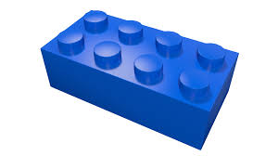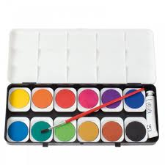

They may develop ways of recording calculations using pictures, etc.



A child’s jotting showing the fingers on each hand as a double.

A child’s jotting showing double three as three cookies on each plate.

**Solve problems involving halving and sharing**

Children may investigate sharing items or putting items into groups using items such as egg boxes, ice cube trays and baking tins which are arrays.

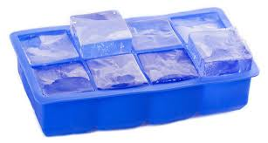

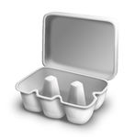

They may develop ways of recording calculations using pictures, etc.



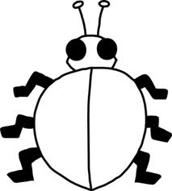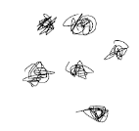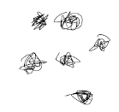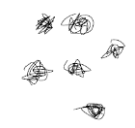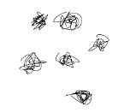

A child’s jotting showing how they shared the apples at snack time between two groups.

A child’s jotting showing halving six spots between two sides of a ladybird.

**Y1**

**End of Year Objective:**

***Solve one-step problems involving multiplication and division, by calculating the answer using concrete objects, pictorial representations and arrays with support.***

**Rapid Recall**

Children should be able to:

* Count in multiples of twos, fives and tens
* Recall and use doubles of all numbers to 10 and corresponding halves

**Solve one-step problems involving multiplication**

In Year One, children will continue to solve multiplication problems using practical equipment and jottings. They may use the equipment to make groups of objects. Children should see everyday versions of arrays, e.g. egg boxes, baking trays, ice cube trays, wrapping paper etc. and use this in their learning, answering questions such as 'How many eggs would we need to fill the egg box? How do you know?'

**Solve one-step problems involving division**

In Year One, children will continue to solve division problems using practical equipment and jottings. They should use the equipment to share objects **equally** and separate them into **equal** groups, answering questions such as 'If we share these six apples between the three of you, how many will you each have? How do you know?' or ‘If six football stickers are shared between two people, how many do they each get?’ They may solve both of these types of question by using a 'one for you, one for me' strategy until all of the objects have been given out.

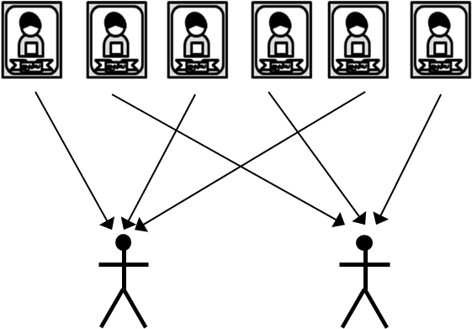

Children will also answer questions that involve grouping rather than sharing, such as ‘Pip puts two football stickers on each page of his sticker book. How many pages does he need?’ This type of problem requires the children to make equal groups from the whole amount.

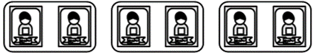**Y2**

**End of Year Objective:**

***Calculate mathematical statements for multiplication and division within the multiplication tables.***

**Rapid Recall**

Children should be able to:

* Count in steps of 2, 3 and 5 from 0
* Recall and use multiplication facts for the 2, 5 and 10 multiplication tables
* Derive and use doubles of simple two-digit numbers (numbers in which the ones total less than 10)
* Derive and use halves of simple two-digit even numbers (numbers in which the tens are even)
* Recognise odd and even numbers

**Mental Strategies**

Children should be able to represent a variety of multiplication and division calculations for facts not limited to two, five and ten times tables. The image and its link to the meaning of multiplication or divisionneeds to be securely understood. As children learn to recall more multiplication and division facts, they should make a choice about the calculations they need to represent to find the answer, and those they can recall.

**Calculate mathematical statements for multiplication**

***Repeated addition using practical equipment***

Children should initially show multiplication as repeated addition in a random arrangement, e.g. 5 x 3 can be shown as five groups of three with counters.

***Repeated addition using arrays***

Practical equipment can be used to represent 5 x 3 as an array in two forms (as it has commutativity).

5 + 5 + 5 = 15

3 + 3 + 3 + 3 + 3 = 15

***Repeated addition using jottings***

Children can develop their recordings of multiplication to using jottings.



***Repeated addition using a bead bar / bead string***

Children can use bead strings or bead bars to help them calculate mathematical statements for multiplication.

5 x 3 = 5 groups of 3

5 x 3 = 15

15

12

9

6

3

***Repeated addition using a number line***

Once children are familiar with the idea of repeated addition using a bead bar or bead string, they can begin to use a number line to show the counting steps.

5 x 3 = 5 groups of 3

5 x 3 = 15

+3

+3

+3

+3

+3

0 3 6 9 12 15

*Examples of calculations*

5 x 4 using commutativity to identify a recalled fact

3 x 10 recalled fact

7 x 3 using a representation

2 x 9 using knowledge that multiplying by 2 is doubling

6 x 6 using a representation

*Prerequisite skills:*

* Count forwards and backwards in ones
* Identifying equal groups

***Doubling using partitioning and base 10 equipment***

When deriving and using doubles of simple two-digit numbers where the ones total is less than 10, children should be taught to represent the number, and then repeat so they have two groups that are **equal in value**, developing their understanding that doubling is the same as multiplying by 2

e.g. double 24.



They should then put the tens together and the ones together:



Finally recombining the tens and ones to find the double, e.g. double 24 is 48.

***Doubling using partitioning and jottings***

Children can then develop their use of jottings to represent the number, e.g. double 24, representing the number twice:

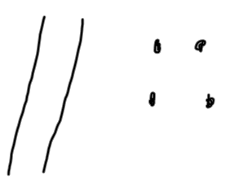 

Finally, they can count in tens, and then ones to recombine the number, e.g. 10, 20, 30, 40, 41, 42, 43, 44, 45, 46, 47, 48.

***Doubling using partitioning***

e.g. double 24

20

24

4

40

8

48

The diagram above illustrates the way children should be thinking about doubling using partitioning, but it is not necessary for them to record in this way if it is not helpful to the child.

*Examples of calculations*

Double 43

Double 31

*Prerequisite skills:*

* Count forwards and backwards in ones and tens
* Represent a number using base ten equipment
* Partition a two digit number into tens and ones
* Recombine a multiple of ten and a multiple of one

**Calculate mathematical statements for division**

***Repeated subtraction using practical equipment***

Children should initially show division as repeated subtraction in a random arrangement, e.g. 15 ÷ 3 can be shown as fifteen divided into groups of three with counters.

15 ÷ 3 = 5 **groups**

***Repeated subtraction using arrays***

Arrays can be used to help children to identify the groups of the divisor in a division calculation, e.g. the groups of 3 in the calculation 15 ÷ 3.

15 ÷ 3 = 5 **groups**

***Repeated subtraction using jottings***

Children can develop their recordings of division to using jottings, e.g. 15 ÷ 3,



***Repeated subtraction using bead bar / bead string***

Children can use bead strings or bead bars to help them calculate mathematical statements for division.

15 ÷ 3 = 5 **groups**

15

12

9

6

3

***Repeated subtraction using number line***

Once children are familiar with the idea of repeated subtraction using a bead bar or bead string, they can begin to use a number line to show the counting steps.

15 ÷ 3 = 5 **groups**

-3

-3

-3

-3

-3

0 3 6 9 12 15

*Examples of calculations*

20 ÷ 5 recalled fact

40 ÷ 10 recalled fact

18 ÷ 3 using a representation

12 ÷ 2 using knowledge that dividing by 2 is halving

*Prerequisite skills:*

* Count forwards and backwards in ones
* Identifying equal groups

***Halving using partitioning and base 10 equipment***When deriving and using halves of simple two-digit even numbers where the tens are even, children should first represent the number, e.g. Find half of 48



They should halve the tens and then halve the ones by sharing each of them into two equal groups, developing their understanding that halving is the same as dividing by 2. A diagram such as the one below might be useful:



Finally, they identify what half of the whole number is, e.g. Half of 48 is 24

***Halving using partitioning and jottings***

Children can then develop their use of jottings to represent the number, e.g. Find half of 48

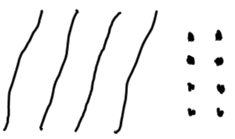

They then share each element of the number into two equal groups. A diagram such as the one below might be useful:

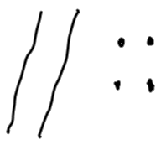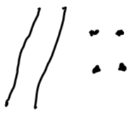

Finally, they identify what half of the whole number is, e.g. Half of 48 is 24.

***Halving using partitioning***

e.g. Find half of 48

40

48

8

20

4

24

The diagram above illustrates the way children should be thinking about halving using partitioning, but it is not necessary for them to record in this way if it is not helpful to the child.

*Examples of calculations*

Find half of 64

Find half of 28

*Prerequisite skills:*

* Count forwards and backwards in ones and tens
* Represent a number using base ten equipment
* Partition a two-digit number into tens and ones
* Recombine a multiple of ten and a multiple of ones

**Y3**

**End of Year Objective:**

***Write and calculate mathematical statements for multiplication and division using the multiplication tables that they know, including two-digit numbers times one-digit numbers.***

**Rapid Recall**

Children should be able to:

* Count in multiples of 4, 8, 50 and 100
* Recall and use multiplication and division facts for the 3, 4 and 8 multiplication tables
* Derive and use doubles of all numbers to 100 and corresponding halves
* Derive and use doubles of all multiples of 50 to 500

**Mental Strategies**

Children should be able to represent multiplication and division calculations, including two-digit numbers multiplied by one-digit numbers. As children learn to recall more multiplication and division facts, they should make a choice about the calculations they need to represent to find the answer, and those they can recall.

**Calculate mathematical statements for multiplication**

***Multiply a one- or two-digit number by 10 and a one-digit number by 100 using base 10 equipment***

Children should initially represent the calculation using base 10 equipment, e.g. 23 x 10

***1010***

***1***

***1***

***1***

All of the base 10 pieces need to be made ten times greater.

***101010***



The children should then compare the two numbers in place value columns.

H T U

2 3

2 3 0

They should notice that each digit has moved one place to the left, i.e. become ten times greater.

***Multiply a one- or two-digit number by 10 and a one-digit number by 100 using a place value chart***

Building on their knowledge from using the base 10 equipment, children can use transparent counters to help them develop their understanding of multiplying by 10 and 100,

e.g. 46 x 10

The children represent 46 on a place value chart using transparent counters.

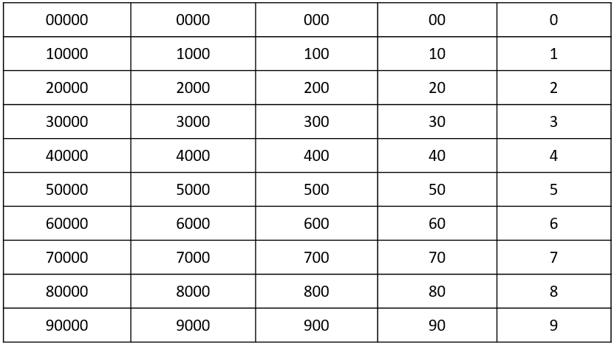

They then move each counter one place to the left to multiply the number by 10.



They then recombine this number to create 460.

*Examples of calculations*

3 x 10

7 x 100

62 x 10

*Prerequisite skills:*

* Represent numbers up to three digits using base 10 equipment
* Partition a two digit number into tens and ones
* Recombine multiples of hundreds and tens

***Within known tables, use related facts to multiply T0 by a one-digit number***

*NB T0 represents a two digit multiple of ten*

Children should be encouraged to identify the **relationships** between numbers in multiplication calculations, e.g. 7 x 8 = 56 could be represented using a multiplication trio as this model allows children to see the **relationships** between the numbers:

56

7

8

This can be used to derive the following calculations:

7 x 8 = 56

8 x 7 = 56

Children can then use the multiplication trio to derive related facts, e.g. 70 x 8 =

560

70

8

Children should be able to explain that because 70 is ten times greater than 7, the answer to 70 x 8 will be ten times greater than 56. They can then use their understanding of multiplying by 10 to calculate this.

*Examples of calculations*

60 x 3

50 x 4

30 x 8

*Prerequisite skills:*

* Recall 2, 3, 4, 5, 8 and 10 multiplication tables
* Understand the effect of multiplying a one- or two-digit number by 10

***Within known tables, use partitioning to multiply T1 by a one-digit number***

*NB T1 represents a two digit number with one as the units*

Squared paper can be used to develop children’s understanding of this calculation and how it is related to multiplying T0 by a one-digit number.

e.g. 31 x 4

Children make the calculation 30 x 4 using squared paper.

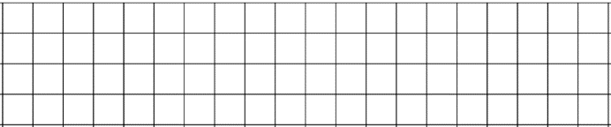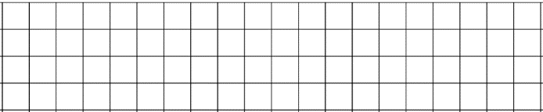

4

30

They should be able to calculate, by using related facts, that 30 x 4 = 120. The children should now consider how to change the representation of 30 x 4 into 31 x 4, i.e. by adding one extra column of four:



4

31

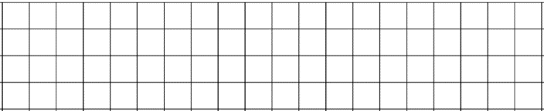

So 31 x 4 = 30 x 4 add 1 x 4

31 x 4 = 120 + 4

31 x 4 = 124

*Examples of calculations*

51 x 3

61 x 4

31 x 8

*Prerequisite skills:*

* Recall 2, 3, 4, 5, 8 and 10 multiplication tables
* Create an array to represent a multiplication calculation
* Understand the effect of multiplying a one- or two-digit number by 10
* Use related facts to multiply T0 by a one-digit number within known tables

***Use compensation to multiply 19 by a one-digit number***

Squared paper can be used to develop children’s understanding of this calculation and how it is related to multiplying twenty by a one-digit number.

e.g. 19 x 4

Children make the calculation 20 x 4 using squared paper.

4

20

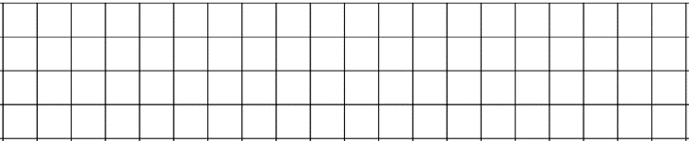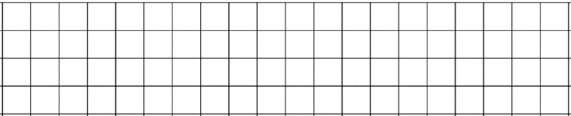

They should be able to calculate, by using related facts, that 20 x 4 = 80. The children should now consider how to change the representation of 20 x 4 into 19 x 4, i.e. by subtracting one column of four:



4

19

So 19 x 4 = 20 x 4 subtract 1 x 4

19 x 4 = 80 – 4

19 x 4 = 76

*Examples of calculations*

19 x 3

19 x 5

19 x 8

*Prerequisite skills:*

* Recall 2, 3, 4, 5, 8 and 10 multiplication tables
* Create an array to represent a multiplication calculation
* Understand the effect of multiplying a one- or two-digit number by 10
* Use related facts to multiply 20 by a one-digit number within known tables

***Use partitioning to double any two-digit number***

Children should continue to develop their understanding of doubling from Y2. They should use related facts to double two-digit multiples of 10. For example, double 7 is 14 so double 70 (ten times greater than 7) is 140 (ten times greater than 14).

e.g. double 76

76

6

70

1400

12

152

The diagram above illustrates the way children should be thinking about doubling using partitioning, but it is not necessary for them to record in this way if it is not helpful to the child.

*Examples of calculations*

Double 39

Double 52

Double 85

*Prerequisite skills:*

* Count forwards in ones and tens, crossing tens and hundreds boundaries
* Partition a two-digit number into tens and ones
* Use related facts to double a two-digit multiple of 10
* Recombine a multiple of ten and a multiple of one

***Use related facts or partitioning to double any multiple of 50 to 500***

Children should use related facts to double multiples of 100. For example, double 3 is 6 so double 300 is 600.

e.g. double 350

350

50

300

100

600

700

*Examples of calculations*

Double 250

Double 450

Double 150

*Prerequisite skills:*

* Count forwards in tens and hundreds
* Partition a multiple of 50 into hundreds and tens
* Use related facts to double a multiple of 100 which is less than 500

**Calculate mathematical statements for division**

Children in Year 3 are learning division by chunking at this point, so calculations should fit the method being taught.

***Use related facts to divide T0 by a one-digit number***

*NB T0 represents a multiple of ten*

Children should be encouraged to identify the **relationships** between numbers in division calculations, e.g. 8 ÷ 4 = 2 could be represented using a division trio as this model allows children to see the **relationships** between the numbers:

8

2

4

This can be used to derive the following calculations:

8 ÷ 4 = 2

8 ÷ 2 = 4

Children can then use the division trio to derive related facts, e.g. 80 ÷ 4 =

80

4

20

Children should be able to explain that because 80 is ten times greater than 8, the answer to 80 ÷ 4 will be ten times greater than 2.

*Examples of calculations*

60 ÷ 3

80 ÷ 2

90 ÷ 3

*Prerequisite skills:*

* Recall 2, 3 and 4 multiplication tables
* Understand the effect of multiplying a one-digit number by 10

***Use partitioning to halve even numbers up to 200***Where the tens digit is even, children can use related facts to halve the multiple of 10. For example, half of 14 is 7 so half of 140 (ten times greater than 14) is 70 (ten times greater than 7).

e.g. Find half of 146

146

140

6

70

3

73

Where the tens digit is odd, children can use partitioning in different ways to help them to calculate, recognising that partitioning the number into an even number of tens and the remainder will help them calculate more efficiently.

e.g. Find half of 78

78

18

60

30

9

39

The diagram above illustrates the way children should be thinking about halving using partitioning, but it is not necessary for them to record in this way if it is not helpful to the child.

*Examples of calculations*

Find half of 162 by partitioning into 160 and 2

Find half of 94 by partitioning into 80 and 14

Find half of 136 by partitioning into 120 and 16

*Prerequisite skills:*

* Partition a two-digit and three-digit number in different ways
* Use related facts to half a multiple of 10, where the tens digit is even, up to 200
* Recombine a multiple of ten and a multiple of one

**Y4**

**End of Year Objective:**

***Use place value, known and derived facts to multiply and divide mentally, including:***

***- multiplying by 0 and 1***

***- dividing by 1***

***- multiplying together three numbers***

**Rapid Recall**

Children should be able to:

* Count in multiples of 6, 7, 9, 25 and 1000
* Recall multiplication and division facts for multiplication tables up to 12 x 12
* Use partitioning to double or halve any number, including decimals to one decimal place
* Recognise and use factor pairs

**Mental Strategies**

Children should be able to represent multiplication and division calculations, including two-digit multiplied by one-digit numbers. As children learn to recall more multiplication and division facts, they should make a choice about the calculations they need to represent to find the answer, and those they can recall.

**Use place value, known and derived facts to multiply mentally**

***Multiply a one- or two-digit number by 10 and 100***

Building on their understanding from Year 3, children use place value columns to multiply one or two-digit numbers by 10 and 100.

e.g. 42 x 100 =

Th H T U

4 2

4 2 0 0

*Examples of calculations*

7 x 10

9 x 100

71 x 10

63 x 100

*Prerequisite skills:*

* Understand and use place value columns when representing numbers
* Understand the effect of multiplying a number by 10 or 100

***Use related facts to multiply H00 by a one-digit number***

*NB H00 represents a multiple of 100*

Children should be encouraged to identify the **relationships** between numbers in multiplication calculations, e.g. 7 x 9 = 63 could be represented using a multiplication trio as this model allows children to see the **relationships** between the numbers:

63

7

9

This can be used to derive the following calculations:

7 x 9 = 63

9 x 7 = 63

Children can then use the multiplication trio to derive related facts, e.g. 700 x 9 =

6300

700

9

Children should be able to explain that because 700 is one hundred times greater than 7, the answer to 700 x 9 will be one hundred times greater than 63. They can then use their understanding of multiplying by 100 to calculate this.

***Use factor pairs to multiply H00 by a one-digit number***

Calculations that involve multiplying H00 by a one-digit numbercan be broken down into smaller steps by using factor pairs.

e.g. 700 x 9 =

becomes 7 x 100 x 9 = (using knowledge of factor pairs)

which becomes 7 x 9 x 100 = (using knowledge of commutativity/associativity)

which becomes 63 x 100 = 6300

*Examples of calculations*

600 x 7

500 x 8

900 x 6

*Prerequisite skills:*

* Recall multiplication tables
* Understand the effect of multiplying a one- or two-digit number by 100
* Recognise and use factor pairs

***Use compensation to multiply T9 by a one-digit number***

*NB T9 represents a two-digit number with 9 ones*

Building on their understanding from Year 3 of multiplying 19 by a one-digit number using squared paper, children multiply by the nearest multiple of ten and then compensate appropriately.

e.g. 59 x 4 =

59 x 4 = 60 x 4 subtract 1 x 4

60 x 4 = 240

So 59 x 4 = 240 – 4 (one group of 4 less than 240)

59 x 4 = 236

*Examples of calculations*

49 x 3

29 x 7

89 x 6

*Prerequisite skills:*

* Recall multiplication tables
* To understand how multiplying by 9 is related to multiplying by 10
* Use related facts to multiply T0 by a one-digit number

***Use related facts to multiply TU x 5 (by multiplying by 10 and halving)***

When learning multiplication tables, children should be encouraged to identify related facts.

e.g. 8 x 10 = 80

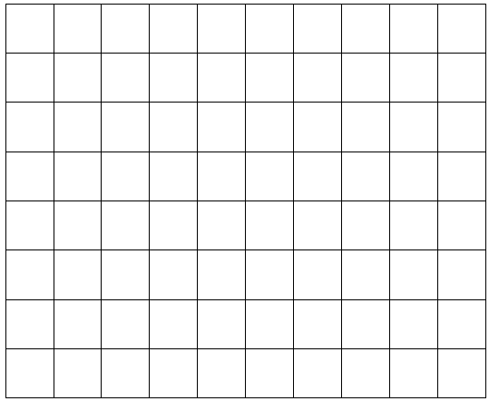

This can be used to calculate:

8 x 5 = 40 (half of 8 x10) because 5 is half of 10

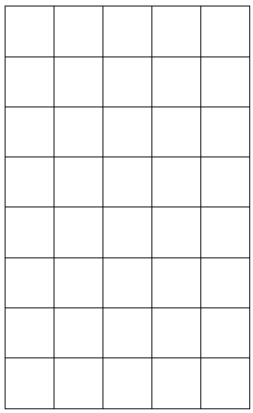

This strategy can then be applied to calculating TU x 5.

e.g. 46 x 5 =

46 x 10 = 460

so

46 x 5 = 230

*Examples of calculations*

28 x 5

81 x 5

54 x 5

*Prerequisite skills:*

* Recall multiplication tables
* Understand the relationship between multiplying by 10 and multiplying by 5
* Multiply a two-digit number by 10
* Halve multiples of 10 up to three-digits

***Use related facts to multiply TU x 20 (by multiplying by 10 and doubling)***

When learning multiplication tables, children should be encouraged to identify related facts.

e.g. 3 x 10 = 30

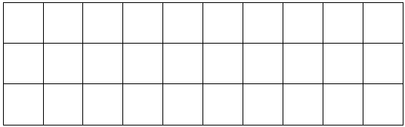

This can be used to calculate:

3 x 20 = 60 (double 3 x 10) because 20 is double 10

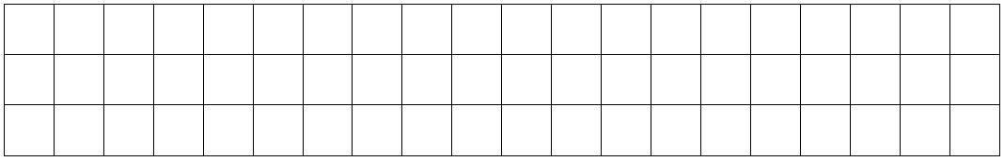

This strategy can then be applied to calculating TU x 20.

e.g. 46 x 20 =

46 x 10 = 460

so

46 x 20 = 920

*Examples of calculations*

34 x 20

47 x 20

68 x 20

*Prerequisite skills:*

* Recall multiplication tables
* Understand the relationship between multiplying by 10 and multiplying by 20
* Multiply a two-digit number by 10
* Double multiples of 10 up to three-digits

***Use partitioning to multiply TU by a one-digit number***

Building on their understanding of the grid method of multiplication from Year 3, children in Year 4 may choose to multiply TU x U using partitioning, but without the use of the grid.

e.g. 67 x 4 =

60 x 4 = 240

7 x 4 = 28

67 x 4 = 268

*Examples of calculations*

57 x 4

36 x 7

93 x 6

*Prerequisite skills:*

* Recall multiplication tables
* Partition a two-digit number into tens and ones
* Recombine a multiple of ten and a multiple of one

***Use partitioning to double numbers including those with one decimal place***

Children should use related facts to double numbers. For example, double 7 is 14 so double 0.7 (ten times smaller than 7) is 1.4 (ten times smaller than 14).

e.g. double 6.8

6.8

0.8

6

1.6

12

13.6

The diagram above illustrates the way children should be thinking about doubling using partitioning, but it is not necessary for them to record in this way if it is not helpful to the child.

*Examples of calculations*

Double 374

Double 4524

Double 7.6

*Prerequisite skills:*

* Count forwards in tenths, ones, tens, hundreds and thousands
* Partition a number into thousands, hundreds, tens, ones and tenths
* Use related facts to double multiples of tenths, ones, tens, hundreds and thousands
* Recombine multiples of tenths, ones, tens, hundreds and thousands

***Multiply together three numbers***

Children should be able to represent multiplying three numbers together practically, e.g. using counters

e.g. 2 x 3 x 4 could be represented as:



2 x 3 four times

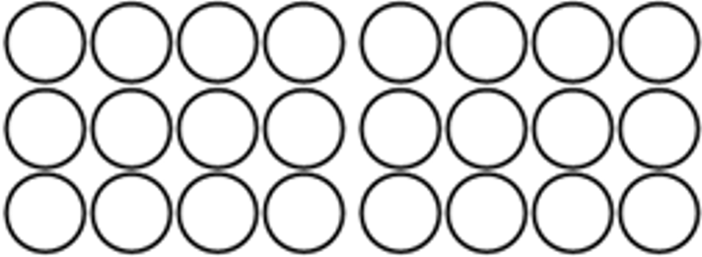

3 x 4 two times



2 x 4 three times

Once children understand how the calculation can be shown practically or pictorially, they should then be encouraged to choose an appropriate order for calculating based on the numbers involved.

e.g. 5 x 7 x 4 =

This could be calculated as:

5 x 7 x 4 = 5 x 4 x 7 = 4 x 7 x 5 =

28

20

35

35 x 4 = 140 20 x 7 = 140 28 x 5 = 140

Children may choose 5 x 4 x 7 as the easiest calculation because 5 x 4 results in a multiple of 10.

*Examples of calculations*

3 x 4 x 6

7 x 3 x 9

5 x 6 x 8

*Prerequisite skills:*

* Represent a multiplication using an array
* Understand that multiplication can be done in any order
* Recall multiplication tables
* Multiply a two-digit number by a one-digit number

***Multiply a number by 0 or 1***

Children should realise through investigation that a calculation is not needed when multiplying by 0 or 1

Any number multiplied by 0 will result in zero, e.g. 76 x 0 = 0 because any number of empty groups does not have a value.

Any number multiplied by 1 will result in the number itself, 356 x 1 = 356 because it is one group of the original amount.

**Use place value, known and derived facts to divide mentally**

***Divide a number by 10 and 100 using base 10 equipment***

Children should initially represent the calculation using base 10 equipment, e.g. 230 ÷ 10

***101010***



All of the base 10 pieces need to be made ten times smaller.

***1010***

***1***

***11***

The children should then compare the two numbers in place value columns.

H T U

2 3 0

2 3

They should notice that each digit has moved one place to the right, i.e. become ten times smaller.

***Divide a number by 10 and 100 using a place value chart***

Building on their knowledge from using the base 10 equipment, children can use transparent counters to help them develop their understanding of dividing a number by 10 and 100.

e.g. 460 ÷ 10

The children represent 460 on a place value chart using transparent counters.



They then move each counter one place to the right to divide the number by 10.



*Examples of calculations*

120 ÷ 10

600 ÷ 100

850 ÷ 10

*NB There is no requirement to divide numbers where the answer is a decimal.*

*Prerequisite skills:*

* Represent numbers up to three digits using base 10 equipment
* Partition a number into hundreds and tens
* Recombine a multiple of ten and a multiple of one

***Use related facts to divide HT0 by a one-digit number***

Children should be encouraged to identify the **relationships** between numbers in division calculations, e.g. 42 ÷ 7 = 6 could be represented using a division trio:

42

6

7

This can be used to derive the following calculations:

42 ÷ 7 = 6

42 ÷ 6 = 7

Children can then use the division trio to derive related facts, e.g. 80 ÷ 4 =

420

7

60

Children should be able to explain that because 420 is ten times greater than 42, the answer to 420 ÷ 7 will be ten times greater than 6.

*Examples of calculations*

480 ÷ 8

630 ÷ 9

300 ÷ 6

*Prerequisite skills:*

* Recall multiplication tables
* Understand the effect of multiplying a one or two-digit number by 10

***Use partitioning to divide TU by a one-digit number***

Building on their understanding of using chunking for division from Year 3, children decide how to partition a two-digit number to help them divide it by a one-digit number.

e.g. 48 ÷ 3 = **16**

48

30

18

30 ÷ 3 = **10**

18 ÷ 3 = **6**

*Examples of calculations*

68 ÷ 4 By partitioning into 40 and 28

95 ÷ 5 By partitioning into 50 and 45

84 ÷ 6 By partitioning into 60 and 24

*Prerequisite skills:*

* Recall multiplication tables
* Understand division as repeated subtraction (chunking)
* Partition two-digit numbers in different ways

***Use partitioning to halve any number including to one decimal place***

Children should be encouraged to decide the best way to partition a number to halve it.

e.g. Find half of 4526

4526

6

20

500

4000

2000

250

3

10

2263

An alternative way of partitioning would be:

Find half 4526

4526

26

4400

100

13

50

2200

2263

The diagrams above illustrate the way children should be thinking about halving using partitioning, but it is not necessary for them to record in this way if it is not helpful to the child.

*Examples of calculations*

Find half of 468

Find half of 7602

Find half of 8.2

Find half of 3.6

*Prerequisite skills:*

* Partition numbers (including in different ways for efficiency)
* Use related facts to halve a multiple of a tenth, one, ten, hundred and thousand
* Recombine multiples of one, ten, hundred and thousand
* Recombine multiples of a tenth and one

***Divide a number by 1***

Children should realise, through investigation, that a calculating process is not necessary when dividing by 1

Any number that is divided by 1 will result in the number itself, e.g. 542 ÷ 1 = 542. This is because any quantity shared into one group will result in that group having the whole quantity in it; or any number grouped into ones will result in the original number of groups.

**Y5**

**End of Year Objective:**

***Multiply and divide numbers mentally drawing upon known facts***

**Rapid Recall**

Children should be able to:

* Recall related tables facts for multiples of 10 (70 x 6 = 420 because 7 x 6 = 42)
* Using times tables, identify related unit fractions, e.g. 7 x 9 = 63 so one-ninth of 63 is 7 and one-seventh of 63 is 9
* Use partitioning to double or halve any number, including decimals to two decimal places
* Recall prime numbers up to 19
* Recall square (²) numbers up to 12 x 12

**Mental Strategies**

In Year 5 children build on their skills and understanding from previous year groups to multiply and divide mentally with larger numbers and numbers to two decimal places. Children should be encouraged to choose the most appropriate strategy based on the numbers involved in the calculation.

**Multiply numbers mentally drawing upon known facts**

***Multiply whole numbers and decimals to two decimal places by 10, 100 and 1000 using a place value chart***

Building on their knowledge of multiplying by 10 and 100 from Year 3 and Year 4, children can use transparent counters to help them develop their understanding of multiplying numbers to two decimal places by 10, 100 and 1000

e.g. 3.72 x 1000

The children represent 3.72 on a place value chart using transparent counters.

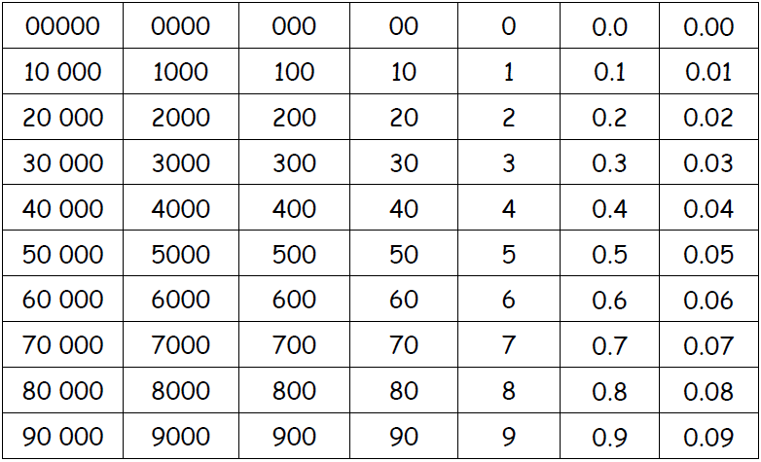

They then move each counter three places to the left to multiply the number by 1000 because 1000 is 10 x 10 x 10



*Examples of calculations*

75.91 x 10

5.07 x 10

670.4 x 100

360 x 1000

0.76 x 1000

*Prerequisite skills:*

* Partition a number into thousands, hundreds, tens, ones, tenths and hundredths
* Recombine multiples of a hundred thousand, ten thousand, thousand, hundred, ten, one and tenth

***Use related facts to multiply Th000 by a one-digit number***

*NB Th000 represents a multiple of 1000*

Children should be encouraged to identify the **relationships** between numbers in multiplication calculations, e.g. 6 x 8 = 48 could be represented using a multiplication trio as this model allows children to see the **relationships** between the numbers:

48

6

8

This can be used to derive the following calculations:

6 x 8 = 48

8 x 6 = 48

Children can then use the multiplication trio to derive related facts, e.g. 6000 x 8 =

48 000

6000

8

Children should be able to explain that because 6000 is one thousand times greater than 6, the answer to 6000 x 8 will be one thousand times greater than 48. They can then use their understanding of multiplying by 1000 to calculate this.

*Examples of calculations*

3000 x 3

7000 x 5

8000 x 9

*Prerequisite skills:*

* Recall multiplication tables
* Understand the effect of multiplying a one- or two-digit number by 1000

***Use related facts to multiply 0.t by a one-digit number***

*NB 0.t represents a multiple of a tenth*

The multiplication trio from the previous strategy can also be used to derive 0.t multiplied by a one-digit number, e.g. 0.6 x 8

4.8

0.6

8

Children should be able to explain that because 0.6 is ten times smaller than 6, the answer to 0.6 x 8 will be ten times smaller than 48. They can then use their understanding of dividing by 10 to calculate this.

*Examples of calculations*

0.3 x 7

0.6 x 9

0.5 x 4

*Prerequisite skills:*

* Recall multiplication tables
* Understand the effect of dividing a one- or two-digit number by 10

***Use factor pairs to multiply T0 x T0***

Calculations that involve multiplying T0 x T0 can be broken down into smaller steps by using factor pairs.

e.g. 60 x 40 =

becomes 6 x 10 x 4 x 10 = (using knowledge of factor pairs)

which becomes 6 x 4 x 10 x 10 = (using knowledge of commutativity/associativity)

which becomes 24 x 100 = 2400

*Examples of calculations*

30 x 60

70 x 80

50 x 40

*Prerequisite skills:*

* Recall multiplication tables
* Understand the effect of multiplying a one- or two-digit number by 100
* Recognise and use factor pairs

***Use compensation to multiply H99 by a one-digit number***

*NB H99 represents a three-digit number with 9 tens and 9 ones*

Building on their understanding from Year 4 of multiplying T9 by a one-digit number, children multiply by the nearest multiple of a hundred and then compensate appropriately.

e.g. 699 x 3 =

699 x 3 = 700 x 3 subtract 1 x 3

700 x 3 = 2100

So 699 x 3 = 2100 – 3 (one group of 3 less than 2100)

699 x 3 = 2097

*Examples of calculations*

599 x 4

399 x 7

699 x 9

*Prerequisite skills:*

* Recall multiplication tables
* Understand how multiplying by 99 is related to multiplying by 100
* Use related facts to multiply H00 by a one-digit number
* Subtract a one-digit number from a multiple of a hundred

***Use partitioning to multiply U.t by a one-digit number***

Children should be encouraged to choose the most efficient method, which may be mental, rather than simply opting for a written method.

e.g. 3.8 x 4 =

3 x 4 = 12

0.8 x 4 = 3.2

3.8 x 4 = 15.2

*Examples of calculations*

6.7 x 4

3.2 x 7

8.5 x 6

*Prerequisite skills:*

* Recall multiplication tables
* Partition U.t into ones and tenths
* Use related facts
* Add numbers with different amounts of digits

***Use partitioning to double numbers including those with two decimal places***

Children should use related facts to double numbers. For example, double 9 is 18 so double 0.09 (a hundred times smaller than 9) is 0.18 (a hundred times smaller than 18).

e.g. double 7.86

7.86

0.06

7

0.8

0.12

14

1.6

15.72

The diagram above illustrates the way children should be thinking about doubling using partitioning, but it is not necessary for them to record in this way if it is not helpful to the child.

*Examples of calculations*

Double 56.7

Double 485.6

Double 8.59

Double 36 742

*Prerequisite skills:*

* Count forwards in hundredths, tenths, ones, tens, hundreds and thousands
* Partition a number into thousands, hundreds, tens, ones, tenths and hundredths
* Use related facts to double multiples of hundredths, tenths, ones, tens, hundreds and thousands
* Recombine multiples of hundredths, tenths, ones, tens, hundreds and thousands

**Divide numbers mentally drawing upon known facts**

***Divide whole numbers and decimals by 10, 100 and 1000 using a place value chart***

Building on their knowledge of dividing by 10 and 100 from Year 3 and Year 4, children can use transparent counters to help them develop their understanding of dividing numbers by 10, 100 and 1000. Answers should include decimals up to two decimal places.

e.g. 35 600 ÷ 1000 =

The children represent 35 600 on a place value chart using transparent counters.



They then move each counter three places to the right to divide the number by 1000

1000 is 10 x 10 x 10 so dividing by 1000 is the same as ÷ 10 ÷ 10 ÷ 10



*Examples of calculations*

874 ÷ 10

60.1 ÷ 10

7043 ÷ 100

48 750 ÷ 1000

*Prerequisite skills:*

* Partition a number into hundred thousands, ten thousands, thousands, hundreds, tens, ones and tenths
* Recombine multiples of ten thousand, thousand, hundred, ten, one, tenth and hundredth

***Use related facts to divide ThH00 by a one-digit number***

*NB ThH00 represents a four-digit multiple of 100*

Children should be encouraged to identify the **relationships** between numbers in division calculations, e.g. 54 ÷ 6 = 9 could be represented using a division trio:

54

9

6

This can be used to derive the following calculations:

54 ÷ 6 = 9

54 ÷ 9 = 6

Children can then use the division trio to derive related facts, e.g. 5400 ÷ 6 = 900

5400

900

6

Children should be able to explain that because 5400 is a hundred times greater than 54, the answer to 5400 ÷ 6 will be a hundred times greater than 9. They can then use their understanding of multiplying by 100 to calculate this.

*Examples of calculations*

8100 ÷ 9

3000 ÷ 6

9600 ÷ 8

*Prerequisite skills:*

* Recall multiplication tables
* Understand the effect of multiplying a one or two-digit number by 100

***Use related facts to divide U.t by a one-digit number***

The division trio from the previous strategy can also be used to derive U.t divided by a one-digit number, e.g. 5.4 ÷ 6 =

5.4

6

0.9

Children should be able to explain that because 5.4 is ten times smaller than 54, the answer to 5.4 ÷ 6 will be ten times smaller than 9. They can then use their understanding of dividing by 10 to calculate this.

*Examples of calculations*

2.1 ÷ 7

3.6 ÷ 9

4.8 ÷ 4

*Prerequisite skills:*

* Recall multiplication tables
* Understand the effect of dividing a one- or two-digit number by 10

***Use related facts to divide U.t by a 0.t***

The division trio from the previous strategy can also be used to derive U.t divided by 0.t, e.g. 5.4 ÷ 0.6 =

5.4

9

0.6

Children should be able to explain that 5.4 is ten times smaller than 54 and 0.6 is ten times smaller than 6. This means that both numbers have been scaled down by the same amount, so the relationship between the numbers stays the same. The answer to 5.4 ÷ 0.6 will therefore be 9 because there are 9 groups of 0.6 in 5.4

*Examples of calculations*

2.1 ÷ 0.7

3.6 ÷ 0.9

4.8 ÷ 0.4

*Prerequisite skills:*

* Recall multiplication tables
* Understand division as repeated subtraction

***Use partitioning to divide HTU by a one-digit number***

Building on their understanding of using partitioning to divide TU by a one-digit number from Year 4, children decide how to partition HTU to help them divide it by a one-digit number.

e.g. 942 ÷ 6 = **157**

342

600 ÷ 6 = **100**

300 ÷ 6 = **50**

600

942

300

42

42 ÷ 6 = **7**

The diagram above illustrates the way children should be thinking about dividing using partitioning, but it is not necessary for them to record in this way if it is not helpful to the child.

*Examples of calculations*

756 ÷ 9 By partitioning into 720 and 36

765 ÷ 5 By partitioning into 500 and 250 and 15

861 ÷ 7 By partitioning into 700 and 140 and 21

*Prerequisite skills:*

* Recall multiplication tables
* Understand division as repeated subtraction
* Partition three-digit numbers in different ways

***Use partitioning to halve any number including to two decimal places***

Children should be encouraged to decide the best way to partition a number to halve it.

e.g. Find half of 6.74

6

6.74

0.04

0.02

0.35

0.7

3

3.37

An alternative way of partitioning would be:

Find half of 6.74

6.74

6.6

0.14

3.3

0.07

3.37

The diagrams above illustrate the way children should be thinking about halving using partitioning, but it is not necessary for them to record in this way if it is not helpful to the child.

*Examples of calculations*

Find half of 4.62

Find half of 18.46

Find half of 8.94

Find half of 17.92

Find half of 32 784

*Prerequisite skills:*

* Partition numbers (including in different ways for efficiency)
* Use related facts to halve a multiple of a hundredth, tenth, ten, hundred and thousand
* Recombine multiples of one, ten, hundred and thousand
* Recombine multiples of a tenth and a hundredth

**Y6**

**End of Year Objective:**

***Perform mental calculations, including with mixed operations and large numbers***

**Rapid Recall**

Children should be able to:

* Recall related tables facts decimal numbers (0.7 x 6 = 4.2 because 7 x 6 = 42)
* Use partitioning to double or halve any number
* Recall prime numbers up to 100
* Recall squares of the corresponding multiples of 10 (i.e. 40² is 1600)

**Mental Strategies**

In Year 6 children build on their skills and understanding from previous year groups to multiply and divide mentally with larger numbers and numbers to three decimal places. Children should be encouraged to choose the most appropriate strategy based on the numbers involved in the calculation.

**Perform mental calculations – Multiplication**

***Multiply whole numbers and decimals to three decimal places by 10, 100 and 1000***

Building on their knowledge of multiplying by 10, 100 and 1000 from Year 5, children use place value columns to multiply numbers to three decimal places by 10, 100 and 1000

e.g. 43.721 x 100 =

Th H T U t h th

4 3 7 2 1

4 3 7 2 1



*Examples of calculations*

4562 x 1000

9.682 x 10

25.784 x 100

*Prerequisite skills:*

* Understand and use place value columns when representing numbers
* Understand the effect of multiplying a number by 10, 100 or 1000

***Identify and use all related facts that link to tables***

Children should be encouraged to select the most appropriate strategy based on the numbers involved in the calculation.

e.g. 8000 x 4 =

Using related facts in a multiplication trio could help with this calculation:

32 000

8000

4

Children should be able to explain that because 8000 is a thousand times greater than 8, the answer to 8000 x 4 will be a thousand times greater than 32.

e.g. 8000 x 40 =

Using factor pairs could help with this calculation:

8000 x 40 =

becomes 8000 x 4 x 10 = (using knowledge of factor pairs)

which becomes 32 000 x 10 = 320 000

*Examples of calculations*

7000 x 6

500 x 40

900 x 300

3000 x 80

*Prerequisite skills:*

* Recall multiplication tables
* Understand the effect of multiplying a number by 10, 100 or 1000
* Recognise and use factor pairs

***Use related facts to multiply 0.0t by a one-digit number***

*NB 0.0t represents a multiple of a hundredth*

Children can use a multiplication trio to derive related facts, e.g. 0.07 x 4

0.28

0.07

4

Children should be able to explain that because 0.07 is a hundred times smaller than 7, the answer to 0.07 x 4 will be a hundred times smaller than 28. They can then use their understanding of dividing by 100 to calculate this.

*Examples of calculations*

0.03 x 7

0.06 x 9

0.05 x 4

*Prerequisite skills:*

* Recall multiplication tables
* Understand the effect of dividing a one- or two-digit number by 100

***Use compensation to multiply U.9 and U.99 by a one-digit number***

Building on their understanding from Year 5 of multiplying H99 by a one-digit number, children multiply by the nearest whole number and then compensate appropriately.

e.g. 6.9 x 4 =

6.9 x 4 = 7 x 4 subtract 0.1 x 4

7 x 4 = 28

So 6.9 x 4 = 28 – 0.4

6.9 x 4 = 27.6

e.g. 6.99 x 4 =

6.99 x 4 = 7 x 4 subtract 0.01 x 4

7 x 4 = 28

So 6.99 x 4 = 28 – 0.04

6.99 x 4 = 27.96

*Examples of calculations*

5.9 x 4

3.99 x 7

9.99 x 6

*Prerequisite skills:*

* Recall multiplication tables
* Understand how multiplying by 0.9 is related to multiplying by 1
* Understand how multiplying by 0.99 is related to multiplying by 1
* Subtract a 0.t or 0.0h from a whole number

***Use partitioning to multiply 0.th by a one-digit number***

Children should be encouraged to choose the most efficient method, which may be mental, rather than simply opting for a written method.

e.g. 0.67 x 4 =

0.6 x 4 = 2.4

0.07 x 4 = 0.28

0.67 x 4 = 2.68

*Examples of calculations*

0.76 x 3

0.28 x 7

0.54 x 6

*Prerequisite skills:*

* Recall multiplication tables
* Partition 0.th into tenths and hundredths
* Use related facts
* Add numbers with different amounts of digits

***Use partitioning to double numbers including those with three decimal places***

Children should use related facts to double numbers. For example, double 9 is 18 so double 0.009 (a thousand times smaller than 9) is 0.018 (a thousand times smaller than 18).

e.g. double 6.374

6.374

0.004

0.07

0.3

6

0.008

0.14

0.6

12

12.748

The diagram above illustrates the way children should be thinking about doubling using partitioning, but it is not necessary for them to record in this way if it is not helpful to the child.

*Examples of calculations*

Double 3.421

Double 6.705

Double 12.594

Double 54 672

Double 674 960

*Prerequisite skills:*

* Count forwards in steps of powers of 10
* Partition a number appropriately
* Use related facts to double multiples of powers of 10
* Recombine multiples of powers of 10

**Perform mental calculations – Division**

***Divide whole numbers and decimals to three decimal places by 10, 100 and 1000***

Building on their knowledge of dividing by 10, 100 and 1000 from Year 5, children use place value columns to divide numbers by 10, 100 and 1000. Answers should include decimals up to three decimal places.

e.g. 356.7 ÷ 100 =

Th H T U t h th

3 5 6 7

3 5 6 7



*Examples of calculations*

9.83 ÷ 10

7.04 ÷ 10

860.2 ÷ 100

56 789 ÷ 1000

*Prerequisite skills:*

* Understand and use place value columns when representing numbers
* Understand the effect of dividing a number by 10, 100 or 1000

***Identify and use all related facts that link to tables***

Children should be encouraged to select the most appropriate strategy based on the numbers involved in the calculation.

e.g. 56 000 ÷ 8 =

Using related facts in a division trio could help with this calculation:

56 000

7000

8

Children should be able to explain that because 56 000 is a thousand times greater than 56, the answer to 56 000 ÷ 8 will be a thousand times greater than 7. They can then use their understanding of multiplying by 1000 to calculate this.

e.g. 5600 ÷ 80 =

The following division trio could be used as a starting point for this calculation:

5600

8

700

Children should be able to explain that because 5600 is a hundred times greater than 56, the answer to 5600 ÷ 8 will be a hundred times greater than 7. They can then use their understanding of multiplying by 100 to calculate this.

The following division trio could then be derived:

5600

80

70

Children should be able to explain that because 80 is ten times greater than 8, the answer to 5600 ÷ 80 will be ten times smaller than the answer to 5600 ÷ 8 because there will be ten times fewer groups.

*Examples of calculations*

81 000 ÷ 9

270 ÷ 30

3000 ÷ 50

9600 ÷ 800

*Prerequisite skills:*

* Recall multiplication tables
* Understand division as repeated subtraction
* Understand the effect of multiplying or dividing by 10, 100 or 1000

***Use related facts to divide TU by 0.t***

e.g. 56 ÷ 0.8 =

Using related facts in a division trio could help with this calculation:

56

0.8

70

Children should be able to explain that because 0.8 is ten times smaller than 8, the answer to 56 ÷ 0.8 will be ten times greater than the answer to 56 ÷ 8 because there will be ten times more groups.

*Examples of calculations*

21 ÷ 0.7

36 ÷ 0.9

48 ÷ 0.4

*Prerequisite skills:*

* Recall multiplication tables
* Understand division as repeated subtraction
* Understand the effect of multiplying or dividing by 10

***Use related facts to divide 0.th by 0.t***

e.g. 0.54 ÷ 0.6 =

The following division trio from Year 5 could be used as a starting point for this calculation:

5.4

0.6

9

Children should be able to explain that 5.4 is ten times smaller than 54 and 0.6 is ten times smaller than 6. This means that both numbers have been scaled down by the same amount, so the relationship between the numbers stays the same. The answer to 5.4 ÷ 0.6 will therefore be 9 because there are 9 groups of 0.6 in 5.4

The following division trio could then be derived:

0.54

0.6

0.9

Children should be able to explain that because 0.54 is ten times smaller than 5.4, the answer to 0.54 ÷ 0.6 will be ten times smaller than 9. They can then use their understanding of dividing by 10 to calculate this.

*Examples of calculations*

0.32 ÷ 0.4

0.64 ÷ 0.8

0.45 ÷ 0.9

*Prerequisite skills:*

* Recall multiplication tables
* Understand division as repeated subtraction
* Understand the effect of multiplying and dividing by 10

***Use related facts to divide by 50***

Dividing by 50 is the same as dividing by 100 and then doubling because 50 is half of 100. Children can investigate this using simple calculations.

e.g. 200 ÷ 100 = 2

2 x 2 = 4

So 200 ÷ 50 = 4

Children can then use this in more complex calculations.

e.g. 3200 ÷ 50 =

3200 ÷100 = 32

32 x 2 = 64

So 3200 ÷ 50 = 64

*Examples of calculations*

4100 ÷ 50

7800 ÷ 50

530 ÷ 50

*Prerequisite skills:*

* Understand the effect of dividing by 100
* Double numbers including those with one decimal place

***Use related facts to divide by 25***

Dividing by 25 is the same as dividing by 100 and then multiplying by 4 because 25 is one quarter of 100. Children can investigate this using simple calculations.

e.g. 200 ÷ 100 = 2

2 x 4 = 8

So 200 ÷ 25 = 8

Children can then use this in more complex calculations.

e.g. 4800 ÷ 25 =

4800 ÷100 = 48

48 x 4 = 192

So 4800 ÷ 25 = 192

*Examples of calculations*

3200 ÷ 25

7600 ÷ 25

360 ÷ 25

*Prerequisite skills:*

* Understand the effect of dividing by 100
* Multiply numbers up to one decimal place by 4

***Use partitioning to divide ThHTU by a one-digit number***

Building on their understanding of using partitioning to divide TU by a one-digit number from Year 4, children decide how to partition ThHTU to help them divide it by a one-digit number.

e.g. 7505 ÷ 5 = **1501**

7505

48

5

2500

5000

5 ÷ 5 = **1**

2500 ÷ 5 = **500**

5000 ÷ 5 = **1000**

The diagram above illustrates the way children should be thinking about dividing using partitioning, but it is not necessary for them to record in this way if it is not helpful to the child.

*Examples of calculations*

5035 ÷ 5 By partitioning into 5000 and 35

1236 ÷ 4 By partitioning into 1200 and 36

9240 ÷ 6 By partitioning into 6000 and 3000 and 240

*Prerequisite skills:*

* Recall multiplication tables
* Understand division as repeated subtraction
* Partition four-digit numbers in different ways

***Use partitioning to halve any number including to three decimal places***

Children should be encouraged to decide the best way to partition a number to halve it.

e.g. Find half of 8.654

8.654

0.004

0.05

0.6

8

0.025

0.002

0.3

4

4.327

An alternative way of partitioning would be:

Find half of 8.654

8.654

8.6

0.04

0.014

4.3

0.02

0.007

4.327

The diagrams above illustrate the way children should be thinking about halving using partitioning, but it is not necessary for them to record in this way if it is not helpful to the child.

*Examples of calculations*

Find half of 4.684

Find half of 12.826

Find half of 6.942

Find half of 15.674

Find half of 478 612

*Prerequisite skills:*

* Partition numbers (including in different ways for efficiency)
* Use related facts to halve a multiple of a thousandth, hundredth, tenth, ten, hundred and thousand
* Recombine multiples of one, ten, hundred and thousand
* Recombine multiples of a tenth, hundredth and thousandth