**BANKS ST. STEPHEN'S C.E. PRIMARY SCHOOL**

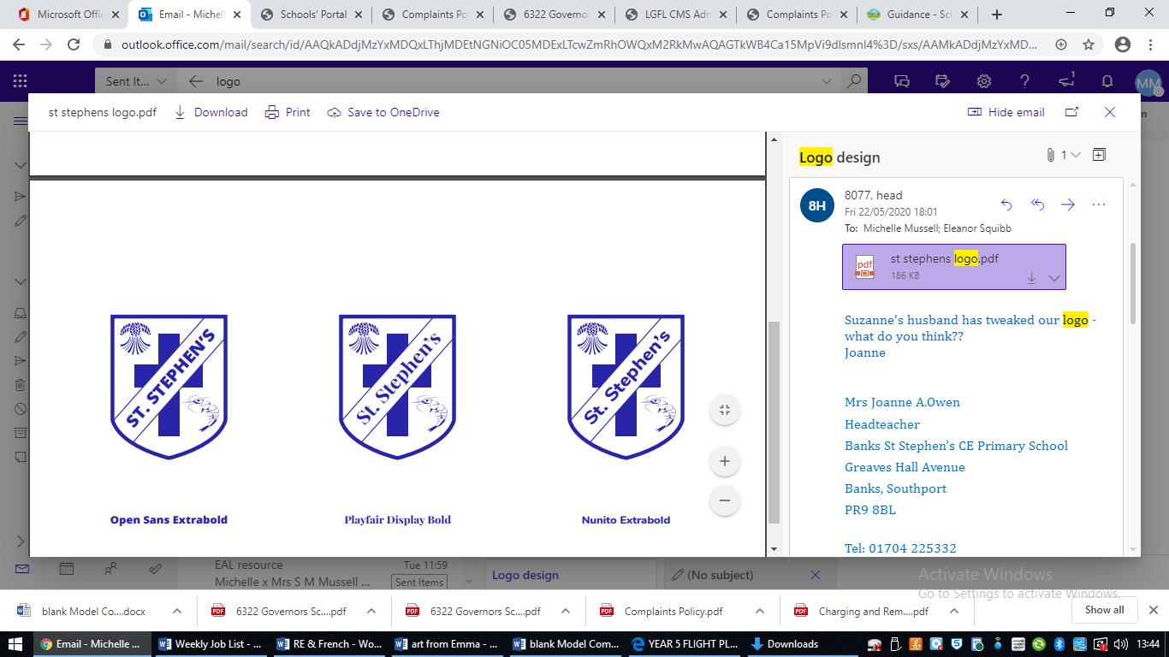

**ENGLISH POLICY**

***Banks St. Stephen’s Church of England Primary School***

***“Belonging, Serving, Succeeding”***

Vision for Banks St. Stephen’s Church of England Primary School

“We actively promote a sense of pride in belonging to this community. Leading by example, we seek opportunities to serve God by serving others.  We are ambitious for each individual and determined to enable every member of the school community to flourish and succeed.”

**Vision for English**

Our English Policy aims to foster a love of language and literacy, enabling every child to communicate effectively and confidently. We are committed to providing a rich, inclusive environment where children develop strong reading, writing, speaking, and listening skills. Our approach, guided by the principles of **Belonging**, **Serving**, and **Succeeding**, ensures that all students are empowered to express themselves and succeed in their learning.

**Belonging**

We create an inclusive and supportive environment where every child feels valued and confident in their ability to use language. By celebrating diversity in language and communication, we ensure all students feel they belong and can contribute their unique voices to discussions, stories, and written work.

**Serving**

Through English, we encourage children to serve others by sharing ideas, stories, and information in meaningful ways. By developing strong communication skills, students learn to listen, empathize, and express themselves to connect with others, fostering a sense of community and mutual respect.

**Succeeding**

Our English curriculum supports every child’s journey to success by providing a structured yet flexible approach to learning. We aim to build fluency and confidence in reading, writing, and speaking, empowering children to succeed academically and communicate effectively in all aspects of life.

In summary, our English Policy ensures that every child feels they belong, is equipped to serve others through their communication, and is empowered to succeed in their literacy development.

### **Purpose**

This policy outlines the expectations and standards for the delivery of English education at Banks St Stephen’s CE for all year groups; EYFS - Year 6. It reflects the school's values and philosophy in relation to the teaching and learning of English. It sets out a framework within which staff can operate and gives guidance on planning, teaching, and assessment. The policy should be read in conjunction with the National Curriculum 2014 which sets out in detail what pupils in different year groups will be taught.

**Philosophy**

The ability to use language well is crucial to a pupil's overall performance in school and later life. Since language can be both written and spoken, we aim to develop pupils' capabilities in speaking and listening, reading, and writing. Promoting a love of books and an appreciation of the power and delight of language is central to our teaching.

Through direct teaching, guided and independent work, and a wide range of carefully structured, attractive books and digital texts—including multicultural texts, non-fiction, and poetry—we aim to develop successful and enthusiastic readers, writers, and speakers.

**Intent**

At Banks St Stephen’s CE Primary School, we intend to nurture and develop the whole child. We strive for all of our children to be Primary Literate Pupils. The overarching aim for English in the national curriculum is to promote high standards of language and literacy by equipping pupils with a strong command of the spoken and written word, and to develop their love of literature through widespread reading for enjoyment. We aim to ensure that all pupils:

* Read easily, fluently, and with good understanding.
* Develop the habit of reading widely and often, for both pleasure and information, knowing that reading is a wonderful relaxation tool and enhances mental health, as well as developing knowledge. We aim for them to be able to identify a number of authors and a genre/genres they enjoy reading.
* Acquire a wide vocabulary, an understanding of grammar, and knowledge of linguistic conventions for reading, writing, and spoken language.
* Write clearly, accurately, and coherently, adapting their language and style for a range of contexts, purposes, and audiences.
* Use discussion to learn; they should be able to elaborate and explain clearly their understanding and ideas.
* Are competent in the arts of speaking and listening, making formal presentations, demonstrating to others, and participating in debate.

**Implementation**

At Banks St Stephen's, the English curriculum is taught using a variety of resources to engage children and enhance learning. We prioritise time daily to read to children to further develop their love of reading and model reading for pleasure and enjoyment, developing vocabulary and feeding pupils’ imagination, opening up a treasure-house of wonder and joy for curious young minds. Links are made to other areas of the curriculum through cross-curricular writing, performance poetry, debate, reading, and the use of computing to write, publish, and communicate in a variety of ways.

**EYFS and Year 1 Expectations**

To ensure a consistent and high-quality English instruction, teachers in EYFS and Year 1 are expected to:

* Teach five English lessons per week.
* Conduct three shared reading sessions per week.
* Provide daily phonics sessions.
* Provide daily handwriting sessions.
* Ensure children read with an adult at least once a week.

**Key Stage 2-6 English Expectations**

To ensure a consistent and high-quality English instruction, teachers in Years 2-6 are expected to:

* Teach five English lessons per week.
* Conduct five 15-minute spelling sessions per week.
* Facilitate three guided reading sessions per week.
* Provide a weekly library session.
* Read and discuss a class novel with students, with a minimum of one dedicated session per week.

**Impact**

The impact of the engaging, rich, literate curriculum is evident in the oracy skills, passion for reading, and range of writing that children of all ages produce across the school.

**Curriculum**

At Banks St Stephen's Church of England Primary School, we follow the statutory guidance for the teaching of English, as set out in the National Curriculum 2014. We aim to develop the English skills children need to equip them for everyday life in an ever-changing society. We strive to create an engaging, language-rich environment where children can learn and develop skills in a purposeful manner, making strong links with other curriculum areas where appropriate. Statutory requirements for the teaching and learning of English are laid out in the Primary National Curriculum English Document (2014) and in the Communication and Language and Literacy sections of the Statutory Framework for the Early Years Foundation Stage (2020).

**Reading**

We believe that giving children the opportunity to hear an adult read to them, develops a child’s ability to comment on and respond to events and experiences within a text and also to hear what good reading sounds like. These sessions also allow the teacher to check a child’s comprehension, by asking literal and inferential questions, which aid deeper understanding of the plot and themes of the story, also increasing their vocabulary. It also provides an essential opportunity for children to listen to an adult role model who has developed skills in expression, phrasing, intonation and reading for effect. In addition, the subject leader for English works closely with parents to support story-time at home. This is facilitated through reading workshops, targeted homework tasks and our Bedtime Story Sacks.

Initiatives to promote reading:

* Class novels, which are quality texts
* Story time in the school library
* World Book Day events
* Book quiz
* Performance poetry competition
* Whole class poetry out loud in assemblies
* Book swap events
* Reading buddies link up with younger children to promote a love of reading through sharing stories
* Visitors such as authors and illustrators
* Parent and Toddler Story Times
* Book Swap
* Book Club
* Bedtime Story Sacks

**Our School library**

We buy into the Lancashire Library Service, who ensure that our book selection is of a high quality and meets the children’s needs. Each class has a weekly session in the school library where they hear a story being read aloud by an adult and also have the opportunity to browse and choose one or two books to take home to read.

We participate in reading initiatives such as Lancashire County Council’s Brilliant Book Award, which encourages children to read more widely and respond to texts.

**Home/School Reading**

All children take home a reading book directly linked to their level of reading to support their learning at home. The reading scheme starts in nursery with picture books to encourage a discussion and vocabulary focus moving onto 100% decodable books to support the teaching and learning of phonics. Initially, children take home Book Banded reading books of a level that is lower than they are currently working on with their teacher or teaching assistant. (These books are from a range of reading schemes). When children have progressed through the Book Bands, they move onto ‘Free Readers’ (‘real’, non-scheme books, suitable for their age). Books are changed at least weekly for the children throughout the school. This is rigorously tracked to identify children who are not reading enough at home. The children also select a library book to take home during their weekly library sessions. We have a reading at home incentive called ‘Starbooks’ where children are given loyalty cards to stamp for every home read. Once they have a full loyalty card they will earn a ticket into a prize draw.

**Early Years Foundation Stage**

In the Foundation Stage, communication and language development involves giving children opportunities to experience a rich language environment; to develop their confidence and skills in expressing themselves; and to speak and listen in a range of situations. Literacy development involves encouraging children to link sounds and letters and to begin to read and write. Children must be given access to a wide range of reading materials (books, poems, and other written materials) to ignite their interest. Children in Reception work within the Early Years Foundation Stage Framework towards the Early Learning Goals. The children experience activities to develop their knowledge, understanding, and skills through the seven areas of learning, including the prime area of Communication and Language and the supporting area of Literacy. The Communication and Language element encourages children to listen, respond, and engage in activities with others and to express themselves effectively. Literacy encompasses reading and writing using their phonic knowledge to decode words and reading and writing simple sentences. Children in Pre-School and Reception follow a structured, synthetic phonics programme, ‘Red Rose Phonics’, taught using multi-sensory, engaging activities and resources, both exclusively and within continuous provision activities. Each session gives an opportunity for children to revisit their previous experience, be taught new skills, practise together, and apply what they have learned. We encourage reading for pleasure and our reading scheme for the Reception children includes a variety of colour-banded phonically regular books, mainly from Oxford Reading Tree. Reception children take part in Shared Reading sessions using the John Murray scheme; Reading Rocketeers.

**Key Stage One**

At Key Stage One (Years 1 and 2), children should learn to speak confidently and listen to what others have to say. They should begin to read and write independently and with enthusiasm. They should use language to explore their own experiences and imaginary worlds. In Key Stage One, children experience a range of text genres aimed at broadening their knowledge of text types and engaging them in literature. Children are taught skills in speaking and listening, reading and writing encompassing phonic knowledge, drama, spelling, grammar, comprehension, composition, and handwriting. Children in Key Stage One, and Key Stage Two if necessary, follow a structured, synthetic phonics programme, ‘Red Rose Phonics’. They are taught using multi-sensory, engaging activities and resources, both exclusively and within continuous provision activities if appropriate for the year group. Each session gives an opportunity for children to revisit their previous experience, be taught new skills, practise together, and apply what they have learned. We encourage reading for pleasure and teach reading through a variety of colour-banded, phonetically decodable books, mainly from Oxford Reading Tree. Children benefit from weekly planned guided reading sessions throughout school. Year 1 use the John Murray Reading Rocketeers Scheme and then move onto the John Murray Guided Reading Scheme; Reading Explorers in Year 2.

**Key Stage Two**

At Key Stage Two (Years 3-6), children should learn to change the way they speak and write to suit different situations, purposes, and audiences. They should read a range of texts and respond to different layers of meaning in them. They should explore the use of language in literary and non-literary texts and learn how the structure of language works, this is also taught through the while school scheme; Power of Reading. Children experience a range of text genres aimed at broadening their knowledge of text types and engaging them in literature. Children are taught skills in speaking and listening, reading and writing encompassing phonic knowledge, drama, spelling, grammar, comprehension, composition, and handwriting. Spelling is taught throughout Key Stage Two using the Spelling Shed tool and weekly guided reading sessions are taught across the key stage supported by the John Murray Reading Explorers scheme.

**Differentiation**

We aim to provide the best teaching for all children so that they all reach their potential in English according to their individual abilities. We identify pupils or groups of pupils that may need additional support and take steps to improve their attainment or deepen their learning using quality first teaching strategies. Programs are used to assist children in achieving their potential where appropriate, including Fast Track Phonics, Bounce Back Phonics, Talk Boost, Toe by Toe, Fast Forward Grammar, Fast Forward Spelling, and IDL. Staff also use a pre-teach approach to aid children, precision teaching for identified children, or use timely intervention to support marking and feedback within lessons. More Able children are identified and suitable learning challenges provided in line with greater depth challenges to assist them to achieve and gain a deeper understanding of their learning.

At St Stephen’s, we agree that a more able child is any child who is attaining beyond their ‘age-related expectations’. This means they are achieving at a higher standard within their own year group expectations. Higher attaining pupils will be predominantly supported by their class teachers and given activities that allow them to gain further ‘mastery’ of their learning by applying it in different ways. Some pupils who are more able in English may generally demonstrate levels of literacy or oral skills that are notably advanced for their age group. Other pupils may have unusual abilities in specific areas e.g. poetry, drama, or their knowledge of grammar, while being unexceptional in the rest of their English work. In these cases, it may be hard to relate pupils’ ability to age-related descriptions. It is important to take a whole-school view to ensure that higher ability in English is also demonstrated in different areas of the curriculum.

**Assessment and Recording**

O Track provides summative termly assessment data from class teachers, outlining whether children are developing, expected, exceeding, or showing deeper learning in line with the national curriculum expectations for reading and writing. Children at phonics age will be assessed and recorded on Phonics Tracker which provides detailed analysis on children’s attainment and gaps in learning. This data is accessible to the English Subject Leader (ESL), who can target support and assess good practice. Teachers will also use formative assessment during lessons to inform future planning and differentiation. At the end of EYFS, children are assessed in relation to the Early Learning Goals. In Y1, children take a statutory Phonics Check to test their decoding skills. In Years 2 and 6, children take statutory assessments in Reading and Spelling, Punctuation, and Grammar, while staff in Years 1, 3, 4, and 5 use the Rising Stars/NFER tests to establish termly assessment data. Staff in EYFS and KS1 use a phonics tracker to record progress half-termly, monitored by the ESL. If children are still working on developing their phonic understanding in KS2, these staff also plan and assess phonics similarly, monitored by the ESL for intervention and parental support where necessary.

**Other Relevant Policies**

* BSS Handwriting Policy
* SEND Policy

Reviewed: January 2025