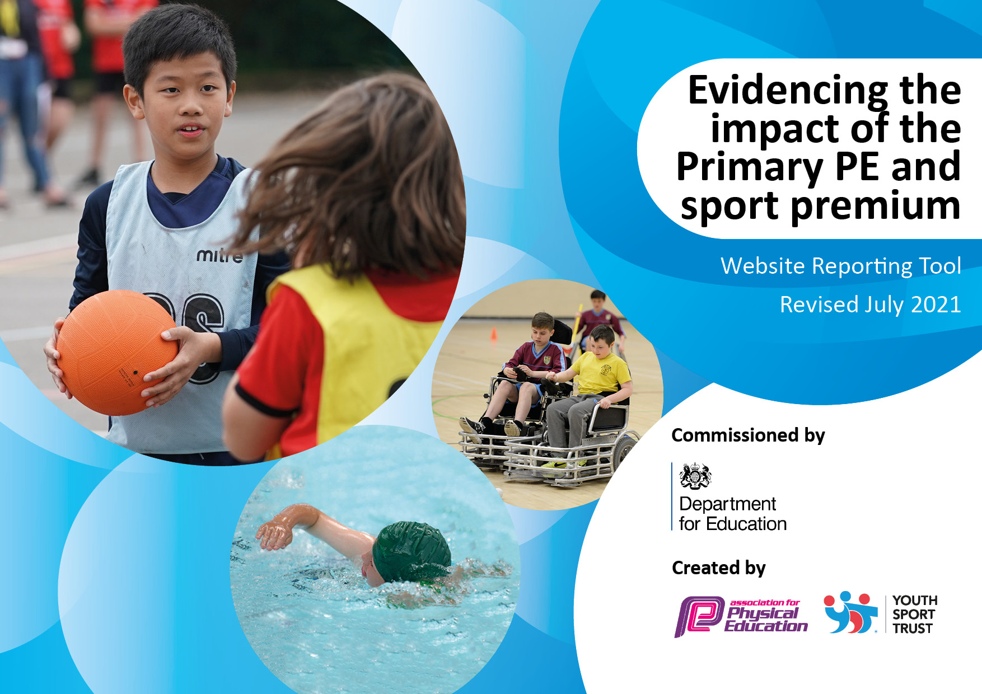
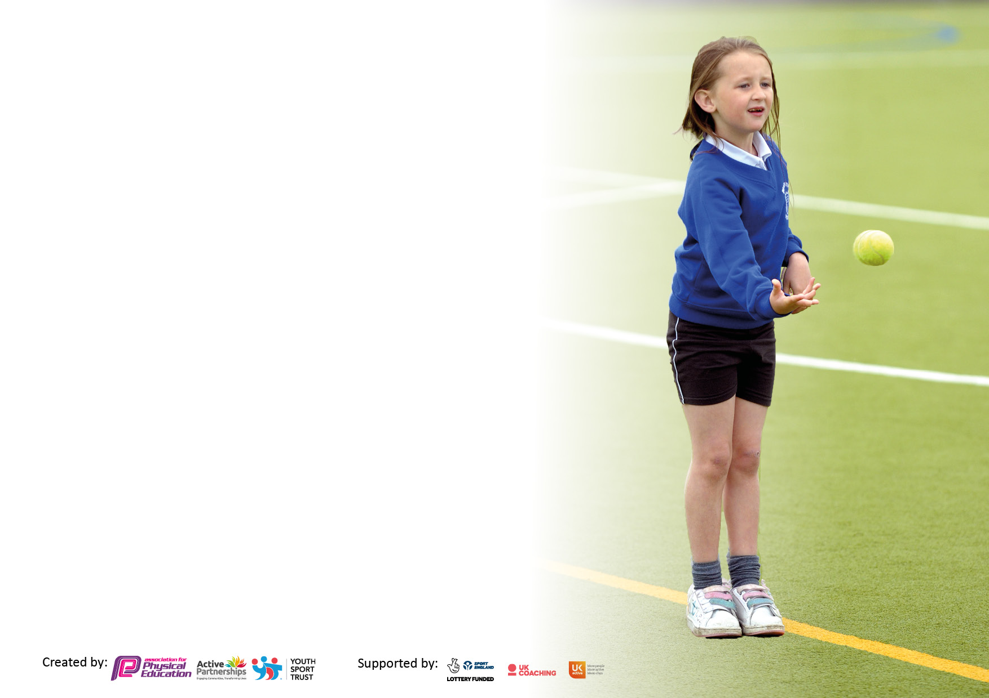

It is important that your grant is used effectively and based on school need. The Education Inspection Framework makes clear there will be a focus on ‘whether leaders and those responsible for governors all understand their respective roles and perform these in a way that enhances the effectiveness of the school’.

Under the Quality of Education Ofsted inspectors consider:
Intent - Curriculum design, coverage and appropriateness
Implementation - Curriculum delivery, Teaching (pedagogy) and Assessment
Impact - Attainment and progress

To assist schools with common transferable language this template has been developed to utilise the same three headings which should make your plans easily transferable between working documents.

Schools must use the funding to make additional and sustainable improvements to the quality of Physical Education, School Sport and Physical Activity (PESSPA) they offer. This means that you should use the Primary PE and sport premium to:

- Develop or add to the PESSPA activities that your school already offer
- Build capacity and capability within the school to ensure that improvements made now will benefit pupils joining the school in future years
- The Primary PE and sport premium should not be used to fund capital spend projects; the school’s budget should fund these.

Pleasevisitgov.ukfortherevisedDfEguidanceincludingthe5keyindicatorsacrosswhichschoolsshoulddemonstrate animprovement.Thisdocumentwillhelpyoutoreviewyourprovisionandtoreportyourspend.DfEencouragesschools to use this template as an effective way of meeting the reporting requirements of the Primary PE and sport premium.

We recommend you start by reflecting on the impact of current provision and reviewing the previous spend.

Schools are required to publish details of how they spend this funding, including any under-spend from 2019/2020, as well as on the impact it has on pupils’ PE and sport participation and attainment. All funding must be spent by 31st July 2022.

We recommend regularly updating the table and publishing it on your website throughout the year. This evidences your ongoing self-evaluation of how you are using the funding to secure maximum, sustainable impact. Final copy must be posted on your website by the end of the academic year and no later than the 31st July 2021. To see an example of how to complete the table please click HERE.

Details with regard to funding
Please complete the table below.

Total amount carried over from 2019/20 | £4,472
Total amount allocated for 2020/21 | £21,764
How much (if any) do you intend to carry over from this total fund into 2021/22? | £10,108
Total amount allocated for 2021/22 | £27,427
Total amount of funding remaining 2021/2022 To be spent by 31st July 2022 | £12,335.04
Swimming Data
Please report on your Swimming Data below.

Meeting national curriculum requirements for swimming and water safety.

N.B. Complete this section to your best ability. For example you might have practised safe self-rescue techniques on dry land which you can then transfer to the pool when school swimming restarts.
Due to exceptional circumstances priority should be given to ensuring that pupils can perform safe self rescue even if they do not fully meet the first two requirements of the NC programme of study
What percentage of your current Year 6 cohort swim competently, confidently and proficiently over a distance of at least 25 metres?  N.B. Even though your pupils may swim in another year please report on their attainment on leaving primary school at the end of the summer term 2020.  Please see note above | 87%
What percentage of your current Year 6 cohort use a range of strokes effectively [for example, front crawl, backstroke and breaststroke]?  Please see note above | 87%
What percentage of your current Year 6 cohort perform safe self-rescue in different water-based situations? | 87%
Schools can choose to use the Primary PE and sport premium to provide additional provision for swimming but this must be for activity over and above the national curriculum requirements. Have you used it in this way? | Yes

Action Plan and Budget Tracking
Capture your intended annual spend against the 5 key indicators. Clarify the success criteria and evidence of impact that you intend to measure to evaluate for pupils today and for the future.

Academic Year: 2020/21 | Total fund allocated: £21,764 | Date Updated:
Intent | Implementation |  | Impact | Sustainability and suggested next steps
Engagement of all pupils in regular physical activity.  Understand the importance and ways to keep fit.  New and developing skills in all areas of sport.  Sport is inclusive. | WLSP service brought in to deliver high quality PE sessions and afterschool clubs.  Forest schools.  Yoga  Health Related Fitness  Play Leaders  New Playground Equipment |  | All children receive high quality PE sessions, twice per week in which they make good progress as evidenced through thorough assessment. Children in KS1 and KS2 are engaged at break times with new equipment. Regular physical exercise is achieved. | Buy into WLSP Service for 2021-2022, 22-23.  Buy “Bolt On” services from WLSP. Review PE and playground equipment using Lunchtime leader and pupil voice.
Intent | Implementation |  | Impact | Sustainability and suggested next steps
To raise the profile of sports.  Children engaged in competition and learning through intra-school activities.  Inter-school activities.  Personal challenge.  Teamwork | Sports Council. Staff PE Kits. New House System, Team Points, intra-school competition. Certificates and rewards. Inter-school competition, School Games Involvement. New Sports Day equipment. Sports Board/Notice Board. |  | Children are aware of the house teams they are in. They have experienced competition and supported teammates. Children work in teams to participate and problem solve. School teams celebrated in assembly and through social media/website. | Sports Day held each Year with review of equipment and types of competition to ensure inclusion. WLSP to provide competition. Membership of TASA sports events.

Intent | Implementation | Impact | Sustainability and suggested next steps
Staff to be confident teaching in all areas of PE and Sport.  Staff to be supported with high quality resources and kit to deliver sessions. | WLSP delivery to be supported by teachers, works as continued CPD and staff access to “Succeedin” website where they can access accurately with PE coaches, retrieve high quality plans and research teaching methods. Staff now have outdoor sports coats and Polo shirts to wear on PE days. Good quality resources bought in. | Teachers are delivering follow up PE lessons with increased confidence and offering more meaningful experiences with the support of appropriate, plentiful resources and good quality planning from “Succeedin” website. | To continue to ensure teachers are present and fully supporting PE sessions. To continue to buy into WLSP service. To monitor follow up PE sessions. Evaluate resources.
Intent | Implementation | Impact | Sustainability and suggested next steps
Children to experience as broader range of sports and activities as possible.  Children to have confidence approaching new sporting challenges. | Involvement in OAA activities, problem solving and multi skills events, inter-school Archery, mindfulness, Yoga, Health Related Fitness. Afterschool clubs for athletics, football, striking and fielding, dodgeball, Bikeability, scooting stars. | All pupils have access to a new experience in sports. Different groups have been able to access various multi-skill and bowling events. Children receive certificates and rewards for their involvement. Whole school accessed Archery, Yoga and Health Related Fitness sessions. KS2 have had continuous weekly sports clubs. | Continue WLSP provision. Enter School Games Competitions. Target SEN or low competence/confidence groups.  Sign-post Gifted and Talented  To local clubs.

Intent | Implementation | Impact | Sustainability and suggested next steps
Children to experience high quality competition, inter and intra school.  Target groups for inclusion and to experience competition. | Enter as many competitions as possible through WLSP and School Games Organisation. Target groups for inclusion to give them good quality experiences. Promote intra-school competition week and reward stickers and certificates. | Children have all been involved in intra-school competition.  Gifted and Talented and SEN groups have had opportunities to represent the school in competition. | Continue to enter competitions using Platform on “Succeedin” website. To continue to assess with PE coaches and open lines of communication for competitors in upcoming events. Develop links with other schools to hold more local and regular sporting competitions in football and Kwik Cricket.

Signed off by
Head Teacher:
Date:
Subject Leader:
Date:
Governor:
Date:

