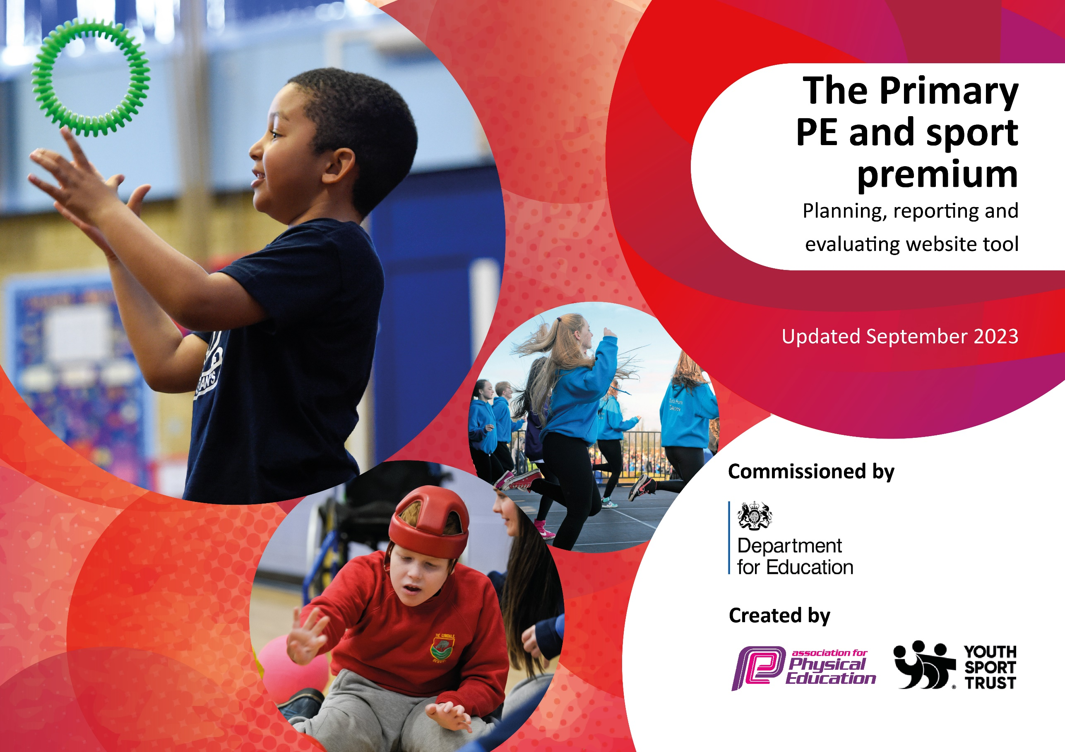

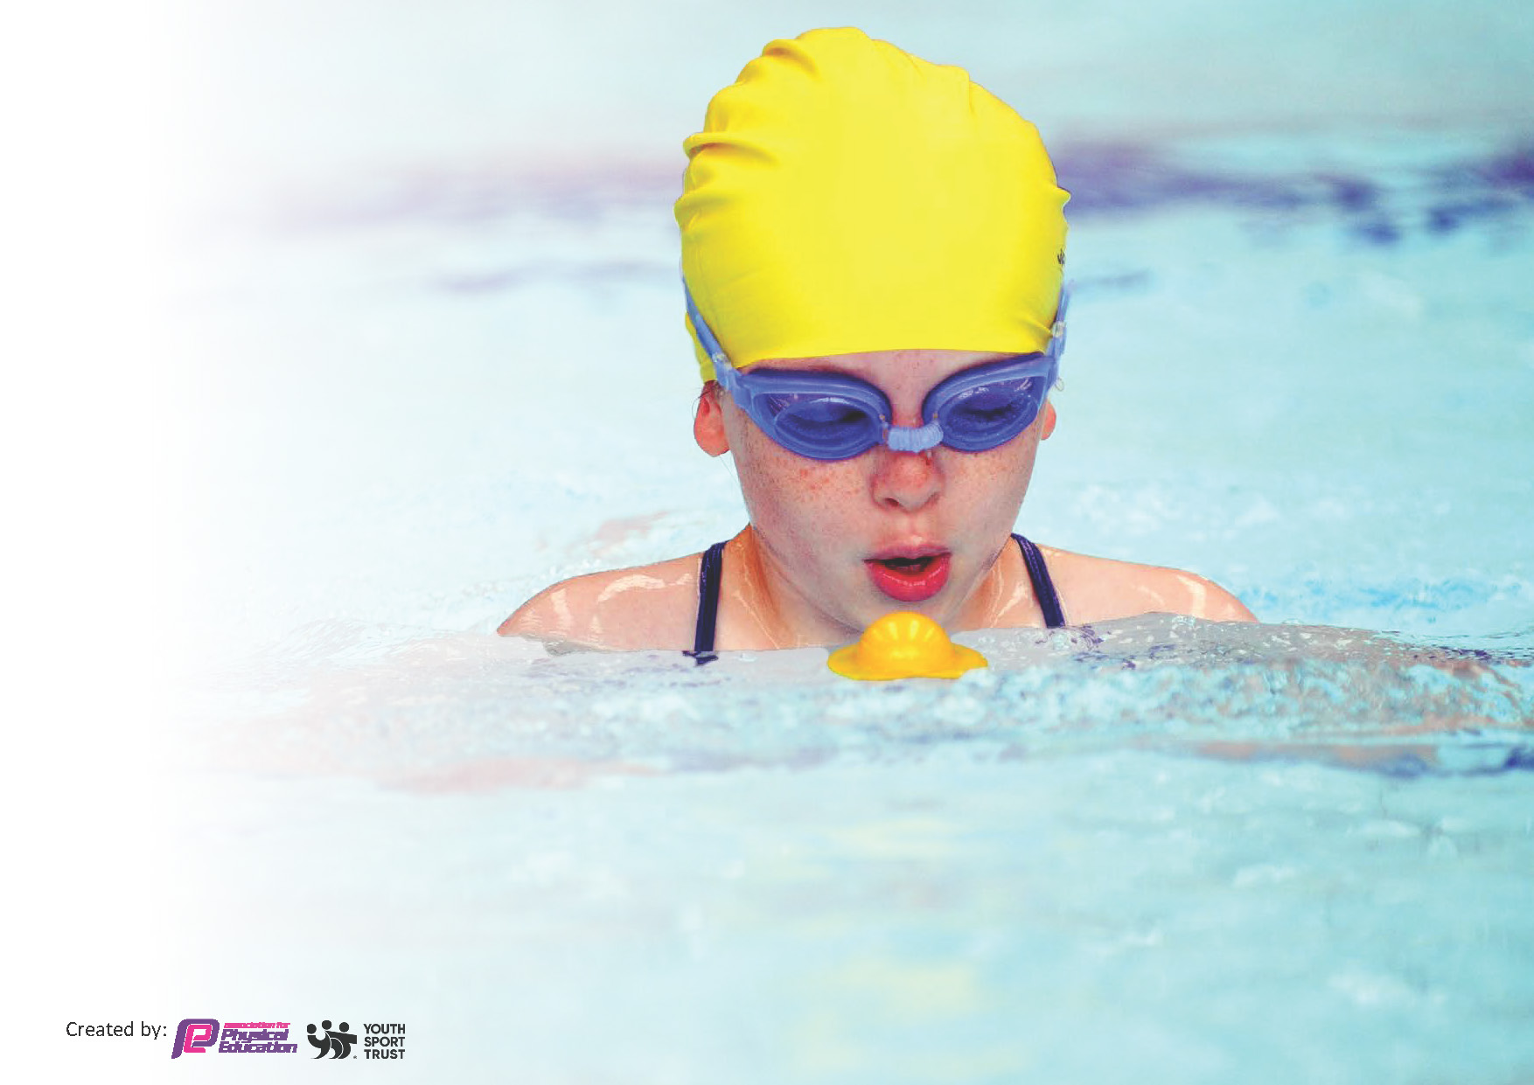
This template can be used for multiple purposes:
by:
- It enables schools to effectively plan their use of the Primary PE and sport premium
- It helps schools to meet the requirements (as set out in guidance) to publish information on their Primary PE and sport premium
- It will be an effective document to support Ofsted inspections enabling schools to evidence progress in Physical Education (PE) and evidence swimming attainment, which forms part of the PE National Curriculum. We would recommend schools consider
the Intent, Implementation and Impact of any spend, as examined within the Education Inspection Framework.

It is important that your grant is used effectively and based on school need.

Schools must use the funding to make additional and sustainable
improvements to the quality of the PE, School Sport and Physical Activity (PESSPA)
they offer. This means that you should use the Primary PE and sport premium to:

- Build capacity and capability within the school to ensure that improvements made now will benefit pupils joining the school in future years
- Develop or add to the PESSPA activities that your school already offers.

The Primary PE and sport premium should not be used to fund capital spend projects; the school’s core budget should fund these. Further detail on capital expenditure can be found in the updated Primary PE and sport premium guidance.

The Primary PE and sport premium guidance, outlines 5 key priorities that funding should be used towards. It is not

necessary that spending has to meet all the key priorities, you should select the priorities that you aim to use any funding towards.

Although completing this template is not a requirement for schools, schools are required to publish details of how they spend this funding. Schools must also outline what the impact this funding has had on pupils’ PE and sport participation and attainment and how any spending will be sustainable in the future. All funding must be spent by 31st July 2024.

The Department for Education has worked closely with the Association for Physical Education (afPE) and the Youth Sport Trust (YST) to develop this template and encourages schools to use it. This template is an effective way of meeting the reporting requirements of the Primary PE and sport premium.
Review of last year’s spend and key achievements (2022/2023)

We recommend you start by reflecting on the impact of current provision and reviewing your previous spend.

Activity/Action | Impact | Comments
- An increase to 1.5 Days High quality PE delivery from WLSP  - Continuous CPD for Teachers  - Swimming years 4,5,6.  - YOGA Mindfulness sessions  - New sports equipment to support class teacher delivery  - Football Kits  - Netball Kits  - Rugby Kits  - Sports Day resources.  - Forest Schools delivery  - 2 Sporting afterschool clubs- covering, invasion games, football, netball, rugby, cricket, dance and orienteering. | - Learners received high quality PE for longer periods from experts in different areas of PE.  - Increased confidence, participation and skill set.  - KS1 able to increase periods of Fundamental Movement Skills and further develop skills and confidence with running, jumping, throwing and catching.  - Learners experienced swimming from an earlier age to increase confidence in an area where many are never taken to swimming pools. Last year the school were dominant in the swimming gala and came away with 14 medals including 5 golds.  - Increased quality equipment in PE has increased enjoyment and a better teaching and learning experience for both teacher and pupils. Children can share or have their own piece of equipment.  - Greater participation in after school clubs, children joining teams from them and representing the school in inter-school competitions.  - Status of PE much higher in school and children wish to compete and wear kits with pride.  - School is performing well in inter-school competitions and has entered most events winning many including a Golf event where a small team won gold against much bigger schools. | - The impact, in all areas of PE and involvement with West Lancashire Schools Partnership has greatly enhanced the status of PE in school and helped us to achieve our 3rd School Games Gold Award. The aim is to achieve Platinum next year to further celebrate our proud achievements as we move through the next school year.

Key priorities and Planning
This planning template will allow schools to accurately plan their spending.

Action – what are you planning to do | Who does this action impact? | Key indicator to meet | Impacts and how sustainability will be achieved? | Cost linked to the action
e.g. Introduce lunchtime sport sessions/activities for pupils. | Lunchtime supervisors / teaching staff, coaches - as they need to lead the activity  pupils – as they will take part. | Key indicator 2 -The engagement of all pupils in regular physical activity – the Chief Medical Officer guidelines recommend that all children and young people aged 5 to 18 engage in at least 60 minutes of physical activity per day, of which 30 minutes should be in school.  Key indicator 4: Broader experience of a range of sports and activities offered to all pupils. | More pupils meeting their daily physical activity goal, more pupils encouraged to take part in PE and Sport Activities. | £1000 costs for additional coaches to support lunchtime sessions.

e.g. CPD for teachers. | Primary generalist teachers. | Key Indicator 1: Increased confidence, knowledge, and skills of all staff in teaching PE and sport.  Key indicator 5: Increased participation in competitive sport. | Primary teachers more confident to deliver effective PE supporting pupils to undertake extra activities inside and outside of school, including teaching water safety and swimming and as a result improved % of pupil’s attainment in PE. | £5000 for 5 teachers to undertake CPD.

Key achievements 2023-2024
This template will be completed at the end of the academic year and will showcase the key achievements schools have made with their Primary PE and sport premium spending.

Activity/Action | Impact | Comments

Swimming Data
Meeting National Curriculum requirements for swimming and water safety.
Priority should always be given to ensuring that pupils can perform safe self-rescue even if they do not fully meet the first two requirements of the National Curriculum programme of study

Question | Stats: | Further context  Relative to local challenges
What percentage of your current Year 6 cohort can swim competently, confidently and proficiently over a distance of at least 25 metres? | % | Use this text box to give further context behind the percentage.  e.g., 30% - we are struggling to get pool space due to our local pool closing so we have had to use a much smaller local school pool. We have had to limit the number of pupils attending swimming lessons during one term which means some pupils have attended fewer swimming lessons than others.
What percentage of your current Year 6 cohort can use a range of strokes effectively [for example, front crawl, backstroke, and breaststroke]? | % | Use this text box to give further context behind the percentage.  e.g., Even though your pupils may swim in another year please report on their attainment on leaving primary school at the end of the summer term 2024

What percentage of your current Year 6 cohort are able to perform safe self-rescue in different water-based situations? | % | Use this text box to give further context behind the percentage.
If your schools swimming data is below national expectation, you can choose to use the Primary PE and sport premium to provide additional top-up sessions for those pupils that did not meet National Curriculum  requirements after the completion of core lessons. Have you done this? | Yes/No
Have you provided CPD to improve the knowledge and confidence of staff to be able to teach swimming and water safety? | Yes/No

Signed off by:

Head Teacher: | (Name)
Subject Leader or the individual responsible for the Primary PE and sport premium: | (Name and Job Title)
Governor: | (Name and Role)
Date:

