Banks St. Stephen’s CE Primary School
Long Term Individual Subject Curriculum Plan 2020-21
Geography
 | Autumn 1 | Autumn 2 | Spring 1 | Spring 2 | Summer 1 | Summer 2
Y6 |  | A WORLD UNITED  (LK) Locate the world’s countries, using maps to concentrate on Europe (including the location of Russia) and North and South America, concentrating on their environmental regions, key human characteristics, countries and major cities (Building on prior learning from Y5 Au, Y4 Au and Y3 Au).  Identify the position and significance of the Prime/Greenwich Meridian and time zones (including day and night).  (H&Ph) Describe and understand key aspects of human geography including: economic activity including trade links and the distribution of natural resources including energy and minerals.  (Aims) Pupils understand the processes that give rise to key human geographical features of the world, how these are interdependent and how they bring about spatial variation and change over time.  (GS&F) Use world maps, atlases and digital/ computer mapping to locate countries and describe features studied.  (Aims) Pupils are competent in the geographical skills needed to interpret a range of sources of geographical information including Geographical Information Systems (GIS).  In this unit the children will bring together their prior learning on the world’s continents and countries. They will locate major cities across the world. The children will consider the relationships between various countries and the impact of the physical landscape on human events. They will study the distribution of key natural resources including energy and minerals (building on prior learning in Y5 Su). Children will learn about the international use of GIS in finding and sourcing these commodities. Children will focus on the environmental regions and key physical/ human characteristics of North and South America. They will learn about the Prime Meridian and time zones across the world. Then children will apply this learning to reflect on trade and the emergence of the BRIC nations.  Vocabulary including:  Prime/ Greenwich Meridian, time zones, trade, distribution, minerals, GIS – geographical information systems, emergent, BRIC nations |  | THE WONDERS OF THE WORLD  (LK – Aims) Develop contextual knowledge of the globally significant places – both terrestrial and marine – including their defining physical and human characteristics.  (GS&F – Aims) Communicate geographical information in a variety of ways, including through maps, numerical and quantitative skills and writing at length.  In this unit the children will draw from their prior learning of key human and physical locations in the world. The children will spend an extended period in personal study of an area of particular interest to them based on consideration of one of the following:  The New 7 Wonders of the World / The New 7 Wonders of Nature / The New 7 Wonders Cities / The 7 Wonders of the Underwater World / The 7 Wonders of the Industrial World.  As a class, the children will consider The Mariana Trench and together research aspects of its physical and human geography. They will communicate this learning through varying maps, graphs and written explanation. This example will act as a basis for the form which their chosen individual topic should take.  Vocabulary including:  terrestrial, marine,  The Mariana Trench, |  | COASTS  (LK) Locate geographical regions and their identifying human and physical features and key topographical features (including hills, mountains, coasts and rivers).  (H&Ph) Describe and understand key aspects of physical geography including: biomes (a coastal ecosystem).  (GS&F) Use six-figure grid references, symbols and key (including the use of Ordnance Survey maps).  Use fieldwork to observe, measure, record and present the physical features in the local area using a range of methods including sketch maps, plans, graphs and digital technologies.  Banks – focus on learning about and experiencing the local coastal areas.  In this unit the children will build in prior learning about biomes (Y5 Au) and apply this to more detail to the local coastal ecosystem. They will study the different features that coastlines can display and where they can be found in the UK. The children will examine Ordnance Survey mapping of our local coastline, analysing its varied land types and features. They will undertake fieldwork reviewing the flora and fauna of this coastal area and investigating the longshore drift on the beach.  The children will go on to consider the future of this area of coastline, taking into account factors such as sea levels and dune movement.  Vocabulary including:  low tide, high tide, tidal reach, wave, dune, dune slack, cave, headland, stack, wave, marram grass, restharrow, sea sandwort, sand lizard, natterjack toad, red squirrel, seagull, tern, curlew, redshank, crab, mollusc, longshore drift
Y5 | THE AMAZON BASIN – A REGION IN SOUTH AMERICA  (LK) Locate the world’s countries (those relevant to this unit, building on prior learning in Y4 Au and Y3 Au units).  Identify the position and significance of latitude, longitude and the Tropics of Cancer and Capricorn.  (PK) Understand geographical similarities and differences through the study of human and physical geography of a region in a European country (in comparison with the prior learning from the Y3 Su unit on Merseyside, UK and the  Y4 Au European unit on Catalonia, Spain).  (H&Ph) Describe and understand key aspects of physical geography including: climate zones, biomes and vegetation belts.  (GS&F) Use world maps, atlases and digital mapping to locate countries and describe features studied.  In this unit children will study the geography of the Amazon Basin – the region of South America drained by the River Amazon and its tributaries. Children will build on prior learning about regions -comparisons with Merseyside (Y3 Su unit) and Catalonia, Spain (Y4 Au). They will also apply prior learning on rivers (Y4 Su). Children will learn about climate zones and the various world biomes. They will focus on the tropical rainforests, in particular, the Amazon. Children will learn about the layers of the rainforest and the varying flora and fauna at each stage. They will go on to consider how the future of these rainforests and other ecosystems is closely connected to human lives and lifestyles.  Vocabulary including:  latitude, longitude, the Tropics of Cancer and Capricorn, climate zone, biome, ecosystem, aquatic biome, rainforest biome, tundra, desert, taiga, deciduous forest, grassland, emergent layer, canopy layer, understory layer, forest floor, humidity, coniferous / deciduous forest, flora, fauna, temperate, tropical, monsoon, polar, extractive industry |  | FOOD – WHERE DOES IT COME FROM?  (LK) Locate the world’s countries concentrating on their environmental regions (those relevant to this unit, building on prior learning in Y5 Au, Y4 Au and Y3 Au units).  (H&Ph) Describe and understand key aspects of human geography including: land use and economic activity and the distribution of natural resources including water and food.  (GS&F) Use atlases and digital mapping to locate countries and describe features studied.  Use six-figure grid references to build their knowledge of the United Kingdom and the wider world.  Use fieldwork to observe, measure, record and present the human and physical features in the local area using a range of methods, including sketch maps, plans, graphs and digital technologies.  Banks – local agricultural business, visiting Flavourfresh and analysis of their production (tomatoes, strawberries, blueberries and blackberries).  In this unit the children will learn about the diverse locations around the world that our food comes from. They will consider the human and physical reasons why crops are grown in these locations (climate, soil, gradient, land tenure, demand, technology and transportation).  The children will then apply these factors at a local level, looking Flavourfresh, a commercial glasshouse producer based in Banks. They will consider the crops produced and the various reasons why these should be successful here. They will plan the route for their visit to Flavourfresh. Children will complete plans of the locations considering the different crops being cultivated in each of them. For this fieldwork visit, children will build on prior learning of 4 figure grid references (Y3 Sp) to learn to use 6 figure grid references.  Vocabulary including:  gradient, land tenure, demand, technology, transportation, commercial, glasshouses, 6 figure grid references |  | A KINGDOM UNITED  (LK) Name and locate counties and cities of the United Kingdom, geographical regions, and their identifying human and physical characteristics, key topographical features (including hills, mountains, coasts and rivers), and land-use patterns; and understand how some of these have changed over time. (To built on some prior learning, especially from Y3 Sp unit).  (H&Ph) Describe and understand key aspects of human geography including: types of settlement and land use.  (GS&F) Use atlases and digital mapping to locate countries and describe features studied.  Use the eight points of a compass to build on their knowledge of the wider world (building on previous learning in Y3 Sp).  Banks – controversial local issue of fracking in Lancashire.  In this unit the children will build on previous learning about the United Kingdom (especially from Y3 Sp and Y2 Sp). They will now go into more depth covering the detail of the counties and cities. The children will consider the variety of UK land types, its impact upon the economics of the regions and the development of settlements (building on similar work in their previous unit – Y5 Sp, when they considered these aspects at a world level). This will lead into consideration of the energy and water needs. They will then look at local water and energy concerns: where our water comes from and the controversial topical issue around fracking.  Vocabulary including:  county, topographical feature, controversy, fracking, hydraulic fracturing, shale gas, campaigners, contamination, methane, groundwater, employment
Y4 |  | CATALONIA - A REGION IN EUROPE  (LK) Locate the world’s countries, using maps to focus on Europe (including the location of Russia). Locate countries within Europe and the major cities.  (PK) Understand geographical similarities and differences through the study of human and physical geography of a region in a European country (in comparison with the prior learning from the Y3 Su unit on Merseyside, UK).  (H&Ph) Describe and understand key aspects of physical geography including: mountains and human geography including: land use, economic activity and distribution of natural resources including minerals (those relevant to this topic).  (GS&F) Use world maps, atlases and digital mapping to locate countries and describe features studied.  In this unit the children will study Catalonia – a region of Europe located in the northwest of Spain. The children will consider key aspects of the human and physical geography of the region. The children will compare this region with Merseyside (using the knowledge from their prior Year 3 unit. These UK and European regions will then be compared with a region in South America: The Amazon in Year 5).  Vocabulary including:  Europe, European Union, autonomy, independence, region, mountain, glacier, industry, rural, economy, minerals, energy |  | THE ENVIRONMENT  (LK) Identify the position and significance of the Arctic and Antarctic Circle.  (H&Ph) Describe and understand key aspects of physical geography including: vegetation belts and human geography including: land use, economic activity and the distribution of natural resources including energy and water.  (GS&F) Use world maps, atlases and digital mapping to locate countries and describe features studied.  In this unit the children will learn about the importance of taking care of the environment. They will consider environments at a range of scales from the classroom to the whole world. It will include issues around litter and waste e.g. damage to the environment; reducing the level of resource use as well as the issue of the recycling of resources. They will begin to identify and explain the differing views that people have about topical environmental issues e.g. flooding/ water scarcity, Greta Thornberg and the climate change eco- protests.  Vocabulary including:  environment, vegetation belt, crops, harvest, distribution, natural resources, recycling, energy, topical issue, climate change, scarcity |  | RIVERS  (LK) Locate the world’s countries (those relevant to this unit, building on prior learning in Y4 Au and Y3 Au units).  and key physical characteristics.  (H&Ph) Describe and understand key aspects of physical geography including: rivers, mountains and the water cycle.  (GS&F) Use world maps, atlases and digital mapping to locate countries and describe features studied.  (GS&F) Use fieldwork to observe, measure, record and present the human features in the local area using a range of methods including sketch maps, plans, graphs and digital technologies.  Banks: consider the sources of local rivers – Alt, Douglas, Lostock and Ribble. Study the course of the River Lostock and conduct fieldwork study.  In this unit children will learn about rivers and the water cycle. They will consider the location of the major world rivers, the main UK rivers and also our local rivers (building on prior learning from Y2 Sp and Y3 Sp). The children will learn about the process of the water cycle in the context of these rivers. They will then learn that rivers have sources, channels, tributaries and mouths, that they receive water from a wide area and that most flew eventually into a lake or sea. They will learn that human activity affects and is influences by rivers. The children will undertake fieldwork in the context of the local River Lostock at Cuerden Valley Park.  Vocabulary including:  water cycle, evaporation, condensation, source, stream, river, upper, middle and lower courses, erosion, waterfall, meander, ox-bow lake, reservoir, lake, estuary, river mouth
Y3 | VOLCANOES AND EARTHQUAKES  (LK) Locate the world’s countries (those relevant to this topic).  Identify the position of the Northern and Southern Hemispheres in reference to the Equator.  (H&Ph) Describe and understand key aspects of physical geography including: volcanoes and earthquakes.  (GS&F) Use world maps, atlases and digital mapping to locate countries and describe features studied.  In this unit children will investigate earthquakes and volcanoes: what they are; why they happen; and how they affect the landscape and human activity. They will learn that the world is constantly moving and changing, inside and on the surface (plate tectonics) resulting in physical features such as earthquakes and volcanoes. They should begin to ask questions about what they hear in the news and make links between what is happening around the world (e.g. natural disasters and what they have learnt in school. For example:  recent volcanic activity: White Island, NZ in December 2019.  Vocabulary including:  Northern Hemisphere, Southern Hemisphere, volcano, earthquake, eruption, dormant, extinct, earthquake zone, seismometer, Richter scale, tidal wave, tsunami |  | THERE’S NO PLACE LIKE HOME  (LK) Name and locate counties and cities in the UK (those relevant to this topic). Identify local regions and identify their human and physical characteristics, key topographical features (including hills, mountains, coasts and rivers) and land-use patterns; and understand how some of these aspects have changed over time.  (H&Ph) Describe and understand key aspects of physical geography including: volcanoes and earthquakes.  (GS&F) Use maps, atlases, globes, and digital mapping to locate countries and describe features studied.  Use four figure grid references, symbols and keys (including the use of Ordnance Survey maps).  Use the eight points of a compass to build on their knowledge of the United Kingdom.  Banks – learn about key local topographical features e.g. glacial outfall features: at the Pumping Station, the Criffel granite erratic.  The children will learn about the local mere and how its drainage over time has affected the local area.  In this unit children will develop on their previous learning about their local area. They will investigate using maps, aerial photos and satellite imagery. They should consider a range of human and physical features of their wider region (building on previous learning about the closer local area). This will be tie in with learning about the changes in land use of Martin Mere, at one time one of the largest freshwater lakes in the country. They will learn how over the last few centuries the works necessary for its drainage have had a substantial impact on the geography of the local area.  The children should begin to realise the impact that scale has on maps i.e. that different types of maps e.g. Ordnance Survey , GoogleEarth etc show different features in more/ less detail.  Vocabulary including:  scale, Ordnance Survey, settlement, land use, crop, region, postcode, four figure grid reference, mere, marshland, drainage, ditch, floodgates, sluice, silt |  | MERSEYSIDE – A REGION IN THE UK  (LK) Name and locate cities in the UK (top 10 largest cities).  (PK) Understand geographical similarities and differences through the study of human and physical geography of a region of the UK.  (H&Ph) Describe and understand key aspects of human geography including: land use and economic activity.  (GS&F) Use fieldwork to observe, measure, record and present the human features in the local area using a range of methods including sketch maps, plans, graphs and digital technologies.  In this unit the children will study a region of the UK: Merseyside (encompassing both banks of the lower reaches of the Mersey Estuary). The children will consider key aspects of the human and physical geography of the region. (This will then be compared with a European region: Catalonia in Year 4 and a region in South America: The Amazon in Year 5).  The children will undertake urban fieldwork to collect and record data for analysis back at school.  Vocabulary including:  region, city, borough, river, estuary, urban, rural, sketch map, plan, land use, economic activity
Y2 |  | KIBERA/ KAPTALMWA, KENYA – A CONTRASTING NON-EUROPEAN COUNTRY  (LK) Name and locate the world’s 7 continents and 5 oceans.  (PK) Understand geographical similarities and differences through studying the human and physical geography of a small area of a small area of the UK and a small area of a contrasting non-European country.  (H&Ph) Use basic geographical vocabulary including: ocean, mountain, valley, vegetation, port and harbour  (GS&F) Use world maps, atlases and globes to identify the continents and oceans studied at this key stage.  In this unit the children will learn about Kibera / Kaptalmwa, a small area in Kenya, East Africa. Initially, they will examine the broader geographical location of the area – its country/ continent/ location on the globe.  Children will then explore similarities and differences between this area and our local area of Banks (based on knowledge gained from previous topics).  Vocabulary including:  ocean, mountain, valley, vegetation, cliff, port and harbour |  | THE PLACE WHERE I LIVE  (LK) Name, locate and identify the 4 countries and capital cities of the UK and the surrounding seas.  (PK) Understand geographical similarities and differences through studying the human and physical geography of a small area of a small area of the UK and a small area of a contrasting non-European country.  Banks: consider the links between local place names and their geographical explanations.  In this unit the children will initially recap and extend previous learning on the countries of the UK. They will also learn about the surrounding and main rivers. The children will then consider where Banks is, in relation to the rest of the UK. They will build on prior learning to investigate the different types of recreation that we have locally – whether these are human or physical features. They will build a sense of the area, why certain buildings/ objects are in the places that they are.  Vocabulary including:  sea, river, recreation, recreational area, residential, commercial and industrial |  | SEASONAL AND DAILY WEATHER  (H&Ph) Identify seasonal and daily weather patterns in the UK.  (GS&F) Use simple fieldwork and observational skills to study the geography of the school and its grounds and the key human and physical features of its surrounding environment.  Use simple compass directions (North, South, East and West) and locational and directional language to describe the location of features and routes on a map.  Devise a simple map and construct basic symbols in a key.  Banks: build on previous learning about the local area, focusing on the built environment directly around the school grounds.  In this unit the children will learn about seasonal and daily weather patterns in the United Kingdom. They will observe and record weather conditions and start to consider how these affect human activity.  The children will also build on learning from previous units in studying the geography of the area surrounding the school. Children will consider the human and physical features of the surrounding area that they previously learnt about but now they will use this knowledge to create maps with keys.  Vocabulary including:  weather pattern, precipitation, cloud cover, temperature, degrees centigrade, data, symbol, key, route
Y1 | HOT AND COLD PLACES  (LK) Name and locate the world’s 7 continents.  (H&Ph) Identify the location of hot and cold areas of the world in relation to the Equator and the North and South Poles.  Use basic geographical vocabulary to refer to key physical and human features.  (GS&F) Use world maps, atlases and globes to identify the continents.  Use world maps, atlases and globes to identify the United Kingdom.  Use simple compass directions: North, South, East and West.  This unit aims to help children to think geographically and to equip them with key knowledge about the continents, the Equator and the North and the South Poles. They will consider the meaning of the terms: human/ physical features and distinguish between examples of each.  Vocabulary including:  continent, country, land,  sea, North, South, East, West the North Pole, the South Pole, the Equator, human feature, physical feature |  | UK COUNTRIES  (LK) Name, locate and identify characteristics of the 4 countries and capital cities of the UK.  (H&Ph) Use basic geographical vocabulary including: city, capital city, town, village  (GS&F) Use world maps, atlases and globes to identify the United Kingdom and its countries.  Banks: Location of Banks in the UK.  In this unit children learn to name, locate and identify the characteristics of the four countries of the United Kingdom (England, Scotland, Wales and Northern Ireland) as well as their capital cities (London, Edinburgh, Cardiff and Belfast).  Children will learn which country Banks is situated in and which part of England it is in.  Vocabulary including:  country, land, sea, city, capital city, town, village |  | THE GREAT OUTDOORS  (H&Ph) Identify seasonal and daily weather patterns in the UK.  Use basic geographical vocabulary including: beach, coast, forest, hill, river, soil, season, weather, factory, farm, house, office, shop and church  (GS&F) Use simple fieldwork and observational skills to study the geography of the school and its grounds.  Use simple compass directions (North, South, East and West) and locational and directional language to describe the location of features and routes on a map.  Use aerial photographs and plan perspectives to recognise landmarks and basic human and physical features.  Devise a simple map.  Banks: Identify the key human and physical features of the Banks locality.  In this unit the children will learn simple fieldwork skills, including observation and recording, to study the geography of the school and its grounds. They will also investigate the key human and physical features of the surrounding area.  Vocabulary including:  season, weather, building, aerial photograph, plan perspective, human feature, physical feature, beach, cliff, coast, marsh, forest, hill, river, soil, season, weather, factory, farm, house, office, shop, church, road and path

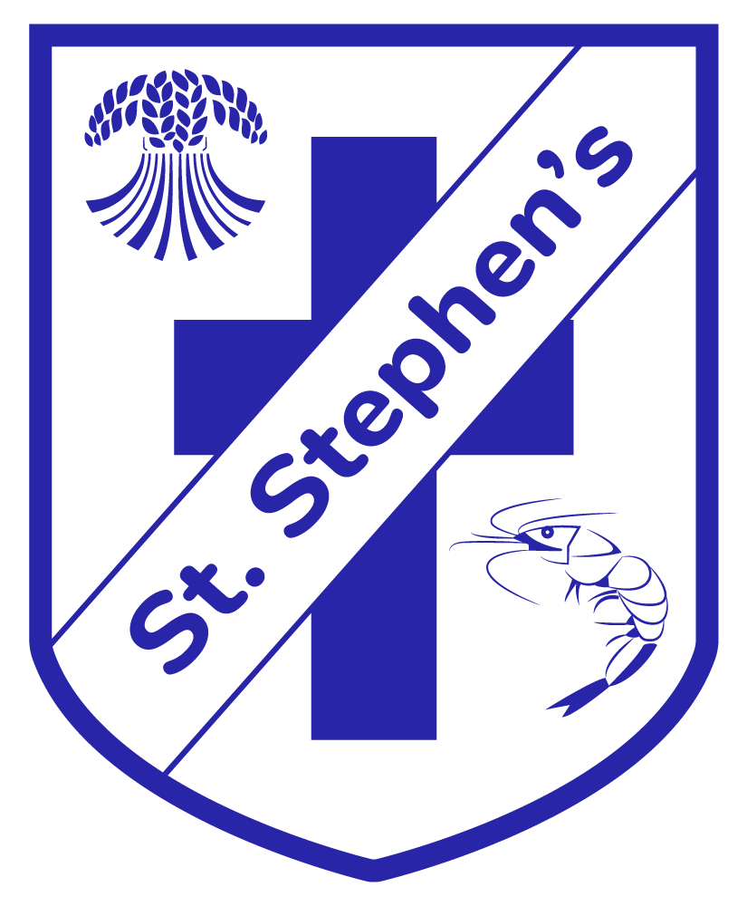

EYFS
Understanding The World – Geographical Development

EYFS Development Bands | Key Learning | Vocabulary
Birth To Five Matters  Range 5  - Comments and asks questions about aspects of their familiar world such as the place where they live or the natural world.  - Can talk about some of the things they have observed such as plants, animals, natural and found objects.  - Talks about why things happen and how things work.  - Develop and understanding of growth, decay and changes over time.  - Shows care and concern for living things and the environment.  Range 6  - Looks closely at similarities, differences, patterns and change.  Statutory Framework Early years Foundation Stage Curriculum 2021  Statutory ELG: People, Culture and Communities Children at the expected level of development will: - Describe their immediate environment using knowledge from observation, discussion, stories, non-fiction texts and maps; - Know some similarities and differences between different religious and cultural communities in this country, drawing on their experiences and what has been read in class; - Explain some similarities and differences between life in this country and life in other countries, drawing on knowledge from stories, non-fiction texts and – when appropriate – maps. | Communication: talk about the features of different places (familiar/other places), talk about patterns and change in relation to places with which they are familiar.  Fieldwork – looking closely at similarities and differences between different places (familiar/ other places), making simple comparisons  Use of Technology – using technology and IT equipment (e.g. camera, iPad, video/ video clips, apps, visualisers or the internet) to make observations or find  information about different locations and places  Mapping – knowing about features of different places, to recognise and talk about the features in familiar/ other places  Enquiry – comment and ask questions about familiar/other places and familiar/other people.  The objectives are taught through the medium of topics or themes that the children show interest in. | house, school, shops, office, bank, church, mosque, farm buildings, stables, village hall, garage, swimming baths, markets, museums, railway station, bus station, garden centre, bridge, lane, street, motorway, cul-de-sac, avenue, roundabout, traffic lights, crossings, fence, wall, gate , railings, pier, promenade, lighthouse, lifeboat station, park, playground, café, lake, grass, lawn, trees, hedge, flowers, boundary, flower beds, vegetable plot, wild flowers, paths, pond, lake, sea, beach, sand

