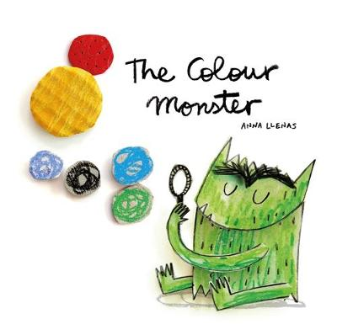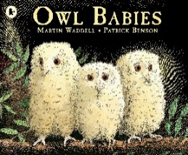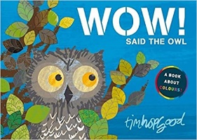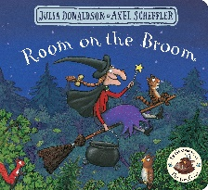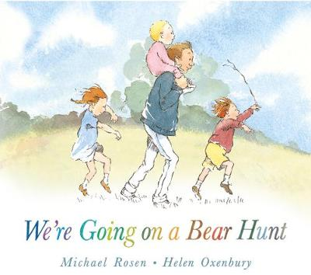

OUR BOOKS OF THE WEEK

KEY VOCABULARY

|  |  |  |  |
| --- | --- | --- | --- |
| Colours | Red, yellow, green, blue, pink, brown, black, white, purple, rainbow, mixing, painting, colouring, daytime, night-time, potions. | Starting Nursery | Teacher, friends, games, toys, learning, singing, listening, joining in, lunchtimes, tables, chairs, carpet, home-time. |
| Feelings | Happy, sad, angry, worried, calm, confused, sharing, talking, comfort. | Changing Me | Baby, toddler, child, grow, change, mummy, daddy, brother, sister, pram, cot, nappies, high-chair, bottle, talking, walking, playing. |
| My School | Classroom, playground, garden, lunch hall, field, woodland, corridor, office, school. | My Body | Head, nose, ears, eyes, mouth, hair, arms, legs, feet, hands, walk, run, jump, skip, fast, slow, heart, hot, tired. |

WHAT WE ARE LEARNING ABOUT

* COLOUR NAMES
* COLOUR ASSOCIATIONS AND MATCHING
* MIXING COLOURS (PAINTS, COLOURED WATER, CRAYONS)
* MAKING A RAINBOW
* HOW ARE RAINBOWS MADE IN NATURE?
* BEING AT SCHOOL AND MAKING FRIENDS
* SITTING AND LISTENING ON THE CARPET AND JOINING IN WITH SONGS AND GAMES
* LISTENING TO STORIES
* NAMING OUR FEELINGS AND WHEN WE FEEL THAT WAY
* EXPLORING SCHOOL AND MAKING SCHOOL MAPS
* HOW WE HAVE CHANGED SINCE BEING BABIES
* NAMING PARTS OF OUR BODY
* THINKING ABOUT HOW OUR BODIES MOVE
* HARVEST FESTIVAL
* LEARNING THE RULES OF FOREST SCHOOL
* ACTING OUT STORIES



FOX CUBS CURRICULUM LEAFLET

Autumn 1

All the Colours of the Rainbow

PERSONAL, SOCIAL & EMOTIONAL DEVELOPMENT

**WE WILL BE:**

-USING SONGS TO HELP US LEARN ROUTINES.

-TALKING ABOUT FEELINGS.

-TALKING ABOUT OUR FAMILIES.

**YOU CAN HELP AT HOME BY:**

-TALK TO ME ABOUT FEELINGS.

-EXPLORE PHOTOGRAPHS OF PEOPLE WHO ARE IMPORTANT TO ME.

LITERACY

**WE WILL BE:**

-LISTENING TO STORIES.

-JOINING IN WITH REPEAT REFRAINS.

-MAKING MARKS IN A VARIETY OF WAYS.

**YOU CAN HELP AT HOME BY:**

-READING A VARIETY OF STORIES WITH ME EVERY DAY.

UNDERSTANDING THE WORLD

**WE WILL BE:**

-EXPLORING HOW WE HAVE CHANGED SINCE BEING BABIES.

-EXPLORING OUR SCHOOL COMMUNITY.

-EXPLORING OUR OUTDOOR AREAS.

**YOU CAN HELP AT HOME BY:**

-LOOKING AT BABY PHOTOS AND VIDEOS.

EXPRESSIVE ARTS

**WE WILL BE:**

-PAINTING AND PRINTING.

-CONSTRUCTING WITH A VARIETY OF RESOURCES.

-EXPLORING MUSIC OUTDOORS.

**YOU CAN HELP AT HOME BY:**

-LOOKING AT WAYS TO MAKE MUSIC AND RHYTHM WITH OBJECTS OR INSTRUMENTS AROUND THE HOME.

MATHEMATICAL DEVELOPMENT

**WE WILL BE:**

-SINGING NUMBER SONGS.

-COUNTING IN A VARIETY OF WAYS.

-EXPLORING 2D SHAPE.

**YOU CAN HELP AT HOME BY:**

-COUNTING WITH ME IN A VARIETY OF SITUATIONS AT HOME AND OUT AND ABOUT.

LANGUAGE & COMMUNICATION DEVELOPMENT

**WE WILL BE:**

-LISTENING AND JOINING IN AT CARPET TIMES.

-WAITING OUR TURN IN CONVERSATIONS.

**YOU CAN HELP AT HOME BY:**

-TALK TO ME ABOUT MY DAY IN NURSERY AND ABOUT MY NEW FRIENDS.

PHYSICAL DEVELOPMENT

**WE WILL BE:**

-EXPLORING GROSS AND FINE MOTOR SKILLS.

-MOVING LIKE CHARACTERS IN STORIES.

**YOU CAN HELP AT HOME BY:**

-TAKING ME TO PARKS AND PLAY AREAS AND ENCOURAGING ME TO PLAY, CLIMB, SWING, JUMP, GRAB AND SLIDE!