BANKS ST. STEPHEN'S C.E. PRIMARY SCHOOL
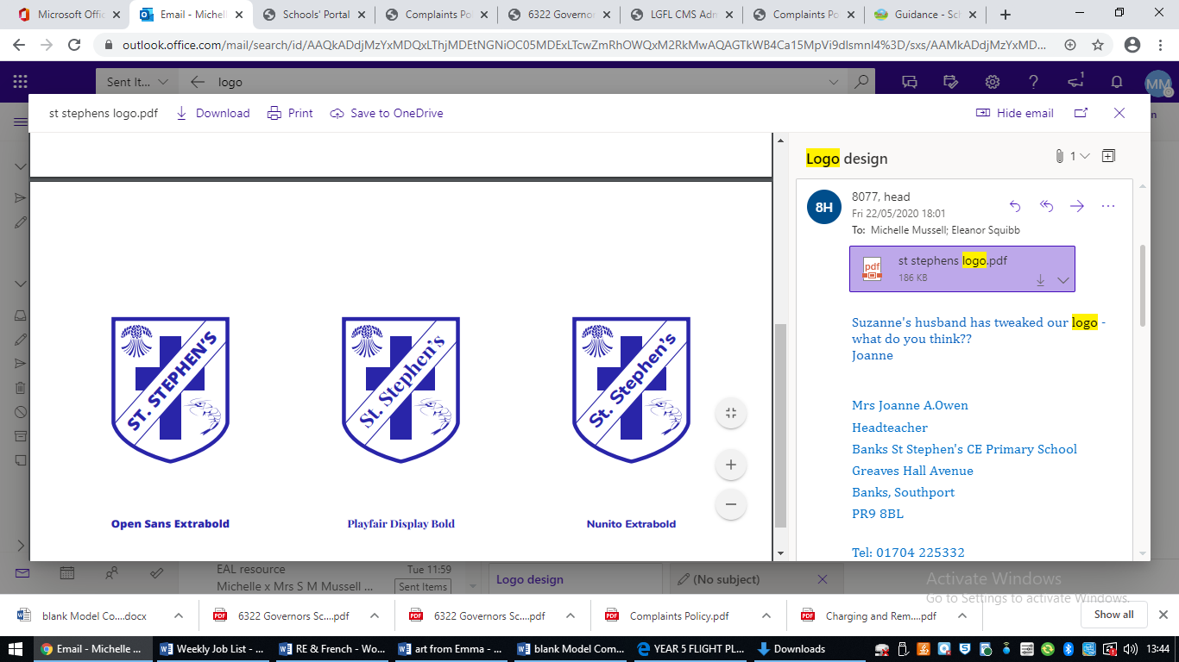

PHONICS POLICY

Updated September 2025
Banks St. Stephen’s Church of England Primary School
“Belonging, Serving, Succeeding”

Vision for Banks St. Stephen’s Church of England Primary School

“We actively promote a sense of pride in belonging to this community. Leading by example, we seek opportunities to serve God by serving others. We are ambitious for each individual and determined to enable every member of the school community to flourish and succeed.”

Intent
At Banks St Stephen’s, we believe that reading is central to all learning. Developing fluent, confident readers enables pupils to access the full curriculum and broadens their opportunities to explore new knowledge and experiences.
To read with understanding, pupils must first be able to recognise and decode the words on the page. High-quality phonics teaching provides the foundation for secure word recognition and decoding, supporting pupils to develop fluency. Once fluency is achieved, children are able to read for pleasure, which in turn allows teachers to focus on developing higher-level comprehension skills.
Implementation
Teaching
Children in Early Years and Key Stage One follow a structured, synthetic phonics programme, ‘Red Rose Phonics’. They are taught using multi-sensory, engaging activities and resources, both exclusively and within continuous provision activities if appropriate for the year group. Each session gives an opportunity for children to revisit their previous experience, be taught new skills, practise together, and apply what they have learned.
Phonics lessons are delivered in a carefully sequenced and progressive manner to ensure that pupils develop secure and confident reading skills. At Banks St Stephen’s, we maintain high expectations for all pupils, with the aim that they are secure in each phonics phase by the designated end points outlined below. Pupils who are identified as not being on track are promptly recognised and provided with timely, targeted intervention to enable them to ‘keep up not catch up.’
Phase | Date to be Secured
Phase 1 | End of Pre-school
Phase 2 | End of Reception Autumn 2
Phase 3 | End of Reception Summer 1
Phase 4 | End of Reception Summer 2
Phase 5 | End of Year 1 (before phonics screening)

Assessment
The online phonics tracker system is used systematically to record and monitor pupils’ phonics attainment. In Reception and Year 1, whole-class assessments are carried out on a termly basis. For pupils receiving targeted support, gap-focused assessments are conducted fortnightly to ensure progress is closely tracked.
These assessments identify the specific sounds within each phase that pupils have secured and inform the formation of targeted intervention groups. This approach ensures that all pupils are supported to keep pace with their cohort. In addition, teachers make use of daily assessment for learning (AfL) strategies within phonics sessions to inform subsequent teaching and provide responsive follow-up activities.
All pupils in Year 1 will take part in the ‘Phonics Screening Check’ which is a statutory assessment carried out in June each year. Any pupil who does not attain the required standard will repeat the screening in Year 2 having accessed support and intervention programmes to equip them with sufficient knowledge and understanding. This is to ensure that all pupils have a secure foundation upon which to build their reading and writing skills

Inclusion
Inclusion is central to our phonics provision and we maintain high expectations for all pupils to develop the fundamental skill of reading, regardless of background or starting point. In EYFS, individual targets are identified and daily phonics-linked support is provided for children who are struggling to keep up, ensuring early gaps are addressed promptly. In KS1, and KS2 where required, Bounce Back Phonics and Fast Track Phonics interventions are used to support children who are not meeting age-related expectations in Year 1 or who have not passed the Phonics Screening Check in Year 2 and beyond. Where appropriate, precision teaching techniques may also be used to support pupils in learning specific sounds, enabling targeted, responsive support that helps all children make progress towards confident, fluent reading.

Impact
Through the implementation of high-quality teaching and rigorous assessment in phonics, pupils develop accurate decoding skills which lead to fluent reading. The majority of pupils are expected to achieve the national standard in the Year 1 Phonics Screening Check, ensuring they are equipped with the essential skills required to successfully access the Year 2 curriculum and beyond.

