Tips for Helping Picky Eaters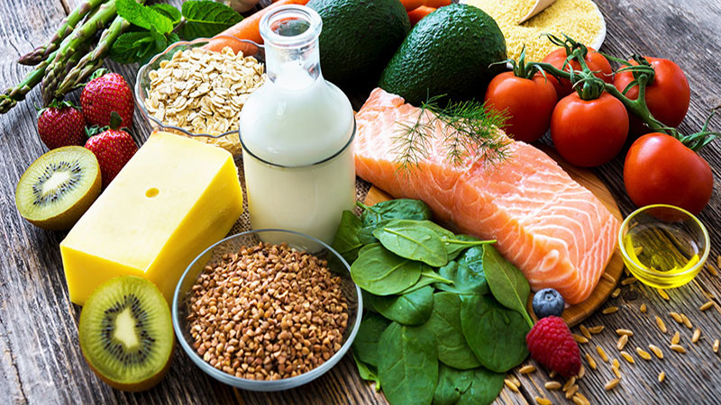
For parents of picky eaters, mealtimes can be exhausting. You may find yourself wondering why on earth your child won’t eat, and what you should be doing to help them. You may beg, reward, demand, and short-order-cook, but for all of your energy and efforts you don’t see any real changes.
Eating is complicated. It requires our children to use all of their sensory systems, coordinate all of their muscles, and experience the sensations of all of their organ systems working together. There is a lot that can go wrong!
The good news for parents is that making your child eat is not your job. You’ve probably realised long ago that you can’t, in fact, make your child eat. Instead, think of your job as giving your child the opportunity and the skills they need to choose to eat new foods. If you give your child the right foods in a good atmosphere and you do what you can to teach them how to bravely explore new foods, you are doing everything you should as the parent of a picky eater.
Here are five strategies that you can start using today to reduce the mealtime battles and help your picky eater try new foods.
- Serve preferred and non-preferred foods. At every meal, serve at least one preferred food and at least one non-preferred food to your child. The preferred food ensures that they will have something to eat, while the non-preferred food gives them important exposure to new foods.
Research shows that children often need to be exposed to a food up to 15 times before accepting it. As a parent, it can be really hard to go through the effort of serving your child a food you know they won’t eat. However, not serving it to them will all but guarantee they won’t learn to like it.
It’s best to pass the foods around the table and encourage your child to put a little bit of each food on their plate, even if they don’t want to eat it. If they aren’t ready to have the food in their sight, they can put it on a “learning plate” nearby or cover it with a napkin. Over time, you may notice that your child becomes comfortable having the food close by.
- Model eating. Whenever possible, bring your child to the same table surface as you or another caregiver so that everyone is at eye level. Let your child see you eating the foods you are serving them. Young children look to those they trust to see what they should and should not eat. Even if your child is older, modeling eating the foods you serve them can be a powerful tool.
You don’t need to try and convince your child to eat the foods. Just talk about the properties of the food. “This bread is really soft! It melts in my mouth. And the butter is salty.”
- Throw out the rules. If you have rules about what your child must eat such as a “one bite rule,” “first eat this, then get that,” or “clear your plate before you leave the table,” consider letting these rules go. Here are a few reasons why:
- These types of demands can make children feel stressed. And when our bodies get stressed, they release cortisol. Cortisol suppresses appetite and makes your child even less likely to eat.
- The research shows that these types of demands don’t help children eat new foods in the long run. They are likely to backfire and make picky eating even worse.
- Telling children to clear their plates or to eat foods they don’t want is linked to obesity later in life, as children are learning to ignore their bodies own cues about how much to eat.

- Use books, videos, and play. Just like our children need instruction to learn, picky eaters need lots of modeling and practice to learn to eat new foods. Here are some creative ways you can help them learn to explore non-preferred foods:
- Read books or watch videos about eating
- Try involving your child in exploring food outside of eating time, when there is less pressure. They can do crafts with spaghetti, paint with pudding, or do experiments with bread, water, and food coloring. Having more positive experience with the foods will help them learn that the foods aren’t going to hurt them.
- Let your child help you cook! Even young kids can peel, stir and be a part of the action.
- Know when to get help. Trying the above tips can help many children start to eat new foods. Some children need more intensive help to address their picky eating. Here are some signs that you may want to look to your GP for assistance:
- Your child eats fewer than 20 foods and has begun eliminating foods from this list as without also adding new foods
- Mealtimes are a battle and your child or family is stressed
- Your child has dropped on the growth curve or there are developmental or nutritional concerns related to their eating
- You suspect your child has trouble chewing, or have observed the following:
  - They frequently gag or choke due to poor chewing
  - Their eyes water when they swallow as if the food is not well-chewed
  - They only eat soft foods
- Your child does not eat any food from a food group (e.g. no fruits, no protein, no vegetables), or only eats one texture of foods (e.g. only crunchy foods)
You don’t have to make lots of changes at once. Pick one that feels easy and try it for a few weeks. You may be surprised at what your child learns.

