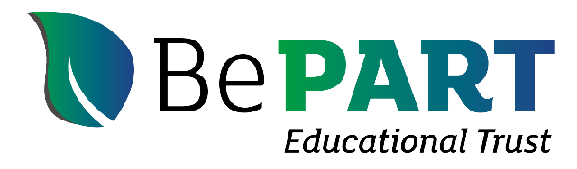

Safeguarding Statement

Adopted by Board: 17 March 2026
Review Period: 3yrs
Review Date: March 2029
Person responsible for policy: Clerk

SAFEGUARDING STATEMENT

BePART Educational Trust recognises that a young person’s welfare is of paramount importance. All young people have a fundamental right to be protected from harm and exploitation as students cannot learn effectively unless they feel safe. Each institution within the Trust has its own Safeguarding policy and procedures. Individuals, in the first instance, are directed to follow the policy and procedures, available on each institutions’ website.

This Safeguarding Statement applies to all settings within the Trust. The Trust:
- is committed to ensuring that best practice is adopted when working with all young people, offering them support and protection.
- accepts that the Trust has a legal and moral responsibility to provide a duty of care, to safeguard students’ well-being, to protect them from abuse and expects all staff, Governors and volunteers to share this commitment.
- provides an environment which promotes self-confidence, a feeling of worth and the knowledge that students’ concerns are listened to and acted upon.
- ensures LGB members, staff and volunteers from each institution understand the importance of working in partnerships with students, their families/carers and other agencies in order to promote and safeguard the welfare of young people.
- is committed to following Wirral’s Local Safeguarding Children Board (LSCB) guidance and locally agreed inter-agency procedures with regard to the safeguarding of young people.
- ensures that each institution has procedures for dealing with allegations of abuse against staff and volunteers that comply with guidance from Wirral’s LSCB and local agreed inter-agency procedures.
- works with parents positively, honestly and confidentially to ensure parents are treated with respect, dignity and courtesy.
- ensures that safeguarding and the welfare of all students is promoted where appropriate in the curriculum within each institution.
- ensures that there is a senior member of staff who is the Designated Safeguarding Lead for each institution to take responsibility, oversee and monitor safeguarding issues.
- ensures that there is a Designated Governor member in each LGB who has oversight of safeguarding in the relevant institution and who is responsible for liaising with Wirral’s LSCB and partner agencies in the event of allegations of abuse being made against a Principal/Headteacher.
- ensures that there is appropriate training for staff and Governors in relation to safeguarding policies, procedures and practices.
- ensures that where services or activities are provided on institution’s premises by another body, the body concerned has appropriate policies and procedures in place in regard to safeguarding and liaises with each institution on these matters, where appropriate.
- recognises that all staff members’ own practice and behaviour puts young people’s welfare first and cannot be misconstrued in any way and does not contravene accepted good practice or the institution’s Staff Code of Practice.
- operates safe recruitment procedures and ensures all appropriate checks are carried out.
- ensures that Disclosure and Barring Service (DBS) Enhanced Disclosures are obtained for all new appointments.
- ensures each institution reviews its policies and procedures annually.
- will review this Safeguarding Statement every three years to assess its effectiveness.

