Free places to go near Bearwood Primary
Canford Park SANG  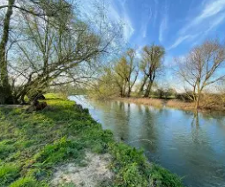  Distance: 0.5 miles  Peaceful green space with walking trails and picnic areas. | Knighton Heath Wood  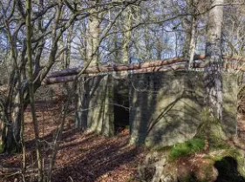  Distance: 1.2 miles  Woodland area with informal paths and wildlife
Bearwood Recreation Ground  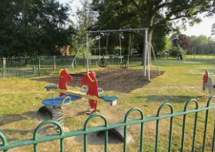  Distance: 0.3 miles  Playground and open fields for games and relaxation. | Slades Farm Recreation Ground  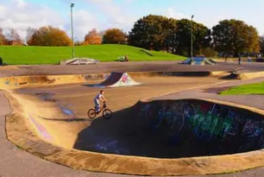  Distance: 3.5 miles  Park with velodrome, skate park, and playground.
St Barnabus Church  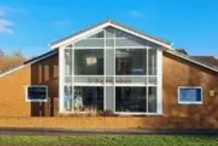  Distance: 0.4 miles  Modern church with community events. | Kinson Library  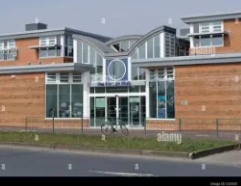  Distance: 2.2 miles  Library with free books, computers, and activities.
Millhams Mead Nature Reserve  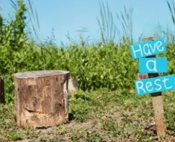  Distance: 4.5 miles  Woodland, grassland, and birdwatching. | River Stour Walks  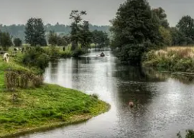  Distance: 2.5 to 4 miles  Riverside paths and scenic countryside
Kingfisher Barn  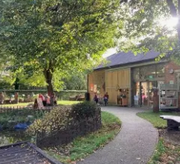  Distance: 2.5 miles  Lots of family activities | Delph Woods  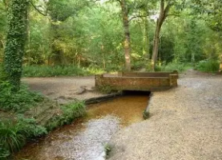  Distance: 3.1 miles  Woodland walks with the odd rope swing to play on
Upton Country Park  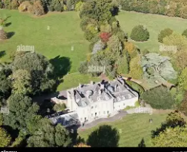  Distance: 6.4 miles  Lots of woodland walks and play areas. | Longham Lakes    Distance: 1.8 miles  Two large lakes – great for riding bikes around or a more leisurely walk. Lots of swan families to spot.

