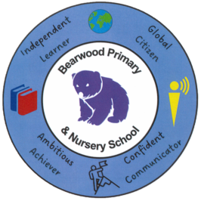
BEARWOOD
Primary and Nursery School
Headteacher Mrs Cheryl Smith
Acting Deputy Headteacher Mrs Hayley Goodfellow
Phone: 01202 590703
Fax: 01202 590703
email: school@bearwood.poole.sch.uk
Web: www.bearwood.poole.sch.uk
Bearwood Primary and Nursery School
Barons Road
Bearwood
Bournemouth
BH11 9UN

Learning, Enjoying & Succeeding Together

Wednesday 12th March 2025

Dear all parent/carers of Bearwood Primary & Nursery School,

RE: PINS Project – Parent / Carer Meeting

Pearl and I would like to extend our heartfelt thanks to everyone who has attended any of the parent/carer meetings we've hosted at your child's school so far. The feedback we’ve received has been invaluable, and we are actively sharing it with the relevant school staff, as well as with the Department for Education, NHS, and BCP. Please rest assured that all schools are kept anonymous in our final report, and we maintain the highest level of confidentiality for all parents and carers involved.

We are excited to announce that our final meeting will take place at your child’s school on Friday 28th March at 9am. This session will be different from the previous ones, as we will have school staff present to engage directly with you. The purpose of this meeting is to gather your insights and ideas on how we can strengthen the partnership between parents/carers and the school.

We encourage parents and carers to approach this meeting with a solution-focused mindset. However, we understand that discussing challenges, particularly around neurodivergence, can sometimes be emotional and difficult. Our goal is to collaborate on ideas and strategies that can help foster a supportive community within the school, ensuring that inclusion and positive relationships are nurtured for both current and future neurodivergent pupils and their families.

We truly believe this meeting will be an opportunity for both parents/carers and school staff to reflect on how they can move forward together in the spirit of collaboration, beyond the scope of the project.

Additionally, we will be sharing information about future workshops PCT are working hard in the background to secure exclusive to your school, which are part of the ongoing PINS project, relevant to neurodivergent children and their families. Please do feedback any particular specific areas of support/workshops you may like to see!

Thank you for your continued support. If you are unable to attend, please don’t hesitate to get in touch via email. Details are included on the flyer, or alternatively please do request our contact details from school.
We look forward to seeing you all at this final meeting.

Best wishes,

Sammie and Pearl 🙂

