

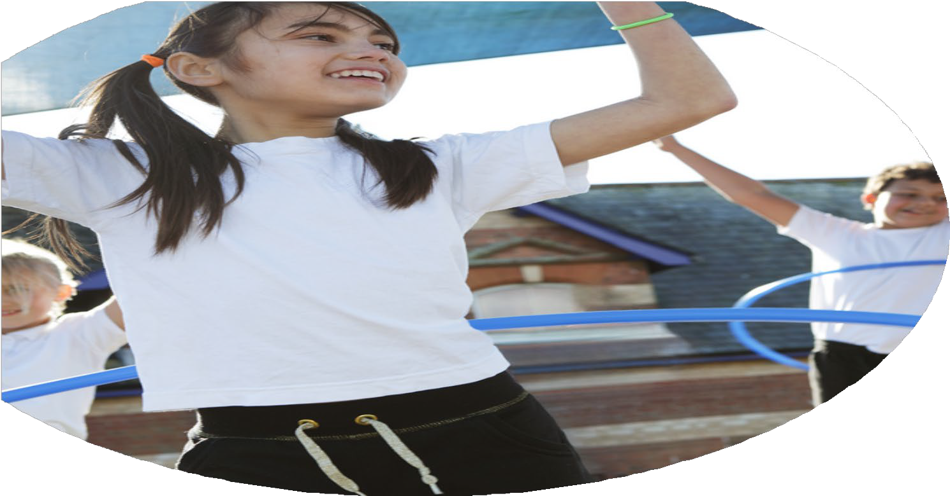
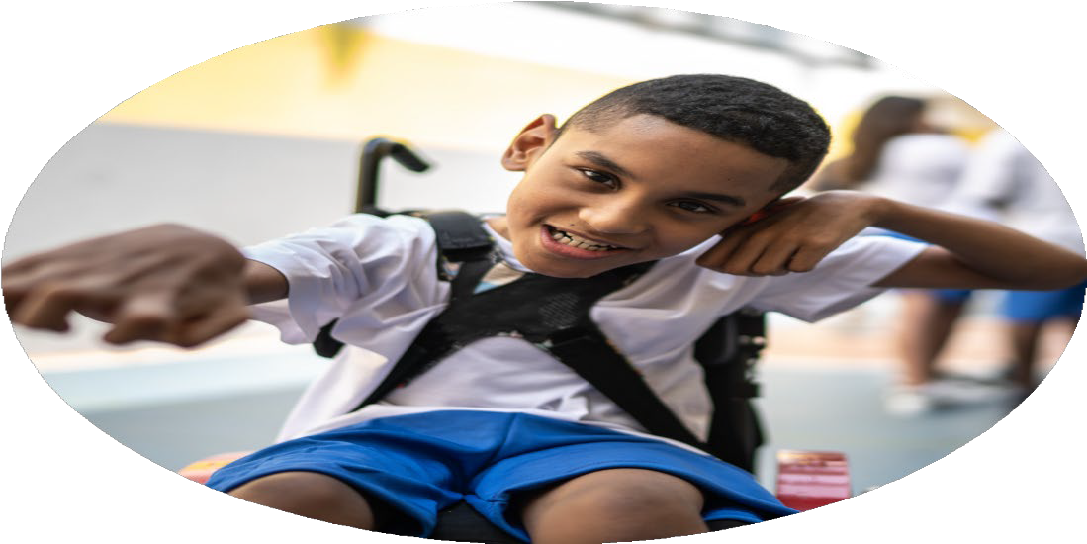
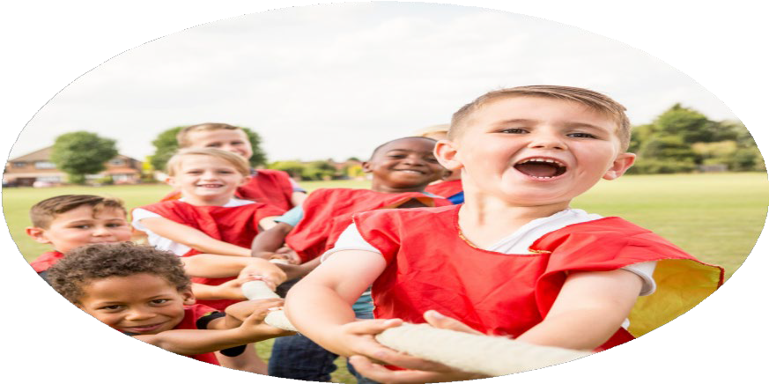



PE Funding

Evaluation Form

Commissioned by

Created by

Images courtesy of Youth Sport Trust

PE Funding Evaluation Form

It is intended that this template should be used as preparation for the completion of the statutory digital reporting tool being introduced this academic year. You can upload data (including swimming) from this template onto this platform once it becomes accessible.
Before you decide how you are going to use the funding for this academic year you should reflect and evaluate the impact of your use of the funding in 2023/24.
All spending of the funding must conform with the terms outlined in the Conditions of Grant document. The template is a working document that you can amend/update during the year.
Based on your evaluation of last year’s funding you should decide what you intend to do this academic year, how you will do it, and what impact you expect it to have.

It is important that the funding is used effectively and based on your school’s needs.
You must use the funding to make additional and sustainable improvements to the PE and sport in your school. You must develop and add to the PESSPA activities that your school already offers.

Summative digital reporting from June 2025 will continue to include swimming and water safety information therefore funding can be used to provide top-up lessons where necessary to ensure pupils meet national curriculum swimming requirements.

We recommend that you start by reflecting on the impact of current provision and reviewing your previous spend

What went well? | How do you know? | What didn’t go well? | How do you know?
Continued to develop our work with  Ed Start to enhance provision, particularly at lunchtime  Pupils participated in a range of competitive sport events  Embedded “The Power of PE” curriculum ensuring it  supports EYFS and has consistent implementation  Provided opportunities for additional swimming sessions for SEND children from Year 4  Continued to fund:  - additional adults at swimming lessons to improve number of children reaching expected standard  - transport to ensure the most is made of the time spent swimming  Sporting activities were inclusive to all  Residential outdoor adventurous visit increased sense of belonging, self-confidence, cultural capital and variety of adventurous opportunities | Numbers of younger children engaging in sporting activity at lunchtime increased  More focused sport activities for all age ranges to enjoy over lunch  Children took part in organized, competitive sporting events over the year including football, netball, cycling and athletics  Observations by subject lead  Training with staff  Child with significant needs accessed additional lessons  Parents shared their positive experience  Pupil voice  Children with additional needs had 1:1 or 1:2 support from additional staff in the water, thus enabling them to access the same curriculum as their peers  Children received the full hour of swimming  All children included irrespective of additional needs eg sports day used paths in school so child in wheelchair can participate  Majority of cohort attended  Pupil and parent voice  Staff voice | Some inconsistent staffing had to be addressed as the year progressed, ready for the start of 2024/25  Some events had to be cancelled due to a lack of referees  Gymnastics unit did not support appropriate progression – new plan for next year  Some children did not meet expectations in swimming and no opportunity at local swimming baths to provide additional lessons  Parents unable to take to private lessons  Cost of visit far exceeded the contributions made by families and Sports Premium/Pupil Premium contributions | Observed by staff/SLT  Discussed at collaborative heads meeting – new plan for next year  Staff voice  Monitoring by PE Lead

What are your plans for 2024/25? | How are you going to action and achieve these plans?
Intent | Implementation
1.Continue to sustain a comprehensive PE & sport agenda and promote an active curriculum – particularly in the teaching of Gymnastics  2.Continue to develop our work with Ed Start to enhance provision and provide training for staff  3.Provide opportunities for children to participate in a range of sporting clubs, events and competitions  4.To enhance the curriculum offer by continuing to support children in accessing adventurous activities  5.To ensure that swimming lessons improve the number of children reaching expected standard | Establish a suitable curriculum for the teaching of Gymnastics across school, ensuring clear progression and learning steps (EdStart Curriculum plans)  Training for the PE Lead to be able to share these plans with teaching staff and monitor their effective implementation  2 afternoons of EdStart coaching to be delivered in PE sessions alongside staff particularly for vulnerable year groups  A timetable of support so that all staff receive this training and all children benefit  Ensure the highest quality of coaching is provided with subject lead monitoring and evaluating  Termly meetings with the EdStart team to ensure feedback is given and improvements suggested  Join the local Sports Partnership to facilitate a greater range of sporting activities for our children  Organise more “local” competitions between local schools  EdStart to facilitate 2 after school sporting clubs a week, ensuring as many children across school can access  Weekend residential at Robin Wood, Todmorden for children in Year 6  Small contribution from families and the rest funded through school so that all children given the opportunity to be able to access  Provide transport to ensure the most is made of the time spent swimming  Where needed, provide extra staffing to support those that need it

What impact/intended impact/sustainability are you  expecting? | How will you know? What evidence do you have or  expect to have?
- More pupils meeting their daily physical activity goal, more pupils encouraged to take part in PE and Sport Activities.  - More pupils engaged in physical activity throughout the school day, not just in PE sessions. Chn more engaged in the afternoon lessons. Staff skilled up to deliver a greater PE and sporting offer.  - Pupils discover skills, talents and excellence in sports that otherwise they would not experience. Pupils begin to access clubs outside of school.  - Children will experience a wider range of sporting and adventurous activities, leading to a broadening of aspiration, resilience and confidence. A sense of belonging will support children back in school to push themselves out of their comfort zone, increase learning resilience and therefore improve outcomes  - All pupils will be supported adequately during swimming lessons and therefore become more proficient swimmers. Children will be confident in taking up swimming outside of school and therefore be safe and healthier. | Subject Lead monitoring of the curriculum and timetables  Pupil voice will tell us that children are active and engaging in our offer  Greater number of children engaged in after school sports provision with close monitoring for equality of engagement between girls/boys  Staff voice about impact on their confidence and ability to deliver high quality PE  Observations by subject lead and SLT to monitor quality of provision  Pupil voice  More children reaching the expected standard in PE  Participation in events and competitions will increase  Children will begin to access clubs outside of school  Successes will be shared in school and with parents  Pupil and parent voice  Improving outcomes  Improving attendance and behavior  Greater number of children will reach the expected standard in swimming  Greater number of children will participate in swimming lessons outside of school time  Children will be able to discuss staying safe in the water and water danger

What impact/sustainability have you seen? | What evidence do you have?

