Emotional Wellbeing Apps
As a school we appreciate that sometimes pupils may be struggling with their emotional wellbeing. In order to support parents, we have produced a list of useful children’s apps that promote good emotional and physical wellbeing that you may wish to download for your child to use. Apps are free to download but please be aware that some may have in-app purchases.

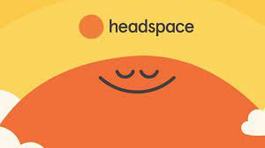
Headspace app – guidance on how to meditate.

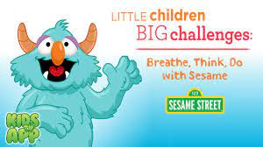 Sesame Street Breathe, Think, Do – suitable for EYFS children.
Mindful Powers – teaches mindful play and can improve focus. (apple devices)

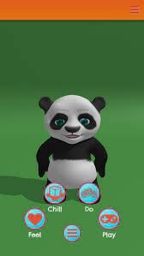 NHS Chillpanda – teaches breathing techniques.

Mindful Gnats – suitable for KS2 pupils.

Daylio – mood tracker. Looks at what children have been doing and how they feel.

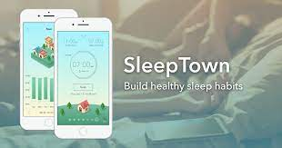 Sleep Town – town grows overnight if children are getting the right amount of sleep.

