KS1 Writing Competition
Write some sentences about this picture.
Noticing | 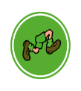  Action | 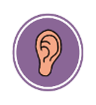  Checking
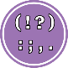  Punctuation | Feelings | 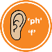  Alliteration
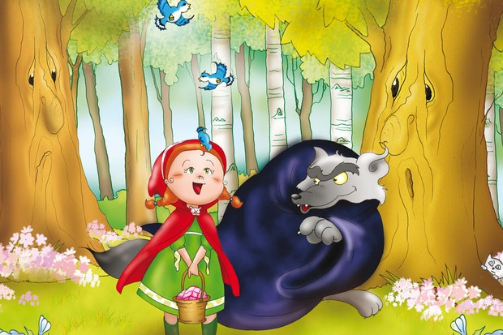
Year 1 and 2 try to make sure you use the symbols above to make your writing interesting as the winner will be someone who can try their best to use them all.

Noticing- something you see with your eyes
Action- something someone or something is doing
Checking- something you can hear
Punctuation- make sure you use capital letters, a full stop, a question mark or an exclamation sentence.

A . ? !

Feelings- how is someone feeling (sad, happy, scared)
Alliteration- using the same letter at the beginning of each word:

Wicked witch
Beautiful butterfly
Silly snake

Your sentences can be typed into Purple Mash or you can take a photo and upload it to Purple Mash. It must be sent to your teachers by Friday 22nd January 2021. I am very excited to see your fantastic writing.
Good luck everyone!
Mrs Robinson

