KS2 Writing Competition
Write a short descriptive narrative (story) about a picture.
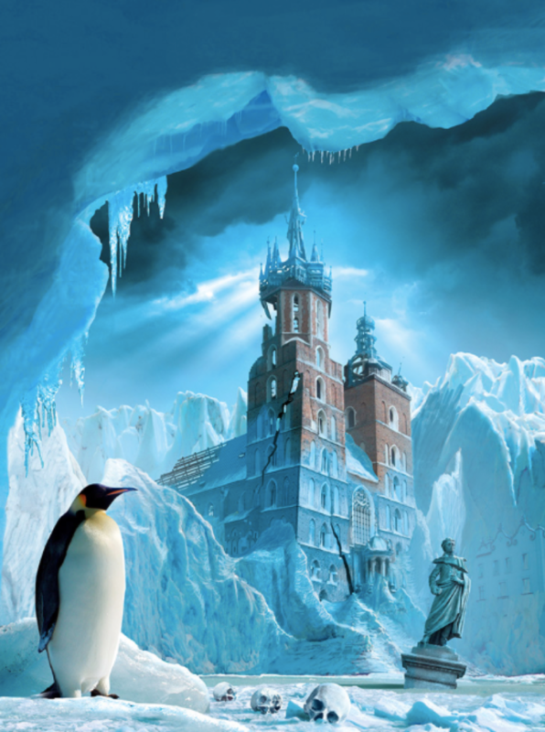

Picture for Year
3 and 4

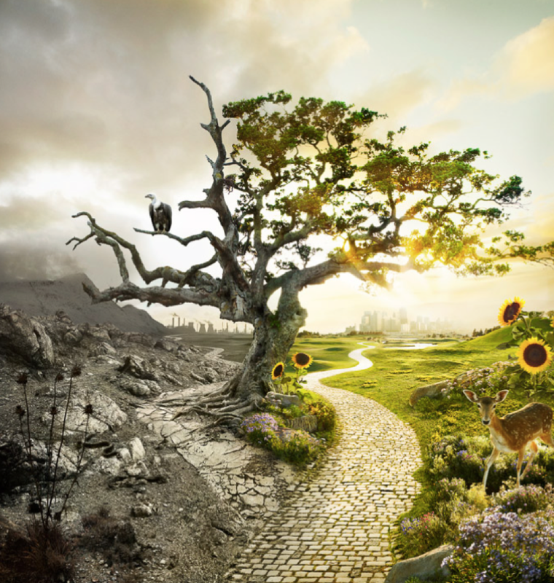

Picture for Year
5 and 6

You must demonstrate how to use the Writing Rainbow symbols in your writing. The winner will be someone who has tried their best to include each symbol in their work.
There will be a winner from Year 3 and 4 and also a winner from Year 5 and 6.
Your sentences can be typed into your Purple Mash blog or you can take a photo and upload it to Purple Mash. It must be sent to your teachers by Friday 21st January 2021. I am very excited to see your fantastic writing.
Adverbs and adverbial phrases | Dialogue and contracted forms | Simile | Repetition
Noticing | 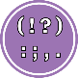  Punctuation | Feelings | 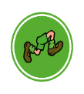  Action
Good luck everyone!
Mrs Robinson

