Nursery Children’s Home Learning Challenges 22/06/20
Try and complete 1 challenge each day
Mums, Dads, Sisters, Brothers please help!

- Count up to 10 and then count back down to 0.

- 1 2 3 4 5 6 7 8 9 10

- Count the gingerbread men. Remember to use your counting finger to help you to count:

- Write your name. Can you hold your pencil like this?

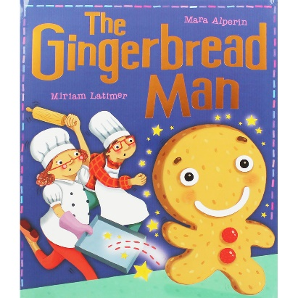
- Listen to the story of ‘The Gingerbread Man’. Click the links below to watch a video, or read through an e-Book version of the story!

- World Book Day link:
https://www.worldbookday.com/videos/the-gingerbread-man-2/

- Twinkl Powerpoint Story link
https://www.twinkl.com/resource/t-t-10794-the-gingerbread-man-story

- Complete the new 2Do on Mini Mash (remember to log in on Purple Mash first). Click the link below to take you to the Purple Mash login page.
https://www.purplemash.com/sch/belfield

- Can you use your voice to make these sounds? Click the link below to play ‘Welcome to the Zoo’.
https://www.phonicsplay.co.uk/resources/phase/1/welcome-to-the-zoo

Watch my Sounds
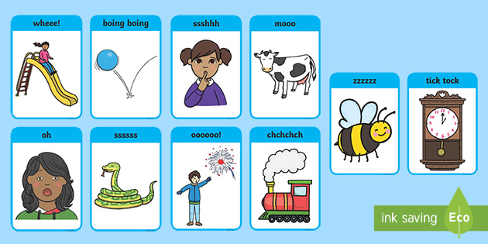
Look in a mirror with your child to help them observe their faces, lips, teeth and tongue as they make different speech sounds and experiment with their voices. Use the sounds from the pictures below and maybe make some more up!

