Have a go at singing this ‘Sound Talk’ song with a family member.
Can you blend the word?
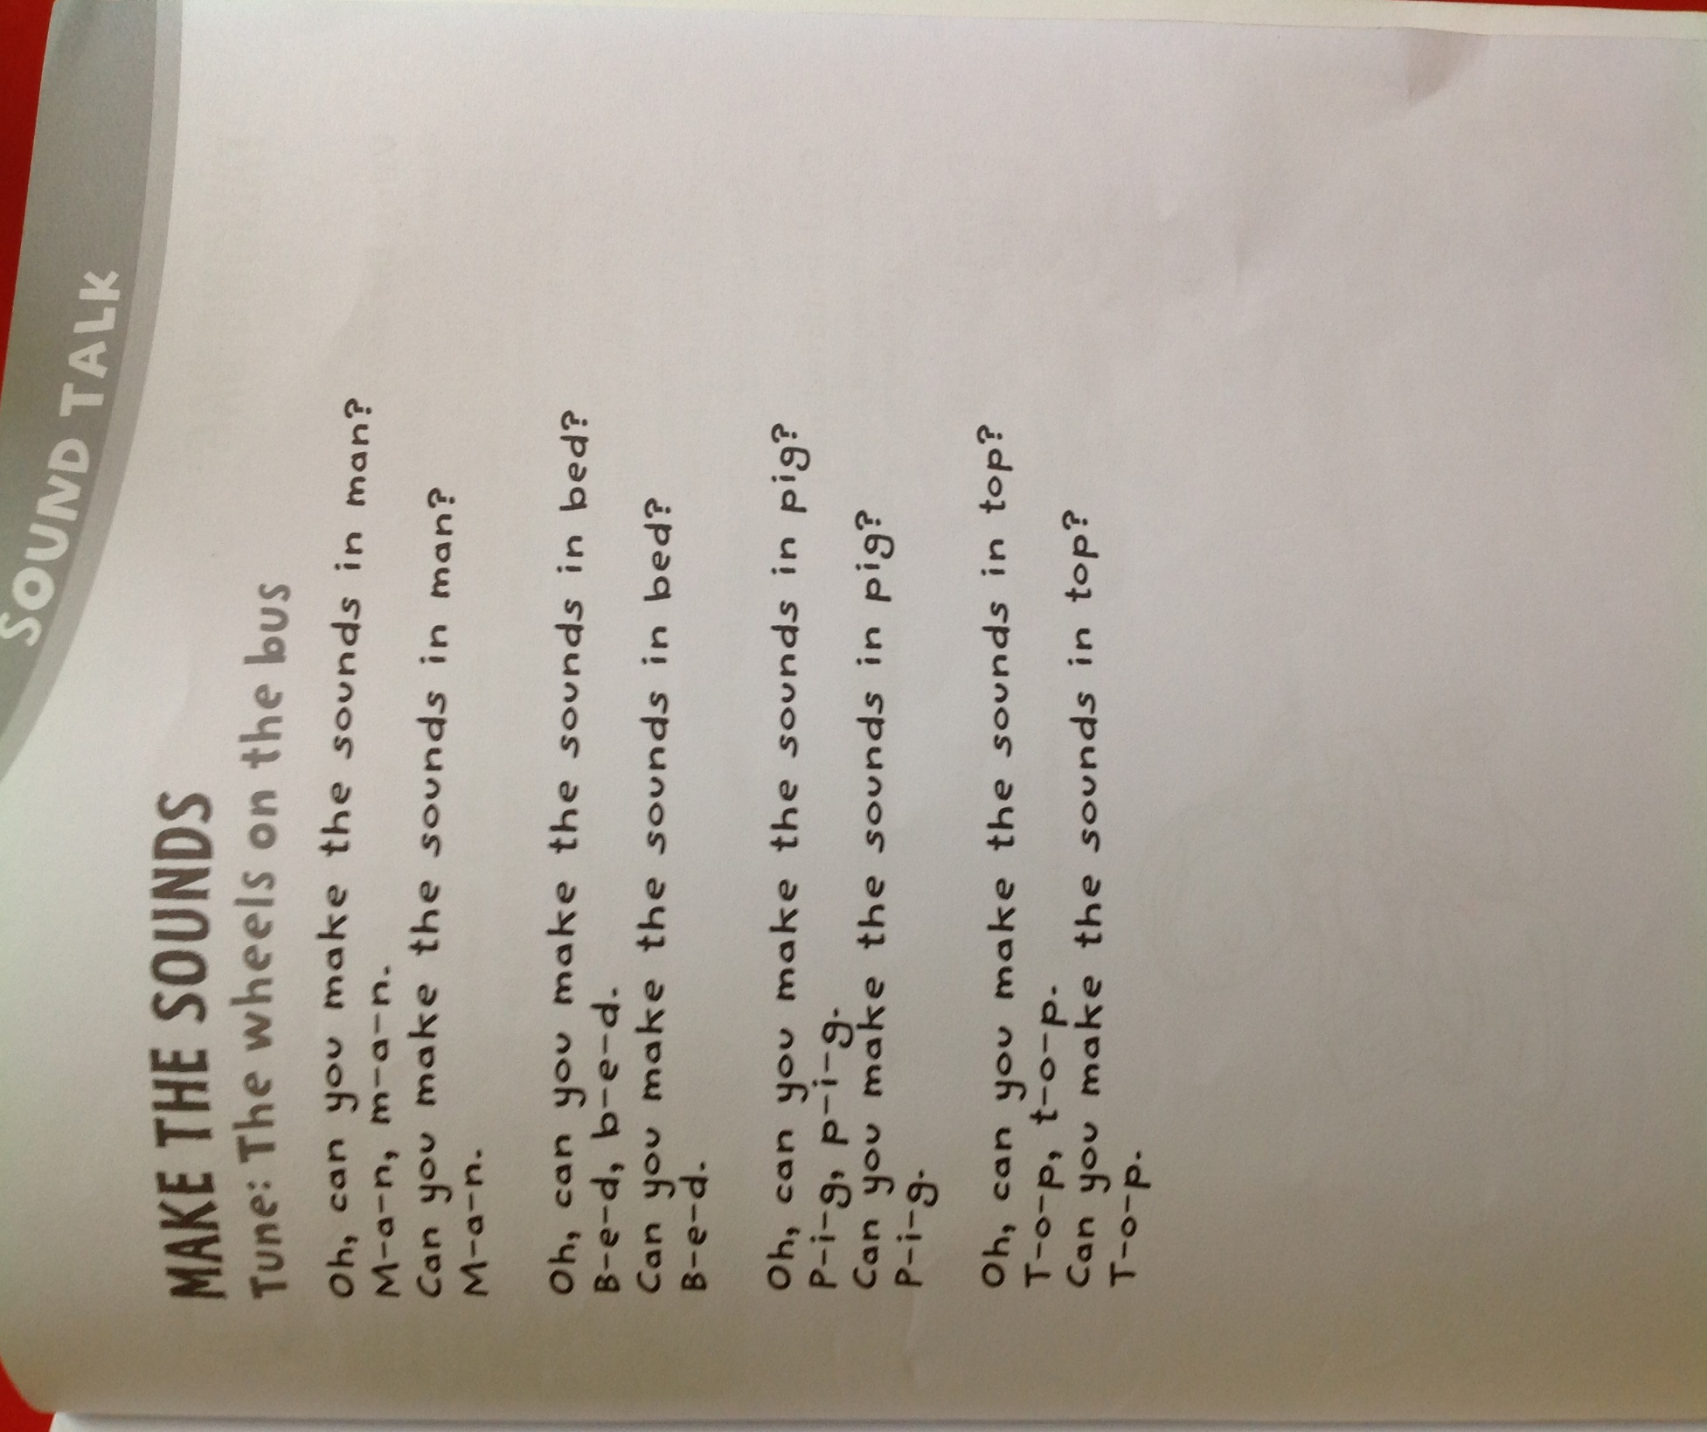
Can you make up some other words; hat, pin, tap…

