Positive Handling Policy January 23 – January 2025
At Belfield Community School we believe that children have the right to independence, choice and inclusion, and we seek to provide opportunities for personal growth and emotional health and wellbeing. Children who are unable to control their actions or unable to appreciate danger have a right to be protected; as do those around them and staff have a duty of care, for all, to exercise.
Rationale
Children learn who they are and how the world is, by forming relationships with people and things around them. The quality of a child’s relationship with significant adults is vital to their healthy development and emotional health and wellbeing.
Many of the pupils who require emotional support from school may have been subject to trauma or distress or may not have had a positive start in life. It is with this in mind, that staff seek to respond to children’s developmental needs by using appropriate safe touch.
Our school policy takes into account the extensive neurobiological research and studies relating to attachment theory and child development that identify safe touch as a positive contribution to brain development, mental health and the development of social skills. The school has adopted an informed, evidence based decision to allow safe touch as a developmentally appropriate intervention that will aid healthy growth and learning.
Our policy rests on the belief that every member of staff needs to know the difference between appropriate and inappropriate touch. Hence, staff need to demonstrate a clear understanding of the difference. Equally, when a child is in deep distress, staff need to know when and how sufficient connection and psychological holding can be provided without touching.
All staff need to be clearly aware of procedures within this policy. The policy should be seen in the wider context of the ‘Behaviour Policy’ which aims to promote positive values and good behaviour choices.
Legal framework
This policy has due regard to statutory legislation including, but not limited to, the following:
● The Education Act 2011
● Equality Act 2010
● The Children Act 1989
This policy also has due regard to government guidance including, but not limited to, the following:
• DfE (2021) ‘Keeping children safe in education’
• DfE (2018) ‘Working Together to Safeguard Children’
• DfE (2013) ‘Use of reasonable force in schools’
This policy operates in conjunction with the following school policies / procedures:
• Safeguarding and Child Protection Policy
• Behaviour Policy

Different types of touch
There are four different types of touch and physical contact that may be used, these are:
- Casual / informal / incidental touch
Staff use touch with pupils as part of a normal relationship, for example comforting a child, giving reassurance and congratulating. This might include putting an arm out to bar an exit from a room, taking a child by the hand, patting on the back or putting an arm around the shoulders. The benefit of this action is often proactive and can prevent a situation from escalating.

- General reparative touch
This is used by staff working with children who are having difficulties with their emotions. Healthy emotional development requires safe touch as a means of calming, soothing and containing distress for a frightened, angry or sad child. Touch used to regulate a child’s emotions triggers the release of the calming chemical oxytocin in the body. Reparative touch may include stroking a back or squeezing an arm.

- Contact/interactive Play
Contact play is used by staff adopting a role similar to a parent in a healthy child-parent relationship.
This will only take place when the child has developed a trusting relationship with the adult and when they feel completely comfortable and at ease with this type of contact. Contact play may include an adult chasing and catching the child or an adult and child playing a game of building towers with their hands.
This sort of play releases the following chemicals in the brain:
● Opioids – to calm and soothe and give pleasure;
● Dopamine – to focus, be alert and concentrate;
● BDNF (Brain Derived Neurotrophic Factor) – a brain ‘fertiliser’ that encourages growth.

- Positive handling (calming a dysregulated child)
Legal framework and national guidance refers to the ‘use of reasonable force’ with the intention of protecting pupils and limiting damage to property. National guidance states that reasonable force may be used in the school to:
- Restrain a pupil who has lost emotional self-control until the situation is diffused.
- Limit the amount of harm that the pupil involved can do to themselves or others.
- Demonstrate to pupils that they are within a safe environment in which adults can contain pupils’ anger and other erratic emotions.
- Protect all pupils against any form of physical intervention which is unnecessary, inappropriate, excessive or harmful.

We interpret this in our school through the use of ‘positive handling’- the positive application of force to protect and calm a dysregulated child. Positive handling will be used only as a measure of last resort and applied using a calm and measured approach.
The relevant considerations which must be taken into account:
- The degree of force must be proportionate to the circumstances and incident, and seriousness of the event (or the consequences it is intended to prevent).
- It should always be the minimum needed to achieve the desired result, (it might also depend on the age, understanding and sex of the pupil.
- Use of force is only reasonable if particular circumstances warrant it, otherwise it is unlawful; it therefore follows that it should not be used for situations that can be resolved without it, or for trivial misdemeanours. All use must be necessary.
- Positive handling must not be used to make a child comply with instructions unless it complies with the key points above.
- A child who is in a state of dysregulation and has no mechanism for self calming or regulating their strong emotional reactions will be physically contained by staff. This kind of containment will usually involve two members of staff, one sat either side, holding the child by the arms in a secure team teach trained manner. It may also be necessary for another member of staff to control a child’s kicking legs. Staff will employ the safest and gentlest means of holding a child, which is entirely designed to enable the child to feel safe and soothed, bring them down from an uncontrollable state of hyperarousal. Maintaining boundaries in such cases can be a vital corrective emotional experience, without which the child can be left at risk of actual physical or psychological damage.

The brain does not develop self-soothing neuronal pathways unless this safe emotional regulation has been experienced. Physical containment of a dysregulating child can be the only way to provide the reassurance necessary to restore calm.
During any incident of physical holding intervention, staff must seek as far as possible to:
- Lower the child’s level of anxiety during the restraint by continually offering verbal reassurance and avoiding generating fear of injury in the child;
- cause the minimum level of restriction of movement of limbs consistent with the danger of injury (so, for example, will not restrict the movement of the child’s legs when they are on the ground unless in an enclosed space where flailing legs are likely to be injured);
- ensure at least one other member of staff is present.
Steps to take before positive handling
If the school is aware that a pupil is likely to behave in a way that might require physical restraint, it should plan how to respond. This will be done using the school Individual Behaviour Plans/Positive Handling Plans.
Consideration should be given to:
- managing the pupil. Use reactive strategies to de-escalate event
- involving parents so that they are fully aware of how the school may have to react
- briefing staff, ensuring that everyone knows what action should be taken
- ensuring that additional support can be summoned if appropriate
- the need to take specific advice about the safest way to hold pupils with specific health needs (particularly SEND)
- Prevention strategies and calming measures which will be employed and the following action should be taken, as much as possible, before a restraint is used;

- conversation, distraction, coaxing skills, gentle persuasion or redirection to other activities (e.g. touching the child’s arm and leading him/her away from danger, gently stroking the child’s shoulder).
- encouraging the pupil to help him/herself feel more secure by wrapping a blanket tightly around him/herself or holding on tightly to a large cushion or stuffed toy.
- put distance between the child and others - move others to a safer place.
- calmly remove anything that could be used as a weapon, including hot drinks, objects, furniture.
- to prevent a child continuing to pose harm in a dangerous situation, advise others to leave but remain with the child.
- use seclusion only if necessary for a short period while waiting for help, preferably where a staff member can observe the child.
- keep talking calmly to the child, explain what is happening and why, how it can stop, and what will happen next.
- use first aid procedures in the event of injury or physical distress when safe to do so.
- adults in charge should take a calm, measured approach to a situation, and never give the impression that they have lost their temper, or are acting out of anger, frustration, or to punish a pupil. If a member of staff’s response had become emotionally charged then a “change of face” strategy should be initiated either by themselves or another member of staff in attendance.
- all trained staff should apply their ‘Team Teach’ restraint training knowledge.

Physical intervention can take many forms:
- physically interposing between pupils or blocking a pupil’s path.
- touching, holding, pushing, or leading a pupil by the arm – in line with team teach training.
- shepherding a pupil away by placing a hand in the centre of the back.
- in extreme circumstances) using a more restrictive holds – as per Team Teach physical handling training
Staff should always avoid touching or holding a pupil in a way that might be considered indecent. In exceptional circumstances, when there is an immediate risk of injury, (eg to prevent a pupil running on to a busy road, hitting someone or throwing something) staff may need to take any necessary action that is consistent with the concept of ‘reasonable force’.
In other circumstances, staff should never act in a way that might reasonably be expected to cause injury, for example by:
- Holding a pupil around the neck or in a way that might restrict breathing.
- Slapping, punching, kicking, tripping or forcing limbs against a joint.
- Holding or pulling a pupil by the hair.
- Holding a pupil face down on the ground.
The key issue is to establish good order, and so any action which could exacerbate the situation should be avoided. The age and level of understanding of the pupil is very relevant in these circumstances. Physical intervention to enforce compliance with staff instruction is likely to be increasingly inappropriate with older pupils. It should never be used as a substitute for good behaviour management.
Who can use positive handling?
Several key members of staff have been Team Teach trained; these staff are listed in appendix B. This training supports staff in using pre-emotive and responsive positive handling strategies and techniques. As far as is possible the staff using positive handling will be those which are Team Teach trained. However, there may be occasions when this is not possible. All staff have a duty of care and may need to be involved in a positive handling scenario. In these circumstances a trained member of staff will replace them as soon as possible.
Steps to take after positive handling
Recording Incidents
Immediately following the incident where positive handling is used, the staff member should tell the Headteacher or member of SLT. A physical handling form must be completed and incidents should be logged on CPOMS immediately after the incident.
Contacting parents
Parents should be informed of the incident, and given the opportunity to discuss it. The Headteacher will need to consider whether parents should be told immediately, or at the end of the school day, and whether they should be informed orally or in writing.
Keeping Records
CPOMS records will be maintained and Positive Handling Plans will be kept in the child’s TAPS folder on the o drive with dates, times and descriptions of incidents.
Behaviour Plans
If an Individual Behaviour Plan or Positive Handling Plan is in place this should be reviewed and updated if necessary following a Positive Handling incident. If there is no plan in place then it is essential that a meeting be arranged as soon as possible to create a plan, this should involve parents as well as relevant staff.
Pupil and staff wellbeing
Following an incident, a member of staff should have a discussion with the pupil that was positively handled to gather their views, thoughts and feelings. A member of the senior leadership team will check in with the member/s of staff involved in positive handling and ensure they have the time to discuss their thoughts and feelings following the incident. A member of staff (usually the class teacher) will speak with other children who may have witnessed the positive handling take place (if appropriate)

Appendix A:
A range of guides, escorts and restraints ranging from least intrusive to most intrusive. These provide a graded and gradual response aimed at intervening with the appropriate amount of reasonable force. Physical Handling where two people are used will be deemed as a more restrictive hold. As the amount of restriction / number of people increases so does the risk; staff need to make a dynamic risk assessment based on the situation as to the level at which they are going to intervene.
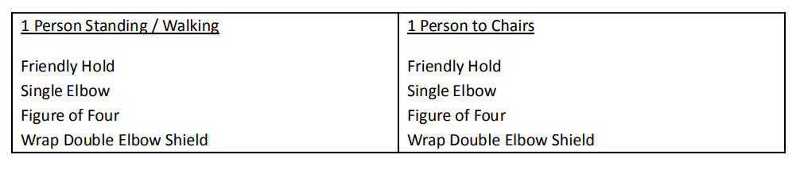
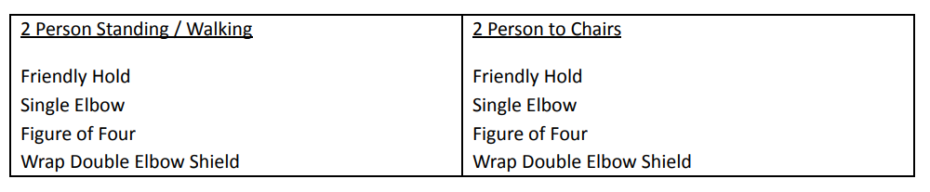
Appendix B:
Current Team Teach positive handling trained staff:
Chris Gibson
Sarah McIntyre
Lauren Robinson
Shane Tighe
Sophie Byrne

Date written | January 2023 | C Wilson
Date of review | January 2024 | Updated names of trained staff and in line with Trauma Informed Practice
Date of next review | January 2025

