[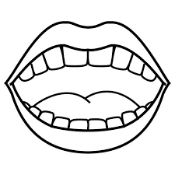](https://www.google.co.uk/imgres?imgurl=http://www.preschoolactivities.us/wp-content/uploads/2014/12/mouth-coloring.jpg&imgrefurl=http://www.preschoolactivities.us/human-organs-coloring-page/boca/&tbnid=RnMxIH9cTxpGFM&vet=10CBoQxiAoCmoXChMIsLLl2evn6QIVAAAAAB0AAAAAEAg..i&docid=FEMfraxSjKsqFM&w=500&h=500&itg=1&q=image%20template%20smiling%20mouth&ved=0CBoQxiAoCmoXChMIsLLl2evn6QIVAAAAAB0AAAAAEAg)

[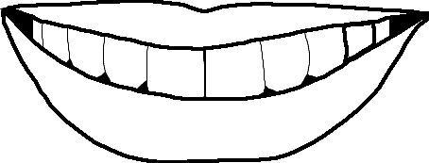](https://www.google.co.uk/url?sa=i&url=https://do2learn.com/picturecards/printcards/coloring/largeimages/mouth.htm&psig=AOvVaw2swxrkRbnwoK0OERZugXiR&ust=1591349151373000&source=images&cd=vfe&ved=0CAIQjRxqFwoTCLCy5dnr5-kCFQAAAAAdAAAAABAK)