Things you will need in reception
Please make sure everything brought into school is clearly named.

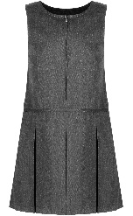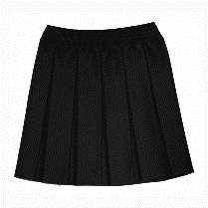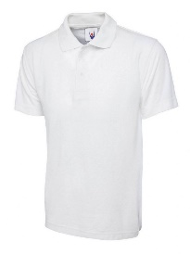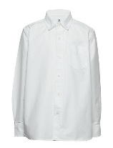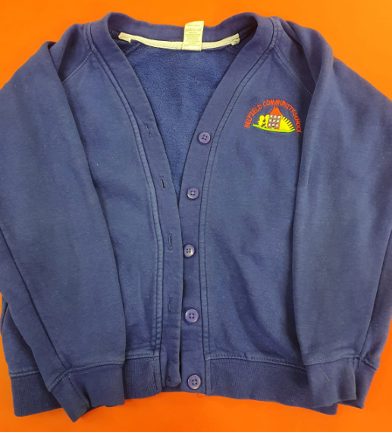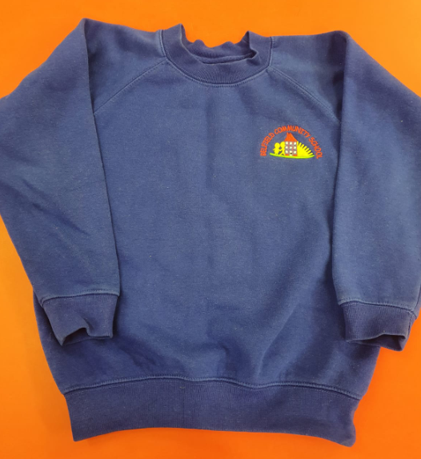
School Uniform
For school we wear a blue jumper or cardigan (this can be bought from Ziggys, or just a plain version from the supermarket is fine too!), a white shirt or polo shirt, and black or grey skirt, trousers or pinafore. Shoes need to be sensible as we spend lots of time outside!
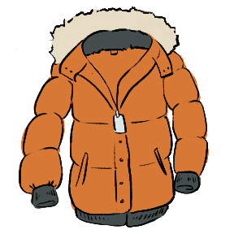
Warm, waterproof coat with a hood
We are outside in all weathers, so need to stay warm and dry.

Wellies
We like to splash in puddles and go to the woods whatever the weather, so make sure you have a pair of wellies named and in a bag.

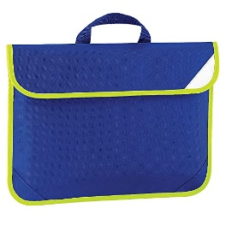
Book bag
These can be bought from the school office.

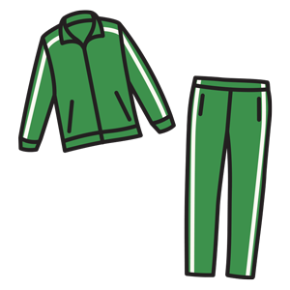
PE kit
We do PE once a week, and on that day we come to school wearing PE kit. Any tracksuit bottoms, leggings or shorts, a t shirt and a jumper, with a pair of trainers.

