Class 1 Home learning ideas week commencing 18.5.20
The activities this week will be suitable for all children. Feel free to adapt them and to spend as much or as little time on each one as your child needs. They will let you know when they have had enough. Play is children’s work. It is where they apply knowledge and practise skills independently. A little bit of reading, writing and maths every day will help your child to keep learning fresh, but playing, developing language and social skills and using their imaginations are just as important.
Music
Make sure you have a clear space for this one… there may be sudden movements…
Follow the links to YouTube:
https://www.youtube.com/playlist?list=PLMwK8CI0gKGjAYcv_RXWH8QlB6YUloCtP
Superhero Instrumental Themes
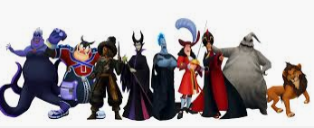
https://www.youtube.com/watch?v=iMGE4hq5e2Y
The Music of the Marvel Cinematic Universe
https://www.youtube.com/watch?v=9ZuWt7ZEFMQ&t=24s
Superhero theme songs playlist
As you listen to the music, encourage your child to move like a superhero! What would a superhero look like? How would they stand? How would they move – fast, slowly, darting, sneaking, jumping, turning? One of you could be the “goodie” or hero and the other could be the “baddie” or villain. If you have instruments, add them in! How can you play the instruments in different ways to match the music? Listen to the volume, pitch and tempo:
volume | Is the music loud or quieter? Will you play your instrument loudly or quietly?
pitch | Does the music have high notes, low notes or a mixture of both? Can you say when the pitch changes?
tempo | Is the music fast or slower? Does the tempo stay the same?
rhythm | Listen carefully to the beat of the music – can you tap or clap out the rhythms you hear?
Children often think that fast = loud, or slowly = quiet… Remember – you can play an instrument slowly and loud, or fast and quietly. Change the tempo and the volume so that you play in different ways.
What sort of movements are you making as a superhero? You could always send me a short video.
Dressing up as your favourite superhero is optional but will definitely enhance this activity!
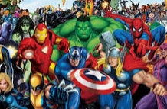
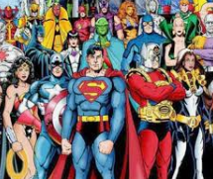

English
Would you rather be a superhero or a villain? What would your special powers be? Would there be anything that could harm you, like Kryptonite is deadly for Superman? Where would you live? Who would your friends be? What would you eat?
Think about the answers to these questions, then write down your answers on the sheet provided. You could tell me about a typical day for you as a superhero or villain, or you could describe your superpowers in more detail.
Art/DT
Draw a design for a superhero costume. You could design one for your superhero or villain character, or somebody else with superpowers. What will the costume look like? What materials will it be made from, and why did you make those choices? Will it have any special features? Label your design to show me each feature. You could colour it in or use materials to collage it.
You could try making a hide-out, cave, lair or shelter for your character, using recyclable materials, packaging, fabric, natural objects or a mix of different materials. Think about where your character would live – what would it look like inside and outside? Would it be camouflaged so that other superheroes or villains couldn’t find it too easily?
Maths
I have sent an email to all parents with links to the Power Maths resources. Please explore these and pick a topic your child is interested in, or that you feel they need to practise. If you need a bit of direction to select appropriate topics, I can help with this. I can also send out some extra resources if people need or want them to support learning.
Oh and have a go at the Times Tables Battles if you are in Year 1! Jacob and Milly have already had certificates, will it be your turn this week?
Science
I have included an investigation this week into the strength of different types of paper. It is suitable for children of different ages to do together and may be best done outside! Children should have a go at recording their findings – how do they think they could do this? Could draw or write or take photos of each stage and result, then stick them in order, depending on the age and stage of your child. Have fun investigating.

I really love seeing all your pictures, writing and maths. It is fantastic that you are all having a go and staying in touch to share your imaginative and unique ideas with me.
Have a lovely week!
Miss Hutton x

