Reception Maths wc 11.5.20
Subtraction – finding the unknown number.
We use maths stories to help children understand concepts such as addition and subtraction. For example: First there were 8 bottles on the wall. Then some were knocked down! Now there are 6 left. How many were knocked down?
Encourage your child to find the difference between 8 and the remaining 6 bottles. They could do this by getting 8 objects and counting along the line to 6 objects – how many objects are left to count? They could count back from 8 to 6 – how many numbers did you say? Be careful your child does not say 8 as they count back, or they will end up with the wrong answer! Or they could cross out 6 of the 8 bottles in the first picture. It is good for children to have several different ways of finding the answer – they can check it by using a different strategy.
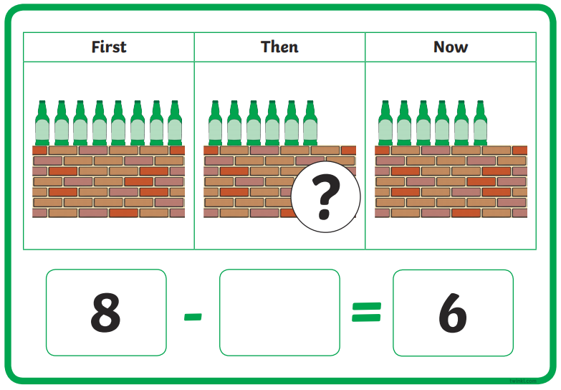
Try making up some maths stories for these pictures to find the unknown number:
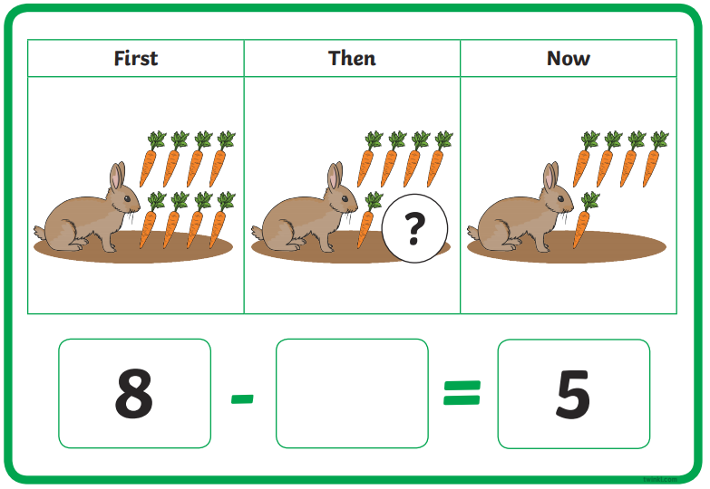

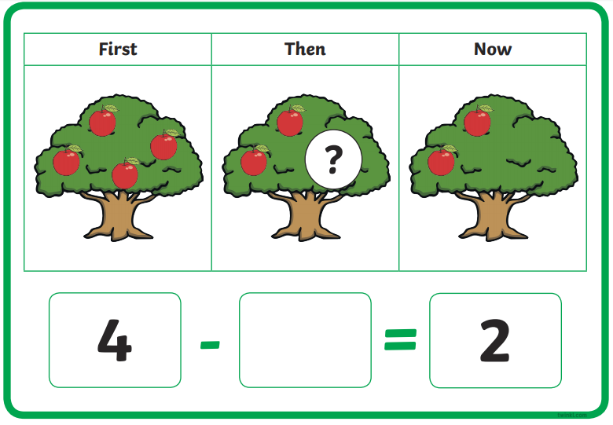
First…
Then…
Now…

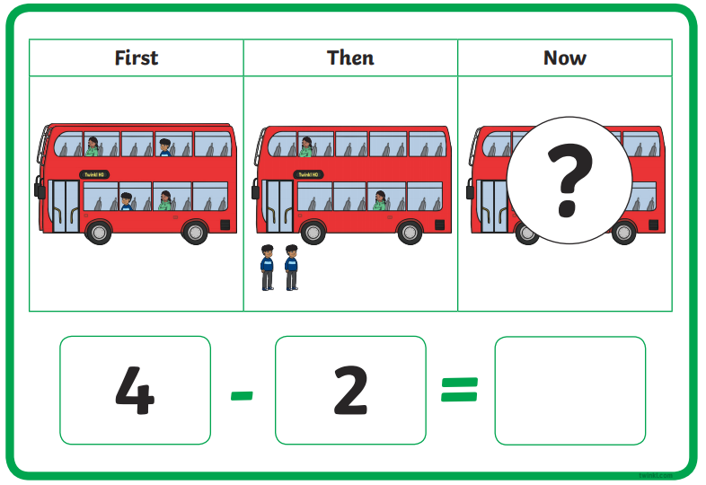
First…
Then…
Now…
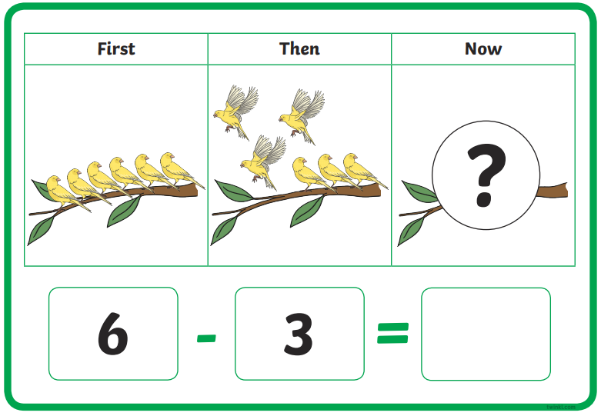
First….
Then…
Now…

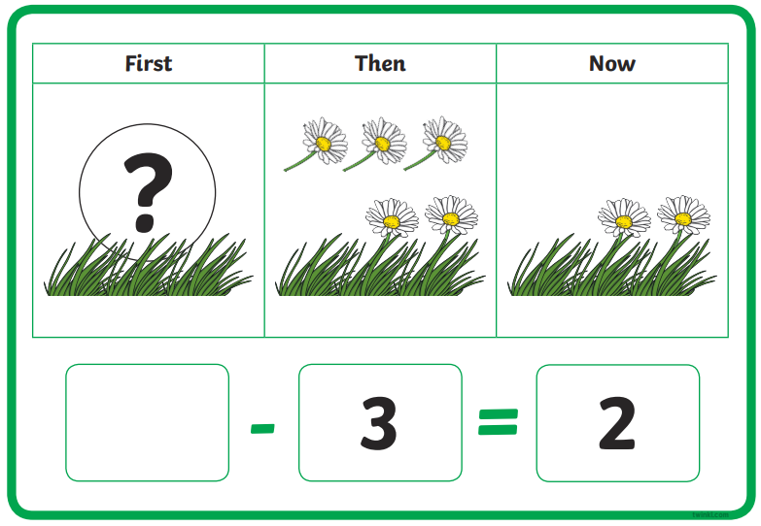
First…
Then…
Now…

