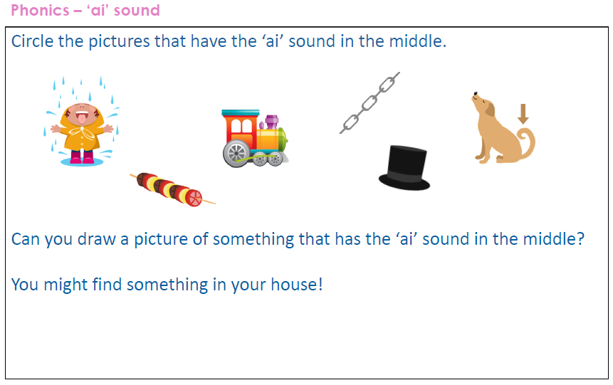
Write a sentence with one of the ai words in it:
______________________________________________________________________________
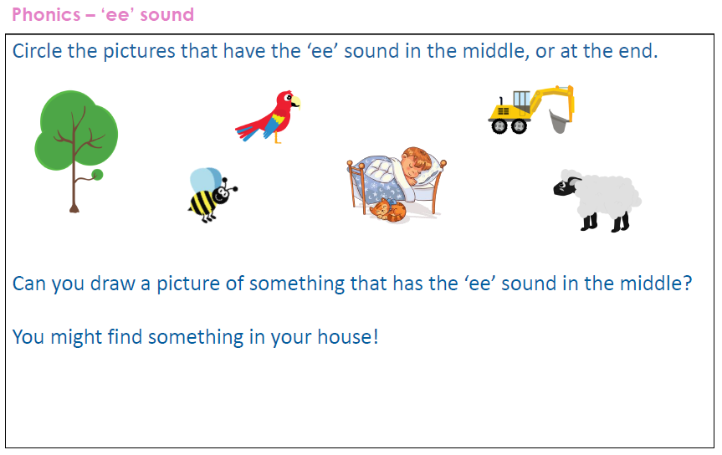
Write a sentence with one of the ee words in it: ______________________________________________________________________
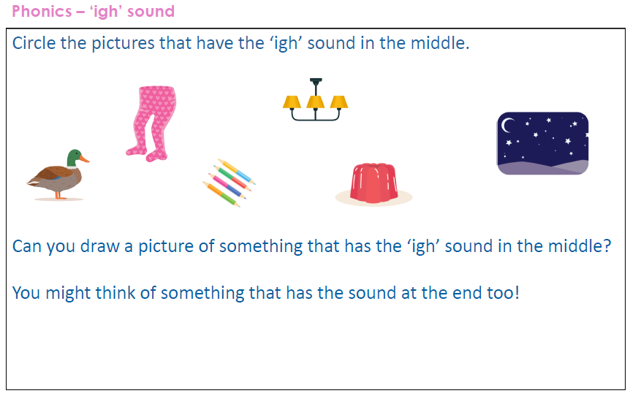
Write a sentence with one of the igh words in it: ______________________________________________________________________
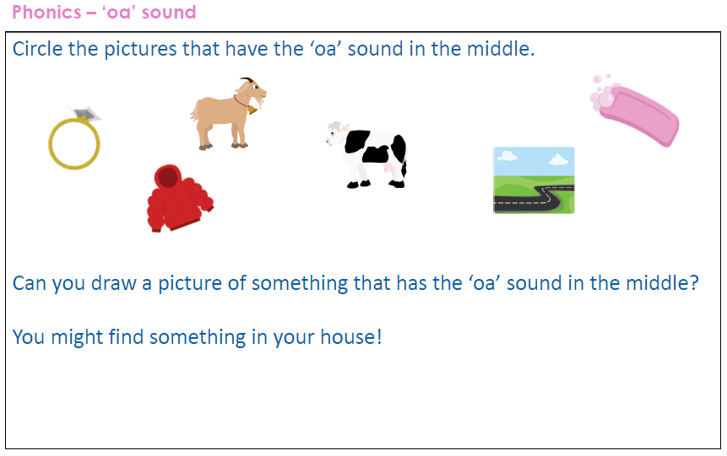
Write a sentence with one of the oa words in it: ______________________________________________________________________
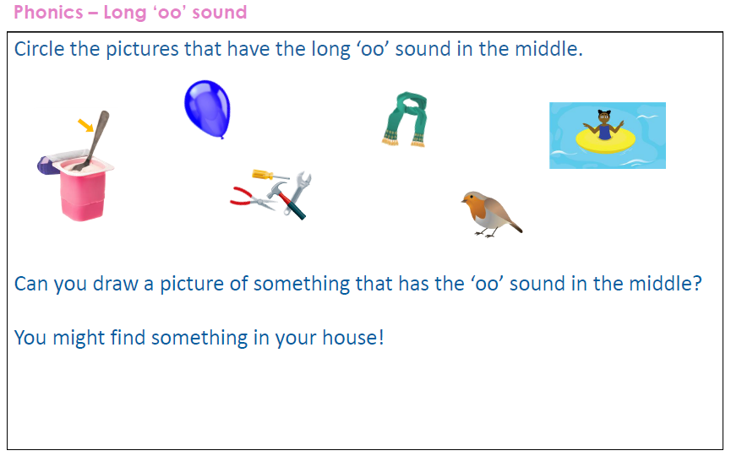
Write a sentence with one of the oo words in it: ______________________________________________________________________
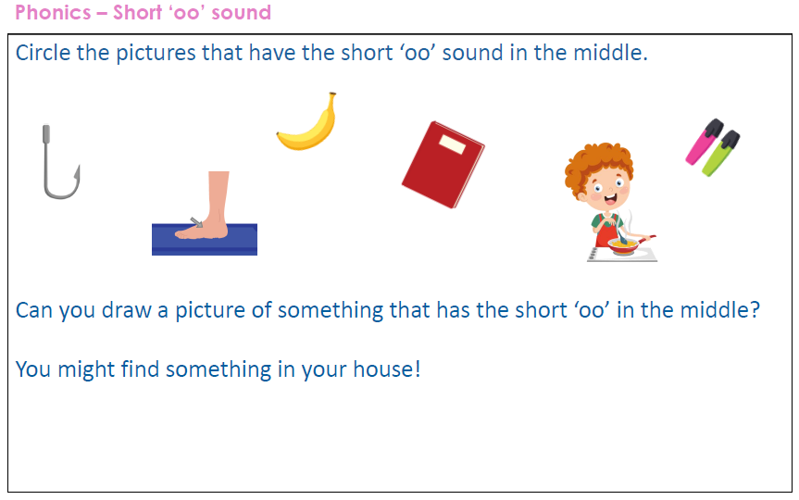
Write a sentence with one of the oo words in it: ______________________________________________________________________
