Home learning – Summer Term Week 5
Maths booklets. Comprehension. English.
This week I have provided the ‘week 4’ work books from Classroom secrets. They match up with some of the bitesize videos from last week (week beginning 11th May). Some of the activities match up to a different day so please read the titles of the activities and videos. The reason we are working a week behind is so that I can explore the resources before setting them – despite being recommended by the government, not all of the resources are up to scratch.
With the Maths, try and keep learning practical and fun. There are lots of educational games that can be found to extend the learning such as: https://www.topmarks.co.uk/maths-games/5-7-years/
With the English work, continue to use your word mats and individual writing checklists. For longer pieces of writing you may need to split the task over two sessions; we often have a break in the middle. Encourage your children to revisit the work when they have finished or on the next day, to edit and improve their work. For example, ask them to look for spelling and punctuation errors using their word mats for reference.
PLEASE NOTE – Year 2 Maths Wednesday – you can find an interactive dice here https://nrich.maths.org/6717
The video on bitesize for year 2 English on 13th May – zig zag letters – does not fit in with our handwriting scheme. I expect the children to use cursive handwriting which they need to try and join up if they can.
Year 3 Maths – Multiplication and Division. I have used https://mathsbot.com/manipulatives/placeValueCounters to show how you can practically work out multiplications. The following representation is 11 x 4 = 44. This could also be used to represent 44 ÷ 4 = 11. You start with 44 and share it into 4 equal groups. 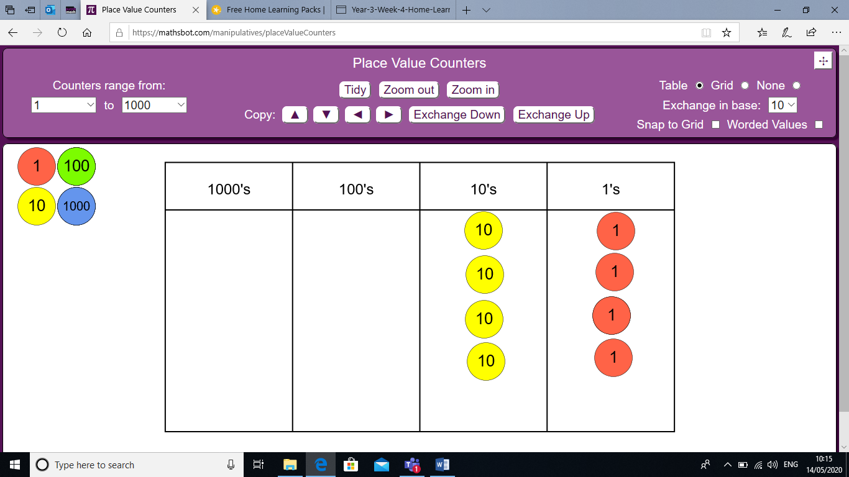
Reading books. You have been provided with an additional three reading books at your level. Please read any of your own books too. For further reading books please visit the website www.oxfordowl.co.uk and log in with the username: birdsedgeclass2 and password: class2

SPaG I will be setting SPaG activities as a ‘To Do’ on purple mash. The children know how to access these.

Phonics. Phase 6 pirate phonics mosaics – Use your phonic knowledge to colour in the tiles to make a picture. Please complete at least one mosaic.

Spelling task. Complete the spelling test on Friday and email the scores to me. I will send out the next set of spellings.
Year 2 | Year 3 | Year 2 alternative spellings | Year 3 alternative spellings
little | I’ll | child | consider
puddle | I’m | children | continue
tinsel | don’t | wild | decide
label | I’d | climb | describe
grass | hadn’t |  | different
pass | you’re
plant | he’ll
path | experience
door | experiment
both | extreme

Topic.
History
Research on the Iron age. https://www.bbc.co.uk/teach/class-clips-video/story-of-britain-iron-age-britain-animation/z42d7nb
Think about how you could present this – a poster, powerpoint presentation, leaflet, non-chronological report. Take care with presentation.

Geography
Using the powerpoint, complete the first page of Scotland’s landscape – physical features.
French. Recap – This half term we have looked at classroom objects and where you live. Look back through the work you have completed. Can you repeat any words or phrases? Can you remember any of them? Test yourself. Say the words/phrases then check your previous work to see if you were correct. Remember to keep watching the other Alain Le Lait videos on youtube so you don’t forget any of the other vocabulary we have learnt.

Art. This half term we would have been looking at drawing patterns and then creating a 3D version. Can you draw a pattern and then make it using salt dough/play dough? Please continue with this activity.

Science.
Year 2 – Our new topic is looking at living things and their habitats. Go through the working together, staying alive powerpoint. Follow the instructions on this slide. There are three levels of challenge with the activity. Choose 1* if you are feeling unsure, 2* if you understand the activity and 3* if you think you are up to the challenge!
Year 3 – Our new topic is looking at forces, this week looking at magnets. This week we would be looking at exploring the different poles on a magnet. Please watch the video on https://www.bing.com/videos/search?q=magnetic+poles+for+children&ru=%2fvideos%2fsearch%3fq%3dmagnetic%2bpoles%2bfor%2bchildren%26FORM%3dHDRSC3&view=detail&mid=A3E178F45AD070808182A3E178F45AD070808182&&FORM=VDRVRV When we return to school we will have opportunities to explore magnets practically. Use the video to complete the worksheet. Answers: Attract, repel, attract, repel.

Music. If you have a ukulele, continue practicing the chords.
Warm up your voice – eg pop it on the head with a ping pong ball/donkeys are in love with carrots. Then sing a song or songs of your choice.

PE. We would be working on bat and ball skills. Can you practice throwing and catching with a small ball? If you do not have a ball, try with a rolled up pair of socks. Try and challenge yourself – use one hand, use your other hand, how many times can you clap in between throwing and catching the ball? Can you further challenge yourself by throwing a different object? Can you throw an object to hit a target? Can you further challenge yourself by moving away from the target? Can you use the hand you do not write with to hit the target? Was this easier or harder? Do you need more practice?

Online resources
I have included individual log in details for Reading Wise and Classroom secrets kids. Please use these websites for any additional learning.
Joe Wicks PE – live on youtube weekdays at 9am.
BBC teach – https://www.bbc.co.uk/bitesize/dailylessons.
NumBots – You can access this through the TT rockstars app or through the NumBots app using your TT rockstars log in details.

Please remember that I am here for any support you need with home learning. Whether that is an explanation, helping you find supportive materials or providing you with extra work linked to what your child is struggling with.
I hope you are all safe and well. Please keep me updated with the fantastic work you are doing and fun you are having at home.
Miss Haigh danielle.haigh@birdsedgefirst.org

