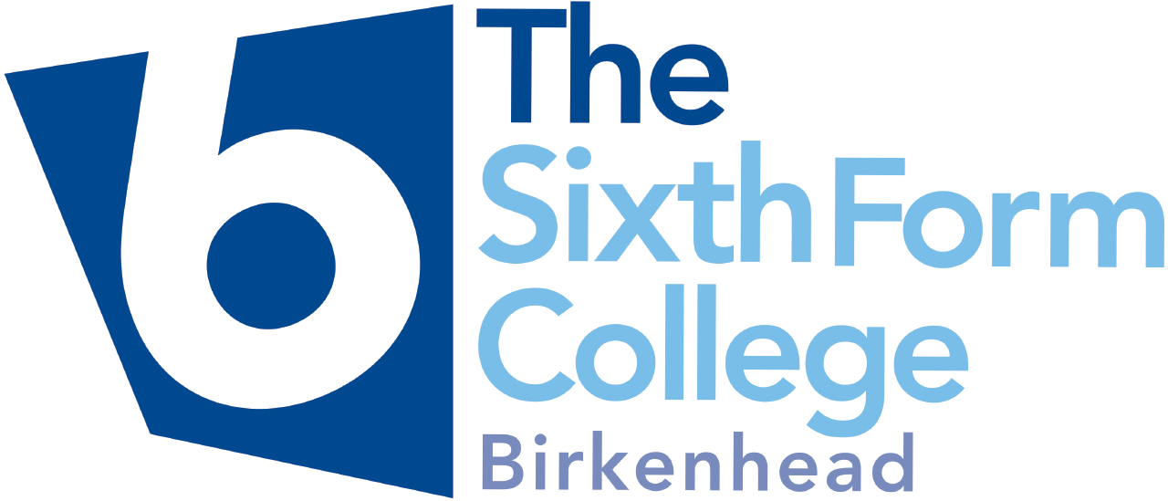

2022-23 Student Bursary Statement

Birkenhead Sixth Form is an outstanding college in which excellence is achieved in a positive, ambitious, resilient and thoughtful environment. We are committed to ensuring that all students have access to the right resources to be successful in their academic studies and that any barriers to participation are removed.

This statement sets out how Birkenhead Sixth Form College implements the 16-19 Bursary Fund guidance issued by the Education and Skills Funding Agency (ESFA). A copy of the ESFA’s 16-19 Bursary Fund Guide for 2022-23 can be accessed on the gov.uk website:
https://www.gov.uk/government/publications/16-to-19-bursary-fund-guide-2022-to-2023-academic-year

Summary of the 16-19 Bursary Fund for 2022-23

Age & residency eligibility:

To be eligible, students must be aged 16 or over but under 19 at 31 August 2022 and meet the residency criteria in the ESFA funding regulations. (https://www.gov.uk/government/organisations/education-and-skills-funding-agency)

Students aged 19 or over are only eligible to receive a discretionary bursary if they are continuing a study programme they began aged 16 to 18 or have an Education, Health & Care Plan (EHCP).

The 16-19 Bursary Fund has two elements:

- Defined vulnerable groups: a bursary of up to £1,200 a year for young people in the following defined vulnerable groups -
a. In care (foster care must be arranged through the local authority)
b. A care leaver (including arrangements made under a Special Guardianship Order)
c. In receipt of Income Support, or Universal Credit because they are financially supporting themselves, or financially supporting themselves AND someone who is dependent on them and living with them
d. In receipt of Disability Living Allowance (DLA) or Personal Independence Payments (PIP) in their own right , as well as Employment and Support Allowance (ESA) or Universal Credit) in their own right

A payment of up to £1200 pa could be awarded based on individual circumstances. Payments will be spread across the academic year and paid directly into a student’s bank account. Vulnerable students will also receive the other relevant benefits listed in the discretionary bursary.

- A discretionary bursary is available to young people in a way that best fits the needs and circumstances of our students. Bursary awards will be targeted towards those young people who face the greatest financial barriers to participation and is spent in a way that removes these barriers. This can include spending bursary funds to ensure that students are supported with the costs of transport, meals, compulsory books, equipment and compulsory trips.

Birkenhead Sixth Form College is free to determine the assessment criteria for eligibility for discretionary bursaries, and the frequency of and conditions for all awards; subject to the requirements of the Equality Act 2010. Birkenhead Sixth Form College’s criteria is linked to household income and uses the same means-tested criteria used for Free School Meals i.e. a student’s parents should be in receipt of one or more of these benefits:

- Income Support
- Income-based Jobseeker’s Allowance
- Income-related Employment and Support Allowance (ESA)
- Support under Part VI of the Immigration and Asylum Act 1999
- The guarantee element of State Pension Credit
- Child Tax Credit (provided they’re not entitled to Working Tax Credit and have an annual gross income of no more than £16,190 as assessed by HMRC)
- Working Tax Credit run-on - paid for 4 weeks after they stop qualifying for Working Tax Credit
- Universal Credit with net earnings not exceeding £7,400 for each year (after tax and not including any benefits they get)

Previously, the College liaised with Wirral Borough Council to verify FSM eligibility. The Council have now outsourced this service to an online portal provided by Capita SIMS. This process is easy for parents to confirm their eligibility for a bursary and it gives an instant decision. The portal checks various government databases so is always up to date and removes the need for the College to see any evidence or seek a signed declaration that the information provided is correct.

Birkenhead Sixth Form College Bursary Awards:

In line with best practice outlined by the Education and Skills Funding Agency, Birkenhead Sixth Form College will pay awards in kind. Cash payments will only be made if in kind payments are not possible or appropriate.

The size and nature of the award made will be subject to the amount of funds available and the type of support requested.

Under exceptional circumstances, an additional discretionary award may be made to a student who makes a Request for Financial Assistance with the support of their Personal Development Tutor. This can include emergency food support.

Students should note that all awards from the Student Bursary Fund will be subject to the expectations outlined in the College’s Core Requirements and satisfactory attendance. The College reserves the right to defer or cancel awards in the event of unsatisfactory student conduct and in the event of the College being made aware of a change in circumstances which has resulted in a student no longer satisfying the eligibility criteria.

Application process:
Vulnerable groups
- Complete paper form available from the Finance Office and supply supporting evidence
- Assessment made and decision documented on the 22/23 bursary database
- Confirmation email/Teams message sent to student
- Payments set up as required

Discretionary bursary
- Complete online form at https://www.cloudforedu.org.uk/ofsm/sims
- College notified of applicants (successful and unsuccessful)
- Assessment made and decision documented on the 22/23 bursary database
- Confirmation email/Teams message send to student

Complaints or appeals
If a student/parent is unhappy with how their application has been handled, they should follow the College’s complaint procedure: https://www.bsfc.ac.uk/college-information/policies

