20th March 2020

Dear Students,

Information for First Year Students

As I am sure you are all aware the Government have announced that schools and colleges will close from Monday 23rd March as part of the country’s ongoing response to coronavirus. In addition to this they also confirmed that exams scheduled for this summer will not go ahead.
The physical college may be closed to staff and students until further notice but studying and learning will very much continue. However if there is a critical reason for you to visit college it will be open from 9am-12:30pm everyday but there will only be a limited number of staff available. Your teachers will be setting you regular work for every lesson to complete by a variety of means including via e-mail, Microsoft teams, Moodle and other possible online platforms.

Your studies

- Check your college e-mail daily for work instructions from your teacher
- Complete the assigned activities
- Submit work as instructed by your teacher by the deadline given
- The completion and engagement with this work will contribute towards your college forecast grades in April and June.
Your progression

Your progression into the second year will follow the same process as previous years.

- Progression from year 1 to year 2 will is based on your attitude to learning, commitment and attendance at college. For the vast majority of you, provided you continue to engage in the work that your teacher sends, you will automatically progress into your 2nd year of study at the end of your first year.

- For a small minority of students progression into their second year of study will not be automatic. This can be for one or more of the reasons outlined below:-
- Poor attendance with little evidence of improvement over the year;
- Poor attitude to learning;
- Continuous breach of college core requirements;

If you feel this may apply to you then there this still time to put it right by fully engaging and completing the work your teacher sets with a high level of effort and commitment.

End of year exams

At present it is unclear whether there will be any internal college exams at the end of the first year. This is a rapidly changing situation and we will be reviewing the situation regularly and will notify you once the situation becomes clearer. Your end of year exams could move to the Autumn term and take place in September or October however as soon as we now more we will notify you.
Your teachers will be doing all they can to support your learning whilst the college is closed. Try not to worry and keep busy by following your teachers’ directions, it is important to maintain a high level of intellectual challenge to prepare for your second year of study.
If you have any queries regarding any matters detailed above please contact your personal tutor.

Yours sincerely

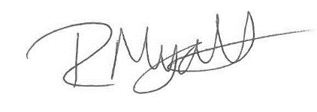

Rob Myatt
Deputy Principal

